NYTS Interviewer Guide – Item Set 3

(Demographics, Antitobacco Messaging, Exposure, and Environment)
Instructions:
- Introduce yourself and ensure that tech is working; respondent should be able to access the web survey and share their screen.
- Briefly discuss the goal of the larger survey and the goal of this interview (i.e., to understand how easy or hard these questions are to answer)
- This is YOUR interview. YOUR chance to give important feedback so kids like you can have a better survey experience.
- Remind the student of consent highlights:
- If possible, take the survey in a private location, away from other family members or your parents.
- Information will not be shared and is only used internally without your name and personal information
- You can skip any question. But, if you feel the question is so uncomfortable that you want to skip it, I’ll ask you why you feel that way.
- The interview will be recorded, and we will take notes.
- Read the OMB statement:
  - CDC estimates the average public reporting burden for this collection of information as 2 hours per response, including the time for reviewing instructions, searching existing data/information sources, gathering and maintaining the data/information needed, and completing and reviewing the collection of information. An agency may not conduct or sponsor, and a person is not required to respond to a collection of information unless it displays a currently valid OMB control number. Send comments regarding this burden estimate or any other aspect of this collection of information, including suggestions for reducing this burden to CDC/ATSDR Information Collection Review Office, 1600 Clifton Road NE, MS D-74, Atlanta, Georgia 30333; ATTN: PRA (0920-0621).
- Explain process.
- Read each question to yourself and answer it through the web survey.
- Pause when you see a stop sign in the survey and I’ll ask you some questions about how you answered.
- There are no wrong answers to any of the questions you will see. In fact, we aren’t going to use the answers you provide in any way. We are more interested in what you think of the questions and response choices you will see. We want your honest feedback about what you think about these questions and response choices. We didn’t write any of these questions so nothing you say about them will bother us.
- Jump in with comments as you’re trying to answer.
- Start with a practice question to make sure they understand how probes work.
- Avoid use or reference to the National Youth Tobacco Survey or NYTS to minimize the introduction of bias.
- After you explain the instructions ask if the respondent has any questions.

Generic probes (use these when the respondent hesitates or appears confused about an item):
- In your own words, what is this question asking?
- Are there any unfamiliar or confusing words in this question?
- How sure are you about your answer? Why?
- How do you think we could make this question less confusing or easier to understand?
- Was anything about this question uncertain or uncomfortable?
  - If so, what is it?
  - If so, do you think others would not want to respond honestly to this question?

Question/Screen (verbatim from NYTS interview) | Question-specific Probes (if required) |  | Notes (for interviewer use)
  - Chewing Tobacco, Snuff, or Dip
The next several sections of questions ask about your use of particular kinds of tobacco products, such as e-cigarettes, cigarettes, cigars, smokeless tobacco, hookahs, roll-your own-cigarettes, pipes, snus, dissolvable tobacco, bidis, heated tobacco products, and nicotine pouches.

At the beginning of each section, you will see a brief description and an image showing examples of each kind of tobacco product.
The next several questions are about the use of chewing tobacco, snuff, or dip, such as Copenhagen, Grizzly, Skoal, or Red Seal.  Do not think about snus or dissolvable tobacco products when you answer these questions.  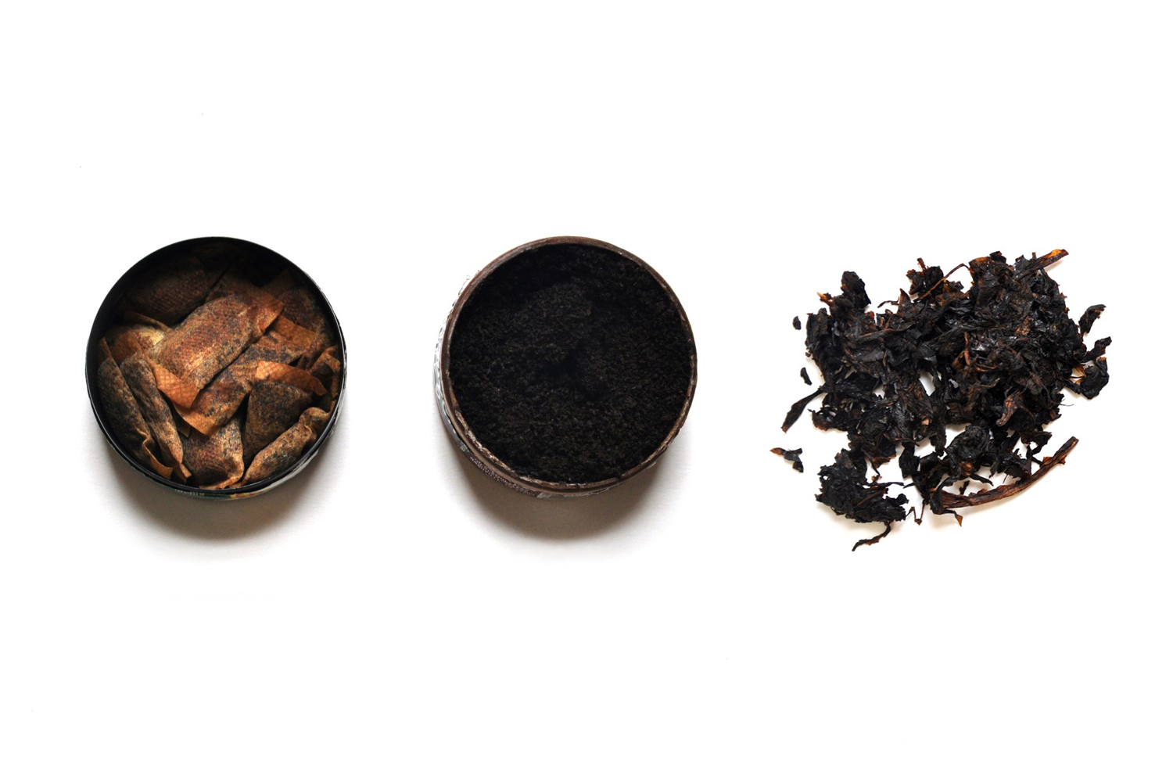 | - In your own words, what is chewing tobacco? What is snuff? What is dip?  - Have you heard of any of the brands mentioned in the description? Which one(s)?  - How well did the description fit the images shown? To what extent did you use the images versus the description in order to understand what types of products it was asking about?
Have you ever used chewing tobacco, snuff, or dip, even just a small amount?
- Yes
- No
[INTERVIEWER: CONTINUE BELOW FOR EVER CHEWING TOBACCO USERS. NEVER USERS SKIP TO PAGE X.]
Question Universe: ever smokeless tobacco users [known]
How old were you when you first used chewing tobacco, snuff, or dip, even just a small amount?
- 8 years old or younger
- 9 years old
- 10 years old
- 11 years old
- 12 years old
- 13 years old
- 14 years old
- 15 years old
- 16 years old
- 17 years old
- 18 years old
- 19 years old or older
Question Universe: ever smokeless tobacco users [or unknown]  During the past 30 days, on how many days did you use chewing tobacco, snuff, or dip?  Specify: |__|__| (Range 0 – 30) | [IF NOT ALREADY PROBED]:  - How easy or hard was it to answer with a specific number of days?
[INTERVIEWER: CONTINUE BELOW FOR PAST 30 DAY CHEWING TOBACCO USERS. EVER USERS SKIP TO PAGE X.]
Question Universe: ever smokeless tobacco users [known]
During the past 30 days, what brands of chewing tobacco, snuff, or dip did you use? (Select one or more)
- Copenhagen
- Grizzly
- Kodiak
- Longhorn
- Red Man
- Red Seal
- Skoal
- Timber Wolf
- Some other brand(s) not listed here (specify): ______________
- Not sure / I don’t know the brand
Question Universe: past 30-day chewing tobacco, snuff, or dip user reporting >1 brand [known]
During the past 30 days, what brand of chewing tobacco, snuff, or dip did you usually use? (Choose only one answer)
- I did not use a usual brand
- Copenhagen
- Grizzly
- Kodiak
- Longhorn
- Red Man
- Red Seal
- Skoal
- Timber Wolf
- Some other brand not listed here (specify): __________________
- Not sure / I don’t know the brand
Question Universe: past 30-day smokeless tobacco user [known]  Was any of the chewing tobacco, snuff, or dip that you used in the past 30 days flavored to taste like menthol, mint, clove or spice, alcoholic drinks, candy, fruit, chocolate, or any other non-tobacco flavor?  Do not think about tobacco flavor when answering this question.  - Yes  - No  - Don’t Know | What does “non-tobacco flavor” mean to you in this question? What does “tobacco flavor” mean?  Would you have answered differently if it didn’t say “Do not think about tobacco flavor when answering this question?
Question Universe: past 30-day smokeless tobacco user [known]  Was any of the chewing tobacco, snuff, or dip that you used in the past 30 days flavored to taste like tobacco?  - Yes  - No  - Don’t Know | What does “flavored to taste like tobacco” mean to you?  Did you think about added artificial flavorings, naturally occurring tobacco flavor, or both?
Question Universe: past 30-day users of flavored smokeless tobacco  What flavors was the chewing tobacco, snuff, or dip that you have used in the past 30 days? (Select one or more)  - Tobacco-flavor  - Menthol  - Mint  - Spice (such as cinnamon, vanilla, or clove)  - Fruit  - Chocolate  - Alcoholic drinks (such as wine, margarita, or other cocktails)  - Non-alcoholic drinks (such as coffee, soda, lemonade, or other beverage)  - Candy, desserts, or other sweets  - Some other flavor not listed here (Specify): __________________________ | What do you think of the answer choices?  What’s the difference between menthol and mint?
Question Universe: past 30-day smokeless tobacco user [known]
During the past 30 days, how did you get your chewing tobacco, snuff, or dip? (Select one or more)
- I bought it myself
- I had someone else buy it for me
- I asked someone to give me some
- Someone offered it to me
- I got it from a friend
- I got it from a family member
- I took it from a store or another person
- I got it in some other way (Specify): ________________________________
Question Universe: past 30-day smokeless tobacco user [known]
During the past 30 days, where did you buy your chewing tobacco, snuff, or dip? (Select one or more)
- I did not buy chewing tobacco, snuff, or dip during the past 30 days à [EXCLUSIVE RESPONSE]
- I bought it from another person (a friend, family member, or someone else)
- A gas station or convenience store
- A grocery store
- A drugstore
- A mall or shopping center kiosk/stand
- A vending machine
- On the Internet (such as a product or store website, eBay or Facebook Marketplace)
- Through the mail
- Through a delivery service (such as DoorDash or Postmates)
- A vape shop or tobacco shop
- Some other place not listed here (Specify): ___________________________
Question Universe: past 30-day smokeless tobacco user (who got a product from someone else)
Earlier you mentioned that you got or bought your chewing tobacco, snuff, or dip from another person, such as a friend or family member. How old was this person?
- Younger than 18 years old
- 18 years old
- 19 years old
- 20 years old
- 21 years old or older
- I don’t know
Question Group Probes:
- Can you describe the chewing tobacco product(s) you’ve used? What else would you call it?
- [IF NOT ALREADY PROBED]: How easy or hard was it to remember your specific experiences, like flavors and where you got your products from?
[INTERVIEWER: CONTINUE BELOW FOR NEVER CHEWING TOBACCO USERS. CURRENT USERS SKIP TO PAGE X.]
Question Universe: never smokeless tobacco product users [known]
Have you ever been curious about using chewing tobacco, snuff, or dip?
- Definitely yes
- Probably yes
- Probably not
- Definitely not
Question Group Probes:
- IF NOT PROBED ALREADY: In your own words, what is the difference between “definitely yes/no” and “probably yes/no”?
  - Snus
The next few questions are about snus, such as Camel Snus, Marlboro Snus, or General Snus. Snus is a type of smokeless tobacco that comes in a small pouch that you put under your lip. Snus is different from some other smokeless tobacco products such as nicotine pouches, because it does contain tobacco leaf.  Do not think about chewing tobacco, snuff, dip, nicotine pouches, or other oral nicotine products when answering these questions.  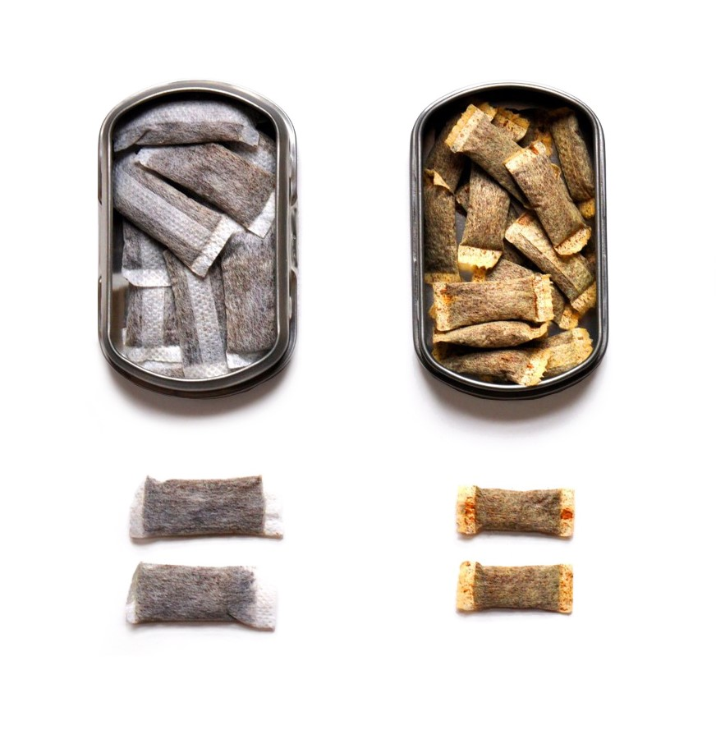 | - Had you ever heard of snus before today?  - What is snus, in your own words? How is it different from chewing tobacco or other types of smokeless tobacco? What types of products would you include or exclude?  - How well did the description fit the images shown? To what extent did you use the images versus the description in order to understand what types of products it was asking about?
Have you ever used snus, even just one time?
- Yes
- No
[INTERVIEWER: CONTINUE BELOW FOR EVER SNUS USERS. NEVER USERS SKIP TO PAGE X.]
Question Universe: ever users of snus [or unknown]  During the past 30 days, on how many days did you use snus?  Specify: |__|__| (Range 0 – 30) | [IF NOT PROBED ALREADY]:  - How easy or hard was it to answer with a specific number of days?
[INTERVIEWER: CONTINUE BELOW FOR PAST 30 DAY SNUS USERS. EVER USERS SKIP TO PAGE X.]
Question Universe: past 30-day snus user [known]
Was any of the snus that you used in the past 30 days flavored to taste like menthol, mint, clove or spice, alcoholic drinks, candy, fruit, chocolate, or any other non-tobacco flavor?
Do not think about tobacco flavor when answering this question.
- Yes
- No
- Don’t Know
Question Universe: past 30-day snus user [known]
Was any of the snus that you used in the past 30 days flavored to taste like tobacco?
- Yes
- No
- Don’t Know

Question Universe: past 30-day users of flavored snus
What flavors was the snus that you have used in the past 30 days? (Select one or more)
- Tobacco-flavor
- Menthol
- Mint
- Spice (such as cinnamon, vanilla, or clove)
- Fruit
- Chocolate
- Alcoholic drinks (such as wine, margarita, or other cocktails)
- Non-alcoholic drinks (such as coffee, soda, lemonade, or other beverage)
- Candy, desserts, or other sweets
- Some other flavor not listed here (Specify): _____________________________
Question Universe: past 30-day snus user [known]
During the past 30 days, how did you get your snus? (Select one or more)
- I bought it myself
- I had someone else buy it for me
- I asked someone to give me some
- Someone offered it to me
- I got it from a friend
- I got it from a family member
- I took it from a store or another person
- I got it in some other way (specify): __________________________________
Question Universe: past 30-day snus user [known]
During the past 30 days, where did you buy your snus? (Select one or more)
- I did not buy snus during the past 30 days à [EXCLUSIVE RESPONSE]
- I bought it from another person (a friend, family member, or someone else)
- A gas station or convenience store
- A grocery store
- A drugstore
- A mall or shopping center kiosk/stand
- A vending machine
- On the Internet (such as a product or store website, eBay, or Facebook Marketplace)
- Through the mail
- Through a delivery service (such as DoorDash or Postmates)
- A vape shop or tobacco shop
- Some other place not listed here (specify): ______________________________
Question Group Probes:
- Can you describe the snus product(s) you’ve used? What else would you call it?
- [IF NOT ALREADY PROBED]: How easy or hard was it to remember your specific experiences, like flavors and where you got your products from?
  - Nicotine Pouches
The next section is about nicotine pouches such as Zyn, on!, Velo, or Rogue. These small, flavored pouches are filled with a nicotine-containing powder. Users place nicotine pouches in their mouth and do not need to spit. Nicotine pouches are different from some other smokeless tobacco products such as snus, dip, or chewing tobacco, because they do not contain any tobacco leaf.  Do not think about chewing tobacco, snuff, dip, snus, or other oral nicotine products when answering these questions.  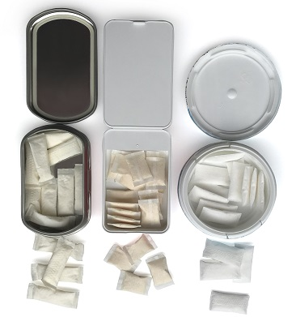 | - In your own words, what is a nicotine pouch?  - How is a nicotine pouch different from chewing tobacco? How is nicotine pouch different from snus? From other oral nicotine products?  - Have you heard of any of the examples of nicotine pouches?  - How well did the description fit the images shown? To what extent did you use the images versus the description in order to understand what types of products it was asking about?
Before today, have you heard of nicotine pouches?
- Yes
- No
- Don’t know/Not Sure
Have you ever used a nicotine pouch, even just one time?  - Yes  - No  - Don’t Know/Not Sure | [IF DON’T KNOW]:  - What makes you unsure about having used nicotine pouches?
[INTERVIEWER: CONTINUE BELOW FOR EVER (OR DK) NICOTINE POUCH USERS. NEVER USERS SKIP TO PAGE X.
Question Universe: ever nicotine pouch user [or unknown/don’t know]  During the past 30 days, on how many days did you use a nicotine pouch?  Specify: |__|__| (Range 0 – 30) | [IF NOT ALREADY PROBED]:  - How easy or hard was it to answer with a specific number of days?
[INTERVIEWER: CONTINUE BELOW FOR PAST 30 DAY NICOTINE POUCH USERS. EVER USERS SKIP TO PAGE X.
Question Universe: past 30-day nicotine pouch user [known]
During the past 30 days, what nicotine pouch brands did you use? (Select one or more)
- on!
- Rogue
- Velo
- Zyn
- Some other brand(s) not listed here (specify): ________________
- Not sure / I don’t know the brand
Question Universe: past 30-day nicotine pouch user reporting >1 brand [known]
During the past 30 days, what brand of nicotine pouches did you usually use? (Choose only one answer)
- I did not use a usual brand
- on!
- Rogue
- Velo
- Zyn
- Some other brand(s) not listed here (specify): _________________
- Not sure / I don’t know the brand

Question Universe: past 30-day nicotine pouch user [known]  Were any of the nicotine pouches that you used in the past 30 days flavored to taste like menthol, mint, clove or spice, alcoholic drinks, candy, fruit, chocolate, or any other non-tobacco flavor?  Do not think about tobacco flavor when answering this question.  - Yes  - No  - Don’t Know | [if not already prompted]  What does “non-tobacco flavor” mean to you in this question? What does “tobacco flavor” mean?  Would you have answered differently if it didn’t say “Do not think about tobacco flavor when answering this question?
Question Universe: past 30-day user of nicotine pouches [known]  Were any of the nicotine pouches that you used in the past 30 days flavored to taste like tobacco?  - Yes  - No  - Don’t Know | [if not already prompted]  What does “flavored to taste like tobacco” mean to you?  Did you think about added artificial flavorings, naturally occurring tobacco flavor, or both?
Question Universe: past 30-day users of flavored nicotine pouches  What flavors were the nicotine pouches that you have used in the past 30 days? (Select one or more)  - Tobacco-flavor  - Menthol  - Mint  - Spice (such as cinnamon, vanilla, or clove)  - Fruit  - Chocolate  - Alcoholic drinks (such as wine, margarita, or other cocktails)  - Non-alcoholic drinks (such as coffee, soda, lemonade, or other beverage)  - Candy, desserts, or other sweets  - Some other flavor not listed here (Specify): _________________________ | What do you think of the answer choices?  What’s the difference between menthol and mint?
Question Universe: past 30-day user of flavored nicotine pouches  Did any of the flavors that you used in the past 30 days have names or descriptions that included the word “ice” or “iced” (for example, blueberry ice or strawberry ice)?  - Yes  - No  - Don’t know | - Have you ever heard of “iced” flavors?  - Was anything about this question confusing?
Question Universe: past 30-day user of flavored nicotine pouches  Did any of the flavors that you used in the past 30 days have a name that did not describe a specific flavor, such as “solar,” “purple,” “jazz,” “island bash,” “fusion” or some other word or phrase?  - Yes (specify): ___________________  - No  - Don’t know | - Was anything about this question confusing?  - Would you describe these flavors any differently?  Are any example words (e.g., jazz) missing?
Question Universe: past 30-day nicotine pouch user [known]
During the past 30 days, how did you get your nicotine pouches? (Select one or more)
- I bought them myself
- I had someone else buy them for me
- I asked someone to give me some
- Someone offered them to me
- I got them from a friend
- I got them from a family member
- I took them from a store or another person
- I got them in some other way (Specify): ____________________________

Question Universe: past 30-day nicotine pouch user [known]
During the past 30 days, where did you buy your nicotine pouches? (Select one or more)
- I did not buy nicotine pouches during the past 30 days à [EXCLUSIVE RESPONSE]
- I bought them from another person (a friend, family member, or someone else)
- A gas station or convenience store
- A grocery store
- A drugstore
- A mall or shopping center kiosk/stand
- A vending machine
- On the Internet (such as a product or store website, eBay, or Facebook Marketplace)
- Through the mail
- Through a delivery service (such as DoorDash or Postmates)
- A vape shop or tobacco shop
- Some other place not listed here (Specify): __________________________

Question Group Probes:
- Can you describe the nicotine pouches you’ve used? What else would you call it?
- [IF NOT ALREADY PROBED]: How easy or hard was it to remember your specific experiences, like flavors and where you got your products from?
  - Oral Nicotine Products
The next few questions are about other oral nicotine products. Oral nicotine products come in a variety of shapes and types, such as lozenges, discs, tablets, gums, dissolvable tobacco products, and other products. Examples of these products include Velo Nicotine Lozenges, Rogue Lozenges, Rogue Tablets, Verve discs, or Stonewall. Most oral nicotine products dissolve in your mouth and do not require spitting.  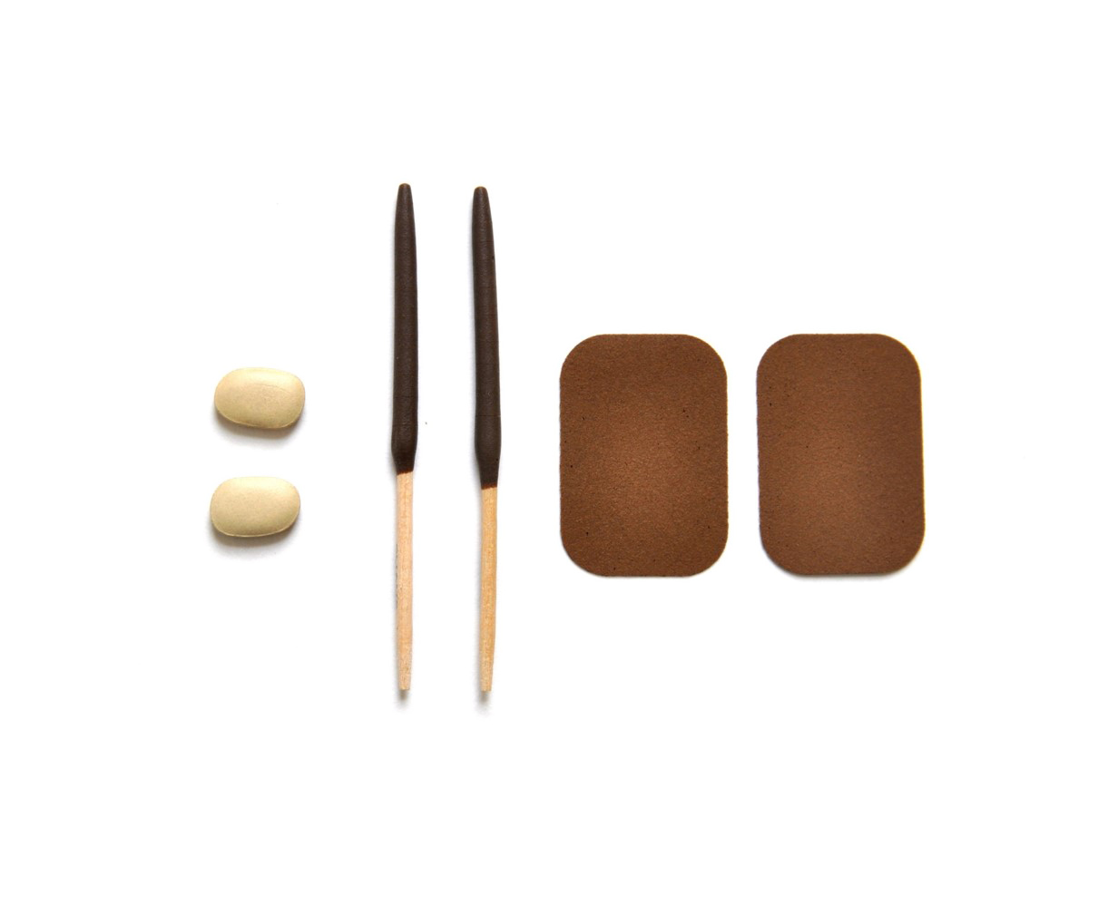  Do not think about chewing tobacco, snuff, dip, snus or nicotine pouches when answering these questions. | - In your own words, what are oral nicotine products? How are these products different from other smokeless tobacco products?  - Have you heard of any of the brands mentioned in the description? Which one(s)?  - Were any of the shapes and types (lozenges, discs, tablets, etc.) hard to understand?  - How well did the description fit the images shown? To what extent did you use the images versus the description in order to understand what types of products it was asking about?
Have you ever used oral nicotine products, even just one time?
- Yes
- No
[INTERVIEWER: CONTINUE BELOW FOR EVER DISSOLVABLE TOBACCO USERS. NEVER USERS SKIP TO PAGE X.
Question Universe: ever users of oral nicotine products [or unknown]  During the past 30 days, on how many days did you use oral nicotine products?  Specify: |__|__| (Range 0 – 30) | [IF NOT PROBED ALREADY]:  - How easy or hard was it to answer with a specific number of days?
[INTERVIEWER: CONTINUE BELOW FOR PAST 30 DAY DISSOLVABLE TOBACCO USERS. EVER USERS SKIP TO PAGE X.]
Question Universe: past 30-day oral nicotine user [known]
Were any of the oral nicotine products that you used in the past 30 days flavored to taste like menthol, mint, clove or spice, alcoholic drinks, candy, fruit, chocolate, or any other non-tobacco flavor?
Do not think about tobacco flavor when answering this question.
- Yes
- No
- Don’t Know
Question Universe: past 30-day oral nicotine product user [known]
Were any of the oral nicotine products that you used in the past 30 days flavored to taste like tobacco?
- Yes
- No
- Don’t Know

Question Universe: past 30-day users of flavored oral nicotine products
What flavors were the oral nicotine products that you have used in the past 30 days? (Select one or more)
- Tobacco-flavor
- Menthol
- Mint
- Spice (such as cinnamon, vanilla, or clove)
- Fruit
- Chocolate
- Alcoholic drinks (such as wine, margarita, or other cocktails)
- Non-alcoholic drinks (such as coffee, soda, lemonade, or other beverage)
- Candy, desserts, or other sweets
- Some other flavor not listed here (Specify): ___________________________
Question Universe: past 30-day oral nicotine user [known]
During the past 30 days, how did you get your oral nicotine products? (Select one or more)
- I bought them myself
- I had someone else buy them for me
- I asked someone to give me some
- Someone offered them to me
- I got them from a friend
- I got them from a family member
- I took them from a store or another person
- I got them in some other way (specify): _______________________________
Question Universe: past 30-day oral nicotine user [known]
During the past 30 days, where did you buy your oral nicotine products? (Select one or more)
- I did not buy oral nicotine products during the past 30 days à [EXCLUSIVE RESPONSE]
- I bought them from another person (a friend, family member, or someone else)
- A gas station or convenience store
- A grocery store
- A drugstore
- A mall or shopping center kiosk/stand
- A vending machine
- On the Internet (such as a website or a secondary source, like eBay or Facebook marketplace)
- Through the mail
- Through a delivery service (such as DoorDash or Postmates)
- A vape shop or tobacco shop
- Some other place not listed here (specify): _____________________________
Question Group Probes:
- Can you describe the oral nicotine product(s) you’ve used? What else would you call it?
- [IF NOT ALREADY PROBED]: How easy or hard was it to remember your specific experiences, like flavors and where you got your products from?
  - All Tobacco Products
[INTERVIEWER: CONTINUE BELOW FOR PAST 30-DAY USERS OF ANY TOBACCO PRODUCT (SEE SCREENER RESPONSES). FOR NEVER OR FORMER USERS, SKIP TO PAGE X.
Instruction Universe: current (past 30-day) tobacco product user (any product) [known]

In answering the next 5 questions, please think about all of the tobacco products that you have used in the past 30 days, including e-cigarettes, cigarettes, cigars, smokeless tobacco, snus, nicotine pouches, other oral nicotine products, hookahs, heated tobacco products, pipe tobacco, bidis, and roll-your own-cigarettes.

Question Universe: current (past 30-day) tobacco product user (any product) [known]  During the past 30 days, on how many days did you use any tobacco product(s)?  Specify: |__|__| (Range 1 – 30) | Walk me through how you answered this question (particularly if respondent uses more than 1 tobacco product).
Question Universe: past 30-day users of any tobacco product [known]  During the past 30 days, have you had a strong craving or felt like you really needed to use a tobacco product of any kind?  - Yes  - No | - In your own words, what is this question asking?
Question Universe: past 30-day users of any tobacco product [known]  How soon after you wake up do you want to use a tobacco product of any kind?  - I do not want to use tobacco products  - Within 5 minutes  - From 6 to 30 minutes  - From more than 30 minutes to 1 hour  - After more than 1 hour but less than 24 hours  - I rarely want to use tobacco products | - How well did the response options fit your answer to this question?
Question Universe: past 30-day tobacco product users (any product) [known]  Are you seriously thinking about quitting the use of all tobacco products? (Please choose the first answer that fits)  - Yes, during the next 30 days  - Yes, during the next 6 months  - Yes, during the next 12 months  - Yes, but not during the next 12 months  - No, I am not thinking about quitting the use of all tobacco products | - What does “seriously thinking about quitting” mean to you here? How did you decide on your answer?  - For those answering [E], are you not interested in quitting, or do you not consider yourself to be a tobacco product user?
Question Universe: past 30-day tobacco product users (any product) [known]
During the past 12 months, how many times have you stopped using all tobacco products for one day or longer because you were trying to quit all tobacco products for good?
- I did not try to quit all tobacco products during the past 12 months
- 1 time
- 2 times
- 3 to 5 times
- 6 to 9 times
- 10 or more times

Instruction Universe: past 30-day tobacco product users (any product) [known]
The next few questions are about getting tobacco products.
Question Universe: past 30-day tobacco product users (any product) [known]
During the past 30 days, did anyone refuse to sell you any tobacco products because of your age?
- I did not try to buy any tobacco products during the past 30 days
- Yes
- No

INTERVIEWER: CONTINUE HERE FOR ALL RESPONDENTS.
Instruction Universe: never, former users of any tobacco product [known/unknown]
The next two questions ask your thoughts about getting tobacco products.
How easy do you think it is for people your age to buy tobacco products in a store?  - Easy  - Somewhat easy  - Not easy at all | - What kinds of stores were you thinking of?
How easy do you think it is for people your age to buy tobacco products online?
- Easy
- Somewhat easy
- Not easy at all

  - Healthcare
The next several questions are about visits to a doctor, dentist, nurse, or other health professional during the past 12 months.
Have you visited a doctor, dentist, or nurse in the past 12 months?  - Yes  - No | - Did you notice that the question asked about the past 12 months?
Please think about cigarettes, only, when answering the next two questions.
During any of these visits to a doctor, dentist, nurse, or other health professional, were you asked if you used cigarettes?
- Yes
- No
During any of these visits, were you advised to not use cigarettes?
- Yes
- No
Please think about e-cigarettes, only, when answering the next two questions.
During any of these visits to a doctor, dentist, nurse, or other health professional, were you asked if you used e-cigarettes?
- Yes
- No
During any of these visits, were you advised to not use e-cigarettes?
- Yes
- No
Please think about all other tobacco products when answering the next two questions.
This includes: cigars, chewing tobacco, snuff, or dip, smokeless tobacco products, snus, nicotine pouches, other oral nicotine products, hookah, heated tobacco products, pipe tobacco, bidis, or roll-your-own cigarettes.
Do not think of e-cigarettes or manufactured cigarettes when answering these questions.
During any of these visits to a doctor, dentist, nurse, or other health professional, were you asked if you used any of these other tobacco products?
- Yes
- No
During any of these visits, were you advised to not use any of these other tobacco products?
- Yes
- No
Question Group Probes:
- For the last couple questions, what products were you thinking about?
- What is a “manufactured cigarette” in your own words?
  - Opinions on Tobacco (B)
The next 8 questions ask about your thoughts on tobacco products.
Compared to a typical cigarette, would you think that a cigarette advertised as low nicotine would be…
- Much less harmful
- Slightly less harmful
- Equally harmful
- Slightly more harmful
- Much more harmful
Do you think that e-cigarettes…
- Never contain nicotine
- Rarely contain nicotine
- Sometimes contain nicotine
- Usually contain nicotine
- Always contain nicotine
How strongly do you agree with the statement ‘All tobacco products are dangerous’?  - Strongly agree  - Agree  - Disagree  - Strongly disagree | What products did you consider?
Do you think that breathing the vapor from other people’s e-cigarettes causes…  - No harm  - Little harm  - Some harm  - A lot of harm | Can you describe what this question is asking in your own words (specifically what “breathing the vapor from other people’s e-cigarettes” means)?
Not including the vapor from e-cigarettes, do you think that breathing smoke from other people’s cigarettes or other tobacco products causes…  - No harm  - Little harm  - Some harm  - A lot of harm | Can you describe what this question is asking in your own words?
Out of every 10 students in your grade at school, how many do you think smoke cigarettes?  - 0  - 1  - 2  - 3  - 4  - 5  - 6  - 7  - 8  - 9  - 10 | - How did you come up with your answer to this question?
Out of every 10 students in your grade at school, how many do you think use e-cigarettes?  - 0  - 1  - 2  - 3  - 4  - 5  - 6  - 7  - 8  - 9  - 10 | - What is the difference between this question and the last one?  - Now that you’ve had a chance to think about it, would you change your answer?
Please complete the following sentence. My friends think that e-cigarette use is…

- Completely acceptable
- Mostly acceptable
- Mostly not acceptable
- Not acceptable
Question Group Probes:
- What kind of harm were you thinking about?
- Some of these questions ask about cigarettes and others ask about e-cigarettes. How clear or confusing was it to understand which questions asked about which type of products?
  - Neighborhood Environment Scale
How true are each of the following statements about your neighborhood?  Response options: Not at all true, A little true, Sort of true, Very true  - There are plenty of safe places to walk or spend time outdoors in my neighborhood  - Every few weeks, some kid in my neighborhood gets beat-up or mugged.  - Every few weeks, some adult gets beat-up or mugged in my neighborhood.  - I have seen people using or selling drugs in my neighborhood.  - In the morning or later in the day, I often see drunk people on the street in my neighborhood.  - Most adults in my neighborhood respect the law.  - I feel safe when I walk around my neighborhood by myself during the day.  - People who live in my neighborhood often damage or steal each other’s property.  - I feel safe when I walk around my neighborhood by myself at night.  - In my neighborhood, the people with the most money are the drug dealers. | - Did the response options make sense for all the questions?  - How did you choose between the response options? What is the difference between “A little true” and “Sort of true”?  - Which of the specific questions are worded in a confusing way or were hard to answer?  - What were you thinking about when you saw the word ‘neighborhood (i.e., how did you define ‘neighborhood’)?

Home and School
The last fourteen questions ask about your experiences at home and at school.
Does anyone who lives with you now…? (Select one or more)  - Use e-cigarettes  - Smoke cigarettes  - Smoke cigars, cigarillos, or little cigars  - Use chewing tobacco, snuff, or dip  - Use snus  - Use nicotine pouches  - Use other oral nicotine products  - Smoke tobacco in a hookah or waterpipe  - Use heated tobacco products  - Smoke pipes filled with tobacco (not hookah or waterpipe)  - Smoke bidis  - Smoke roll-your-own cigarettes  - No one who lives with me now uses any form of tobacco à [EXCLUSIVE] | - How did you decide “who lives with you”?
Do you speak a language other than English at home?
- Yes
- No
Sexual orientation is a person’s emotional, romantic, and/or sexual attraction to another person. There are many ways a person can describe their sexual orientation and many labels a person can use. Which of these options best describes your sexual orientation?  - Heterosexual (straight)  - Gay or Lesbian  - Bisexual, Pansexual, or Queer  - Asexual  - Not Sure  - I do not know what this question is asking | - How did you come up with your answer?  - Were there any categories you hadn’t heard before?  - Were there other answer categories you wish were there?  - If you could write-in your own response, would that have changed your answer?
Some people describe themselves as transgender and/or nonbinary when the way they think or feel about their gender is different from their sex assigned at birth. Do you identify as transgender and/or nonbinary?  - No, I am not transgender and/or nonbinary  - Yes, I am transgender and/or nonbinary  - I am not sure if I am transgender and/or nonbinary  - I am not sure yet or questioning if I am transgender and/or nonbinary  - I do not know what this question is asking | - In your own words, what is this question asking?  - How clear or confusing was the question? How easy or hard to answer?
During the past two weeks, how often have you been bothered by any of the following problems?  Response options: Not at all, Several Days, More than half of the days, Nearly every day  - Little interest or pleasure in doing things  - Feeling down, depressed, or hopeless  - Feeling nervous, anxious, or on edge  - Not being able to stop or control worrying | - This question asks about experiences during the past two weeks. Do you think this is typical of your normal experiences?  - How clear are these response options?
Does your family own a vehicle (such as a car, van, or truck)?
- No
- Yes, one
- Yes, two or more
Do you have your own bedroom?
- No
- Yes
How many computers (including laptops and tablets, not including game consoles and smartphones) does your family own?
- None
- One
- Two
- More than two
During the past 12 months, how many times did you travel on vacation with your family?
- Not at all
- Once
- Twice
- More than twice
During the past 12 months, how would you describe your grades in school?
- Mostly A’s
- Mostly B’s
- Mostly C’s
- Mostly D’s
- Mostly F's
- None of these grades
- Not sure
Because of a physical, mental, or emotional condition, do you have serious difficulty concentrating, remembering, or making decisions?
- Yes
- No
Question Group Probes:
- How did it feel or sound for the intro to this section to talk about “the last fourteen questions”? Did you notice that?
- Were these questions what you expected when the intro said, “your experiences at home and at school”? How else would you describe these questions?
- How clear or confusing were these questions? Was there anything that was hard to answer?
- How comfortable did you feel answering these questions? Did you feel like you could answer honestly?
- How did the COVID-19 pandemic change any of your responses to the questions? For example, did you travel on vacation less during the past 12 months than you normally would have in any other year? Did you have more experiences with anxiety or stress, or get better or worse grades, than you normally would have?

