NYTS Interviewer Guide – Item Set 2

(Cigarettes, E-Cigarette Ads, Social Media, and Discrimination)
Instructions:
- Introduce yourself and ensure that tech is working; respondent should be able to access the web survey and share their screen.
- Briefly discuss the goal of the larger survey and the goal of this interview (i.e., to understand how easy or hard these questions are to answer)
- This is YOUR interview. YOUR chance to give important feedback so kids like you can have a better survey experience.
- Remind the student of consent highlights:
- If possible, take the survey in a private location, away from other family members or your parents.
- Information will not be shared and is only used internally without your name and personal information
- You can skip any question. But, if you feel the question is so uncomfortable that you want to skip it, I’ll ask you why you feel that way.
- The interview will be recorded, and we will take notes.
- Read the OMB statement:
  - CDC estimates the average public reporting burden for this collection of information as 2 hours per response, including the time for reviewing instructions, searching existing data/information sources, gathering and maintaining the data/information needed, and completing and reviewing the collection of information. An agency may not conduct or sponsor, and a person is not required to respond to a collection of information unless it displays a currently valid OMB control number. Send comments regarding this burden estimate or any other aspect of this collection of information, including suggestions for reducing this burden to CDC/ATSDR Information Collection Review Office, 1600 Clifton Road NE, MS D-74, Atlanta, Georgia 30333; ATTN: PRA (0920-0621).
- Explain process.
- Read each question to yourself and answer it through the web survey.
- Pause when you see a stop sign in the survey and I’ll ask you some questions about how you answered.
- There are no wrong answers to any of the questions you will see. In fact, we aren’t going to use the answers you provide in any way. We are more interested in what you think of the questions and response choices you will see. We want your honest feedback about what you think about these questions and response choices. We didn’t write any of these questions so nothing you say about them will bother us.
- Jump in with comments as you’re trying to answer.
- Start with a practice question to make sure they understand how probes work.
- Avoid use or reference to the National Youth Tobacco Survey or NYTS to minimize the introduction of bias.
- After you explain the instructions ask if the respondent has any questions.

Generic probes (use these when the respondent hesitates or appears confused about an item):
- In your own words, what is this question asking?
- Are there any unfamiliar or confusing words in this question?
- How sure are you about your answer? Why?
- How do you think we could make this question less confusing or easier to understand?
- Was anything about this question uncertain or uncomfortable?
  - If so, what is it?
  - If so, do you think others would not want to respond honestly to this question?

Question/Screen (verbatim from NYTS interview) | Question-specific Probes (if required) | Notes (for interviewer use)

Cigarettes
The next several sections of questions ask about your use of particular kinds of tobacco products, such as e-cigarettes, cigarettes, cigars, smokeless tobacco, hookahs, roll-your own-cigarettes, pipes, snus, dissolvable tobacco, bidis, heated tobacco products, and nicotine pouches.

At the beginning of each section, you will see a brief description and an image showing examples of each kind of tobacco product.

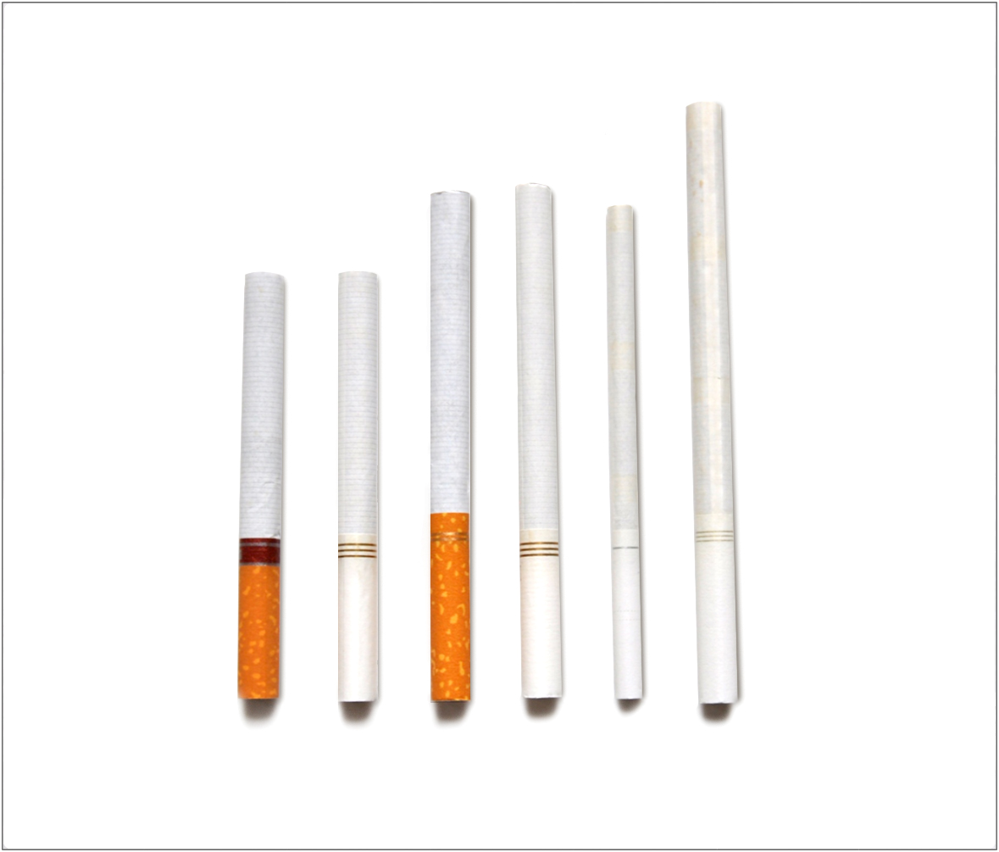
The next several questions are about smoking cigarettes (ones that have to be lit and burned). | - What is a “cigarette” in your own words?  - How is it different from other things a person could smoke?  - How did the definition in the questionnaire change how you think about what a cigarette is?  - How well did the description fit the images shown? To what extent did you use the images versus the description in order to understand what types of products it was asking about?
Have you ever smoked a cigarette, even one or two puffs?
- Yes
- No
[INTERVIEWER: CONTINUE BELOW FOR EVER CIGARETTE USERS. NEVER USERS SKIP TO PAGE X.]
Question Universe: ever cigarette smokers [known]
How old were you when you first smoked a cigarette, even one or two puffs?
- 8 years old or younger
- 9 years old
- 10 years old
- 11 years old
- 12 years old
- 13 years old
- 14 years old
- 15 years old
- 16 years old
- 17 years old
- 18 years old
- 19 years old or older
Question Universe: ever cigarette smokers [known]
About how many cigarettes have you smoked in your entire life?
- 1 or more puffs but never a whole cigarette
- 1 cigarette
- 2 to 5 cigarettes
- 6 to 15 cigarettes (about 1/2 a pack total)
- 16 to 25 cigarettes (about 1 pack total)
- 26 to 99 cigarettes (more than 1 pack, but less than 5 packs)
- 100 or more cigarettes (5 or more packs)
Question Universe: ever cigarette smokers [or unknown]  During the past 30 days, on how many days did you smoke cigarettes?  Specify: |__|__| (Range: 0 – 30) | - How easy or hard was it to answer with a specific number of days?
Question Universe: ever/current cigarette smokers [known]  When was the last time you smoked a cigarette, even one or two puffs? (Please choose the first answer that fits)  - Earlier today  - Not today but sometime during the past 7 days  - Not during the past 7 days but sometime during the past 30 days  - Not during the past 30 days but sometime during the past 6 months  - Not during the past 6 months but sometime during the past year  - 1 to 4 years ago  - 5 or more years ago | - How did you come up with your answer?
[INTERVIEWER: CONTINUE BELOW FOR PAST 30 DAY CIGARETTE USERS. EVER USERS SKIP TO PAGE X.]
Question Universe: past 30-day cigarette smokers [known]
During the past 30 days, on the days you smoked, about how many cigarettes did you smoke per day? A pack usually has 20 cigarettes in it.
- Less than 1 cigarette per day
- 1 cigarette per day
- 2 to 5 cigarettes per day
- 6 to 10 cigarettes per day
- 11 to 20 cigarettes per day
- More than 20 cigarettes per day
Question Universe: past 30-day cigarette smokers [known]
During the past 30 days, what brands of cigarettes did you smoke? (Select one or more)
- American Spirit
- Camel
- Eagle
- Kool
- Marlboro
- Maverick
- Newport
- L&M
- Pall Mall
- Winston
- Some other brand not listed here (Please specify: _____________________)
- Not sure / I don’t know the brand
Question Universe: past 30-day cigarette smokers reporting more than 1 brand [known]  During the past 30 days, what brand of cigarettes did you usually smoke? (Choose only one answer)  - I did not smoke a usual brand  - American Spirit  - Camel  - Eagle  - Kool  - Marlboro  - Maverick  - Newport  - L&M  - Pall Mall  - Winston  - Some other brand not listed here (Please specify): ________________________________________  - Not sure / I don’t know the brand | [IF R CHOOSES “NOT SURE” TO THIS QUESTION OR PREVIOUS]:  - Can you tell me more about why you weren’t sure about the brand?
Question Universe: past 30-day cigarette smokers [known]  Menthol cigarettes are cigarettes that taste like mint. During the past 30 days, were the cigarettes that you usually smoked menthol?  - Yes  - No  - Not sure | - Did you understand what we meant when we described menthol cigarettes as tasting like mint? Is there another way you would distinguish menthol from other cigarettes?  - In your own words, what does “usually smoked” mean here?
Question Universe: past 30-day cigarette smokers [known]
During the past 30 days, how did you get your cigarettes? (Select one or more)
- I bought them myself
- I had someone else buy them for me
- I asked someone to give me some
- Someone offered them to me
- I got them from a friend
- I got them from a family member
- I took them from a store or another person
- I got them in some other way (specify): _______________________________
Question Universe: past 30-day cigarette smokers [known]  During the past 30 days, where did you buy your cigarettes? (Select one or more)  - I did not buy cigarettes during the past 30 days à [EXCLUSIVE RESPONSE]  - I bought them from another person (a friend, family member, or someone else)  - A gas station or convenience store  - A grocery store  - A drugstore  - A mall or shopping center kiosk/stand  - A vending machine  - On the Internet (such as a product or store website, eBay or Facebook Marketplace)  - Through the mail  - Through a delivery service (such as DoorDash or Postmates)  - A vape shop or tobacco shop  - Some other place not listed here (specify): _________________________________ | - Were there any other places you’d want to buy them that weren’t listed?
Question Universe: past 30-day cigarette user (who got a product from someone else)
Earlier you mentioned that you got or bought your cigarettes from another person, such as a friend or family member during the past 30 days. How old was this person?
- Younger than 18 years old
- 18 years old
- 19 years old
- 20 years old
- 21 years old or older
- I don’t know
Question Universe: past 30-day users of cigarettes [known]  Are you seriously thinking about quitting cigarettes? (Please choose the first answer that fits)  - Yes, during the next 30 days  - Yes, during the next 6 months  - Yes, during the next 12 months  - Yes, but not during the next 12 months  - No, I am not thinking about quitting cigarettes | - How did you decide whether you’re “seriously thinking” about quitting?  - What does the phrase “seriously thinking” mean in your own words?
Question Universe: past 30-day users of cigarettes [known]  During the past 12 months, how many times have you stopped smoking cigarettes for one day or longer because you were trying to quit smoking cigarettes for good?  - I did not try to quit during the past 12 months  - 1 time  - 2 times  - 3 to 5 times  - 6 to 9 times  - 10 or more times | - How did you come up with your answer?  - What about the question was confusing?
[INTERVIEWER: CONTINUE BELOW FOR NEVER CIGARETTE SMOKERS. EVER SMOKERS SKIP TO PAGE X.]
Question Universe: never cigarette smokers [known]
Have you ever been curious about smoking a cigarette?
- Definitely yes
- Probably yes
- Probably not
- Definitely not
Question Universe: never cigarette smokers [known]
Do you think that you will try a cigarette soon?
- Definitely yes
- Probably yes
- Probably not
- Definitely not
Question Universe: never cigarette smokers [known]
Do you think you will smoke a cigarette in the next year?
- Definitely yes
- Probably yes
- Probably not
- Definitely not
Question Universe: never cigarette smokers [known]
If one of your best friends were to offer you a cigarette, would you smoke it?
- Definitely yes
- Probably yes
- Probably not
- Definitely not
Question Group Probes:
- In your own words, what’s the difference between “definitely yes/no” and “probably yes/no”?
- What else was confusing about the past few questions?
  - Cigars
The next several questions are about the use of cigars, cigarillos, or little cigars such as Swisher Sweets, Middleton’s (Black & Mild), Backwoods, Garcia y Vega, Cheyenne, White Owl, or Dutch Masters.  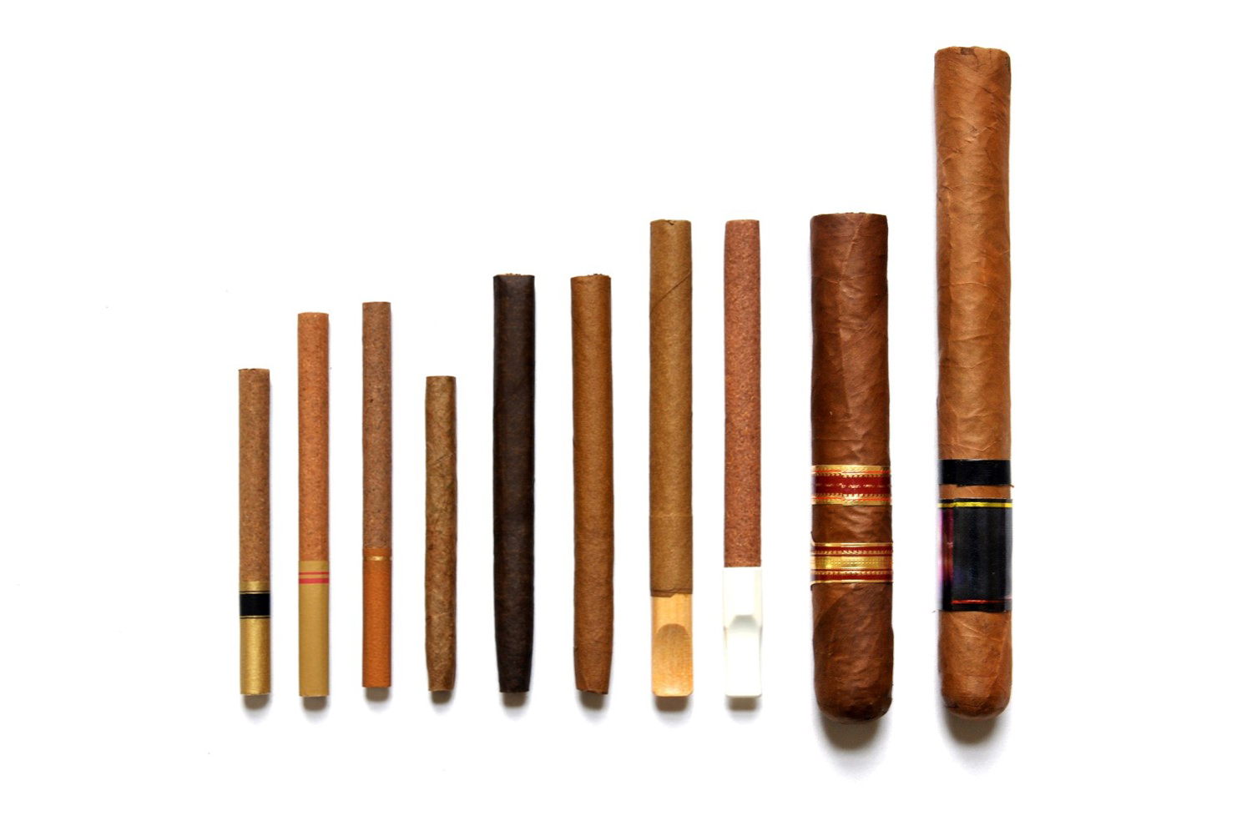 | - In your own words, how is a cigar different from a cigarette? How about a cigarillo or little cigar, how is that different from a cigarette? How is a cigar, cigarillos, or little cigar different from each other?  - How well did the description fit the images shown? To what extent did you use the images versus the description in order to understand what types of products it was asking about?
Have you ever smoked a cigar, cigarillo, or little cigar, even one or two puffs?
- Yes
- No
[INTERVIEWER: CONTINUE BELOW FOR EVER CIGAR SMOKERS. NEVER SMOKERS SKIP TO PAGE X.]
Question Universe: ever cigar smokers [known]
How old were you when you first smoked a cigar, cigarillo, or little cigar, even one or two puffs?
- 8 years old or younger
- 9 years old
- 10 years old
- 11 years old
- 12 years old
- 13 years old
- 14 years old
- 15 years old
- 16 years old
- 17 years old
- 18 years old
- 19 years old or older
Question Universe: ever cigar smokers [or unknown]  During the past 30 days, on how many days did you smoke cigars, cigarillos, or little cigars?  Specify: |__|__| (Range 0 – 30) | [IF NOT ALREADY PROBED]:  - How easy or hard was it to answer with a specific number of days?
[INTERVIEWER: CONTINUE BELOW FOR PAST 30 DAY CIGAR SMOKERS. EVER SMOKERS SKIP TO PAGE X.]
Question Universe: past 30-day cigar smokers [known]
During the past 30 days, on the days that you smoked, about how many cigars, cigarillos, or little cigars did you smoke per day?
- Less than 1 cigar, cigarillo, or little cigar per day
- 1 per day
- 2 to 5 per day
- 6 to 10 per day
- 11 to 20 per day
- More than 20 per day
Question Universe: past 30-day cigar smokers [known]  During the past 30 days, which of the following types of cigars have you smoked? (Select one or more)  - Regular cigars  - Cigarillos  - Little Cigars  - Don’t Know à [EXCLUSIVE] | How did you know the differences between these types of cigars?  [if select DK] – did you select this response because you didn’t know how these products were different? Or because you didn’t know what you smoked?
Question Universe: past 30-day cigar smokers [known]
During the past 30 days, what brands of cigars, cigarillos, or little cigars did you smoke? (Select one or more)
- Backwoods
- Cheyenne
- Dutch Masters
- Garcia Y Vega
- Middleton’s (including Black & Mild)
- Optimo
- Phillies
- Swisher Sweets
- White Owl
- Some other brand not listed here (specify): ____________________
- Not Sure / I don’t know the brand
Question Universe: past 30-day cigar user reporting >1 brand [known]
During the past 30 days, what brand of cigars, cigarillos, or little cigars did you usually use? (Choose only one answer)
- I did not use a usual brand
- Backwoods
- Cheyenne
- Dutch Masters
- Garcia Y Vega
- Middleton’s (including Black & Mild)
- Optimo
- Phillies
- Swisher Sweets
- White Owl
- Some other brand not listed here (specify): ____________________
- Not Sure / I don’t know the brand
Question Universe: past 30-day cigar user [known]  Were any of the cigars, cigarillos, or little cigars that you used in the past 30 days flavored to taste like menthol, mint, clove or spice, alcoholic drinks, candy, fruit, chocolate, or any other non-tobacco flavor?  Do not think about tobacco flavor when answering this question.  - Yes  - No  - Don’t Know | What does “non-tobacco flavor” mean to you in this question? What does “tobacco flavor” mean?  Would you have answered differently if it didn’t say “Do not think about tobacco flavor when answering this question?
Question Universe: past 30-day e-cigarette user [known]  Were any of the cigars, cigarillos, or little cigars that you used in the past 30 days flavored to taste like tobacco?  - Yes  - No  - Don’t Know | What does “flavored to taste like tobacco” mean to you?  Did you think about added artificial flavorings, naturally occurring tobacco flavor, or both?
Question Universe: past 30-day users of flavored cigars  What flavors were the cigars, cigarillos, or little cigars that you have used in the past 30 days? (Select one or more)  - Tobacco-flavor  - Menthol  - Mint  - Spice (such as cinnamon, vanilla, or clove)  - Fruit  - Chocolate  - Alcoholic drinks (such as wine, margarita, or other cocktails)  - Non-alcoholic drinks (such as coffee, soda, lemonade, or other beverage)  - Candy, desserts, or other sweets  - Some other flavor not listed here (Specify: _____________________________) | What do you think of the answer choices?  What’s the difference between menthol and mint?
Question Universe: past 30-day user of flavored cigars  Did any of the flavors that you used in the past 30 days have names or descriptions that included the word “ice” or “iced” (for example, blueberry ice or strawberry ice)?  - Yes  - No  - Don’t know | Have you ever heard of “iced” flavors?  Was anything about this question confusing?
Question Universe: past 30-day user of flavored cigars  Did any of the flavors that you used in the past 30 days have a name that did not describe a specific flavor, such as “solar,” “purple,” “jazz,” “island bash,” “fusion” or some other word or phrase?  - Yes (specify): ___________________  - No  - Don’t know | - Was anything about this question confusing?  - Would you describe these flavors any differently?  - Are any example words (e.g., jazz) missing?
Question Universe: past 30-day cigar smokers [known]
During the past 30 days, how did you get your cigars, cigarillos, or little cigars? (Select one or more)
- I bought them myself
- I had someone else buy them for me
- I asked someone to give me some
- Someone offered them to me
- I got them from a friend
- I got them from a family member
- I took them from a store or another person
- I got them in some other way (specify: ___________________________________)
Question Universe: past 30-day cigar smokers [known]
During the past 30 days, where did you buy your cigars, cigarillos, or little cigars? (Select one or more)
- I did not buy cigars, cigarillos, or little cigars during the past 30 days à [EXCLUSIVE RESPONSE]
- I bought them from another person (a friend, family member, or someone else)
- A gas station or convenience store
- A grocery store
- A drugstore
- A mall or shopping center kiosk/stand
- A vending machine
- On the Internet (such as a product or store website, eBay, or Facebook Marketplace)
- Through the mail
- Through a delivery service (such as DoorDash or Postmates)
- A vape shop or tobacco shop
- Some other place not listed here (specify): ________________________________
Question Universe: past 30-day cigar user (who got a product from someone else)
Earlier you mentioned that you got or bought your cigars, cigarillos, or little cigars from another person, such as a friend or family member during the past 30 days. How old was this person?
- Younger than 18 years old
- 18 years old
- 19 years old
- 20 years old
- 21 years old or older
- I don’t know
Question Group Probes:
- Can you describe the type or brand of cigar or thing you were smoking? What else would you call it?
- [IF NOT ALREADY PROBED]: How easy or hard was it to remember your specific experiences, like flavors and where you got your products from?
[INTERVIEWER: CONTINUE BELOW FOR NEVER CIGAR SMOKERS. EVER SMOKERS SKIP TO PAGE X.]
Question Universe: never cigar smokers [known]
Have you ever been curious about smoking a cigar, cigarillo, or little cigar?
- Definitely yes
- Probably yes
- Probably not
- Definitely not
Question Universe: never cigar smokers [known]
Do you think you will try a cigar, cigarillo, or little cigar soon?
- Definitely yes
- Probably yes
- Probably not
- Definitely not
Question Universe: never cigar smokers [known]
Do you think you will smoke a cigar, cigarillo, or little cigar in the next year?
- Definitely yes
- Probably yes
- Probably not
- Definitely not
Question Universe: never cigar smokers [known]
If one of your best friends were to offer you a cigar, cigarillo, or little cigar, would you smoke it?
- Definitely yes
- Probably yes
- Probably not
- Definitely not
Question Group Probes:
- IF NOT PROBED ALREADY: In your own words, what is the difference between “definitely yes/no” and “probably yes/no”?

Marijuana Cigars
The next question asks about marijuana use in cigars, cigarillos, or little cigars. Sometimes people take the tobacco out of a cigar, cigarillo, or little cigar and replace it with marijuana (also called pot, weed, or cannabis). This is sometimes called a blunt.
Have you ever smoked part or all a cigar, cigarillo, or little cigar with marijuana in it?  - Yes  - No | - If yes: Did you include those when answering the questions about cigars in the last section? Do you also use tobacco/nicotine-only cigars? Which do you use more often?
Question Group Probes:
- Before today had you heard about marijuana being used or smoked in cigars, cigarillos, or little cigars?
- Have you ever heard the term, “blunt”?
- How would you describe this kind of cigar in your own words?
- To what extent are you comfortable responding to questions about marijuana use?
- To what extent do you think people will respond honestly to questions about marijuana use?

Hookah
The next several questions are about smoking tobacco in a hookah, which is a type of waterpipe. Shisha (or hookah tobacco) is smoked in a hookah.  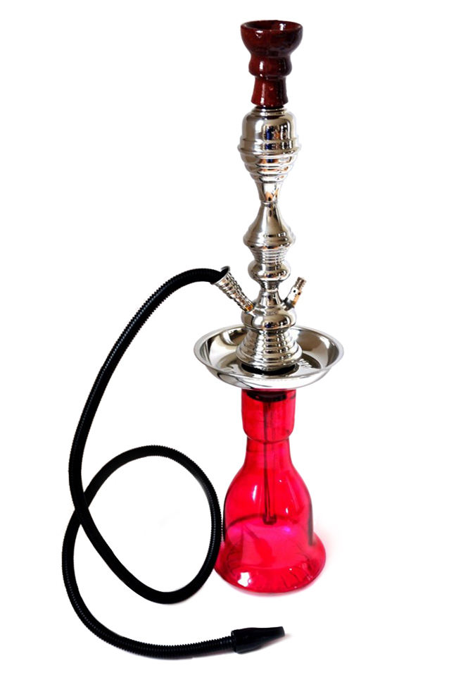 | GOAL: Ensure they know what hookah is.  - Before today had you heard of the term hookah?  - How would you describe a water pipe?  - How well did the description fit the images shown? To what extent did you use the images versus the description in order to understand what types of products it was asking about?
Have you ever smoked tobacco in a hookah or waterpipe, even one or two puffs?
- Yes
- No
[INTERVIEWER: CONTINUE BELOW FOR EVER HOOKAH USERS. NEVER USERS SKIP TO PAGE X.]
Question Universe: ever hookah users [known]
How old were you when you first smoked tobacco in a hookah or waterpipe, even one or two puffs?
- 8 years old or younger
- 9 years old
- 10 years old
- 11 years old
- 12 years old
- 13 years old
- 14 years old
- 15 years old
- 16 years old
- 17 years old
- 18 years old
- 19 years old or older
Question Universe: ever hookah users [or unknown]  During the past 30 days, on how many days did you smoke tobacco in a hookah or waterpipe?  Specify: |__|__| (Range 0 – 30) | [IF NOT ALREADY PROBED]:  - How easy or hard was it to answer with a specific number of days?
[INTERVIEWER: CONTINUE BELOW FOR PAST 30 DAY HOOKAH USERS. EVER USERS SKIP TO PAGE X.]
Question Universe: past 30-day hookah users [known]
During the past 30 days, where did you smoke tobacco in a hookah or waterpipe? (Select one or more)
- At my house
- At a friend’s house
- At a family member’s house, other than my house
- At a hookah bar
- At a café or restaurant
- Some other place not listed here
Question Universe: past 30-day hookah user [known]
Was any of the tobacco in a hookah or waterpipe that you used in the past 30 days flavored to taste like menthol, mint, clove or spice, alcoholic drinks, candy, fruit, chocolate, or any other non-tobacco flavor?
Do not think about tobacco flavor when answering this question.
- Yes
- No
- Don’t Know
Question Universe: past 30-day hookah user [known]
Was any of the tobacco in a hookah or waterpipe that you used in the past 30 days flavored to taste like tobacco?
- Yes
- No
- Don’t Know
Question Universe: past 30-day users of flavored hookah tobacco
What flavors was the tobacco in a hookah or waterpipe that you have used in the past 30 days? (Select one or more)
- Tobacco-flavor
- Menthol
- Mint
- Spice (such as cinnamon, vanilla, or clove)
- Fruit
- Chocolate
- Alcoholic drinks (such as wine, margarita, or other cocktails)
- Non-alcoholic drinks (such as coffee, soda, lemonade, or other beverage)

- Candy, desserts, or other sweets
- Some other flavor not listed here (Specify: _____________________________)
Question Universe: past 30-day hookah user [known]
During the past 30 days, how did you get your hookah tobacco? (Select one or more)
- I bought it myself
- I had someone else buy it for me
- I asked someone to give me some
- Someone offered it to me
- I got it from a friend
- I got it from a family member
- I took it from a store or another person
- I got it in some other way (Specify): _________________________________
Question Universe: past 30-day hookah user [known]
During the past 30 days, where did you buy your hookah tobacco? (Select one or more)
- I did not buy hookah tobacco during the past 30 days à [EXCLUSIVE RESPONSE]
- I bought it from another person (a friend, family member, or someone else)
- A gas station or convenience store
- A grocery store
- A drugstore
- A mall or shopping center kiosk/stand
- A vending machine
- On the Internet (such as a product or store website, eBay, or Facebook Marketplace)
- Through the mail
- Through a delivery service (such as DoorDash or Postmates)
- A vape shop or tobacco shop
- Some other place not listed here (Specify): ________________________________
Question Universe: past 30-day hookah user (who got a product from someone else)
Earlier you mentioned that you got or bought your hookah tobacco from another person, such as a friend or family member. How old was this person?
- Younger than 18 years old
- 18 years old
- 19 years old
- 20 years old
- 21 years old or older
- I don’t know
Question Group Probes:
- [IF NOT ALREADY PROBED]: How easy or hard was it to remember your specific experiences, like flavors and where you got your products from?
INTERVIEWER: CONTINUE BELOW FOR NEVER HOOKAH USERS. CURRENT USERS SKIP TO PAGE X.
Question Universe: never hookah users [known]
Have you ever been curious about smoking tobacco in a hookah or waterpipe?
- Definitely yes
- Probably yes
- Probably not
- Definitely not
Question Group Probes:
- IF NOT PROBED ALREADY: In your own words, what is the difference between “definitely yes/no” and “probably yes/no”?
  - Roll-your-own Cigarettes
The next few questions are about roll-your-own cigarettes.  Do not think about manufactured cigarettes when answering these questions. | - In your own words, what is this definition saying? What kinds of cigarettes should you include or exclude?  - How well did the description fit the images shown? To what extent did you use the images versus the description in order to understand what types of products it was asking about?
Have you ever smoked roll-your-own cigarettes, even just one time?
- Yes
- No
[INTERVIEWER: CONTINUE BELOW FOR EVER ROLL-YOUR-OWN USERS. NEVER USERS SKIP TO PAGE X.]
Question Universe: ever users of roll-your-own tobacco products [or unknown]  During the past 30 days, on how many days did you smoke roll-your-own cigarettes?  Specify: |__|__| (Range 0 – 30) | [IF NOT PROBED ALREADY]:  - How easy or hard was it to answer with a specific number of days?
[INTERVIEWER: CONTINUE BELOW FOR PAST 30 DAY ROLL-YOUR-OWN USERS. EVER USERS SKIP TO PAGE X.]
Question Universe: past 30-day roll-your-own user [known]
Were any of the roll-your-own cigarettes that you used in the past 30 days flavored to taste like menthol, mint, clove or spice, alcoholic drinks, candy, fruit, chocolate, or any other non-tobacco flavor?
Do not think about tobacco flavor when answering this question.
- Yes
- No
- Don’t Know
Question Universe: past 30-day roll-your-own user [known]
Were any of the roll-your-own cigarettes that you used in the past 30 days flavored to taste like tobacco?
- Yes
- No
- Don’t Know

Question Universe: past 30-day users of flavored roll-your-own cigarettes
What flavors were the roll-your-own cigarettes that you have used in the past 30 days? (Select one or more)
- Tobacco-flavor
- Menthol
- Mint
- Spice (such as cinnamon, vanilla, or clove)
- Fruit
- Chocolate
- Alcoholic drinks (such as wine, margarita, or other cocktails)
- Non-alcoholic drinks (such as coffee, soda, lemonade, or other beverage)
- Candy, desserts, or other sweets
- Some other flavor not listed here (Specify: _____________________________)
Question Universe: past 30-day roll-your-own user [known]
During the past 30 days, how did you get your roll-your-own cigarettes? (Select one or more)
- I bought them myself
- I had someone else buy them for me
- I asked someone to give me some
- Someone offered them to me
- I got them from a friend
- I got them from a family member
- I took them from a store or another person
- I got them in some other way (specify: _______________________________)
Question Universe: past 30-day roll-your-own user [known]  During the past 30 days, where did you buy your roll-your-own cigarettes? (Select one or more)  - I did not buy roll-your-own cigarettes during the past 30 days à [EXCLUSIVE RESPONSE]  - I bought them from another person (a friend, family member, or someone else)  - A gas station or convenience store  - A grocery store  - A drugstore  - A mall or shopping center kiosk/stand  - A vending machine  - On the Internet (such as a product or store website, eBay, or Facebook Marketplace)  - Through the mail  - Through a delivery service (such as DoorDash or Postmates)  - A vape shop or tobacco shop  - Some other place not listed here (specify): ________________________________ | - In your own words, what does it mean to “buy your roll-your-own cigarettes”?
Question Group Probes:
- Can you describe the roll-your-own cigarettes you’ve used? What else would you call it?
- How easy or hard was it to remember your specific experiences, like flavors and where you got your products from?
  - Pipe Tobacco
The next few questions are about smoking tobacco in a pipe.  Do not think about smoking tobacco in a hookah (waterpipe) when answering these questions.  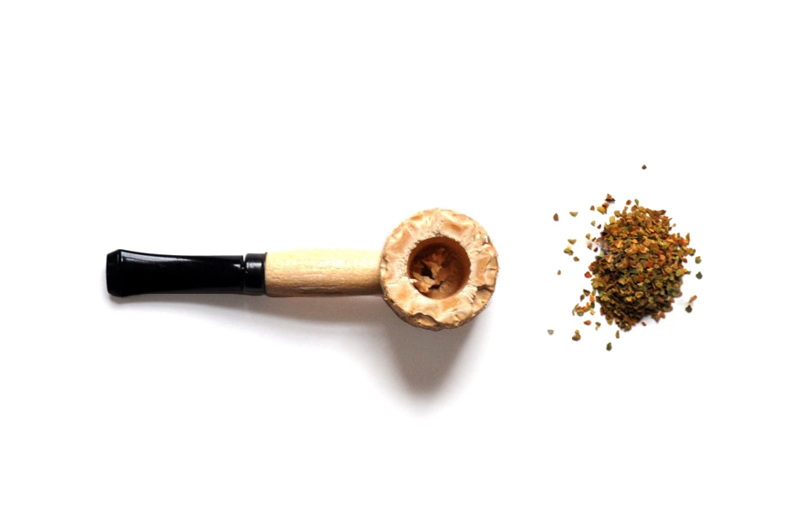 | - In your own words, what is this definition asking you to include or exclude?  - Have you had any pipe smoking experiences you weren’t sure whether should be included or excluded?  - How well did the description fit the images shown? To what extent did you use the images versus the description in order to understand what types of products it was asking about?
Have you ever smoked pipes filled with tobacco (not hookah or waterpipe), even just one time?  - Yes  - No | - In your own words, what does “filled with tobacco mean? All tobacco? Some tobacco? Did you include any pipes you smoked that were filled with tobacco and something else?
[INTERVIEWER: CONTINUE BELOW FOR EVER PIPE USERS. NEVER USERS SKIP TO PAGE X.]
Question Universe: ever users of pipes [or unknown]  During the past 30 days, on how many days did you smoke pipes filled with tobacco?  Specify: |__|__| (Range 0 – 30) | [IF NOT PROBED ALREADY]:  - How easy or hard was it to answer with a specific number of days?
[INTERVIEWER: CONTINUE BELOW FOR PAST 30 DAY PIPE USERS. EVER USERS SKIP TO PAGE X.]
Question Universe: past 30-day pipe tobacco user [known]
Were any of the pipes filled with tobacco that you used in the past 30 days flavored to taste like menthol, mint, clove or spice, alcoholic drinks, candy, fruit, chocolate, or any other non-tobacco flavor?
Do not think about tobacco flavor when answer this question.
- Yes
- No
- Don’t Know
Question Universe: past 30-day pipe tobacco user [known]
Were any of the pipes filled with tobacco that you used in the past 30 days flavored to taste like tobacco?
- Yes
- No
- Don’t Know

Question Universe: past 30-day users of flavored pipe tobacco
What flavors were the pipes filled with tobacco that you have used in the past 30 days? (Select one or more)
- Tobacco-flavor
- Menthol
- Mint
- Spice (such as cinnamon, vanilla, or clove)
- Fruit
- Chocolate
- Alcoholic drinks (such as wine, margarita, or other cocktails)
- Non-alcoholic drinks (such as coffee, soda, lemonade, or other beverage)
- Candy, desserts, or other sweets
- Some other flavor not listed here (Specify: _____________________________)
Question Universe: past 30-day pipe tobacco user [known]
During the past 30 days, how did you get your pipe tobacco? (Select one or more)
- I bought it myself
- I had someone else buy it for me
- I asked someone to give me some
- Someone offered it to me
- I got it from a friend
- I got it from a family member
- I took it from a store or another person
- I got it in some other way (specify: ___________________________________)
Question Universe: past 30-day pipe tobacco user [known]
During the past 30 days, where did you buy your pipe tobacco? (Select one or more)
- I did not buy pipe tobacco during the past 30 days à [EXCLUSIVE RESPONSE]
- I bought it from another person (a friend, family member, or someone else)
- A gas station or convenience store
- A grocery store
- A drugstore
- A mall or shopping center kiosk/stand
- A vending machine
- On the Internet (such as a product or store website, eBay, or Facebook Marketplace)
- Through the mail
- Through a delivery service (such as DoorDash or Postmates)
- A vape shop or tobacco shop
- Some other place not listed here (specify): _________________________________
Question Group Probes:
- Can you describe the pipes you’ve used? What else would you call it?
- [IF NOT ALREADY PROBED]: How easy or hard was it to remember your specific experiences, like flavors and where you got your products from?
  - Bidis
The next several sections of questions ask about your use of particular kinds of tobacco products, such as e-cigarettes, cigarettes, cigars, smokeless tobacco, hookahs, roll-your own-cigarettes, pipes, snus, dissolvable tobacco, bidis, heated tobacco products, and nicotine pouches.

At the beginning of each section, you will see a brief description and an image showing examples of each kind of tobacco product.

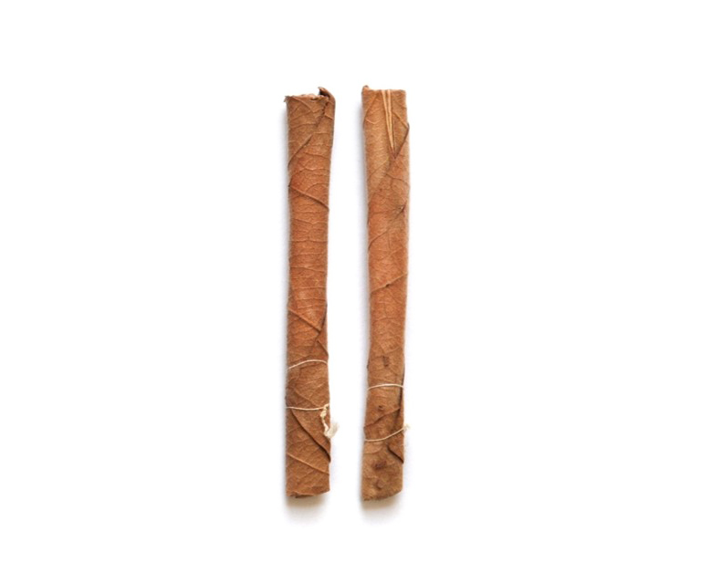
The next few questions are about bidis. Bidis are small brown cigarettes wrapped in a leaf that are typically tied on one or both ends with a string. | - In your own words, what is a bidi?  - How is a bidi different from a cigarette in your mind?  - How well did the description fit the images shown? To what extent did you use the images versus the description in order to understand what types of products it was asking about?
Have you ever smoked bidis, even just one time?
- Yes
- No
[INTERVIEWER: EVER BIDI SMOKERS CONTINUE BELOW. NEVER SMOKERS SKIP TO PAGE X.]
Question Universe: ever users of bidis [or unknown]  During the past 30 days, on how many days did you smoke bidis?  Specify: |__|__| (Range 0 – 30) | - How easy or hard was it to count the number of days?
[INTERVIEWER: PAST 30 DAY BIDI SMOKERS CONTINUE BELOW. EVER SMOKERS SKIP TO PAGE X.]
Question Universe: past 30-day bidis user [known]
Were any of the bidis that you used in the past 30 days flavored to taste like menthol, mint, clove or spice, alcoholic drinks, candy, fruit, chocolate or any other non-tobacco flavor?
- Yes
- No
- Don’t Know
Question Universe: past 30-day bidis user [known]
Were any of the bidis that you used in the past 30 days flavored to taste like tobacco?
- Yes
- No
- Don’t Know

Question Universe: past 30-day users of flavored bidis
What flavors were the bidis that you have used in the past 30 days? (Select one or more)
- Tobacco-flavor
- Menthol
- Mint
- Spice (such as cinnamon, vanilla, or clove)
- Fruit
- Chocolate
- Alcoholic drinks (such as wine, margarita, or other cocktails)
- Non-alcoholic drinks (such as coffee, soda, lemonade, or other beverages)
- Candy, desserts, or other sweets
- Some other flavor not listed here (Specify): _________________________
Question Universe: past 30-day bidis user [known]
During the past 30 days, how did you get your bidis? (Select one or more)
- I bought them myself
- I had someone else buy them for me
- I asked someone to give me some
- Someone offered them to me
- I got them from a friend
- I got them from a family member
- I took them from a store or another person
- I got them in some other way (Specify): ____________________________
Question Universe: past 30-day bidis user [known]
During the past 30 days, where did you buy your bidis? (Select one or more)
- I did not buy bidis during the past 30 days à [EXCLUSIVE RESPONSE]
- I bought them from another person (a friend, family member, or someone else)
- A gas station or convenience store
- A grocery store
- A drugstore
- A mall or shopping center kiosk/stand
- A vending machine
- On the Internet (such as a product or store website, eBay, or Facebook Marketplace)
- Through the mail
- Through a delivery service (such as DoorDash or Postmates)
- A vape shop or tobacco shop
- Some other place not listed here (Specify): ___________________________
Question Group Probes:
- Can you describe the bidis you’ve used? What else would you call it?
- [IF NOT ALREADY PROBED]: How easy or hard was it to remember your specific experiences, like flavors and where you got your products from?
  - Opinions on Tobacco (A)
The next 9 questions ask about your thoughts on tobacco products.
How much do you think people harm themselves when they smoke cigarettes some days but not every day?
- No harm
- Little harm
- Some harm
- A lot of harm
How much do you think people harm themselves when they smoke cigars, cigarillos, or little cigars, some days but not every day?
- No harm
- Little harm
- Some harm
- A lot of harm
Do you believe that cigars, cigarillos, or little cigars are less addictive, equally addictive, or more addictive than cigarettes?
- Less addictive
- Equally addictive
- More addictive
- I have never heard of cigars, cigarillos, or little cigars
- I don’t know enough about these products
How much do you think people harm themselves when they use chewing tobacco, snuff, dip or snus, some days but not every day?  - No harm  - Little harm  - Some harm  - A lot of harm | For this question, did you think about each of these products, individually, or collectively? Would your answer have changed if we asked about each product separately?
Do you believe that chewing tobacco, snuff, dip or snus are (LESS ADDICTIVE, EQUALLY ADDICTIVE, or MORE ADDICTIVE) than cigarettes?  - Less addictive  - Equally addictive  - More addictive  - I have never heard of chewing tobacco, snuff, dip or snus  - I don’t know enough about these products | For this question, did you think about each of these products, individually, or collectively?  Would your answer have changed if we asked about each product separately?
Question Universe: all students  How much do you think people harm themselves when they use nicotine pouches or other oral nicotine products some days but not every day?  - No harm  - Little harm  - Some harm  - A lot of harm | For this question, did you think about each of these products, individually, or collectively? Would your answer have changed if we asked about each product separately?
Question Universe: all students  Do you believe that nicotine pouches or other oral nicotine products are (LESS ADDICTIVE, EQUALLY ADDICTIVE, or MORE ADDICTIVE) than cigarettes?  - Less addictive  - Equally addictive  - More addictive  - I have never heard of nicotine pouches or other oral nicotine products  - I don’t know enough about these products | For this question, did you think about each of these products, individually, or collectively? Would your answer have changed if we asked about each product separately?
How much do you think people harm themselves when they use e-cigarettes some days but not every day?

- No harm
- Little harm
- Some harm
- A lot of harm
Do you believe that e-cigarettes are (LESS ADDICTIVE, EQUALLY ADDICTIVE, or MORE ADDICTIVE) than cigarettes?

- Less addictive
- Equally addictive
- More addictive
- I have never heard of e-cigarettes
- I don’t know enough about these products
How much do you think people harm themselves when they smoke tobacco in a hookah or waterpipe some days but not every day?

- No harm
- Little harm
- Some harm
- A lot of harm
Do you believe that smoking tobacco in a hookah or waterpipe is (LESS ADDICTIVE, EQUALLY ADDICTIVE, or MORE ADDICTIVE) than cigarettes?

- Less addictive
- Equally addictive
- More addictive
- I have never heard of smoking tobacco in a hookah or waterpipe
- I don’t know enough about these products
Question Group Probes:
- What did “some days but not every day” mean in your own words?
- What kind of harm were you thinking about?
- IF R CHOSES “I DON’T KNOW ENOUGH”: What did you think this question was asking?
- Did you notice that some questions ask about “believe” instead of “think”? In your own words what’s the difference? Would it change your answer?

Adolescent Discrimination Distress Index
After each statement, tell us whether you have experienced each of the following types of discrimination because of your race or ethnicity. Remember we are only interested in occasions when racial-ethnic discrimination was at least partly responsible for your experience.  Response options: Yes, No  - You were discouraged from joining an advanced level class.  - You were wrongly disciplined or given after-school detention.  - You were given a lower grade than you deserved.  - You were discouraged from joining a club.  - Others your age did not include you in their activities.  - People expected more of you than they expected of others your age.  - People expected less of you than they expected of others your age.  - People assumed your English was poor.  - You were hassled by police.  - You were hassled by a store clerk or store guard.  - You were called racially insulting names.  - You received poor service at a restaurant or store.  - People acted as if they thought you were not smart.  - People acted as if they were afraid of you.  - You were threatened. | - Did you understand what racial-ethnic discrimination is?  - How comfortable were you answering these questions?  - Did the instructions, questions, and response options match in your mind? Anything confusing about the instructions? Do you think they are needed or could be changed in any way? Longer? Shorter?  - Which of the specific questions are worded in a confusing way or were hard to answer?
If you had this experience, did it upset you?  Response options: Not at all, Slightly, Moderately, Considerably, Extremely  - You were discouraged from joining an advanced level class.  - You were wrongly disciplined or given after-school detention.  - You were given a lower grade than you deserved.  - You were discouraged from joining a club.  - Others your age did not include you in their activities.  - People expected more of you than they expected of others your age.  - People expected less of you than they expected of others your age.  - People assumed your English was poor.  - You were hassled by police.  - You were hassled by a store clerk or store guard.  - You were called racially insulting names.  - You received poor service at a restaurant or store.  - People acted as if they thought you were not smart.  - People acted as if they were afraid of you.  - You were threatened. | - What did “being upset” mean to you?  - IF R CHOSE “MODERATELY”, “CONSIDERABLY,” OR “EXTREMELY”: How did you choose between your answer and one of the other options next to it?
  - Tobacco Exposure
The next four questions ask about you being around other people’s tobacco smoke.
Do not include exposure to vapor from e-cigarettes.
During the past 7 days, on how many days did someone smoke tobacco products in your home while you were there?  - 0 days  - 1 day  - 2 days  - 3 days  - 4 days  - 5 days  - 6 days  - 7 days | [IF MORE THAN 0]:  - How easy or hard was it to remember the number of days?  - How confident do you feel about your answer?  - Were you thinking only about people who live in your home, or visitors as well?
During the past 7 days, on how many days did you ride in a vehicle when someone was smoking a tobacco product?  - 0 days  - 1 day  - 2 days  - 3 days  - 4 days  - 5 days  - 6 days  - 7 days | [IF MORE THAN 0 AND NOT PROBED ABOVE]:  - How easy or hard was it to remember the number of days?  [IF NOT PROBED ABOVE]:  - How confident do you feel about your answer?
During the past 30 days, on how many days were you exposed to the smoke from someone who was smoking tobacco products in an indoor public place? Examples of indoor public places are school buildings, stores, restaurants, and sports arenas. Do not think about homes when answering this question.  - 0 days  - 1 or 2 days  - 3 to 5 days  - 6 to 9 days  - 10 to 19 days  - 20 to 29 days  - All 30 days | - What kinds of places did you think about when answering this question?  - Did you know what we meant when we asked about being “exposed” to smoke? How did you determine if you were “exposed” to smoke? What did this mean to you?
During the past 30 days, on how many days were you exposed to the smoke from someone who was smoking tobacco products in an outdoor public place? Examples of outdoor public places are school grounds, sidewalks, parking lots, stadiums, and parks.  - 0 days  - 1 or 2 days  - 3 to 5 days  - 6 to 9 days  - 10 to 19 days  - 20 to 29 days  - All 30 days | - In your own words, how is this question different from the last one?  - What kinds of places did you think about when answering this question?
Question Group Probes:
- At the beginning of this section, it said, “Do not include exposure to vapor from e-cigarettes.” How easy or hard was it to separate tobacco smoke from e-cigarette vapor for these questions? Are you usually aware of the difference?
- Would you change your answers now that you’ve had a chance to think about it?
The next five questions ask about being around other people’s e-cigarette vapor.
Do not include exposure to smoke from cigarettes or other tobacco products.
During the past 7 days, on how many days did someone use e-cigarettes in your home while you were there?
- 0 days
- 1 day
- 2 days
- 3 days
- 4 days
- 5 days
- 6 days
- 7 days

During the past 7 days, on how many days did you ride in a vehicle when someone was using an e-cigarette?

- 0 days
- 1 day
- 2 days
- 3 days
- 4 days
- 5 days
- 6 days
- 7 days
During the past 30 days, on how many days were you exposed to the vapor from someone who was using an e-cigarette in an indoor public place? Examples of indoor public places are school buildings, stores, restaurants, and sports arenas. Do not think about homes when answering this question.  - 0 days  - 1 or 2 days  - 3 to 5 days  - 6 to 9 days  - 10 to 19 days  - 20 to 29 days  - All 30 days | How did you determine if you were “exposed” to vapor from someone’s e-cigarette? What did this mean to you?
During the past 30 days, on how many days were you exposed to the vapor from someone who was using an e-cigarette in an outdoor public place? Examples of outdoor public places are school grounds, sidewalks, parking lots, stadiums, and parks.
- 0 days
- 1 or 2 days
- 3 to 5 days
- 6 to 9 days
- 10 to 19 days
- 20 to 29 days
- All 30 days
While at school or on school property, have you ever seen anyone using an e-cigarette, such as JUUL, Vuse, NJOY, Puff Bar, blu, or Bidi Stick in any of the following locations? (Select one or more)  - Yes, inside a school bathroom or locker room  - Yes, inside a classroom  - Yes, inside some other area of the school (hallway, cafeteria)  - Yes, outside of the school, such as in the parking lot, sidewalk, sports field, or other school grounds  - Yes, somewhere else not listed here [Specify): _______________________  - No à [EXCLUSIVE] | [IF YES]:  - How easy or hard was it to remember where you saw someone using an e-cigarette?  - For those answering “somewhere else” – what types of locations were you thinking about?  - Was it clear that we wanted to know experiences on school property, only?
Question Group Probes:
- [IF NOT PROBED ABOVE]: At the beginning of this section, it said “Do not include exposure to smoke from cigarettes or other tobacco products.” How easy or hard was it to separate tobacco smoke from e-cigarette vapor for these questions? Are you usually aware of the difference?

