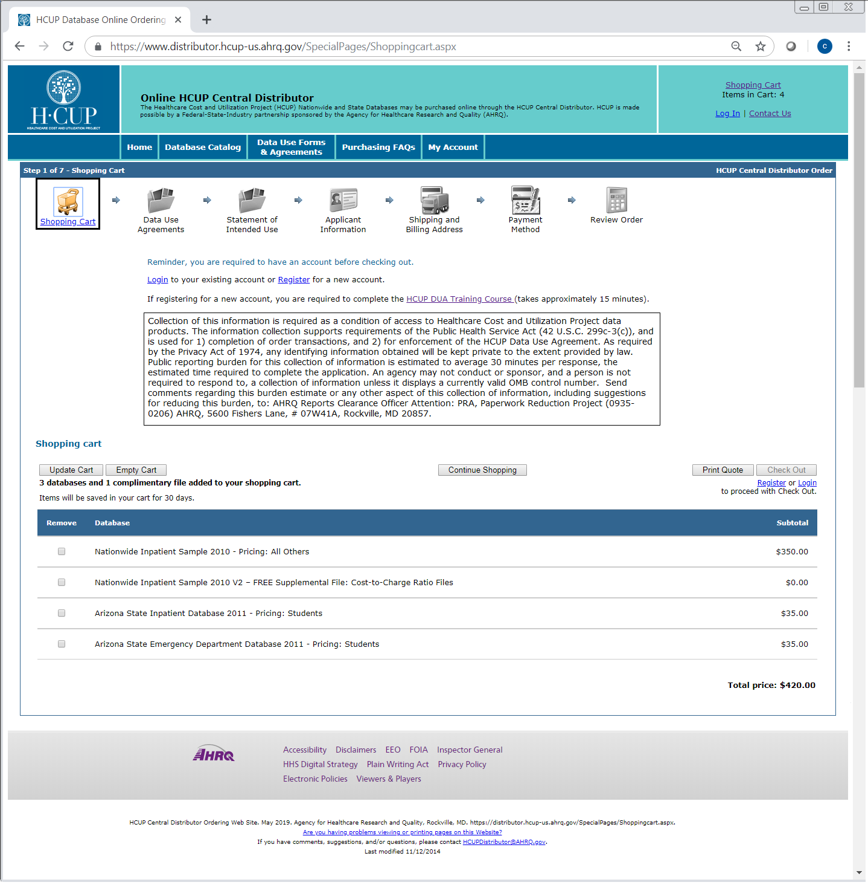

*OMB Control No. 0935-xxxx expires 01/31/20xx.*