Community Questionnaire Introduction Screen

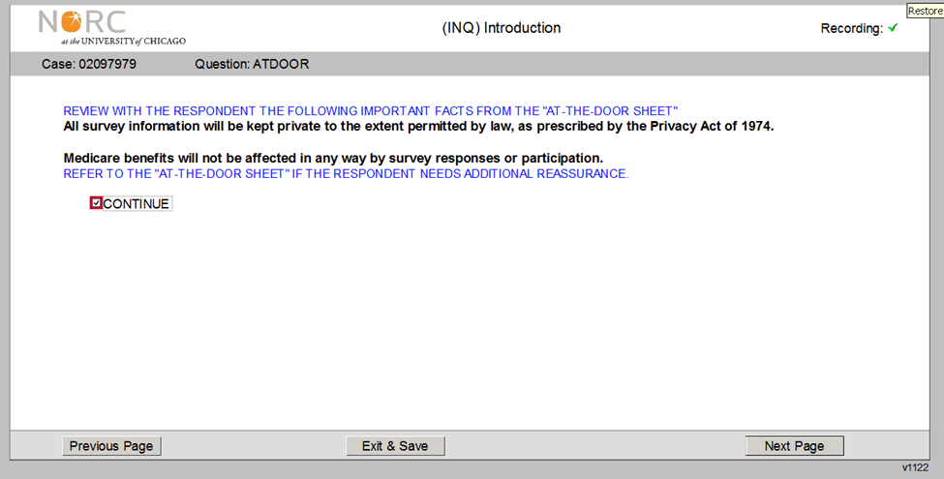

OMB No. 0938-0568, expires 2/29/2024

Community Questionnaire End Screen

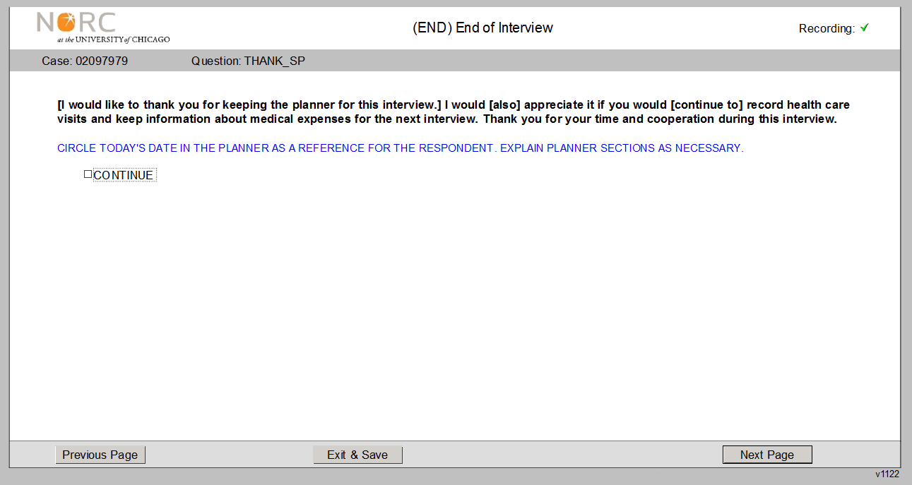

OMB No. 0938-0568, expires 2/29/2024

Community Questionnaire End Screen for Baseline Beneficiaries

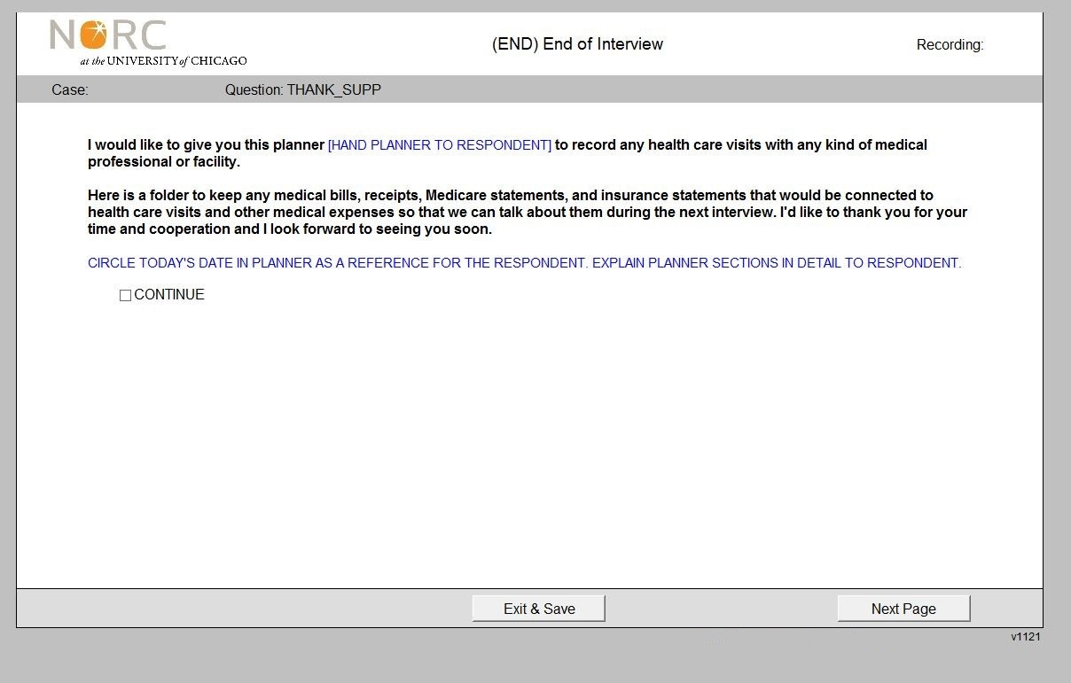

OMB No. 0938-0568, expires 2/29/2024

Facility Instrument Screenshot

Facility Screener Screenshot

