DATE
[Respondent Name]
[Respondent Address]
[Respondent City, State Zip]

Dear [Respondent Name]:

You have been selected to participate in a brief 15 minute telephone interview regarding your experiences receiving health care services during the COVID-19 pandemic. The Centers for Medicare & Medicaid Services (CMS), part of the Department of Health & Human Services, is conducting these telephone interviews to better understand the experiences of people with Medicare across the United States. The best way to gather this information is by hearing directly from people like you.
The information you provide during the interview will help us understand how the coronavirus pandemic has impacted people’s health care needs. You will be sharing valuable information about your experience that will help the Medicare program, your health care providers, and fellow health care consumers like you. NORC at the University of Chicago, a respected social science research organization, has been contracted to conduct this study. A professional interviewer will contact you by phone.
Your participation in this study is your choice. Your Medicare benefits cannot be affected in any way by your decision to participate or the answers you provide, and your information will be kept private to the extent permitted by law, as prescribed by the Federal Privacy Act of 1974.
If you have any questions about the study or would like to schedule an appointment to participate, please call us toll-free at 1-877-389-3429 or email mcbs@norc.org. You can also review the Frequently Asked Questions on the other side of this letter.
I hope you will be able to help us with this important study to improve Medicare services.
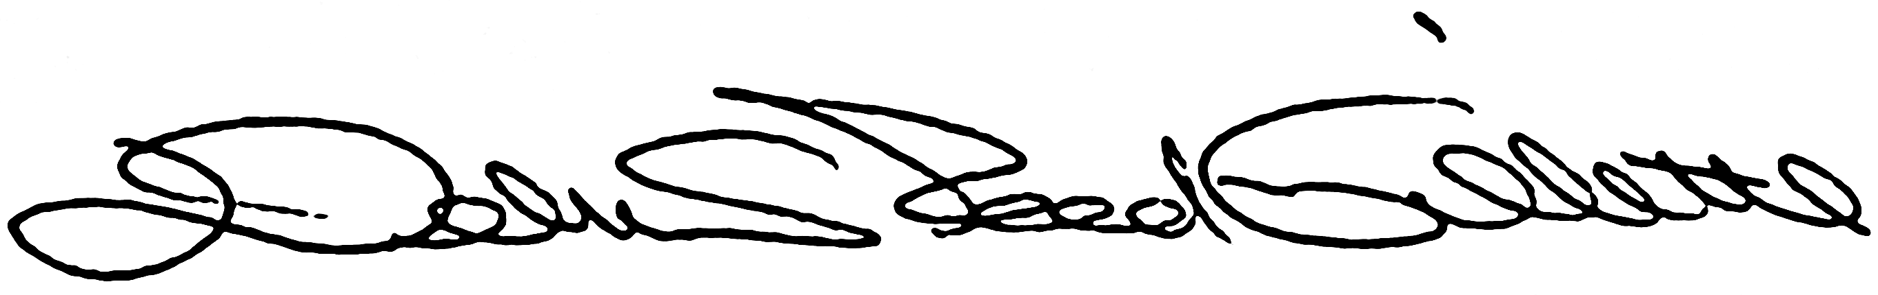
Debra Reed-Gillette, Director
Survey Management and Analytics Group
Centers for Medicare & Medicaid Services

Frequently Asked Questions

How was I selected for the survey?
This survey was designed to include Medicare beneficiaries whose doctors are part of a Next Generation Accountable Care Organization (ACO). According to Medicare administrative files, your doctor participates in the NextGen ACO Model. We have scientifically selected your name from the Medicare administrative files, and we cannot substitute another person for you in this study. You, along with the 18,000 other Medicare beneficiaries have been selected to participate in this survey. Each study participant represents all of the nation's Medicare beneficiaries who are part of this group. Your experiences represent thousands of other people, making your participation critical.

What is a Next Generation Accountable Care Organization?
Next Generation ACOs are groups of doctors, hospitals, and other health care providers and suppliers that come together to provide coordinated, high-quality care at lower cost to Medicare. You can find more information about the initiative on the Medicare webpage at innovation.cms.gov/innovation-models/next-generation-aco-model

How much time will this take?
The interview will take around 15 minutes to complete. The interview will be scheduled at your convenience.

How do I know my answers will be kept private?
We guarantee it. Only people working on the project will see the information you give the interviewer. The Privacy Act of 1974 states that the answers you give will not be connected with your name. The information you give will only be used for summary statistics or put into graphs and tables.

What will you be asking me about?
We will ask you about your experiences with healthcare during the COVID-19 pandemic, including any care you may have skipped or delayed. We'll also ask you about things you may have done in response to COVID-19 and where you get information.

Who is NORC at the University of Chicago?
NORC at the University of Chicago serves the public interest and improves lives through objective social science research that supports informed decision making. Founded in 1941, NORC has helped establish and continues to strengthen the rapidly evolving field of social science research. The Centers for Medicare and Medicaid Services have chosen NORC to help conduct this study. To find more information view NORC's website at www.norc.org

Will I lose my Social Security, Medicare, or other government benefits if I don’t do this?
No, your benefits will not be affected by your decision to participate in the survey. However, this is a very important study, and your participation will help us to better understand the needs of people on Medicare.

Is this survey part of a larger project?
The interview is part of a larger study called the Medicare Current Beneficiary Survey, or MCBS for short. The MCBS began to collect information about health and cost of care for people in September 1991. It has been conducted continuously since then because of the extreme value this data provides in understanding and rethinking Medicare and health care policies in this country. The Centers for Medicare and Medicaid Services, part of the U.S. Department of Health and Human Services, sponsors this study, and also oversees the Medicare program. In sponsoring this study, CMS hopes to gain valuable insight from you.

