Another friendly reminder about
your AmeriSpeak survey
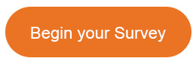
get 20,000 AmeriPoints today!

Hi <<PANALEST_NAME>>,
We recently invited you to participate in an AmeriSpeak survey on behalf of the Social Security Administration (SSA). We are sending you a friendly reminder to let you know that we would love to hear from you on this important topic. Your voice will represent people just like you all across the nation. Please complete this survey soon and you'll receive 20,000 AmeriPoints.
This is a longer survey so we are paying you more! Remember, once you have 10,000 AmeriPoints, you can redeem them for Mastercard® reward cards and a variety of gift cards. Thank you for your time. We are eager to hear your thoughts.
Sincerely,
The AmeriSpeak Team

