Direct Deposit
  - Office of Management & Budget
(OMB) Screen Package (December 2021)
Contents
1.0 Direct Deposit Landing Page 2
1.1 Update Your Direct Deposit Information 2
1.2 Enroll in Direct Deposit 3
2.0 Entering Direct Deposit Information 4
2.1 Your Direct Deposit Information 4
2.2 Customer is the Owner or Co-Owner of a Bank Account 5
2.3 Customer is not the Owner or Co-Owner of a Bank Account 6
3.0 Review of Direct Deposit Information 7
4.0 Confirmation 8

Direct Deposit Landing Page

1.1 Update Your Direct Deposit Information
This screen will appear when a customer has an existing direct deposit account on file.

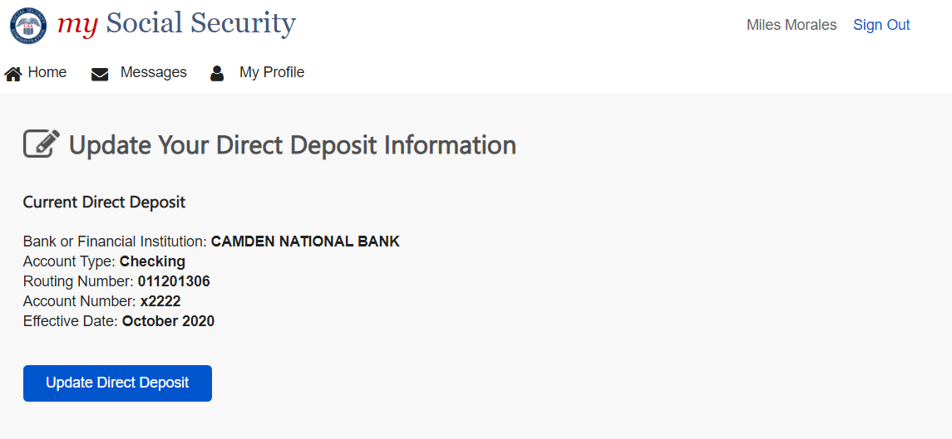

1.2 Enroll in Direct Deposit
This screen will appear when a customer who currently receives a paper check initiates direct deposit enrollment.

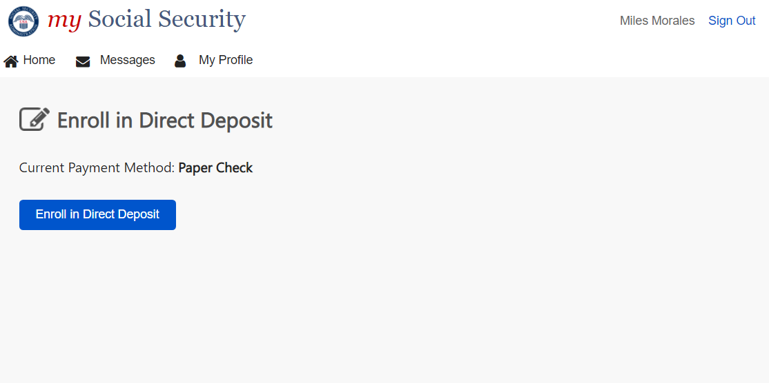

2.0 Entering Direct Deposit Information

2.1 Your Direct Deposit Information
This screen will appear for all users who continue with their update or enrollment of direct deposit.

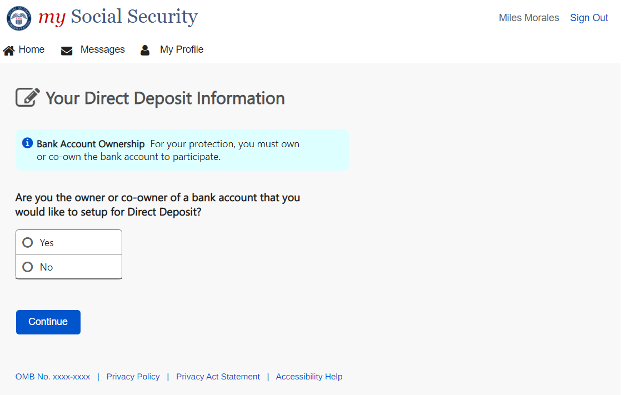

2.2 Customer is the Owner or Co-Owner of a Bank Account
This screen will appear if a customer selects “yes” from screen 2.1.

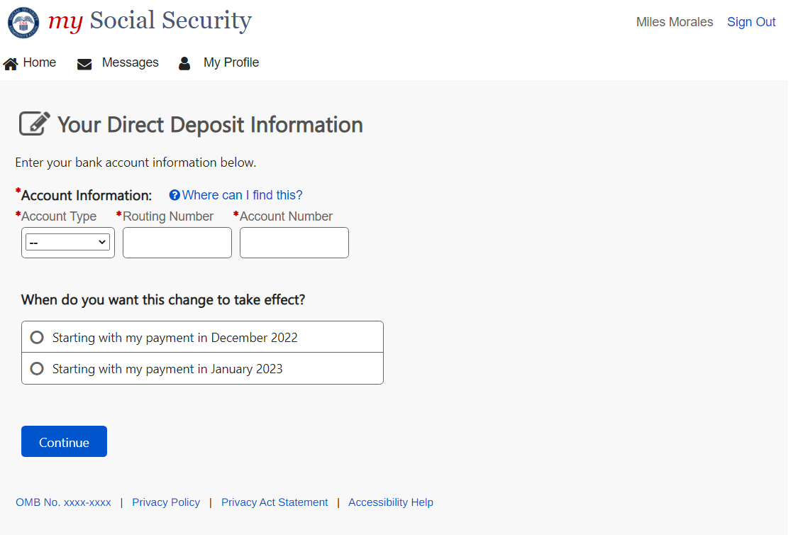

2.3 Customer is not the Owner or Co-Owner of a Bank Account
This screen will appear if a customer selects “no” from screen 2.1.

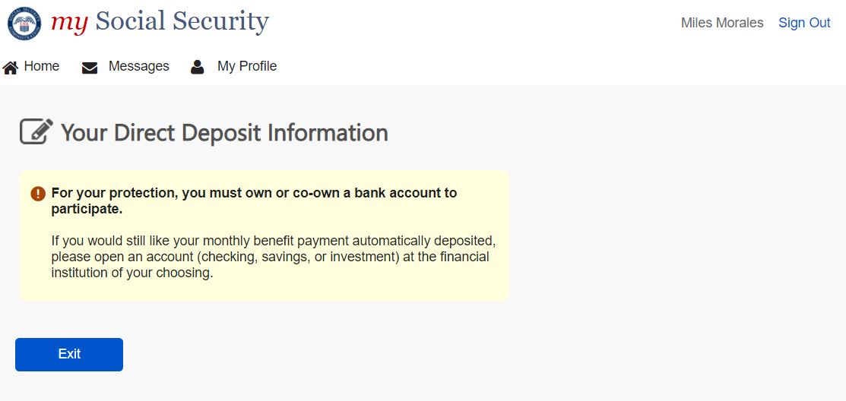

Review of Direct Deposit Information
This screen will appear after a user enters their bank account information and selects “Continue” from screen 2.2.

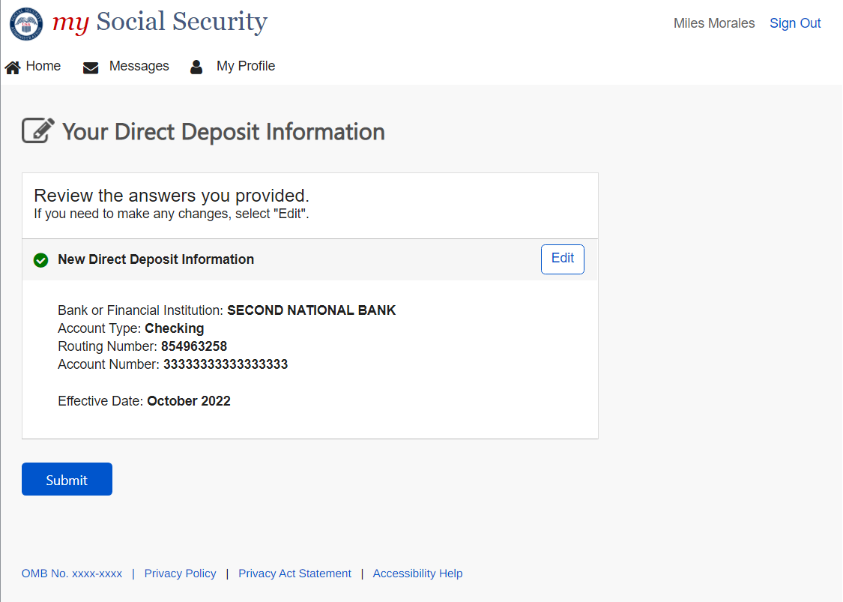

Confirmation
This screen will appear when a user clicks “Submit” from screen 3.0.

