Appendix AA.

Materials to encourage completion of FACES and AIAN FACES consent forms

Appendix AA.1

FACES and AIAN FACES Consent Letter to On-Site Coordinator (EXAMPLE)

**NOTE**: Study liaisons will send the attached email to programs that have not yet achieved a consent rate of 75 percent and have at least 10 consents outstanding. The email describes two options designed to reduce burden on program staff. The first is for liaisons to contact selected parents directly by phone or by email. The second, offered only to programs allowing in-person visits, is offering to send a field staff member to distribute consent forms, speak to parents, and mail completed consent forms back to the contractor. We also offer the option to hire a member of the community to serve in this role.

**TO:** [OSC EMAIL ADDRESS]

**FROM:** [LIAISON]

**SUBJECT: (**FACES/AIAN FACES) consent strategies

Dear [OSC],

Thanks again for your hard work throughout the (FACES/AIAN FACES) fall data collection! Because collecting consent forms last fall was challenging, we decided to continue collecting consents through the spring to make sure we can have as many families as possible participate in the spring wave of data collection. We would like to propose [IF IN-PERSON APPROACH PROPOSED: a few ideas/ IF IN-PERSON APPROACH NOT PROPOSED: an idea] to help us push to get as many consents as possible.

* Would you be willing to give us parent contact information for the (FACES/AIAN FACES) children at your program and allow us to contact them directly?
* If so, we will send parents an email with a link to the electronic consent form or call them to complete the consent form over the phone.
* If you prefer that we do not contact families directly, we understand. We would like to send you a flyer to share with (FACES/AIAN FACES) families. This flyer will have a phone number for parents to call and complete the consent form over the phone.
* [PROGRAMS WHERE AN IN-PERSON APPROACH WOULD BE APPROPRIATE] In past (FACES/AIAN FACES) studies, we had a lot of success sending a member of our field staff to distribute consent forms, answer questions from parents, and collect completed consent forms. Is your program currently allowing visitors? If so, would you let a Mathematica staff person visit the program to do this? We would like to visit as soon as possible. The Mathematica staff person who visits your program would be fully vaccinated and follow all local and Head Start health and safety protocols. [IF MORE THAN {IF FACES: 4/ IF AIAN FACES: 5} WEEKS FROM PROGRAM END DATE: We are also open to hiring someone in your community who has ties to your program for this role if we can identify someone by [DATE {IF FACES: 4/ IF AIAN FACES: 5} WEEKS FROM PROGRAM END DATE].]

However, we move forward, we want to make sure we disrupt your program as little as possible. We know that you and your staff have worked very hard to distribute and collect consents and we appreciate all of your efforts. We want to take as much of the burden off you as possible as we continue to collect consent forms this spring. We also want to hear from you! Please let us know if there are ways we could improve how we collect consent forms from your parents.

Sincerely,

[LIAISON]

Appendix AA.2

FACES/AIAN FACES Spring 2022 Special Parent Flyer

**NOTE:** The purpose of this flyer is to encourage parents of selected children to complete consent forms and participate in FACES and AIAN FACES. Center staff will send the flyers home with selected children whose parents have not yet completed their consent forms. The flyer could also be posted to the classroom door, or to a private page of a social media tool, such as Class Dojo or Ready Rosie, for groups of selected children.

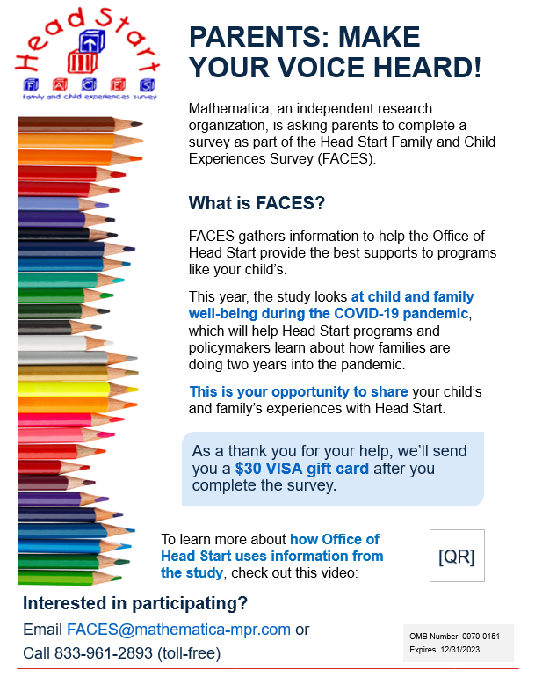

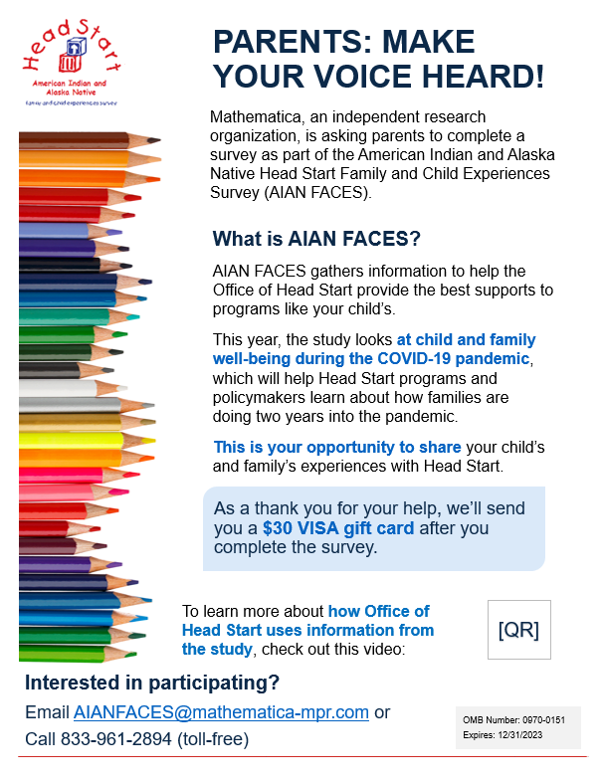

Appendix AA.3

FACES/AIAN FACES Spring 2022 Special Study Information Sheet

**NOTE**: The purpose of these study information sheets is to encourage consents and survey completion by describing the studies to sampled parents, teachers, center directors, and program directors in a compelling way. The sheets include a direct request to “hear the voice of Head Start parents” and a finding from a previous wave of the study to show why the study is important and how the data is used. Parents, teachers, center directors, and program directors will receive the information sheets with their hard copy consent forms (parents) and study invitations (staff).

Examples below are intended for:

1. FACES parents
2. FACES teachers in fall 2021 (child-level) cohort
3. FACES teachers in spring 2022 cohort
4. FACES directors
5. AIAN FACES parents
6. AIAN FACES teachers
7. AIAN FACES directors

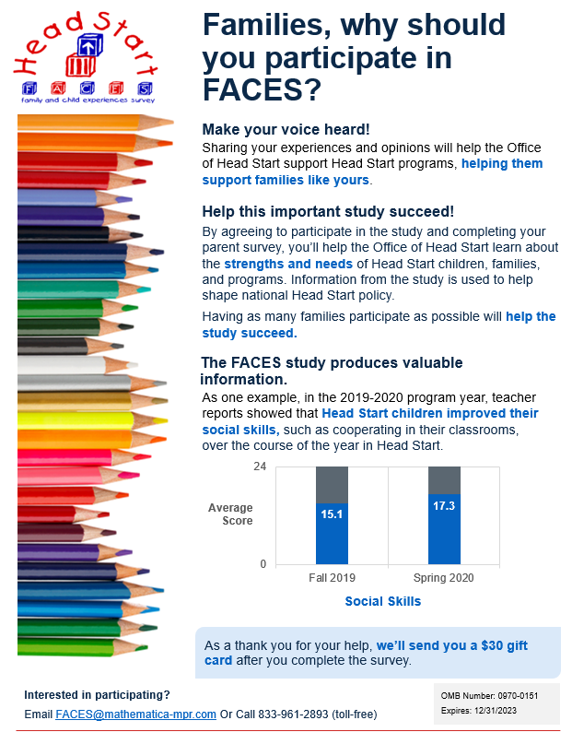

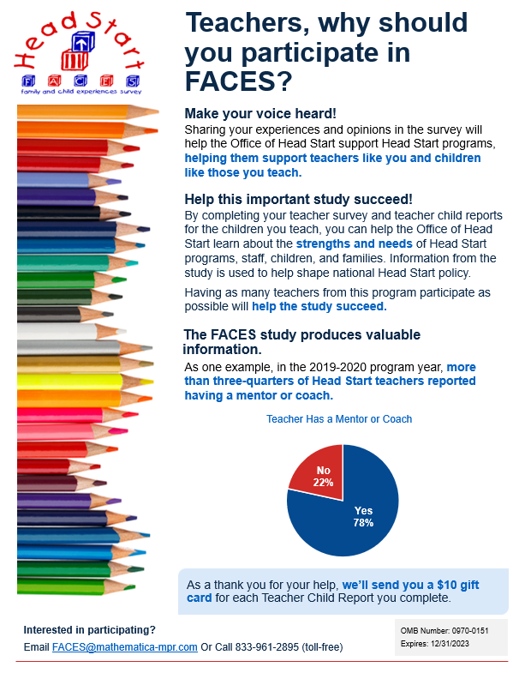

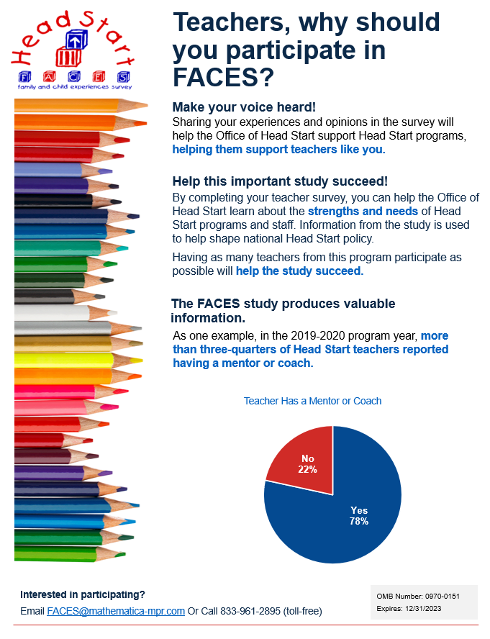

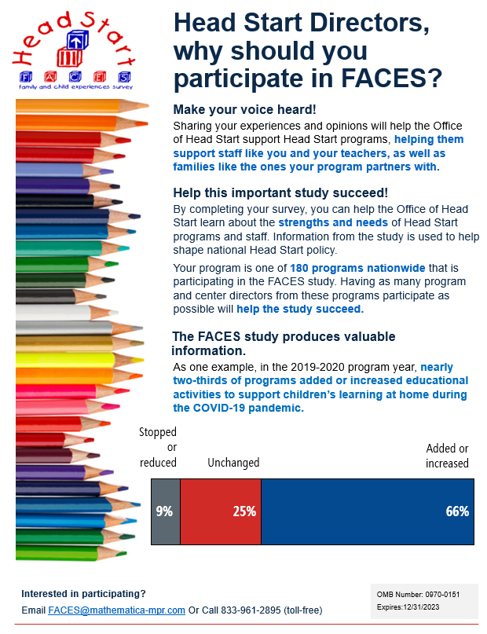

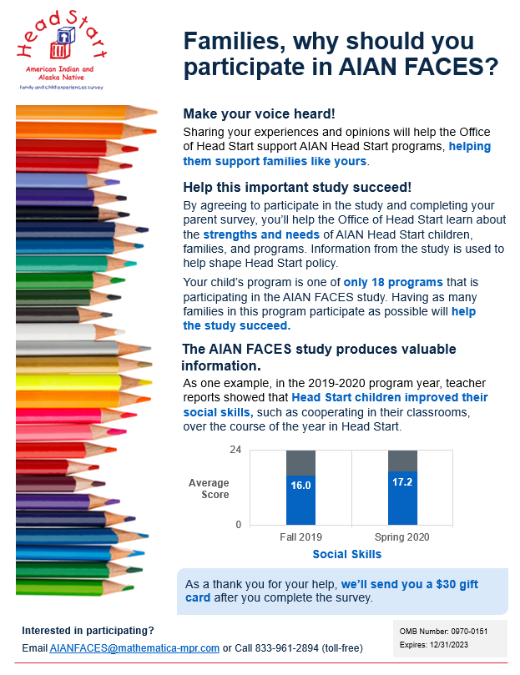

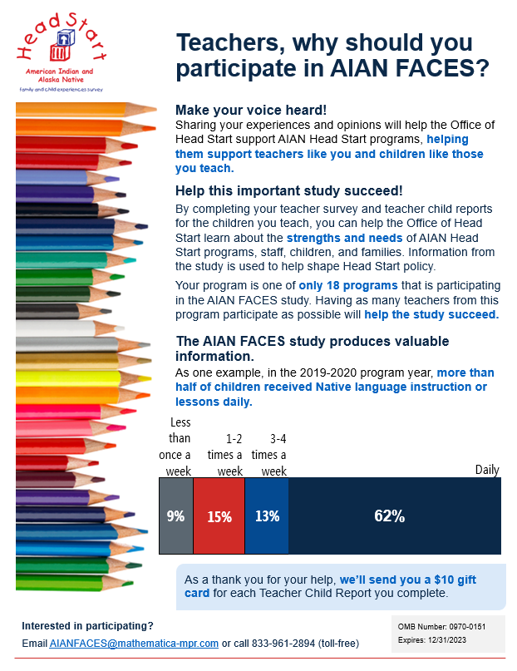

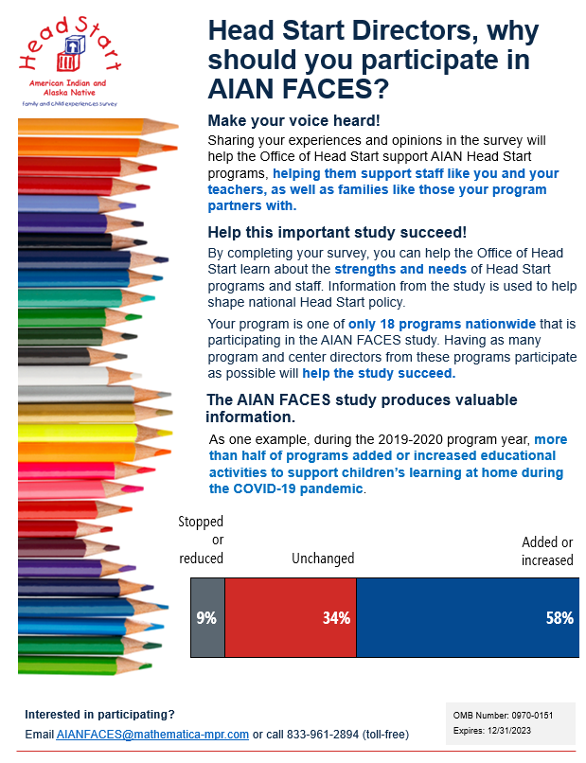

Appendix AA.4

FACES/AIAN FACES Examples of reminder language that will be used across different platforms

**NOTE**: To encourage participation in FACES and AIAN FACES, the study team drafted example text that can be used by OSCs and/or directors to remind selected parents to complete their consent form and survey and remind teachers to complete their survey and teacher child reports. These messages can be used across different platforms such as email, text, or private social media communication. The examples below show text for both FACES and AIAN FACES programs, but study level references and information would be customized appropriately by the study team before sending to program staff. The study team will work with the OSC to ensure that these templates are only shared with parents and teachers in sampled classrooms.

**Example 1: Parent message (long)**

Dear parents,

As you may have heard, our program is participating in a national study of Head Start programs called [AIAN] FACES. This is a great opportunity for you to make your voice heard and help Head Start learn how to best support programs and families!

If you haven't done so already, we hope you will complete the consent form and survey. You will get a $30 VISA gift card after you finish the survey. Please contact [FACES@mathematica-mpr.com/AIANFACES@mathematica-mpr.com] to learn more or call 833-961-289[3/4] to consent to participate over the phone.

Best,

[Contact name]

**Example 2: Parent message (short)**

Hi parents,

This is a friendly reminder to complete the consent form and survey for [AIAN] FACES! This survey is an opportunity to make your voice heard and share your child's and family's experiences with Head Start.

Please contact [FACES@mathematica-mpr.com/AIANFACES@mathematica-mpr.com] or call 833-961-289[3/4] to learn more.

Best,

[Contact name]

**Example 3: Teacher message (long)**

Dear teachers,

As you may have heard, our program is participating in a national study of Head Start programs called [AIAN] FACES. This is a great opportunity for you to share your experiences and help the Office of Head Start learn how to best support programs!

If you haven't done so already, we hope you will complete the survey [IF PARTICIPATING IN CHILD-LEVEL DATA COLLECTION: and child-level reports for the children in your selected classroom(s). You will get a $10 VISA gift card for each child-level report you complete]. Please contact [FACES@mathematica-mpr.com/AIANFACES@mathematica-mpr.com] or call 833-961-289[3/4] to learn more.

Best,

[Contact name]

**Example 4: Teacher message (short)**

Hi teachers,

This is a friendly reminder to complete your survey [IF PARTICIPATING IN CHILD-LEVEL DATA COLLECTION: and child reports] for [AIAN] FACES! This is an opportunity to make your voice heard and share your experiences with Head Start.

Please contact [FACES@mathematica-mpr.com/AIANFACES@mathematica-mpr.com] or call 833-961-289[3/4] to learn more.

Best,

[Contact name]