E810 provides more structure and the ability to reuse information for repetitive reporting. Screen shots of relevant data gathering are shown in Figure 1 to Figure 5. The Cross reference to the regulation is included below each figure. However, much of the requirement information is not amenable to form style data gathering and is handled in e810 via attached documents.

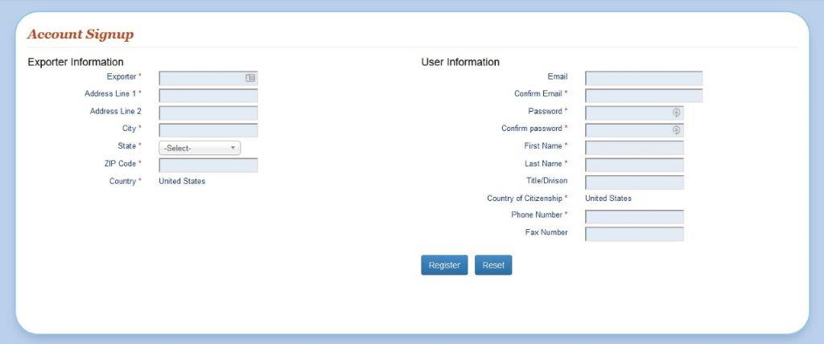

Figure 1 - Account Creation in e810

The data required in Figure 1 fulfills the requirements described in §§ 810.11(a)(1), 810.12(a)(1), and 810.12(c)(1). This form cannot handle the intricacies of corporate control, which would be required to be submitted as an attached file to any actual submittals. There are 11 text fields to be filled out with information readily available to any exporter in this industry. And One drop down selection to establish the state of residence of the export. Once this is completed within e810 it would only have to be addressed if information changes.

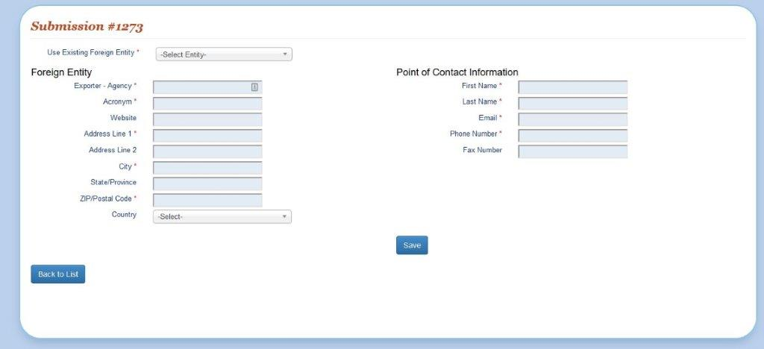

Figure 2 - Foreign entity in e810

The data required in Figure 2 on the left side fulfills the requirements described in §§810.11(a)(2), 810.12(a)(2), and 810.12(c)(2). The additional required information on the right is asked only for specific authorizations and is not explicitly within the rule. This information is to provide other government agencies information to allow the request processing to be done more quickly.

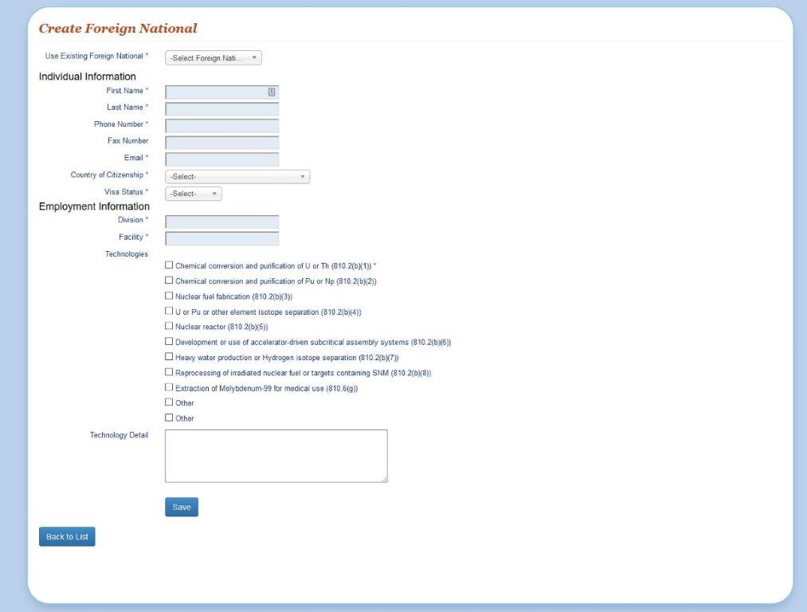

Figure 3 - Foreign National in e810

The data required in Figure 3 fulfills the requirements described in §810.11(b)(1), and partially fulfills the requirements in §810.11(b)(4). The additional information required in §810.11(b) is too complex for a simple form and is handle via document attachment in e810.

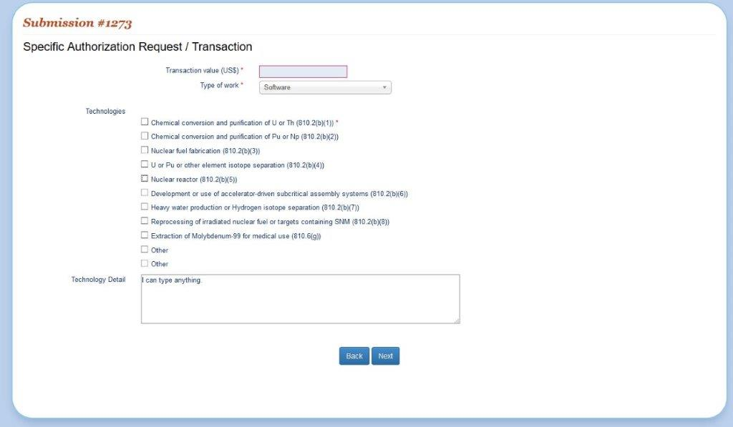

Figure 4 - Transaction information in e810

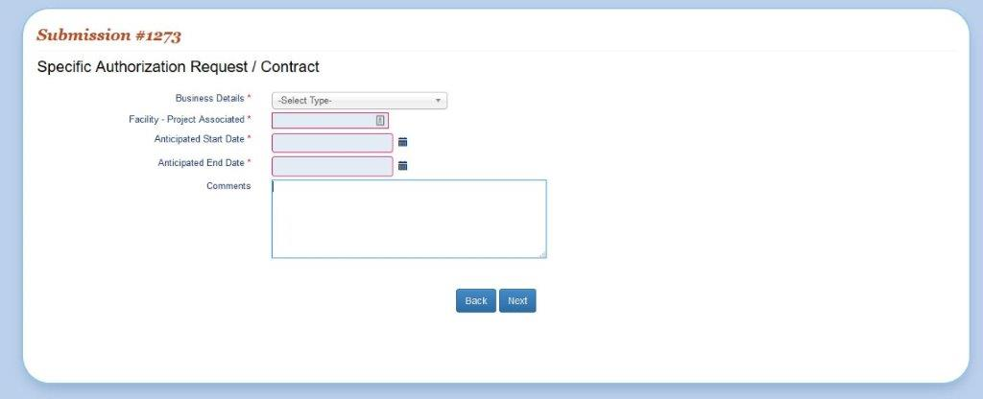

Figure 5 - Contract information in e810

The information requested in Figure 3 and Figure 4 fulfill the requirements in §810.11(a)(3). The checkbox list of technology is directly from relevant sections of the rule and simplify the exporter application by clarifying what specific area of the regulation they believe applies. Where possible, suggested dropdown lists limit free form typing and create more consistency. However, the exporter is always allowed an “other” option with freeform text to explain.

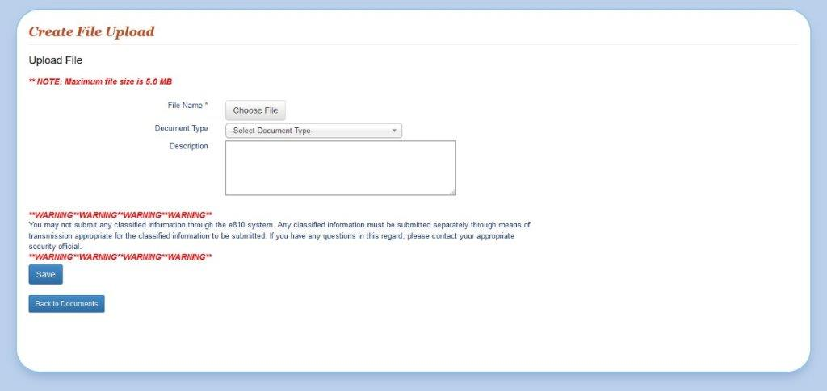

Figure 6 - File upload in e810

To allow the users flexibility in providing the more complex information needed to process Part 810 submittals, free form documents can be attached either via e-mail or within the e810 system. Figure 6 depicts the upload screen.