ATTACHMENT C

Safer Choice Program: Private Label Submissions in the Safer Choice Community Cloud-based Salesforce System
(Private Label Companies, Licensees, or Toll Manufacturers)

OMB Control No. 2070-NEW
Approval expires XX/XX/XX

This collection of information is approved by OMB under the Paperwork Reduction Act, 44 U.S.C. 3501 et seq. (OMB Control No. 2070-NEW). Responses to this collection of information are voluntary. An agency may not conduct or sponsor, and a person is not required to respond to, a collection of information unless it displays a currently valid OMB control number. The public reporting and recordkeeping burden for this collection of information is estimated to be 16 hours per response for formulators of cleaning and non-cleaning products and eight hours per response for partners wishing to add private label partners and products, including the time for reviewing instructions, gathering information, and completing and reviewing the application. Send comments on the Agency’s need for this information, the accuracy of the provided burden estimates and any suggested methods for minimizing respondent burden to the Regulatory Support Division Director, U.S. Environmental Protection Agency (2821T), 1200 Pennsylvania Ave., NW, Washington, D.C. 20460. Include the OMB control number in any correspondence. Do not send the completed form to this address.

Following are screenshots from the Private Label Submission form in the Safer Choice Community cloud-based Salesforce data system. Please refer to Section 12b, IC#1 for a full list of data items collected. Note that the specific details of the screenshots may change over time as the Safer Choice program improves and/or modifies the system. However, the general and fundamental components of the cloud-based Salesforce system will be similar to what is presented in the following screenshots.

Private Label/Alternate Name Submissions

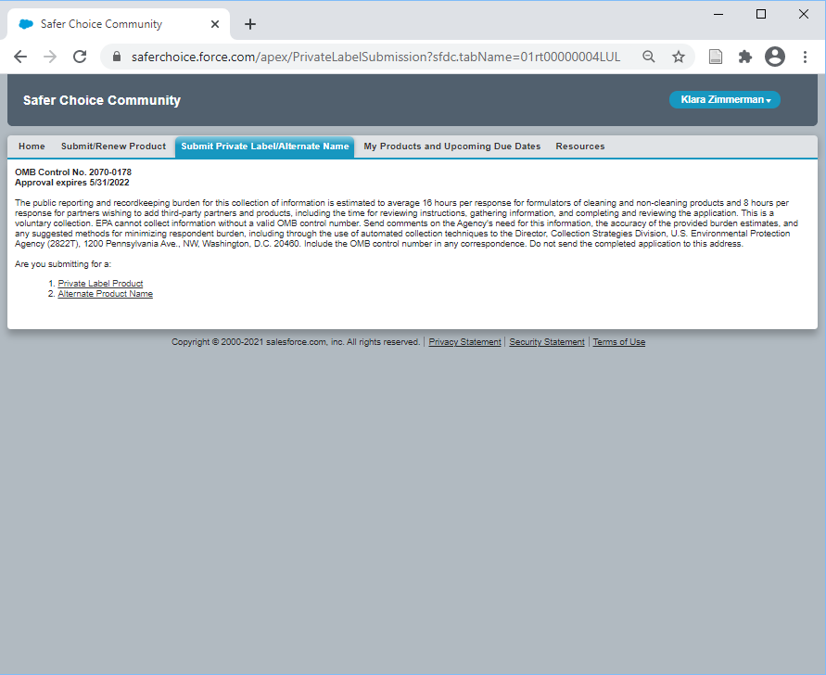

Private Label

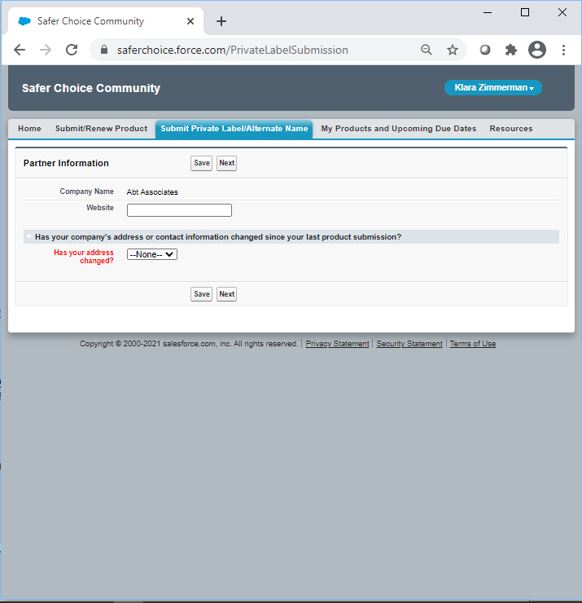

Has your address changed: Dropdown options are Yes, No. If yes, more options appear to update company and contact information.

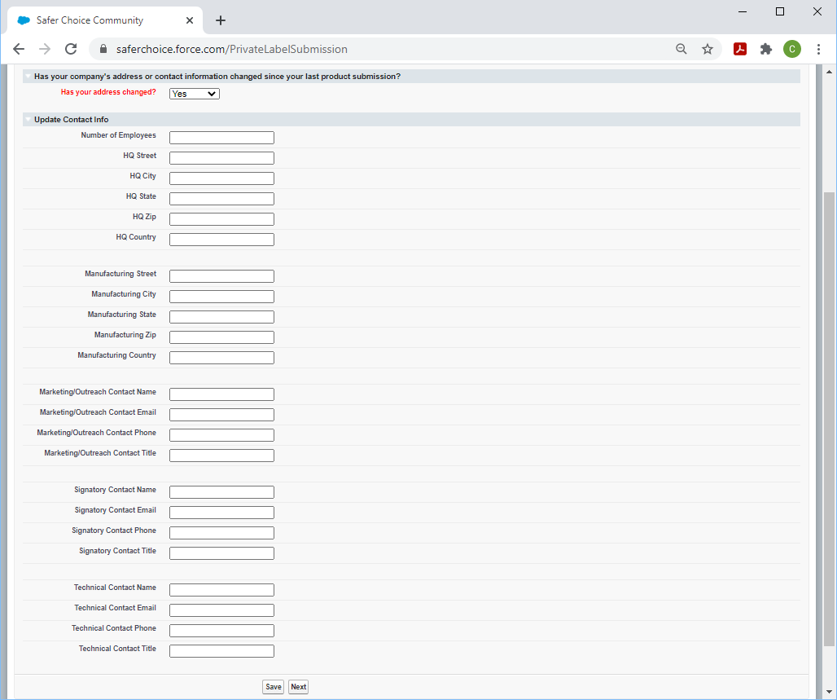

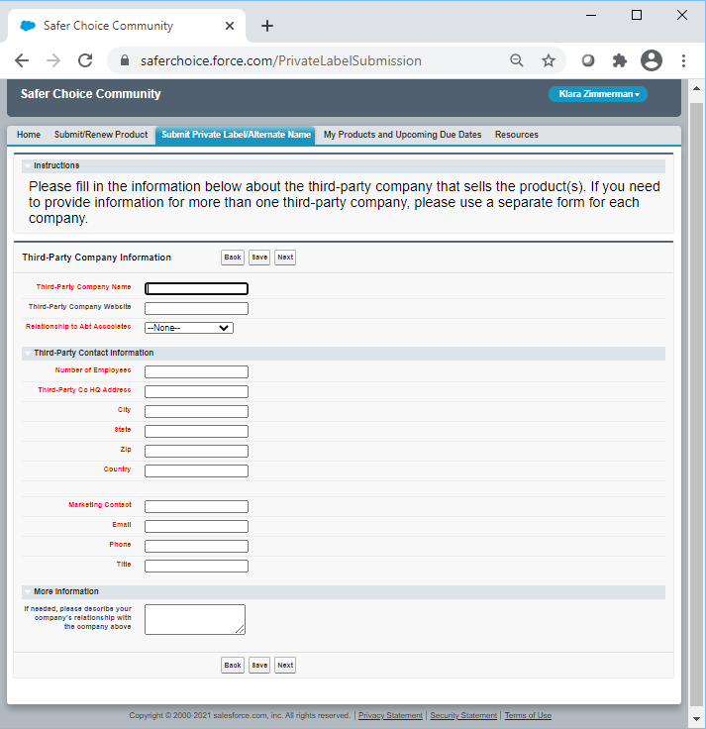

Relationship to Company: Dropdown options are Private Label, Licensee, Toll Manufacturer

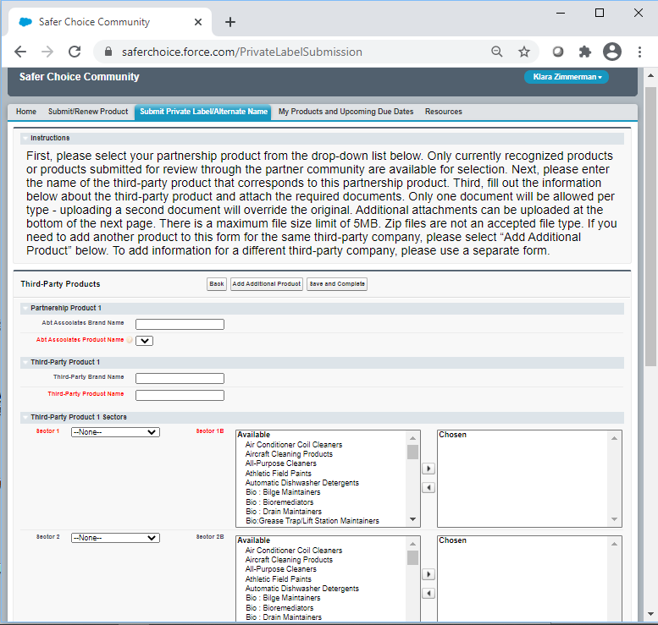

Partner Company Product Name: Dropdown options are the company’s currently Safer Choice-certified products.

Sector 1 and Sector 2: Dropdown options are Consumer, Industrial/Institutional, Both, N/A

Sector 1B and Sector 2B: Pick list options are Air Conditioner Coil Cleaners; Aircraft Cleaning Products; All-Purpose Cleaners; Athletic Field Paints; Automatic Dishwasher Detergents; Bio: Bilge Maintainers; Bio: Bioremediators; Bio: Drain Maintainers; Bio: Grease Trap/Lift Station Maintainers; Bio: Septic SystemTreatments; Bio: Vehicle/Parts Wash Additives; Bio: Wastewater Inoculants; Brick and Masonry Cleaners; Car Care Products; Carpet Care Products: Carpet Cleaners; Carpet Care Products: Spot Removers; Degreasers; Deicers; Descalers; Dish Soaps; Dry Erase Board Cleaners; Fire-Fighting Products; Floor Care Products: Floor Cleaners; Floor Care Products: Floor Finishes; Floor Care Products: Floor Strippers; Graffiti Removers; Granite/Stone Cleaners; Grease Trap Products; Hand Soaps; Industrial Coating: Conversion Coatings; Industrial Coating: Pavement Treatments; Inkjet Printing Products; Kitchen/Countertop Cleaners; Laundry Products: Fabric Softeners; Laundry Products: Laundry Detergents; Laundry Products: Pre-Treaters; Leather Cleaners; Marine/RV Cleaners; Medical Instrument Cleaners; Metal Cleaner/Polishes; Odor Removers; Oven/Grill/Barbeque Cleaners; Parts Washers; Semiconductor/Microelectronics Cleaners; Soluble Films; Stainless Steel Cleaners; Tire Additives; Toilet Bowl Cleaners; Tub/Tile Cleaners; Upholstery Cleaners; Window/Glass Cleaners; Wood Cleaners; Other Industrial/Institutional Products; Other Consumer Products

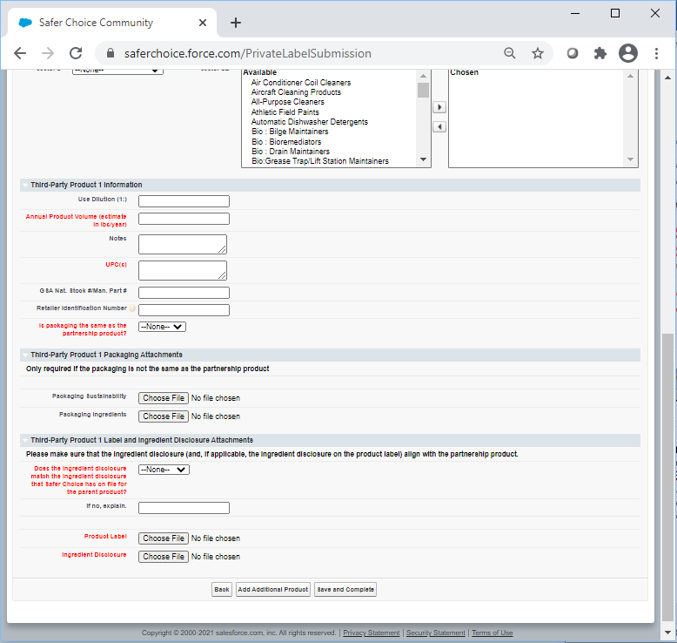

Is packaging the same as the partnership product: Dropdown options are Yes, No

Does the ingredient disclosure match the ingredient disclosure that Safer Choice has on file for the parent product: Dropdown options are Yes, No, Unknown

Alternate Name

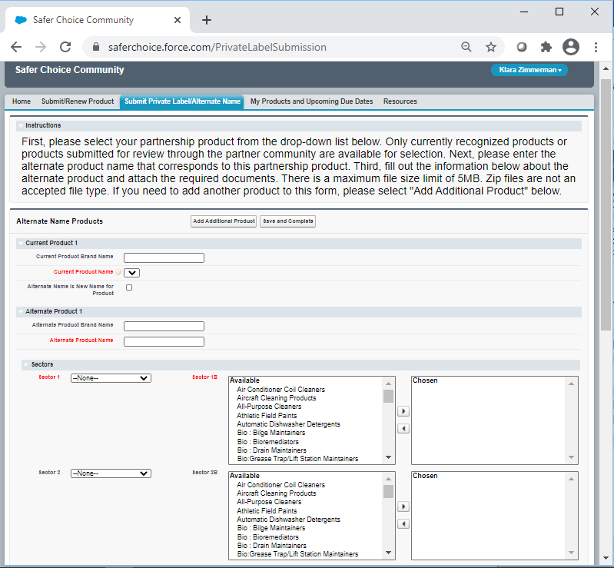

Current Product Name: Dropdown options are the company’s currently Safer Choice-certified products.

Sector 1 and Sector 2: Dropdown options are Consumer, Industrial/Institutional, Both, N/A

Sector 1B and Sector 2B: Pick list options are Air Conditioner Coil Cleaners; Aircraft Cleaning Products; All-Purpose Cleaners; Athletic Field Paints; Automatic Dishwasher Detergents; Bio: Bilge Maintainers; Bio: Bioremediators; Bio: Drain Maintainers; Bio: Grease Trap/Lift Station Maintainers; Bio: Septic System Treatments; Bio: Vehicle/Parts Wash Additives; Bio: Wastewater Inoculants; Brick and Masonry Cleaners; Car Care Products; Carpet Care Products: Carpet Cleaners; Carpet Care Products: Spot Removers; Degreasers; Deicers; Descalers; Dish Soaps; Dry Erase Board Cleaners; Fire-Fighting Products; Floor Care Products: Floor Cleaners; Floor Care Products: Floor Finishes; Floor Care Products: Floor Strippers; Graffiti Removers; Granite/Stone Cleaners; Grease Trap Products; Hand Soaps; Industrial Coating: Conversion Coatings; Industrial Coating: Pavement Treatments; Inkjet Printing Products; Kitchen/Countertop Cleaners; Laundry Products: Fabric Softeners; Laundry Products: Laundry Detergents; Laundry Products: Pre-Treaters; Leather Cleaners; Marine/RV Cleaners; Medical Instrument Cleaners; Metal Cleaner/Polishes; Odor Removers; Oven/Grill/Barbeque Cleaners; Parts Washers; Semiconductor/Microelectronics Cleaners; Soluble Films; Stainless Steel Cleaners; Tire Additives; Toilet Bowl Cleaners; Tub/Tile Cleaners; Upholstery Cleaners; Window/Glass Cleaners; Wood Cleaners; Other Industrial/Institutional Products; Other Consumer Products

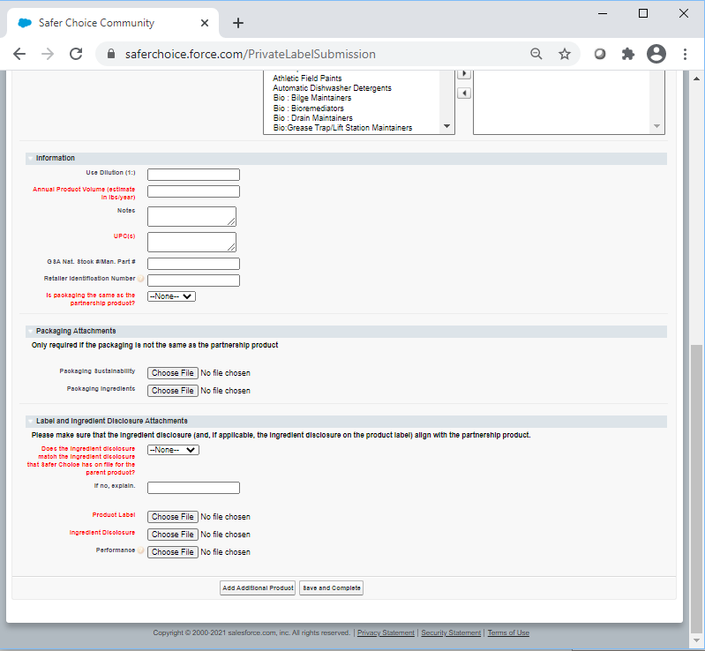

Is packaging the same as the partnership product: Dropdown options are Yes, No

Does the ingredient disclosure match the ingredient disclosure that Safer Choice has on file for the parent product: Dropdown options are Yes, No, Unknown

