U. S. DEPARTMENT OF HOUSING AND URBAN DEVELOPMENT
REQUEST FOR A MEDICAL EXCEPTION TO THE COVID‐19 VACCINATION REQUIREMENT
Government-wide policy requires all Federal employees, as defined in 5 U.S.C. § 2105, to be vaccinated against COVID-19, with exceptions only as required by law. Employees may seek a legal exception to the vaccination requirement due to a disability, using the form below. The agency may also ask for other information, as needed. Requests for “medical accommodation” or “medical exceptions” will be treated as requests for a disability accommodation and evaluated and decided under applicable Rehabilitation Act standards for reasonable accommodation absent undue hardship to the agency. An employee may also request to delay complying with the vaccination requirement based on certain medical considerations that may not justify an exception under the Rehabilitation Act. Safer Federal Workforce Task Force guidance on medical considerations that may warrant a delay is available here. The agency will be required to keep confidential any medical information provided, subject to the applicable Rehabilitation Act standards. Employees who receive an exception or a delay from the vaccination requirement would instead comply with alternative health and safety protocols.
Signing this form constitutes a declaration that the information you provide is true and correct to the best of your knowledge and ability. Any intentional misrepresentation to the Federal Government may result in legal consequences, including termination or removal from Federal Service.
To request a medical exception or delay from the COVID-19 vaccination:
- Part 1 of this form must be completed. Your medical provider must complete Part 2 of this form.
- When both are completed, they must be submitted to:
Reasonableaccommodationbranch@hud.gov.

Privacy Act Statement
Authority: The Rehabilitation Act, 29 U.S.C. § 791, and Title VII of the Civil Rights Act, 42 U.S.C. § 2000e, as well as Executive Orders 13164 and 14043, and 29 C.F.R. §§ 1605 and 1614
Principal Purpose: The purpose of this collection is to allow HUD to compile, process, monitor, and track requests submitted by individuals (including employees for employment) seeking religious and/or medical exceptions to the federal COVID-19 vaccination requirement.
Routine Uses: HUD will not disclose the information collected to third parties except as required by law and as described in the System of Record Notice (SORN).
Disclosure: Voluntary: failure to submit requested information may result in disapproval of request.
SORN ID: Human Resource (HR) Case Management Solution, HUD/OCHCO-01
(https://www.federalregister.gov/documents/2021/11/16/2021-24892/privacy-act-of-1974-system-of-records)

STATEMENT OF BURDEN: According to the Paperwork Reduction Act of 1995, no persons are required to respond to a collection of information unless such collection displays a valid OMB control number.

Public reporting burden for this collection of information is estimated to average 1.5 hours per
response, including time for reviewing instructions, searching existing data sources, gathering
and maintaining the data/information needed, and completing and reviewing the collection of
Information. Requests for an exception to the COVID vaccination requirement will be documented
on this form. Send comments regarding the burden estimate or any other aspect of this collection of
information, including suggestions for reducing this burden, to the U. S. Department of Housing and Urban
Development, Office of the Chief Human Capital Officer, Departmental Clearance Officer,
451 7th St. S. W., Washington, DC 20410.

To Be Completed by the Employee
Employee Name | Date of Request

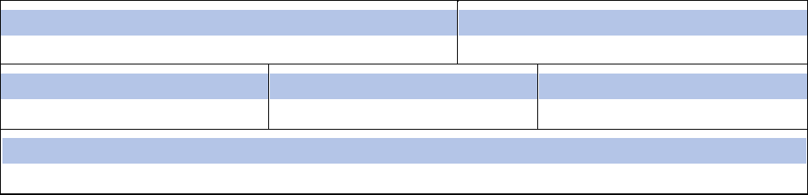
Position
Employee Email Address
Department
Supervisor
Division
Phone Number
Medical or Disability Exception Request
I am requesting a medical exception to the requirement for COVID-19 vaccination or a delay because of a temporary condition or medical circumstance. I declare that the information I have provided is true and correct to the best of my knowledge and ability.
Employee Signature | Date

Part 2 – To be Completed by the Employee's Medical Provider
Employee Name
Medical Certification for COVID-19 Vaccine Exception
Dear Medical Provider:
The U.S. Department of Housing and Urban Development (HUD) requires its employees to be fully vaccinated against COVID-19 pursuant to Executive Order of the President of the United States. The individual named above is seeking a medical exception to the requirement for COVID-19 vaccination or a delay because of a temporary condition or medical circumstance. Please complete this form to assist HUD in its reasonable accommodation process. If you have questions about completing this form, please contact HUD’s reasonable accommodation coordinator at: ReasonableAccommodationBranch@hud.gov.
Please provide at least the following information, where applicable:
- The applicable contraindication or precaution for COVID-19 vaccination, and for each contraindication or precaution, indicate: (a) whether it is recognized by the CDC pursuant to its guidance; and (b) whether it is listed in the package insert or Emergency Use Authorization fact sheet for each of the COVID-19 vaccines authorized or approved for use in the United States;
- A statement that the individual’s condition and medical circumstances relating to the individual are such that COVID-19 vaccination is not considered safe, indicating the specific nature of the medical condition or circumstances that contraindicate immunization with a COVID-19 vaccine or might increase the risk for a serious adverse reaction; and
- Any other medical condition that would limit the employee from receiving any COVID-19 vaccine.
Description of the medical condition for which the employee listed above should be excepted from complying with a COVID-19 vaccination requirement:

The condition described above is: | ☐ temporary ☐ long-term
If this is a temporary condition or medical circumstance, when it is expected to end or expire: (Allowing for COVID-19 vaccination to begin after the date provided)
Medical Provider Name/Title
Medical Provider Signature |  | Date
When both forms are completed, you must submit the forms to:
Reasonableaccommodationbranch@hud.gov

