Veteran Employment Through Technology Education Courses
(VET TEC) Online Application Form Screen Captures

Purpose

The purpose of this document is to provide images of the online VET TEC Application form (VA Form 22-0994) to facilitate the OMB form approval process. The VET TEC Application form allows Veterans to apply for the Veteran Employment Through Technology Education Courses (VET TEC) pilot program. The form will exist solely online and will be accessible via the VA.gov website.

Screen Captures

The screen captures on the following pages illustrate the proposed user interface and content of VA Form 22-0994 that is currently on the VA.gov staging environment (as of 03/04/2019). Where applicable, multiple versions of the same page have been included to illustrate how additional form controls appear dynamically based on user responses.

Introduction page for VET TEC

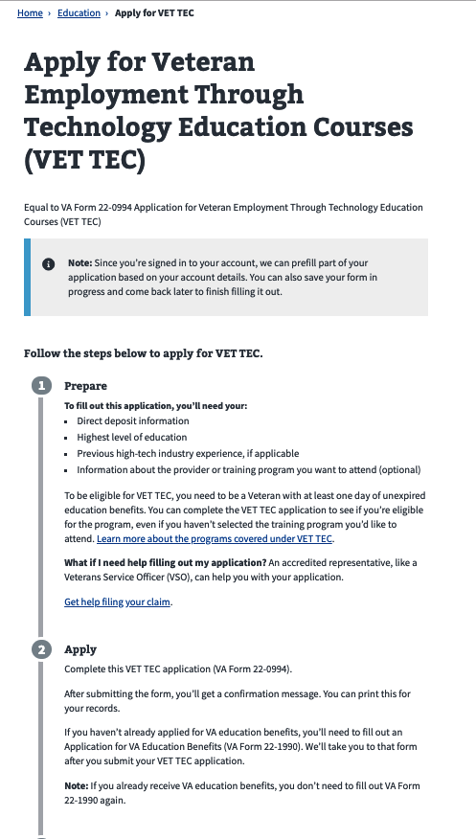
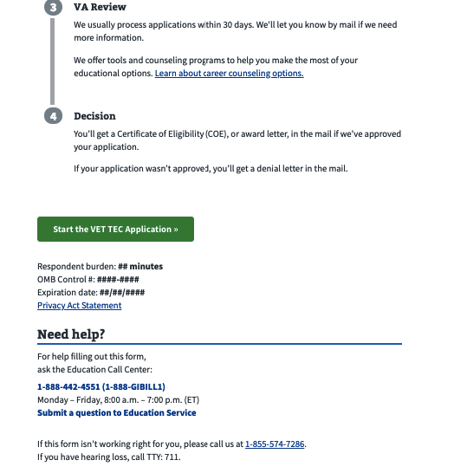

Step 1 of 7: Applicant information
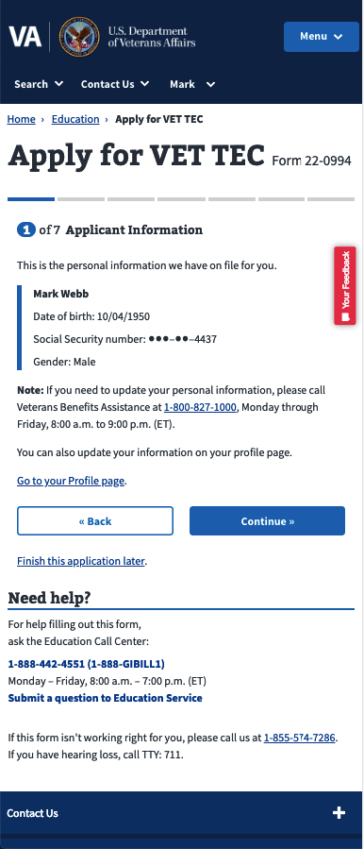

Step 1 of 7: Applicant information
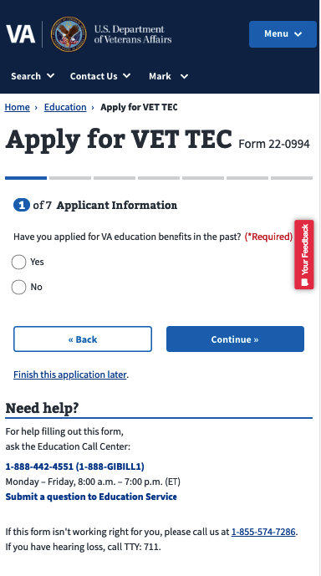 | 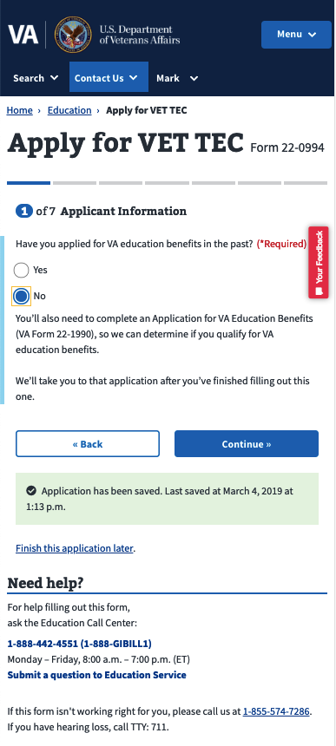

Step 2 of 7: Military service
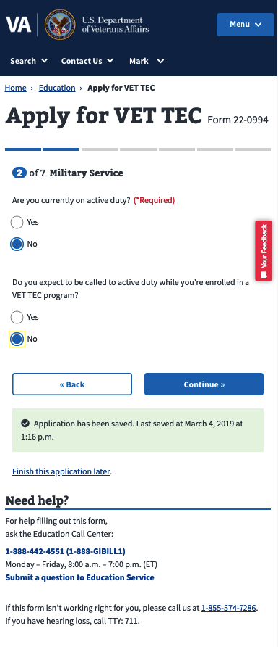 |  | 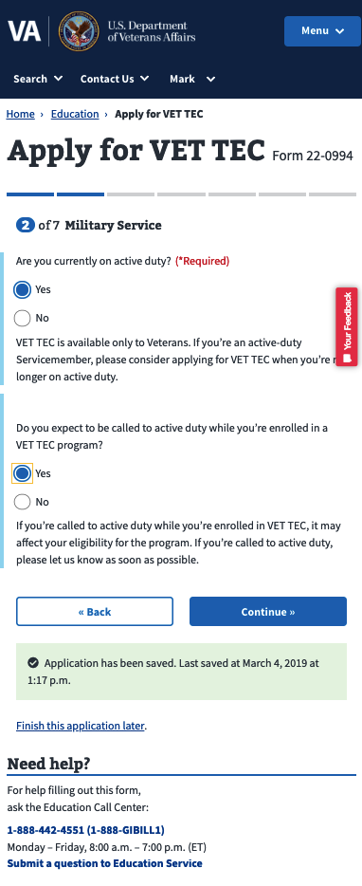

Step 3 of 7: Education history
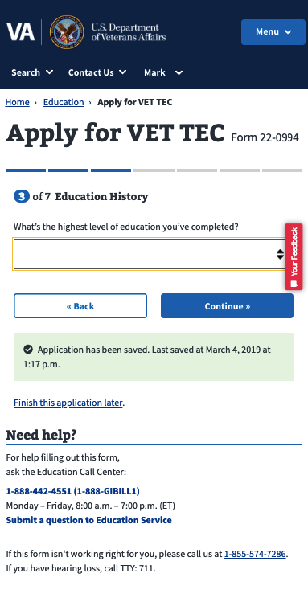 | 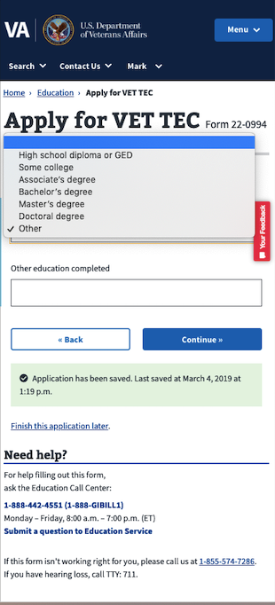 | 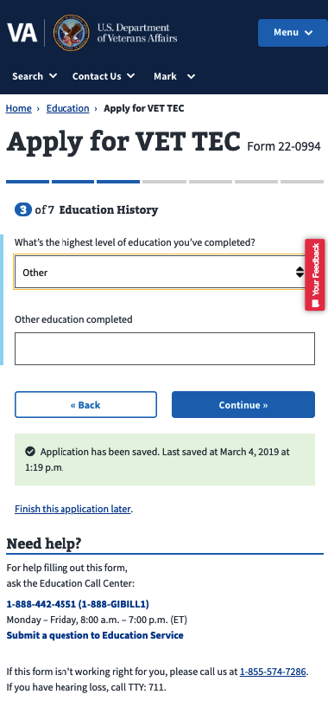

Step 4 of 7: Work Experience
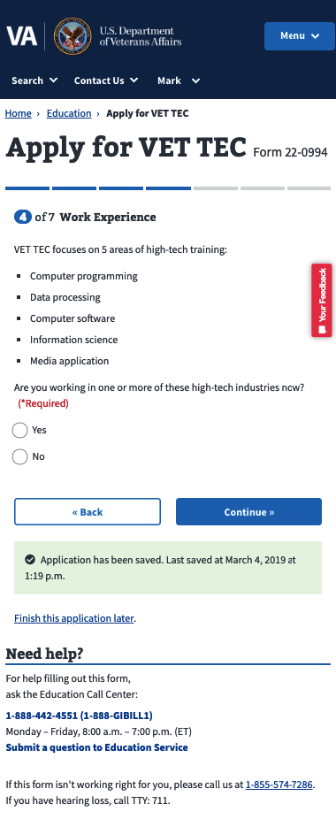 | 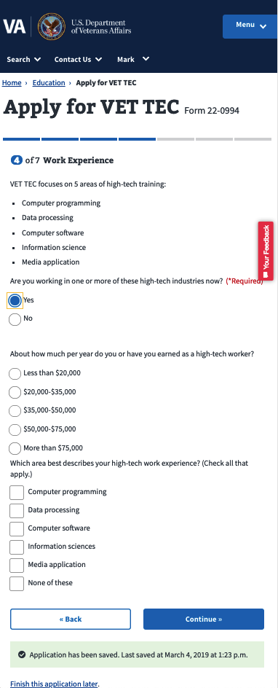
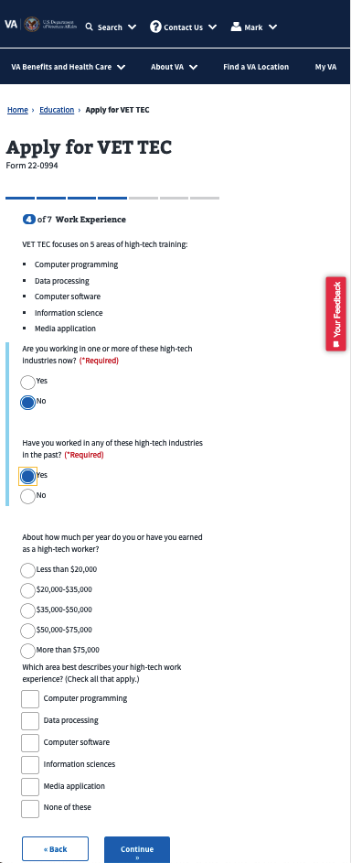

Step 5 of 7: Program selection - Yes
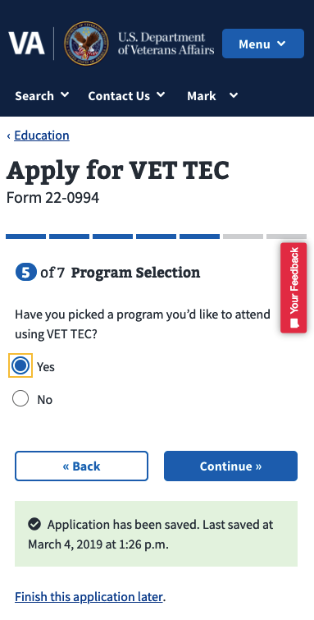 | 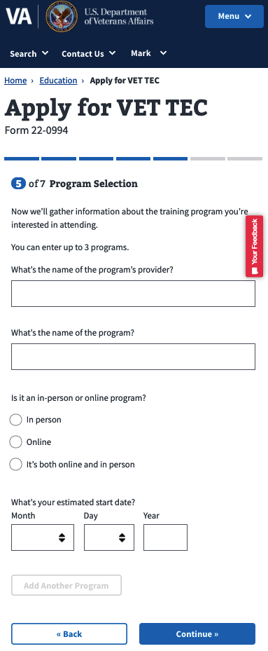 | 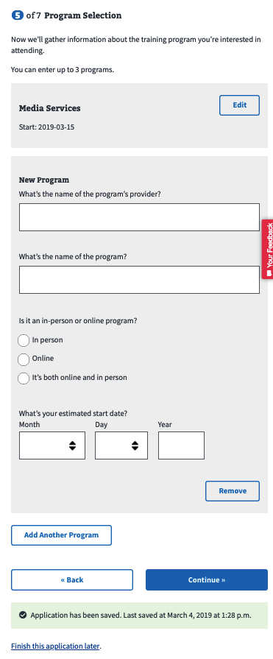

Step 5 of 7: Program selection – No
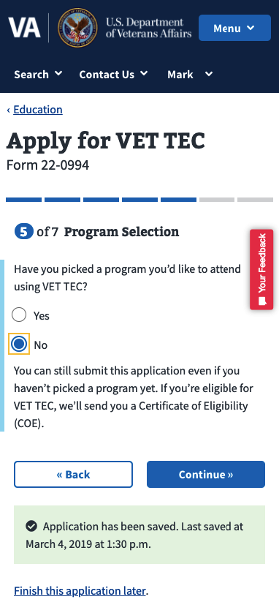

Step 6 of 7: Personal information – contact info
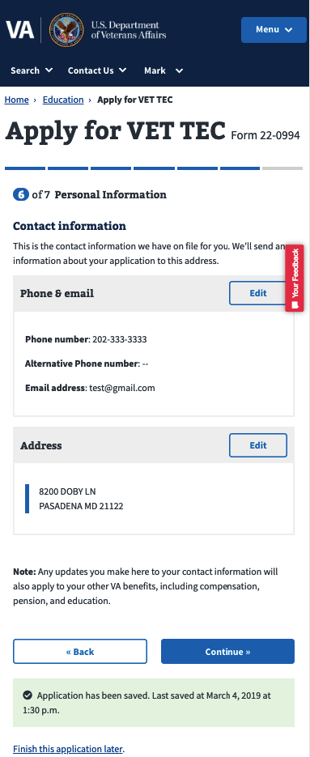

Step 6 of 7: Personal Information – Direct deposit information
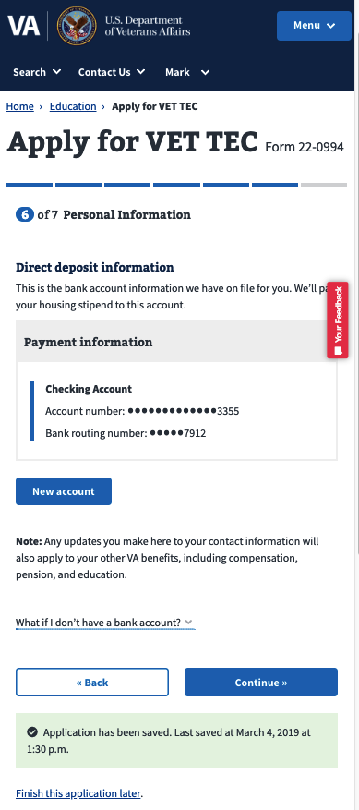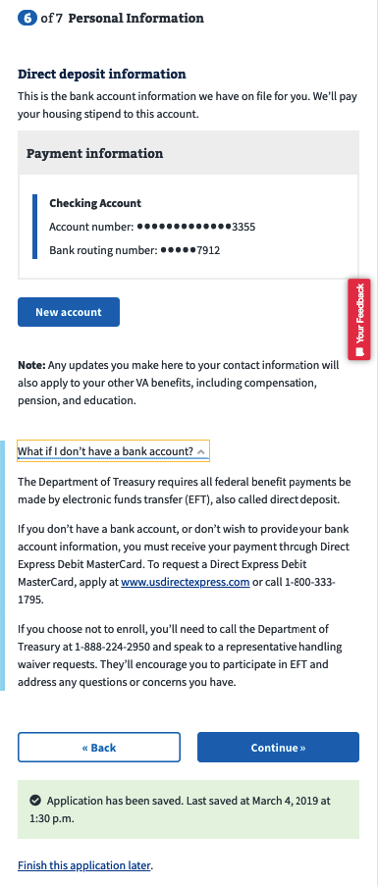

Step 7 of 7: Review Application
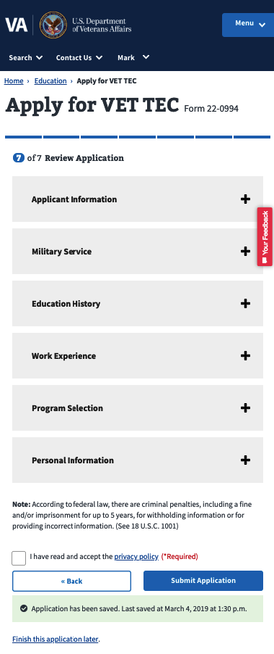 | 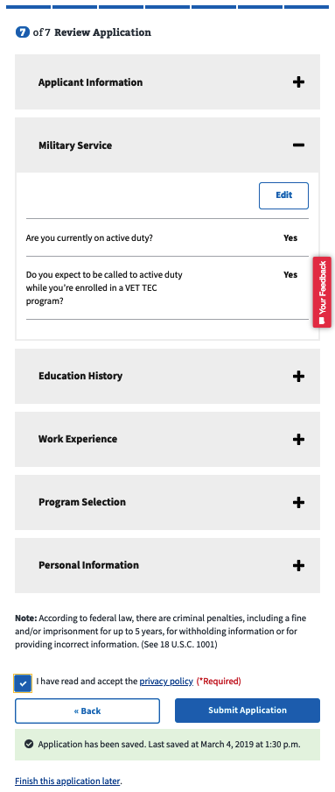

Confirmation page

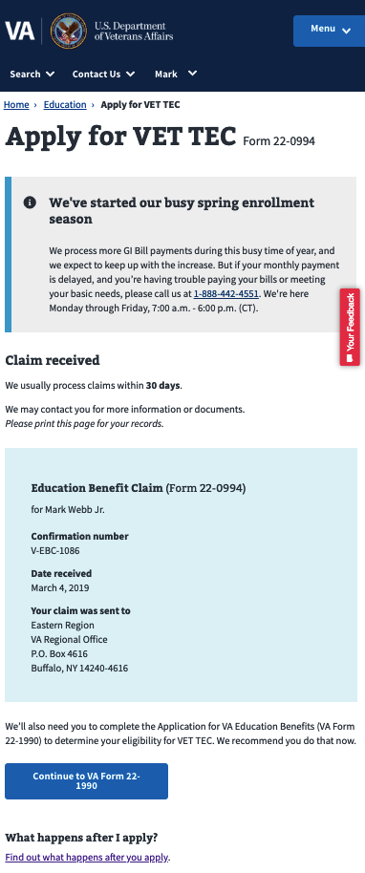

**Users only sees message to continue to VA Form 22-1990 IF they told us in the beginning of the VET TEC workflow that they had not completed it.

