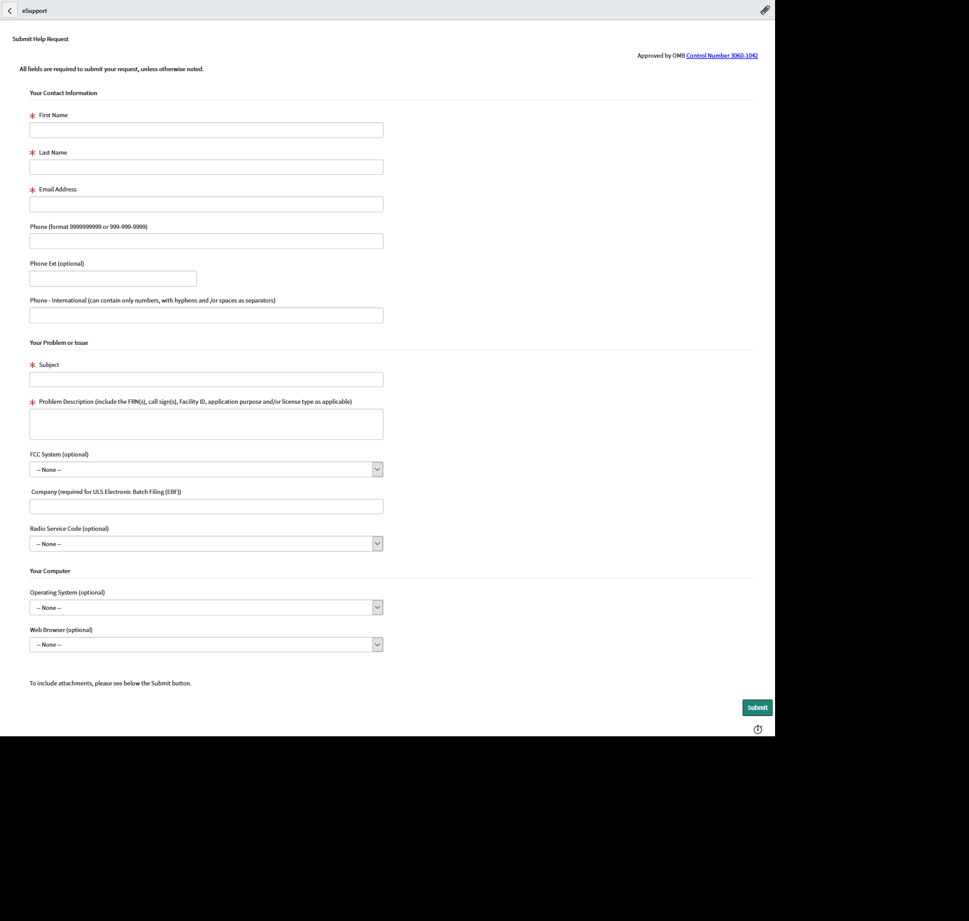

**We propose to add the following text between the problem description and FCC System Fields**

**Please provide any upcoming filing date (i.e. call sign expiration date, required notification date, ect.):**