NON-SUBSTANTIVE CHANGE REQUEST FOR
OMB CONTROL NUMBER 3060-0798

The Federal Communications Commission is submitting a non-substantive change request for OMB control number 3060-0798. The reason for the change request is described below:

* The Commission is providing the final version of the Revenue and Asset for Applicant, FCC Form 601 screenshots, to the Office of Management and Budget (OMB) for its files/records.

These non-substantive changes will not impact the burden hours or cost for this collection.

Federal Communications Commission 3060-0084 NOT YET APPROVED BY
Washington, D.C. 20554 OMB

DRAFT FCC FORM 2100, SCHEDULE 323-E
INSTRUCTIONS FOR OWNERSHIP REPORT FOR NONCOMMERCIAL BROADCAST STATIONS

GENERAL INSTRUCTIONS

1. Definitions. For the purposes of completing this form:

- A Licensee is a natural person or an entity that holds a Commission license for a noncommercial educational broadcast station.

- A Permittee is a natural person or an entity that holds a Commission construction permit for a noncommercial educational broadcast station.

- A Respondent is any person or entity that is required to file Form 2100, Schedule 323-E.

2. Filing Requirements: Non-Biennial Ownership Reports. Licensees and Permittees of noncommercial educational AM, FM, or full power television stations must file Form 2100, Schedule 323-E to report all attributable interests in the Licensee or Permittee as follows.

- Transfers of Control/Assignment of License or Construction Permit. Licensees and Permittees must file Form 2100, Schedule 323-E within 30 days after the consummation of a transfer of control or an assignment of a noncommercial educational AM, FM, or full power television station license or construction permit. See 47 C.F.R. Section 73.3615(f). Note: FCC consent is required prior to consummation of transfers of control/assignments of broadcast authorizations.

- Post-grant of Construction Permit. A Permittee of a new noncommercial educational AM, FM, or full power television broadcast station must file Form 2100, Schedule 323-E within 30 days after the grant of an original construction permit. See 47 C.F.R. Section 73.3615(e)(i).

- Application for Station License. On the date that a Permittee applies for a license to cover an original construction permit for a new noncommercial educational AM, FM, or full power television broadcast station, the Permittee must file Form 2100, Schedule 323-E to update its ownership information. A filer may choose to certify the continuing accuracy and completeness of a previously-filed ownership report. If the permit was not assigned or transferred since it was first granted, the filer may certify the continuing accuracy and completeness of a previously-filed report that was submitted pursuant to item (1), above (i.e., a report that was filed in connection with grant of the original construction permit). If the permit was assigned or transferred since it was first granted, the filer may certify the continuing accuracy and completeness of a previously-filed report that was submitted pursuant to item (2), above (i.e., a post-consummation ownership report). In either case, the information in the previously-filed report must remain accurate. See 47 C.F.R. Section 73.3615(e)(ii).

In the case of organizational structures that include holding companies or other forms of indirect ownership, a separate FCC Form 2100, Schedule 323-E must be filed for each entity in the organizational structure that has an attributable interest in the Licensee or Permittee. If a Permittee or Licensee holds multiple construction permits and/or station licenses for which the filing of a non-biennial ownership report was triggered pursuant to (1), (2), or (3), above, and the information submitted on the Permittee’s or Licensee’s ownership report is equally applicable to each such permit and/or license, the Licensee or Permittee may file a single Form 2100, Schedule 323-E listing all such licenses and/or permits. Similarly, if a non-Licensee/Permittee Respondent holds attributable interests in multiple Licensees or Permittees and the information submitted on the Respondent’s ownership report is equally applicable to each such Licensee/Permittee and all associated licenses/permits, the Respondent may file a single Form 2100, Schedule 323-E listing all such Licensees/Permittees and licenses/permits. Notwithstanding the foregoing, any Respondent that both (1) is a Licensee and/or Permittee and (2) holds attributable interests in one or more Licensees and/or Permittees must file two ownership reports – one as a Licensee/Permittee and one as a non-Licensee/Permittee Respondent.

3. This form is not to be used to request a transfer of control or assignment of license or construction permit. The appropriate forms for use in connection with such transfers or assignments are FCC Forms 314, 315, and/or 316. See 47 C.F.R. Sections 73.3540 and 73.3541. It is the responsibility of the Licensee or Permittee to determine if a given transaction constitutes a transfer of control or an assignment.

4. Filing Requirements: Biennial Reports. Licensees of noncommercial educational AM, FM, and full power television broadcast stations, as well as Licensees of Class A Television and Low Power Television (LPTV) stations, must file FCC Form 2100, Schedule 323-E every two years to report all attributable interests in the Licensee. Ownership reports must be filed by December 1 in all odd-numbered years. The information in each ownership report shall be current as of October 1 of the year in which the ownership report is filed. See 47 C.F.R. Section 73.3615(d).

In the case of organizational structures that include holding companies or other forms of indirect ownership, a separate FCC Form 2100, Schedule 323-E must be filed for each entity in the organizational structure that has an attributable interest in the Licensee. If a Licensee holds multiple station licenses and the information submitted on the Licensee’s ownership report is equally applicable to each such license, the Licensee may file a single Form 2100, Schedule 323-E listing all such licenses. Similarly, if a non-Licensee Respondent holds attributable interests in multiple Licensees and the information submitted on the Respondent’s ownership report is equally applicable to each such Licensee and all licenses, the Respondent may file a single Form 2100, Schedule 323-E listing all such Licensees and licenses. Notwithstanding the foregoing, any Respondent that both (1) is a Licensee and (2) holds attributable interests in one or more Licensees must file two ownership reports – one as a Licensee and one as a non-Licensee Respondent.

If there has been no change in the information submitted since the filing of the last biennial report, and that last biennial report was filed on the current version of Form 2100, Schedule 323-E, a Licensee or other Respondent may electronically validate and resubmit its previously-filed biennial Form 2100, Schedule 323-E.

5. Electronic Filing of FCC Form 2100, Schedule 323-E. All Form 2100, Schedule 323-E filings must be submitted electronically. Use the Media Bureau Electronic Filing system (http://www.fcc.gov/encyclopedia/media-bureau-filing-systems-and-databases).

Section I – General Information (All Respondents Must Complete)

Questions 1 and 2: Respondent and Contact Representative. In response to Question 1, enter the legal name, address, contact information and FCC Registration Number of the Respondent. If the report is filed on behalf of more than one license/permit, enter the call sign and Facility ID Number of one of the licenses/permits covered by the report. Provide the name, organization, and contact information for the Respondent’s representative in response to Question 2.

For non-U.S. addresses, include the country name with the city in the City field, and answer “NA” in the State field. Provide a U.S. zip code or non-U.S. postal code, as applicable, in the Zip/Postal Code field.

Licensees/Permittees. The name of the Licensee or Permittee should be stated exactly as it appears on the station’s existing license or construction permit. The current street address or post office box used by the Licensee or Permittee for receipt of Commission correspondence should be set forth. Any change in the name of the Licensee or Permittee, which does not involve a change in ownership requiring prior Commission approval, can be communicated to the Commission by letter. Changes in the mailing address previously used by the Licensee or Permittee should be promptly transmitted to the Commission. See 47 C.F.R. Section 1.5. To report any changes in the mailing address, use the Media Bureau Electronic Filing system (http://www.fcc.gov/encyclopedia/media-bureau-filing-systems-and-databases).

FCC Registration Number (FRN). The Respondent must provide its FRN – a ten-digit unique entity identifier. An FRN can be obtained through the Commission Registration System, CORES, which is listed among the FCC E-Filing systems (http://www.fcc.gov/e-file/).

If a Respondent submits and/or is listed as an attributable interest holder on multiple ownership reports, it must provide the same FRN on all such ownership reports. Filers should coordinate with each other to ensure such consistency.

Questions concerning the FCC Registration Number can be directed to the Commission’s Registration System help desk via email at CORES@fcc.gov or by calling 1-877-480-3201 (Mon.-Fri. 8 a.m.-6 p.m. ET).

Facility ID Number. Facility ID numbers can be located by using the “Station Search” at the Media Bureau Electronic Filing system (http://www.fcc.gov/mb/elecfile.html). In addition, the Facility ID Number is included on all broadcast authorizations and postcards.

Question 3: Respondent and Report Information. In response to subsection (a), select the appropriate option to indicate whether the Respondent, is

- a Licensee;

- a Permittee (non-biennial reports only); or

- an entity required to file a Form 2100, Schedule 323-E because it holds an attributable interest in one or more Licensees or, in the case of non-biennial reports, Permittees.

Also indicate whether the Respondent’s governing board (or other governing entity) is directly or indirectly under the control of another entity. If “yes” is selected, a separate Form 2100, Schedule 323-E must be submitted for each such controlling entity.

In response to subsection (b), indicate the report is (1) filed to satisfy the biennial filing requirement; (2) a validation and resubmission of a previously-filed biennial report (certifying no change from the previously-filed biennial report), (3) filed in connection with a transfer of control or assignment of permit or license, (4) a report by a Permittee within 30 days after the grant of a construction permit; (5) a report in conjunction with a Permittee’s application for a station license; (6) a certification of accuracy of a previously filed ownership report by a Permittee (report in conjunction with a Permittee’s application for a station license); or (7) for the purposes of amending a previously-filed report.

A Respondent with a current and unamended biennial ownership report on file with the Commission that is still accurate and that was filed using this version of Form 2100, Schedule 323-E may select option (2) to validate and resubmit the Respondent’s previously-filed biennial ownership report. A Respondent that selects option (2) will not be permitted to make changes to the information contained in Section I, Question 4, or Section II-B of the new biennial report. If such changes are needed, the Respondent should NOT select option (2) but instead should make use of the report copying or prefilling capabilities within CDBS to create the new report.

If a report is filed pursuant to option (6), provide the file number of the previously-filed report that is being certified. A Respondent that selects option (6) will not be permitted to make changes to the information contained in Section I, Question 4, or Section II-A of the new report. If such changes are needed, the Respondent should NOT select option (6) and should instead select option (5) and make use of the report copying or prefilling capabilities within CDBS to create the new report.

A Respondent should select option (7) only if the purpose of the filing is to correct one or more errors in a previously-submitted report. Filing under option (7) will update the previously-filed report, and the report will have the same file number as the previously-filed report. If the report is being submitted pursuant to option (7), provide the File Number of the previously-filed report and an exhibit listing, by Section and Question Number, the portions of the previous report that are being revised. A Respondent that wishes to create a new report based on data contained in a previously-submitted report should NOT select option (7). Instead, the Respondent should make use of the report copying or prefilling capabilities within the Commission’s electronic filing system to create the new report.

Also enter the “as of” date in the field provided. When filing a biennial ownership report (option (1) or (2)), the date entered must be Oct. 1 of the filing year.

Question 4: Licensee/Permittee and License/Permit Information. All Licensee/Permittee Respondents must enter the name and FRN of the Licensee/Permittee and provide information for each license/permit held by the Licensee/Permittee and covered by the ownership report, including call sign, Facility ID Number, community of license, and class of service. All non-Licensee/Permittee Respondents must enter the name and FRN for each Licensee/Permittee covered by the ownership report. In addition, such Respondents must provide the required information for each license/permit that is held by one of those Licensee(s)/Permittee(s) and covered by the ownership report.

Section II-A – Non-Biennial Ownership INFORMATION

Question 1: Contract Information. Licensees and Permittees of full power noncommercial educational television stations, AM radio stations, and FM radio stations are required to file with the Commission any contracts or other instruments, or modifications thereof, relating to the ownership, control, or management of the Licensee or Permittee or to its stock. See 47 C.F.R. Section 73.3613. Licensees and Permittees must file all contracts or instruments of the types specified in Section 73.3613. The filing requirement is not limited to executed contracts, but includes documents such as options, pledges, and other executory agreements and contracts relating to ownership, control, or management.

Licensee/Permittee Respondents should list all documents required to be filed pursuant to Section 73.3613 for all of the stations covered by the report. For each contract or instrument, the Respondent should provide a description of the document, a listing of the parties, the month and year of execution, and the month and year of expiration (if the agreement is perpetual or does not have a fixed expiration date, select “No Expiration Date”). In addition, the Respondent should use the checkboxes provided to indicate whether each document is a network affiliation agreement or another type of document. If an agreement falls into both categories, check both boxes. If “other” is selected, indicate the agreement type. Each contract/instrument must be identified and listed directly in the fields provided. For the purposes of completing Question 1, only a listing of the relevant contract and instruments, including the specific information discussed above, is required. Do not attach copies of the contracts/instruments to the form.

Non-Licensee/Permittee Respondents should select “Not Applicable” in response to this question and should not provide any information concerning contracts or other instruments.

Question 2: Ownership Interests. As used in Question 2, an attributable interest is an ownership interest in or relationship to a Licensee that confers on its holder a certain degree of influence or control over the Licensee as defined in the Commission’s rules. For guidance concerning attributable interests, Respondents should consult the instructions below. In addition, Respondents should review the Commission’s attribution policies and standards, which are set forth in 47 C.F.R. Section 73.3555, as revised and explained in Review of the Commission’s Regulations Governing Attribution of Broadcast and Cable/MDS Interests, MM Docket No. 94-150, 14 FCC Rcd 12559 (1999), recon. granted in part, 16 FCC Rcd 1097 (2000) and Report and Order in MM Docket No. 83-46, 97 FCC 2d 997 (1984), recon. granted in part, 58 RR 2d 604 (1985), further modified on recon., 61 RR 2d 739 (1986). Finally, Respondents should consult Promoting Diversification of Ownership in the Broadcasting Services, MB Docket No. 07-294, Second Report and Order, and Order on Reconsideration, FCC 16-1, ¶¶ 47-50 (Jan. 20, 2016).

Part (a). This Question requires Respondents to enter detailed information about ownership interests by generating a series of subforms. Answer each question on each subform. The first subform listing should be for the Respondent itself. If the Respondent is not a natural person, also list each of the officers, directors, stockholders, non-insulated partners, non-insulated members and other persons or entities with a direct attributable interest in the Respondent. (A “direct” interest is one that is not held through any intervening companies or entities.) In the case of vertical or indirect ownership structures, report only those interests in the Respondent that also represent an attributable interest in the Licensee(s) and/or Permittee(s) for which the report is being submitted.

List each person or entity with a direct attributable interest in the Respondent separately. Entities that are part of an organizational structure that includes holding companies or other forms of indirect ownership must file separate ownership reports. In such a structure, do not report or file separate reports for persons or entities that do not have an attributable interest in the Licensee(s) and/or Permittee(s) for which the report is being submitted.

Attributable Agreements. Pursuant to Section 73.3555, Notes 2(j) and 2(k), certain agreements give rise to an attributable interest in a Licensee or Permittee. Any party to such agreement that creates an attributable interest in the Licensee/Permittee by virtue of the standards set forth in 73.3555, Notes 2(j) and 2(k) must be listed in response to Question 2(a) in the ownership report filed by the Licensee/Permittee – regardless of whether or not the Licensee/Permittee itself is a party to the agreement(s). In addition, each such party must file its own ownership report(s), pursuant to the standards set forth in these Instructions, in connection with the relevant Licensee/Permittee and license(s)/permit(s).

FCC Registration Numbers (FRNs). Respondents must provide an FRN – a ten-digit unique entity identifier – for each person or entity reported on Form 2100, Schedule 323-E. An FRN can be obtained through the Commission Registration System, CORES, which is listed among the FCC E-Filing systems (http://www.fcc.gov/e-file/).

Individuals For each individual (but not entities) reported on Form 2100, Schedule 323-E, a Respondent may report either must provide a CORES FRN, or a Restricted Use FRN (RUFRN), or a Special Use FRN (SUFRN) on Form 2100, Schedule 323-E. While Respondents are encouraged to report either a CORES FRN or RUFRN for each individual on Form 2100, Schedule 323-E, Respondents also have the option of reporting an SUFRN for an individual interest holder. However, if an individual has already obtained an RUFRN or CORES FRN (or if an RUFRN or CORES FRN has already been obtained on behalf of an individual), the Respondent must report that existing RUFRN or CORES FRN for that individual. If an RUFRN or CORES FRN has been previously reported for an individual on one or more ownership report filings (either commercial or noncommercial), the Respondent must use that previously-reported RUFRN or CORES FRN for that individual on all current and future ownership report filings.

In limited circumstances, a Respondent may report a Special Use FRN (SUFRN) for an individual. Before generating or submitting an SUFRN for an individual, Respondents should read the Commission’s Form 2100, Schedule 323 and Form 2100, Schedule 323-E Frequently Asked Questions concerning the SUFRN (http://www.fcc.gov/bureaus/mb/industry_analysis/form323faqs.html). By reporting an SUFRN for an individual, the Respondent affirms to the Commission that after using reasonable and good faith efforts, the Respondent attempted and was unable to identify an existing CORES FRN or RUFRN for that individual based on previous ownership reports and information that is publicly available in the CORES database. See Promoting Diversification of Ownership in the Broadcasting Services, MB Docket No. 07-294, Order on Reconsideration, FCC 17-42, at 8, para. 13 (Apr. 21, 2017) is unable to obtain an FRN and/or obtain and/or receive permission to use the Social Security Number or other identifying information of that individual in order to generate a CORES FRN or RUFRN for that individual. If an individual interest holder does not already have a CORES FRN, we expect filers to acquire an RUFRN or CORES FRN for that individual or instruct the individual to obtain his or her own RUFRN or CORES FRN and to provide the FRN to the filer for reporting on the ownership report form. Filers must take specific steps to substantiate that they are making the required reasonable and good faith efforts, which include informing reportable individuals of their obligations and the risk of enforcement action for failing to provide an RUFRN or CORES FRN or to permit an RUFRN or CORES FRN to be obtained on their behalf. An SUFRN may be obtained only if an individual still refuses to provide a means of reporting a valid RUFRN or CORES FRN after the filer has taken such steps. See Promoting Diversification of Ownership in the Broadcasting Services, MB Docket No. 07-294, Report and Order, Second Report and Order, and Order on Reconsideration, FCC 16-1, ¶¶ 56-58 (Jan. 20, 2016) (Second Report and Order). Respondents are encouraged to refer individual interest holders who are resistant to providing the Respondent with the means of reporting a CORES FRN or RUFRN to the Second Report and Order and to the Commission’s Form 2100, Schedule 323 and Form 2100, Schedule 323-E website.
While the burden to obtain an RUFRN or CORES FRN or to permit the filer to acquire an RUFRN or CORES FRN falls to the interest holder, the The Commission reminds filers of their obligation to review the ownership report and affirm that, to the best of the filer’s “knowledge and belief, all statements in [the ownership report] are true, correct, and complete.” This includes verifying that the CORES FRN or RUFRN reported for each reported party is correct and that no SUFRN has been used for an individual who has previously been reported with a CORES FRN or RUFRN on one or more ownership report filings (either commercial or noncommercial) or who has an assigned CORES FRN or RUFRN that is publicly available in the CORES database in the absence of reasonable and good-faith efforts to obtain an RUFRN or CORES FRN, including informing a recalcitrant interest holder of the obligation and potential for enforcement action. However, the filer itself will be exempt from enforcement action if the filer substantiates that it has used reasonable and good-faith efforts as described herein.
If an SUFRN has not been reported previously for an individual on any ownership report filings (either commercial or noncommercial), and, pursuant to the instructions and standards set forth above, the Respondent is unable to obtain determines that the individual does not have a an existing CORES FRN or RUFRN for that individual, the Respondent should may click the button on the relevant subform for this question to generate an SUFRN for that individual. If an SUFRN has been previously reported for an individual on one or more ownership report filings (either commercial or noncommercial) and, pursuant to the discussion and standards set forth above, the Respondent remains unable to obtain determines that the individual does not have a an existing CORES FRN or RUFRN for that party, the Respondent must report the previously-used SUFRN for the individual.

RUFRNs and SUFRNs may only be used to file ownership reports, and may not be used for any other purpose at the FCC. RUFRNs and SUFRNs are only available for natural persons. In addition, RUFRNs and SUFRNs are not available for any natural person who is a Respondent on one or more ownership reports.

If a party submits and/or is listed as an attributable interest holder on multiple ownership reports, it must provide the same FRN on all such ownership reports, regardless of whether that FRN is a CORES FRN, RUFRN, or SUFRN. Filers should coordinate with each other to ensure such consistency.

The guidance concerning Special Use FRNs provided in Media Bureau Announces Online Availability of Revised Biennial Form 323, an Instructional Workshop on the Revised Form, and the Possibility of Obtaining a Special Use FRN for the Form, MB Docket No. 07-294, Public Notice, 24 FCC Rcd 14329 (Med. Bur. 2009) has been superseded as discussed herein and as provided in Promoting Diversification of Ownership in the Broadcasting Services, MB Docket No. 07-294, Second Report and Order, and Order on Reconsideration, 31 FCC Rcd 398 (2016), recon. granted in part, Order on Reconsideration, FCC 17-42 (Apr. 21, 2017) the Second Report and Order.

Questions concerning the FCC Registration Number can be directed to the Commission’s Registration System help desk via email at CORES@fcc.gov or by calling 1-877-480-3201 (Mon.-Fri. 8 a.m.-6 p.m. ET).

Address Information. Provide address information for the interest holder in the relevant fields. Provide a U.S. zip code or non-U.S. postal code, as applicable, in the Zip/Postal Code field. If the interest holder has a non-U.S. address, select “NA” in the State field and provide the name of the country in the Country field. Otherwise, select the proper state abbreviation for the State field and leave the Country field blank.

Listing Type. Indicate whether the interest holder is the Respondent on the report. Respondent interest holders should be identified on the first subform of this question.

Positional Interests: Check the boxes for each type of interest in the Respondent held by the interest holder. If “other” is selected, specify the interest type.

Principal Profession or Occupation: Indicate the principal profession or occupation of the reported individual. Interest holders that are not natural persons should answer “Not Applicable” in response to this question.

By Whom Appointed or Elected: Indicate the person(s) responsible for appointing or electing the reported individual. Interest holders that are not natural persons should answer “Not Applicable” in response to this question.

Percentages of Votes and Total Assets (Equity Debt Plus). Provide the interest holder’s voting percentage in the Respondent in the field provided. If the interest holder holds an attributable interest in the Respondent solely pursuant to the Commission’s Equity Debt Plus attribution standard, discussed above, provide the interest holder’s percentage of total assets (Equity Debt Plus) in the field provided. Otherwise, leave the total assets (Equity Debt Plus) field blank.

Other Broadcast Interests. Use the radio buttons on the subform to indicate whether the interest holder reported on that subform also has attributable interests in one or more broadcast stations other than those covered by the ownership report.

Part (b). Respondents must indicate that the information provided in part (a) of Question 2 is complete by certifying that all interests, including equity, financial, or voting interests, not reported in response to Question 2(a) are non-attributable.

Part (c). If the Respondent seeks an attribution exemption for any officer or member of the governing board (or other governing entity) with duties wholly unrelated to the Licensee(s)/Permittee(s), select “Yes” and enter the name and title of the each such individual in the applicable fields. For each such individual, provide an exhibit establishing that he or she will not exercise authority or influence in areas that will affect the Respondent or the Licensee(s)/Permittee(s) and station(s) covered by the report. This exhibit should describe that individual’s duties and responsibilities and explain the manner in which such individual is insulated from the Respondent and, therefore, should not be attributed an interest. Attach any such explanation as Exhibit 4.

When answering this question, Respondents should note that exemption from attribution cannot be invoked for an officer or member of the governing board (or other governing entity) unless he or she does not, and will not, have the ability to influence the broadcast operations of the Permittee(s)/Licensee(s) or Station(s). See 47 C.F.R. § 73.3555, Note 2(g).

Section II-B – Biennial Ownership INFORMATION

Question 1: Contract Information. Licensees of full power noncommercial educational television stations, AM radio stations, and FM radio stations are required to file with the Commission any contracts or other instruments, or modifications thereof, relating to the ownership, control, or management of the Licensee or to its stock. See 47 C.F.R. Section 73.3613. Licensees must file all contracts or instruments of the types specified in Section 73.3613. The filing requirement is not limited to executed contracts, but includes documents such as options, pledges, and other executory agreements and contracts relating to ownership, control, or management.

Licensee Respondents that hold one or more licenses for full power noncommercial educational television stations, AM radio stations, and/or FM radio stations should list all documents required to be filed pursuant to Section 73.3613 for all of the stations covered by the report. For each contract or instrument, the Respondent should provide a description of the document, a listing of the parties, the month and year of execution, and the month and year of expiration (if the agreement is perpetual or does not have a fixed expiration date, select “No Expiration Date”). In addition, the Respondent should use the checkboxes provided to indicate whether each document is a network affiliation agreement or another type of document. If an agreement falls into both categories, check both boxes. If “other” is selected, indicate the agreement type. Each contract/instrument must be identified and listed directly in the fields provided. For the purposes of completing Question 1, only a listing of the relevant contract and instruments, including the specific information discussed above, is required. Do not attach copies of the contracts/instruments to the form.

Non-Licensee Respondents, as well as Licensee Respondents that hold only authorizations for Class A Television or LPTV stations, should select “Not Applicable” in response to this question and should not provide any information concerning contracts or other instruments.

Question 2: Ownership Interests. As used in Question 2, an attributable interest is an ownership interest in or relationship to a Licensee that confers on its holder a certain degree of influence or control over the Licensee as defined in the Commission’s rules. For guidance concerning attributable interests, Respondents should consult the instructions below. In addition, Respondents should review the Commission’s attribution policies and standards, which are set forth in 47 C.F.R. Section 73.3555, as revised and explained in Review of the Commission’s Regulations Governing Attribution of Broadcast and Cable/MDS Interests, MM Docket No. 94-150, 14 FCC Rcd 12559 (1999), recon. granted in part, 16 FCC Rcd 1097 (2000) and Report and Order in MM Docket No. 83-46, 97 FCC 2d 997 (1984), recon. granted in part, 58 RR 2d 604 (1985), further modified on recon., 61 RR 2d 739 (1986). Finally, Respondents should consult Promoting Diversification of Ownership in the Broadcasting Services, MB Docket No. 07-294, Second Report and Order, and Order on Reconsideration, FCC 16-1, ¶¶ 47-50 (Jan. 20, 2016).

Part (a). This Question requires Respondents to enter detailed information about ownership interests by generating a series of subforms. Answer each question on each subform. The first subform listing should be for the Respondent itself. If the Respondent is not a natural person, also list each of the officers, directors, stockholders, non-insulated partners, non-insulated members and other persons or entities with a direct attributable interest in the Respondent. (A “direct” interest is one that is not held through any intervening companies or entities.) In the case of vertical or indirect ownership structures, report only those interests in the Respondent that also represent an attributable interest in the Licensee(s) for which the report is being submitted.

List each person or entity with a direct attributable interest in the Respondent separately. Entities that are part of an organizational structure that includes holding companies or other forms of indirect ownership must file separate ownership reports. In such a structure, do not report or file separate reports for persons or entities that do not have an attributable interest in the Licensee(s) for which the report is being submitted.

Attributable Agreements. Pursuant to Section 73.3555, Notes 2(j) and 2(k), certain agreements give rise to an attributable interest in a Licensee. Any party to such agreement that is attributable in the Licensee by virtue of the standards set forth in 73.3555, Notes 2(j) and 2(k) must be listed in response to Question 2(a) in the ownership report filed by the Licensee – regardless of whether or not the Licensee itself is a party to the agreement(s). In addition, each such party must file its own ownership report(s), pursuant to the standards set forth in these Instructions, in connection with the relevant Licensee(s) and license(s).

FCC Registration Numbers (FRNs). Respondents must provide an FRN – a ten-digit unique entity identifier – for each person or entity reported on Form 2100, Schedule 323-E. An FRN can be obtained through the Commission Registration System, CORES, which is listed among the FCC E-Filing systems (http://www.fcc.gov/e-file/).

Individuals For each individual (but not entities) reported on Form 2100, Schedule 323-E, a Respondent may report either must provide a CORES FRN, or a Restricted Use FRN (RUFRN), or a Special Use FRN (SUFRN) on Form 2100, Schedule 323-E. While Respondents are encouraged to report either a CORES FRN or RUFRN for each individual on Form 2100, Schedule 323-E, Respondents also have the option of reporting an SUFRN for an individual interest holder. However, if an individual has already obtained an RUFRN or CORES FRN (or if an RUFRN or CORES FRN has already been obtained on behalf of an individual), the Respondent must report that existing RUFRN or CORES FRN for that individual. If an RUFRN or CORES FRN has been previously reported for an individual on one or more ownership report filings (either commercial or noncommercial), the Respondent must use that previously-reported RUFRN or CORES FRN for that individual on all current and future ownership report filings.

In limited circumstances, a Respondent may report a Special Use FRN (SUFRN) for an individual. Before generating or submitting an SUFRN for an individual, Respondents should read the Commission’s Form 2100, Schedule 323 and Form 2100, Schedule 323-E Frequently Asked Questions concerning the SUFRN (http://www.fcc.gov/bureaus/mb/industry_analysis/form323faqs.html). By reporting an SUFRN for an individual, the Respondent affirms to the Commission that after using reasonable and good faith efforts, the Respondent attempted and was unable to identify an existing CORES FRN or RUFRN for that individual based on previous ownership reports and information that is publicly available in the CORES database. See Promoting Diversification of Ownership in the Broadcasting Services, MB Docket No. 07-294, Order on Reconsideration, FCC 17-42, at 8, para. 13 (Apr. 21, 2017) is unable to obtain an FRN and/or obtain and/or receive permission to use the Social Security Number or other identifying information of that individual in order to generate a CORES FRN or RUFRN for that individual. If an individual interest holder does not already have a CORES FRN, we expect filers to acquire an RUFRN or CORES FRN for that individual or instruct the individual to obtain his or her own RUFRN or CORES FRN and to provide the FRN to the filer for reporting on the ownership report form. Filers must take specific steps to substantiate that they are making the required reasonable and good faith efforts, which include informing reportable individuals of their obligations and the risk of enforcement action for failing to provide an RUFRN or CORES FRN or to permit an RUFRN or CORES FRN to be obtained on their behalf. An SUFRN may be obtained only if an individual still refuses to provide a means of reporting a valid RUFRN or CORES FRN after the filer has taken such steps. See Promoting Diversification of Ownership in the Broadcasting Services, MB Docket No. 07-294, Report and Order, Second Report and Order, and Order on Reconsideration, FCC 16-1, ¶¶ 56-58 (Jan. 20, 2016) (Second Report and Order). Respondents are encouraged to refer individual interest holders who are resistant to providing the Respondent with the means of reporting a CORES FRN or RUFRN to the Second Report and Order and to the Commission’s Form 2100, Schedule 323 and Form 2100, Schedule 323-E website.
While the burden to obtain an RUFRN or CORES FRN or to permit the filer to acquire an RUFRN or CORES FRN falls to the interest holder, the The Commission reminds filers of their obligation to review the ownership report and affirm that, to the best of the filer’s “knowledge and belief, all statements in [the ownership report] are true, correct, and complete.” This includes verifying that the CORES FRN or RUFRN reported for each reported party is correct and that no SUFRN has been used for an individual who has previously been reported with a CORES FRN or RUFRN on one or more ownership report filings (either commercial or noncommercial) or who has an assigned CORES FRN or RUFRN that is publicly available in the CORES database in the absence of reasonable and good-faith efforts to obtain an RUFRN or CORES FRN, including informing a recalcitrant interest holder of the obligation and potential for enforcement action. However, the filer itself will be exempt from enforcement action if the filer substantiates that it has used reasonable and good-faith efforts as described herein.
If an SUFRN has not been reported previously for an individual on any ownership report filings (either commercial or noncommercial), and, pursuant to the instructions and standards set forth above, the Respondent is unable to obtain determines that the individual does not have a an existing CORES FRN or RUFRN for that individual, the Respondent should may click the button on the relevant subform for this question to generate an SUFRN for that individual. If an SUFRN has been previously reported for an individual on one or more ownership report filings (either commercial or noncommercial) and, pursuant to the discussion and standards set forth above, the Respondent remains unable to obtain determines that the individual does not have a an existing CORES FRN or RUFRN for that party, the Respondent must report the previously-used SUFRN for the individual.

RUFRNs and SUFRNs may only be used to file ownership reports, and may not be used for any other purpose at the FCC. RUFRNs and SUFRNs are only available for natural persons. In addition, RUFRNs and SUFRNs are not available for any natural person who is a Respondent on one or more ownership reports.

If a party submits and/or is listed as an attributable interest holder on multiple ownership reports, it must provide the same FRN on all such ownership reports, regardless of whether that FRN is a CORES FRN, RUFRN, or SUFRN. Filers should coordinate with each other to ensure such consistency.

The guidance concerning Special Use FRNs provided in Media Bureau Announces Online Availability of Revised Biennial Form 323, an Instructional Workshop on the Revised Form, and the Possibility of Obtaining a Special Use FRN for the Form, MB Docket No. 07-294, Public Notice, 24 FCC Rcd 14329 (Med. Bur. 2009) has been superseded as discussed herein and as provided in Promoting Diversification of Ownership in the Broadcasting Services, MB Docket No. 07-294, Second Report and Order, and Order on Reconsideration, 31 FCC Rcd 398 (2016), recon. granted in part, Order on Reconsideration, FCC 17-42 (Apr. 21, 2017) the Second Report and Order.

Address Information. Provide address information for the interest holder in the relevant fields. Provide a U.S. zip code or non-U.S. postal code, as applicable, in the Zip/Postal Code field. If the interest holder has a non-U.S. address, select “NA” in the State field and provide the name of the country in the Country field. Otherwise, select the proper state abbreviation for the State field and leave the Country field blank.

Listing Type. Indicate whether the interest holder is the Respondent on the report. Respondent interest holders should be identified on the first subform of this question.

Positional Interests. Check the boxes for each type of interest in the Respondent held by the interest holder. If “other” is selected, specify the interest type.

Principal Profession or Occupation. Indicate the principal profession or occupation of the reported individual. Interest holders that are not natural persons should answer “Not Applicable” in response to this question.

By Whom Appointed or Elected. Indicate the person(s) responsible for appointing or electing the reported individual. Interest holders that are not natural persons should answer “Not Applicable” in response to this question.

Citizenship, Gender, Ethnicity, and Race Information. Among other things, Question 2(a) seeks information as to those persons to which the Commission’s minority and female ownership policies have historically applied. In addition to citizenship and gender information, Question 2(a) seeks information concerning the ethnicity and race of reported individuals. Interest holders that are not natural persons should answer “N/A” in response to this question.

Ethnicity. Indicate whether or not the individual being reported is Hispanic or Latino (i.e., a person of Cuban, Mexican, Puerto Rican, South or Central American, or other Spanish Culture or origin, regardless of race).

Race. The five racial categories are as follows:

- American Indian or Alaska Native. A person having origins in any of the original peoples of North and South America (including Central America), and who maintains tribal affiliation or community attachment.

- Asian. A person having origins in any of the original peoples of the Far East, Southeast Asia, or the Indian Subcontinent including, for example, Cambodia, China, India, Japan, Korea, Malaysia, Pakistan, the Philippine Islands, Thailand, and Vietnam.

- Black or African American. A person having origins in any of the black racial groups of Africa.

- Native Hawaiian or Other Pacific Islander. A person having origins in any of the original peoples of Hawaii, Guam, Samoa, or other Pacific Islands.

- White. A person having origins in any of the original peoples of Europe, the Middle East, or North Africa.

Check all racial categories that apply to the individual being reported.

Tribal Nation or Tribal Entity. The Respondent may use the checkbox provided to identify any entity reported in response to Question 2(a) that is a Tribal Nation or Tribal entity. For purposes of this question, a Tribal Nation or Tribal entity means any Indian or Alaska Native Tribe, band, nation, pueblo, village or community which is acknowledged by the federal government to constitute a government-to-government relationship with the United States and eligible for the programs and services established by the United States for Indians. See The Federally Recognized Indian Tribe List Act of 1994 (Indian Tribe Act), Pub. L. 103-454, 108 Stat. 4791 (1994) (the Secretary of the Interior is required to publish in the Federal Register an annual list of all Indian Tribes which the Secretary recognizes to be eligible for the special programs and services provided by the United States to Indians because of their status as Indians); Statement of Policy on Establishing a Government-to-Government Relationship with Indian Tribes, Policy Statement, 16 FCC Rcd 4078, 4080 (2000); see also 47 C.F.R. §§ 73.3573(f)(6) & Note 5, 73.7000.

Percentages of Votes, Equity, and Total Assets (Equity Debt Plus). Provide the interest holder’s voting and equity percentages in the Respondent in the fields provided. If the interest holder holds an attributable interest in the Respondent solely pursuant to the Commission’s Equity Debt Plus attribution standard, discussed above, provide the interest holder’s percentage of total assets (Equity Debt Plus) in the field provided. Otherwise, leave the total assets (Equity Debt Plus) field blank.

Other Broadcast Interests. Use the radio buttons on the subform to indicate whether the interest holder reported on that subform also has attributable interests in one or more broadcast stations other than those covered by the ownership report.

Part (b). Respondents must indicate that the information provided in part (a) of Question 2 is complete by certifying that all interests, including equity, financial, or voting interests, not reported in response to Question 2(a) are non-attributable.

Part (c). If the Respondent seeks an attribution exemption for any officer or member of the governing board (or other governing entity) with duties wholly unrelated to the Licensee(s)/Permittee(s), select “Yes” and enter the name and title of the each such individual in the applicable fields. For each such individual, provide an exhibit establishing that he or she will not exercise authority or influence in areas that will affect the Respondent or the Licensee(s)/Permittee(s) and station(s) covered by the report. This exhibit should describe that individual’s duties and responsibilities and explain the manner in which such individual is insulated from the Respondent and, therefore, should not be attributed an interest. Attach any such explanation as Exhibit 4.

When answering this question, Respondents should note that exemption from attribution cannot be invoked for an officer or member of the governing board (or other governing entity) unless he or she does not, and will not, have the ability to influence the broadcast operations of the Permittee(s)/Licensee(s) or Station(s). See 47 C.F.R. § 73.3555, Note 2(g).

Question 3: Licensee Ownership Structure Chart. Licensees must include as an attachment a chart or similar document showing the Licensee’s vertical or other ownership structure including the Licensee and all entities that have attributable interests in the Licensee. Any chart format is acceptable provided that it (a) meets the technical requirements for the submission of attachments via the Commission’s online filing system; and (b) accurately depicts the Licensee’s complete ownership structure, as described above. Licensee Respondents with a single parent entity may provide a brief explanatory textual exhibit in lieu of a flowchart or similar document. Licensee Respondents with no parent entities should so indicate in a textual exhibit. Non-Licensee Respondents should select “N/A” in response to this question.

SECTION III – CertificatioN (All Respondents Must Complete)

The person certifying the accuracy of the information in this report must be the individual Licensee or Permittee, an appropriate officer or member of the governing board (or other governing entity) of the Licensee or Permittee. If this report is filed for a Respondent that is not a Licensee or Permittee, the person certifying the accuracy of the information must be an appropriate officer or member of the governing board (or other governing entity) of the Respondent. The date of the signature must be no earlier than Oct. 1 of the filing year when filing a biennial ownership report.

FCC NOTICE REQUIRED BY THE PAPERWORK REDUCTION ACT AND THE PRIVACY ACT

We have estimated that each response to this collection of information will take 1 to 1.5 hours. Our estimate includes the time to read the instructions, look through existing records, gather and maintain the required data, and actually complete and review the form or response. If you have any comments on this burden estimate, or on how we can improve the collection and reduce the burden it causes you, please write to the Federal Communications Commission, AMD-PERM, Paperwork Reduction Project (3060-0084), Washington, DC 20554. We will also accept your comments via the Internet if you send them to pra@fcc.gov. Please DO NOT SEND COMPLETED APPLICATIONS TO THIS ADDRESS. Remember - you are not required to respond to a collection of information sponsored by the Federal government, and the government may not conduct or sponsor this collection, unless it displays a currently valid OMB control number or if we fail to provide you with this notice. This collection has been assigned an OMB control number of 3060-0084.

The Federal Communications Commission (FCC or Commission) is soliciting this information under authority of Sections 2(a), 4(i), 257, 303(r), 307, 309, and 310 of the Communications Act of 1934, as amended, as part of its responsibilities that relate to the ownership of non-commercial broadcast stations, including radio and television stations. The Commission needs this information to process FCC Form 2100, Schedule 323-E, “Ownership Report for Noncommercial Broadcast Stations.”

The authority under which the FCC requires filers to comply with the requirements of FCC Form 2100, Schedule 323-E, “Ownership Report for Noncommercial Broadcast Stations,” including the submission of their personally identifiable information, is derived from 47 C.F.R. Sections 73.3555 and 73.3615.

The Commission uses these records in this system:

- To assess the data contained in responses to FCC Form 2100, Schedule 323-E, “Ownership Report for Noncommercial Broadcast Stations,” which the Commission uses to undertake studies of minority and female ownership that support its diversity policy goals and other ownership studies to support its statutory requirement to review the media ownership rules quadrennially to determine whether they are necessary in the public interest as the result of competition. This form is filed:

- To satisfy the biennial filing requirement (Biennial Ownership Report);
- As a validation and resubmission of a previously filed Biennial Ownership Report;
- In connection with the transfer of control or assignment of a broadcast station;
- By a permittee within 30 days after the grant of a construction permit and on the date that the permittee files its license application;
- As a certification of accuracy of the initial or post-consummation Ownership Report filed by the permittee in conjunction with its application for a station license; or
- As an amendment of a previously filed Ownership Report.

- Any other uses of FCC Form 2100, Schedule 323-E within the Commission’s authority.

The PII that is contained in FCC Form 2100, Schedule 323-E and the PII that may be stored in the Commission’s information system(s) are covered by the FCC system of records notice, FCC/MB-1, “Ownership Report for Commercial Broadcast Stations.” Information about individuals covered by this system of records notice may routinely be disclosed under the following conditions for:

- Public Access – under the rules of the Commission, documents filed under CDBS are publicly available.

- Adjudication and Litigation – where by careful review, the agency determines that the records are both relevant and necessary to litigation and the use of such records is deemed by the agency to be for a purpose that is compatible with the purpose for which the agency collected the records, these records may be used by a court or adjudicative body in a proceeding when: (a) the agency or any component thereof; or (b) any employee of the agency in his or her official capacity; or (c) any employee of the agency in his or her individual capacity where the agency has agreed to represent the employee; or (d) the United States Government is a party to litigation or has an interest in such litigation;

- Financial obligations under the Debt Collection Acts – a record from this system may be disclosed to other Federal agencies for the purpose of collecting and reporting on delinquent debts as authorized by the Debt Collection Act of 1982 or the Debt Collection Improvement Act of 1996. A record from this system may be disclosed to any Federal, state, or local agency to conduct an authorized computer matching program in compliance with the Privacy Act of 1974, as amended, to identify and locate individuals who are delinquent in their repayment of certain debts owed to the U.S. Government. A record from this system may be used to prepare information on items considered income for taxation purposes to be disclosed to Federal, state, and local governments;

- Law enforcement and Investigation – where there is an indication of a violation or potential violation of a statute, regulation, rule, or order, records from this system may be shared with appropriate Federal, State, or local authorities either for purposes of obtaining additional information relevant to a FCC decision or for referring the record for investigation, enforcement, or prosecution by another agency;

- Congressional Inquiries – when requested by a Congressional office in response to an inquiry by an individual made to the Congressional office for their own records;

- Government-wide Program Management and Oversight – when requested by the National Archives and Records Administration for the purpose of records management inspections conducted under authority of 44 U.S.C. 2904 and 2906; when the U.S. Department of Justice is contacted in order to obtain that department’s advice regarding disclosure obligations under the Freedom of Information Act; or when the Office of Management and Budget is contacted in order to obtain that office’s advice regarding obligations under the Privacy Act; and

- Breach Notification – a record from this system may be disclosed to appropriate agencies, entities, and persons when (1) the Commission suspects or has confirmed that the security or confidentiality of information in the system of records has been compromised; (2) the Commission has determined that as a result of the suspected or confirmed compromise there is a risk of harm to economic or property interests, identity theft or fraud, or harm to the security or integrity of this system or other systems or programs (whether maintained by the Commission or another agency or entity) that rely upon the compromised information; and (3) the disclosure made to such agencies, entities, and persons is reasonably necessary to assist in connection with the Commission’s efforts to respond to the suspected or confirmed compromise and prevent, minimize, or remedy such harm.

In each of these cases, the FCC will determine whether disclosure of the records is compatible with the purpose for which the records were collected.

THE FOREGOING NOTICE IS REQUIRED BY THE PAPERWORK REDUCTION ACT OF 1995, P.L. 104-13, OCTOBER 1, 1995, 44 U.S.C. 3507 AND THE PRIVACY ACT OF 1974, PUBLIC LAW 93-579, DECEMBER 31, 1974, 5 U.S.C. SECTION 552A(E)(3).

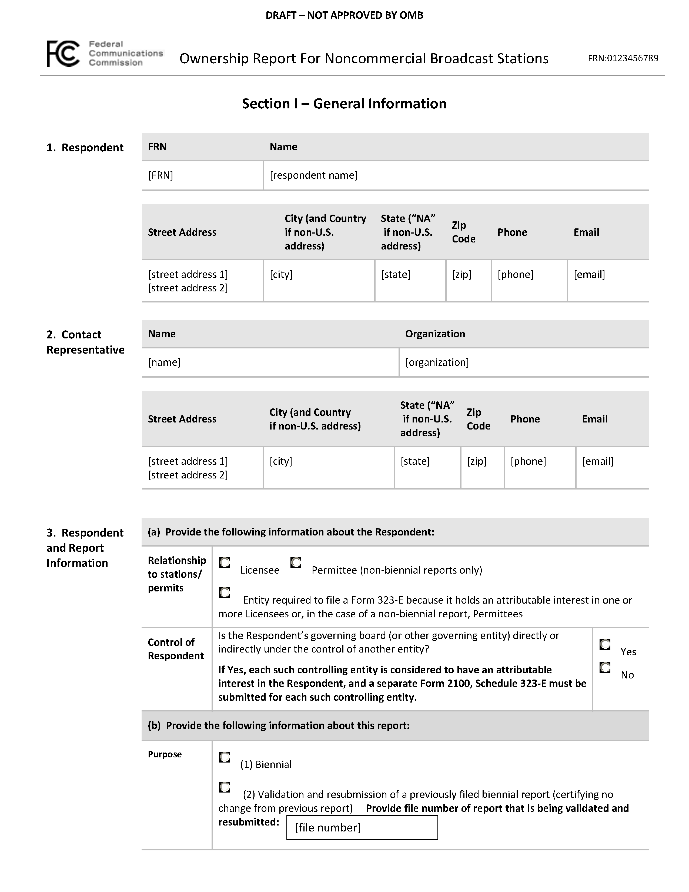
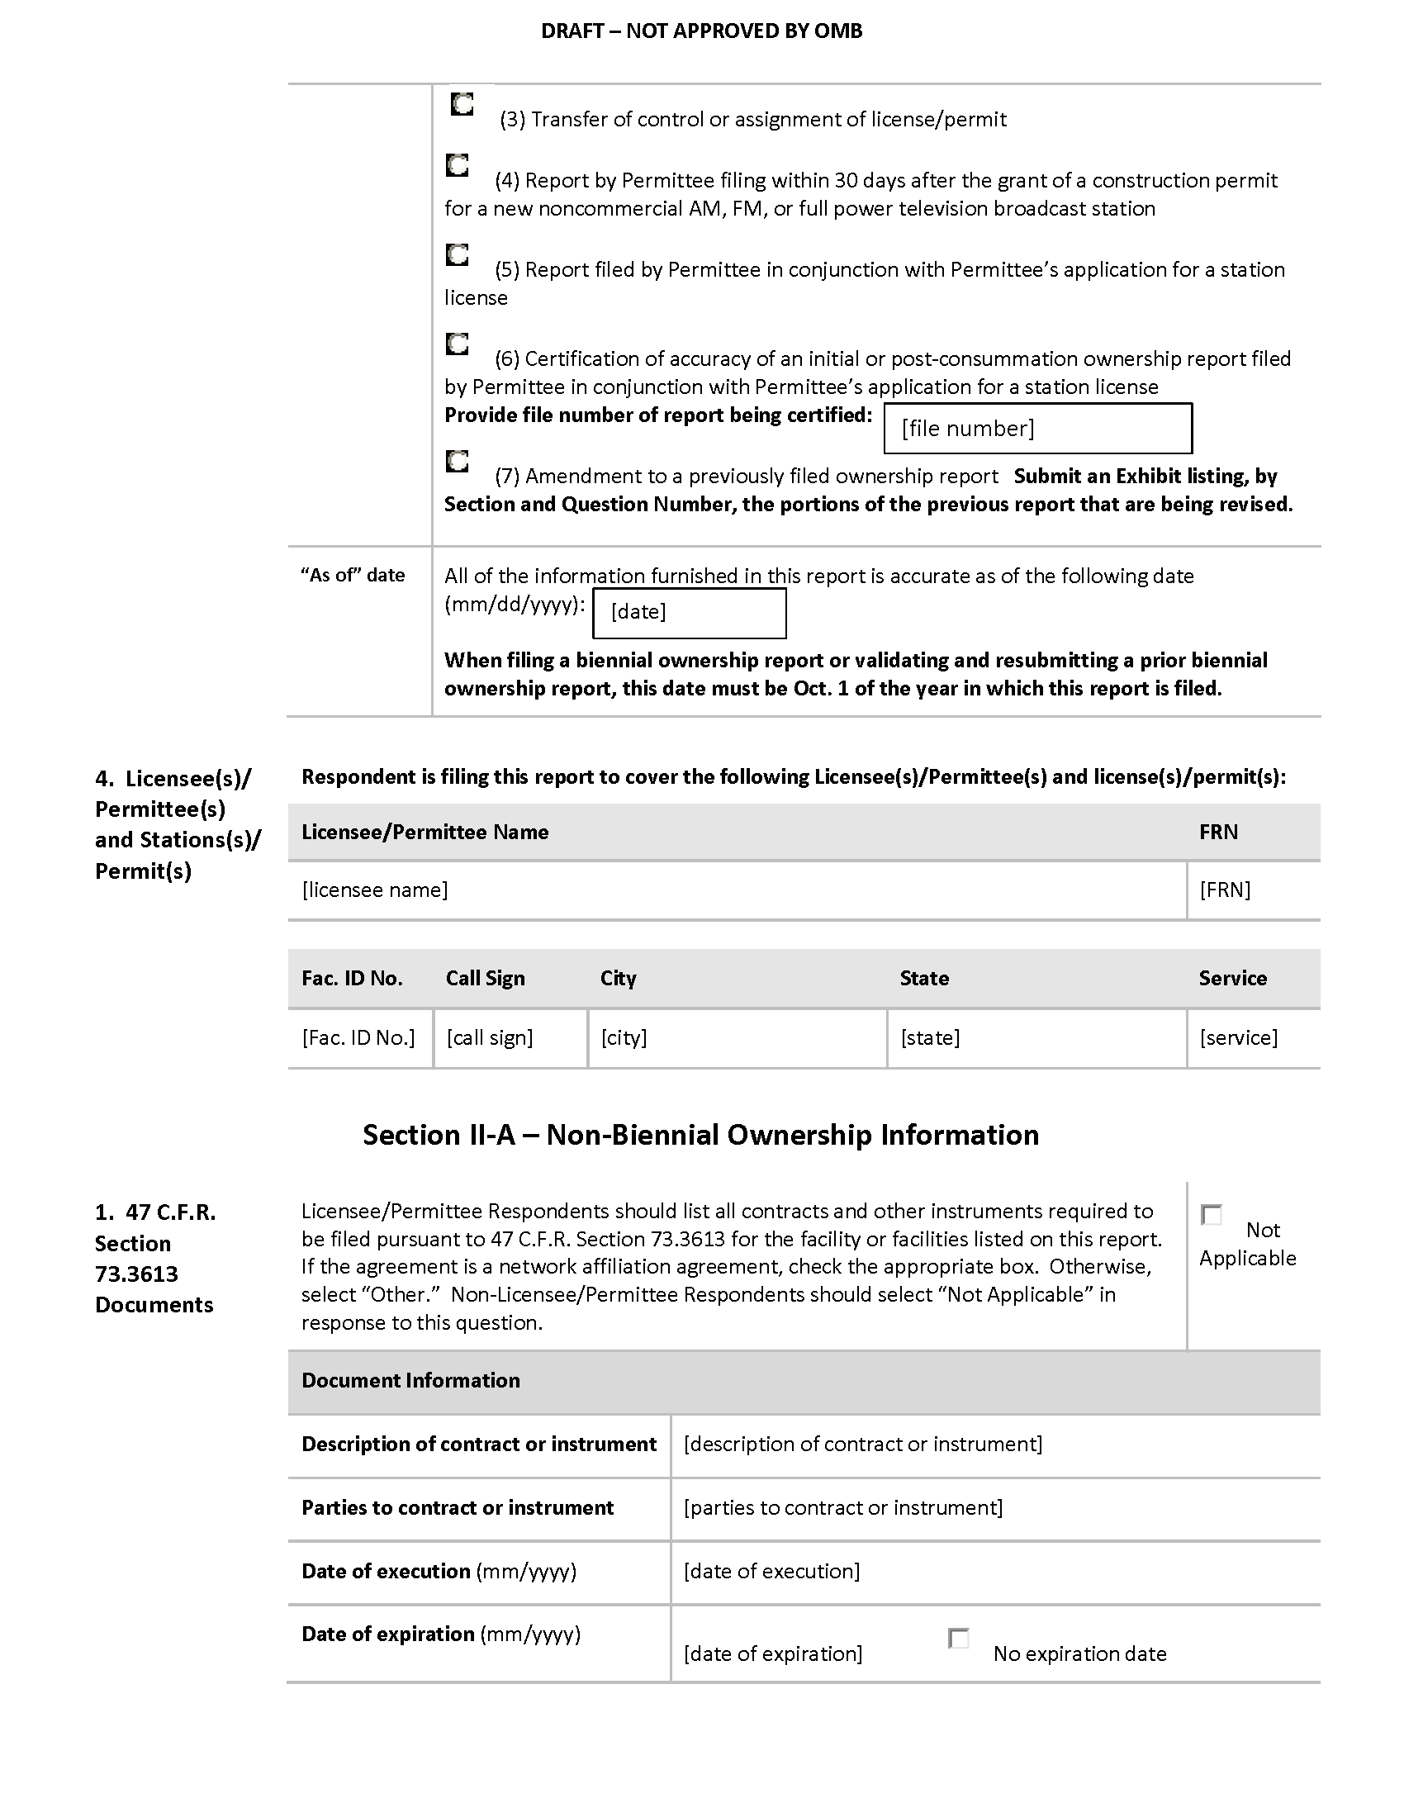
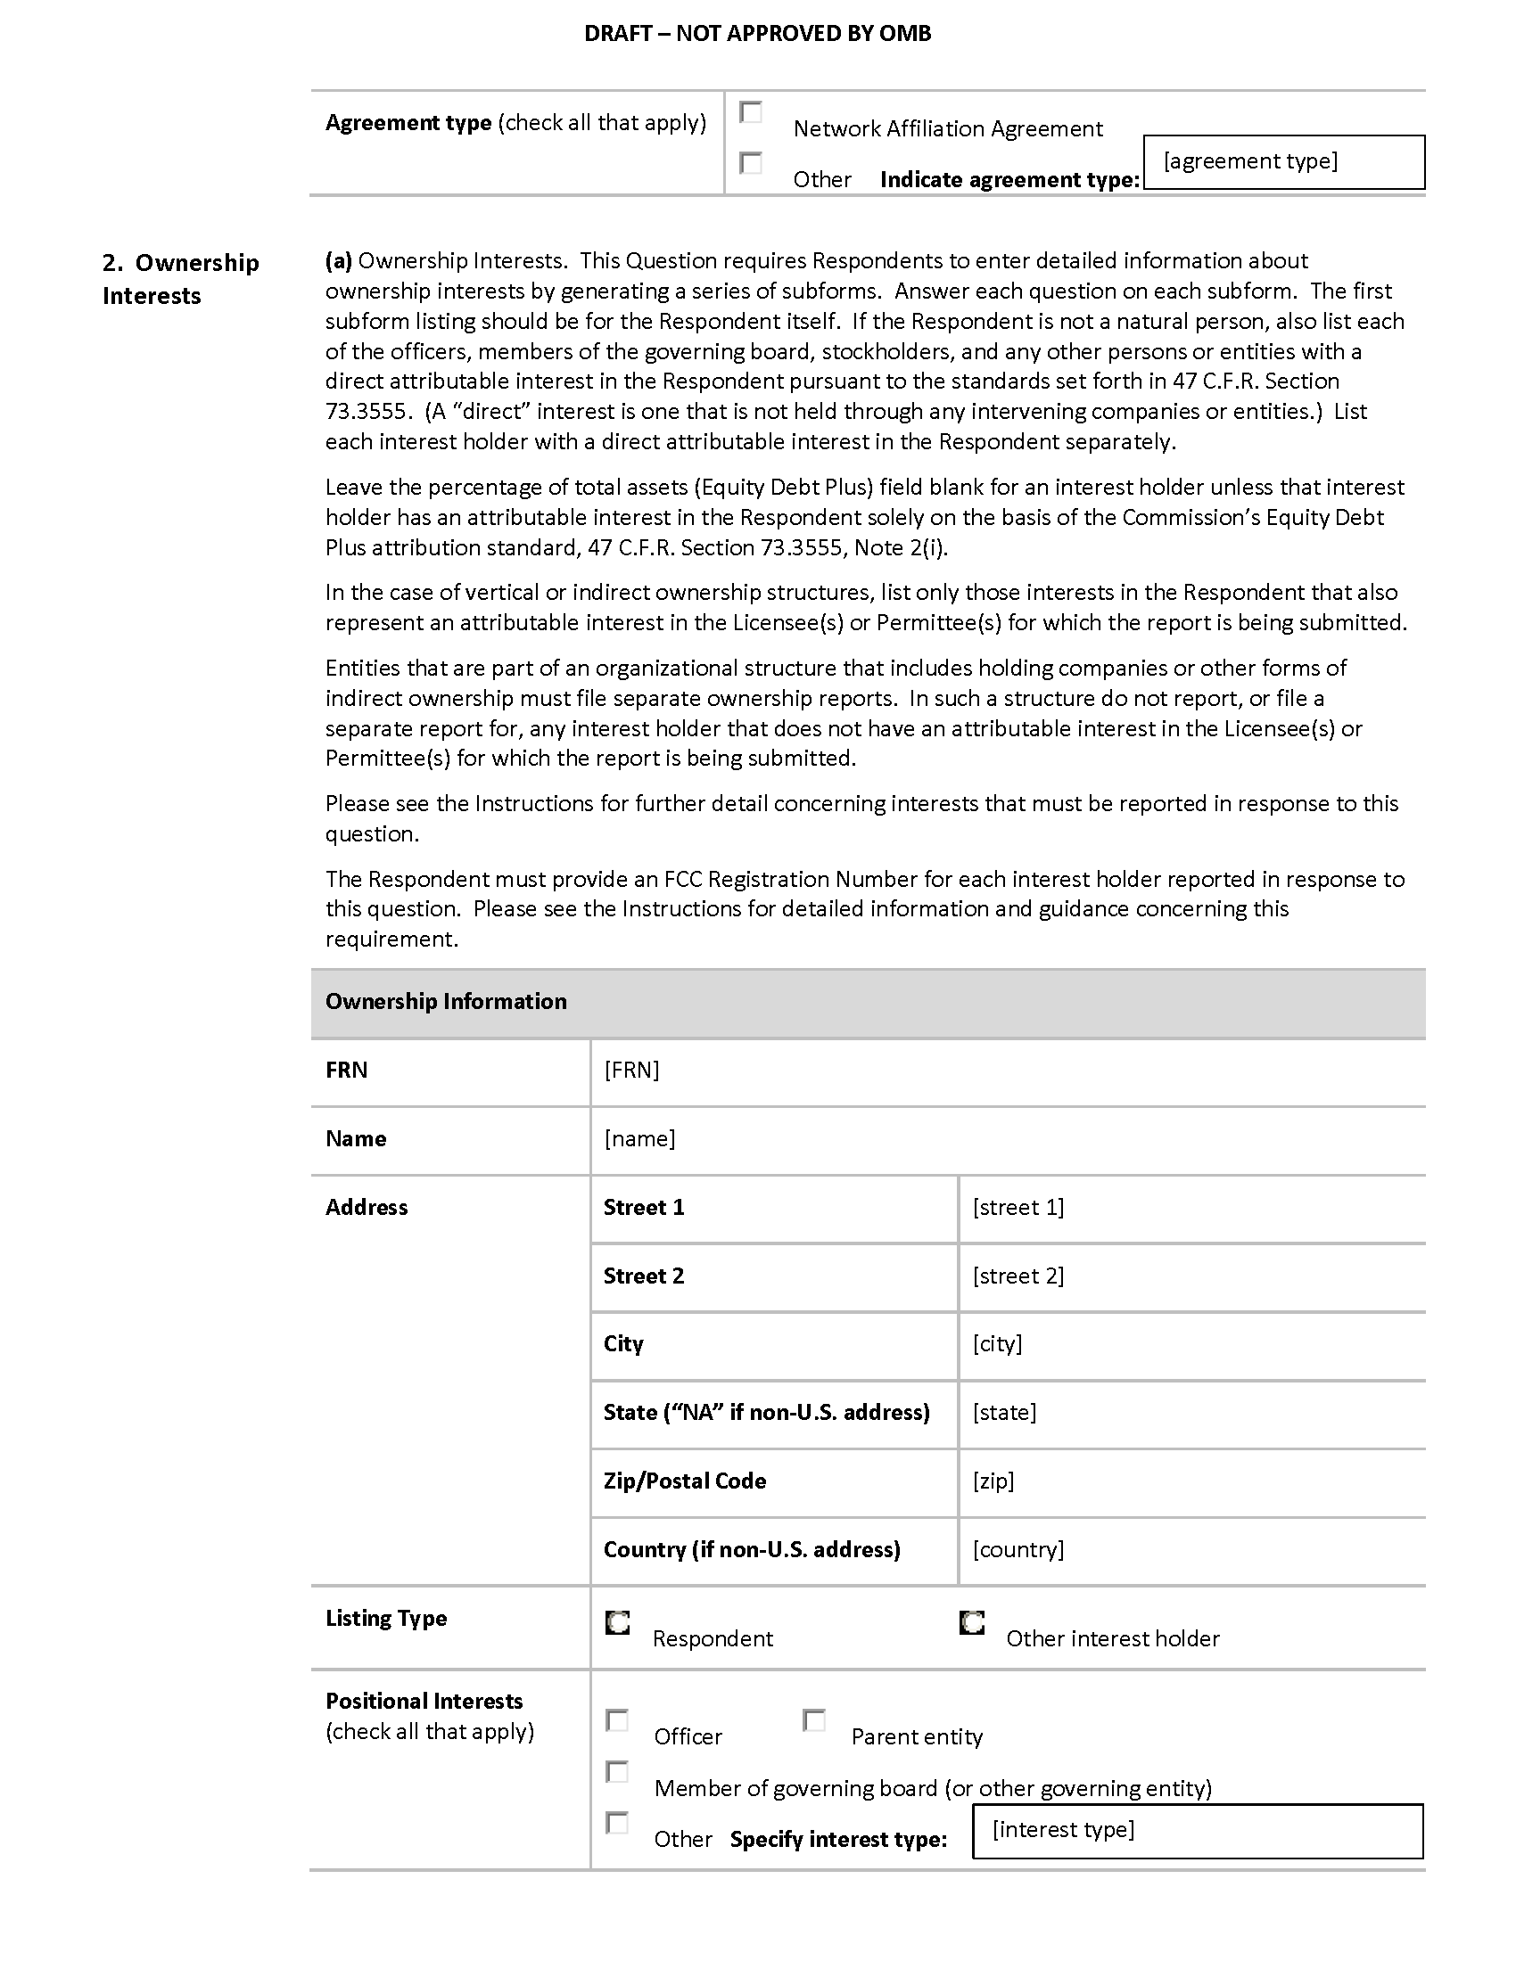
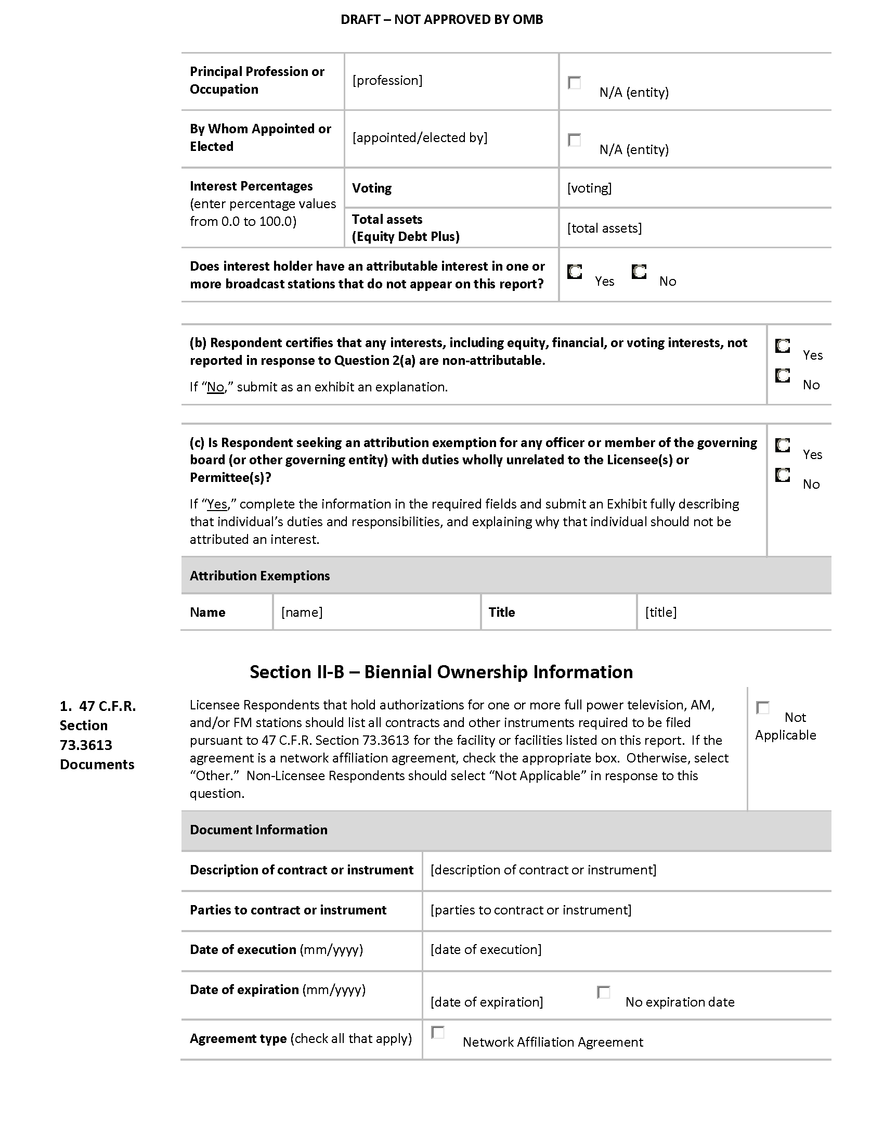
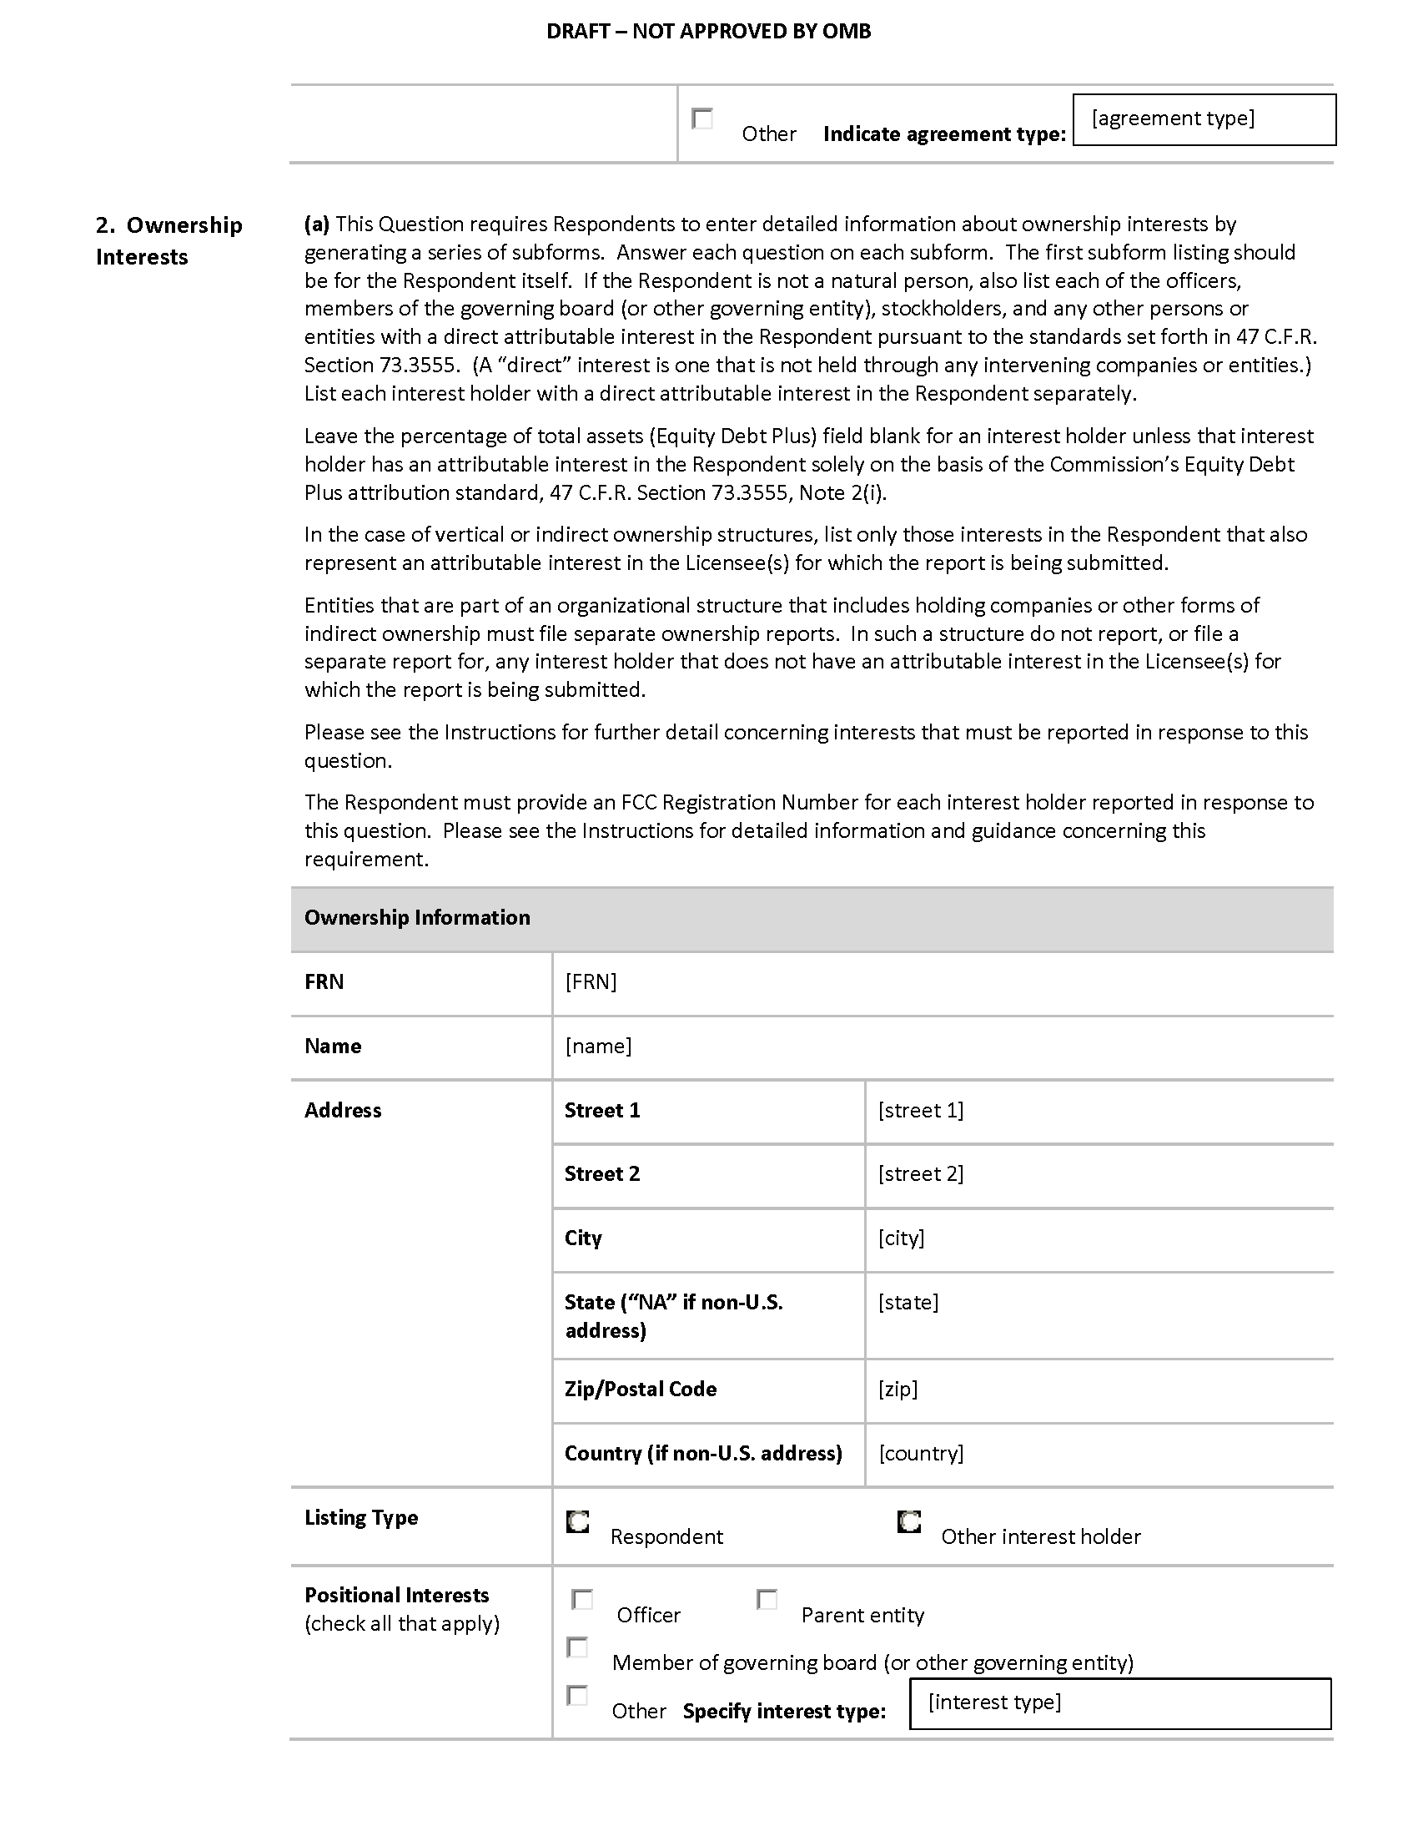
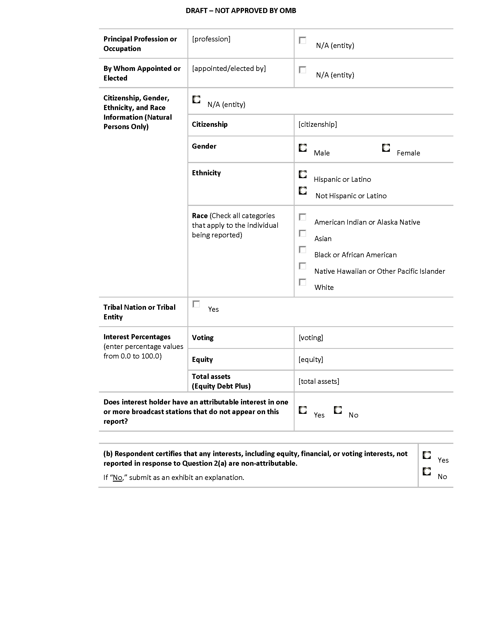
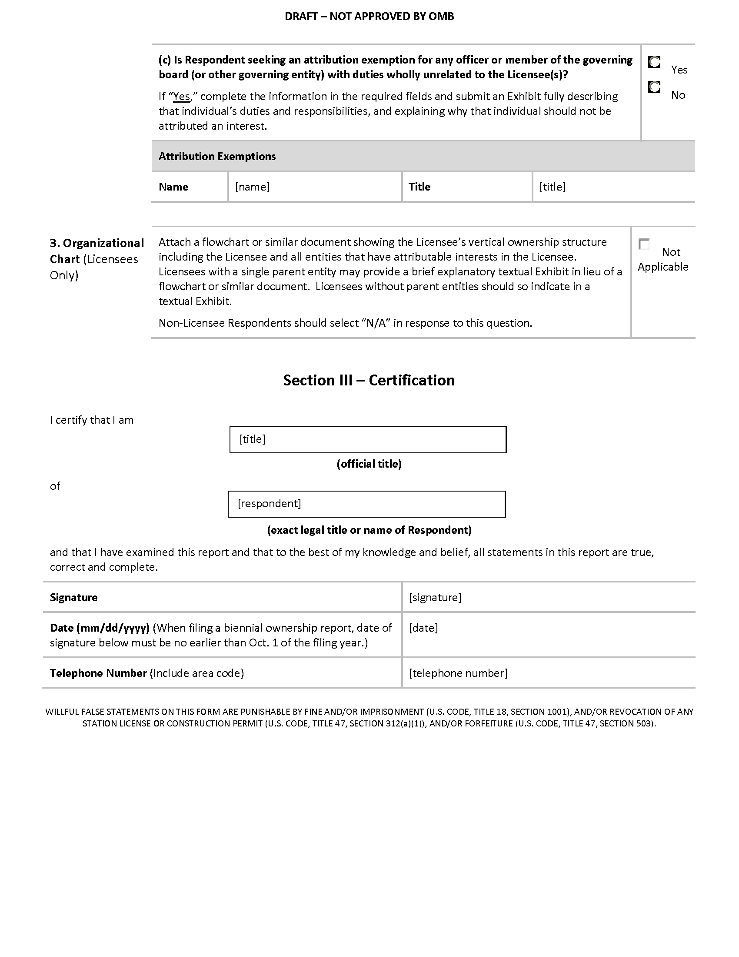

After this system of records notice is revised, we expect that the title will be changed to FCC/MB-1, “Ownership Report for Commercial and Noncommercial Broadcast Stations.”

