Antenna Structure Registration (ASR):
Initial data entry screen (Null and No):
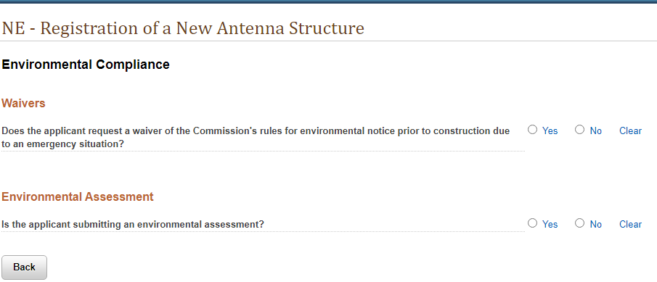
NEPA question answered “Yes”:
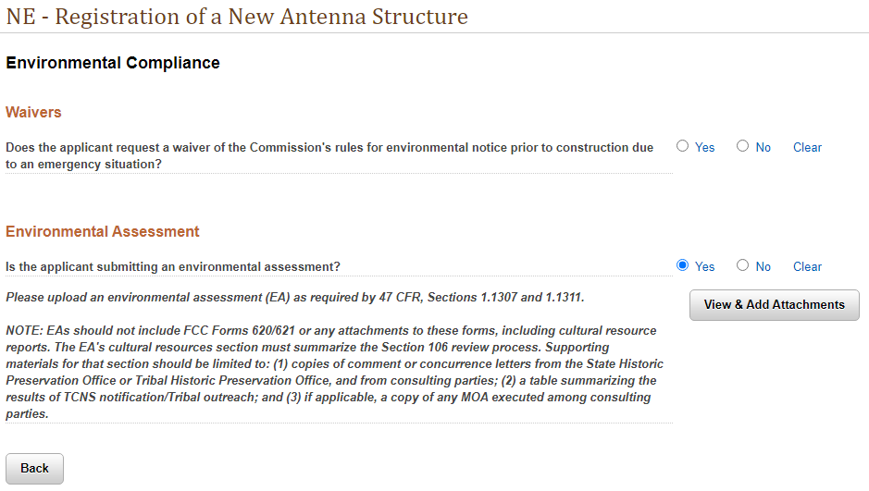
Add a Registered Link to MM License in ULS:
Initial data entry screen (Null and No):
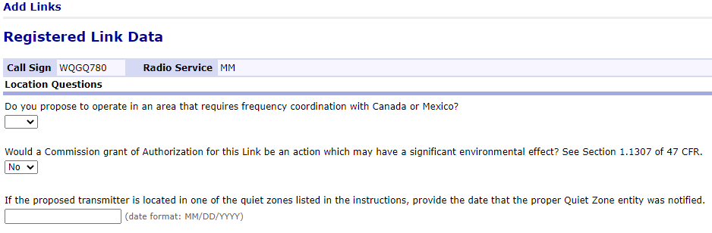
NEPA question answered “Yes”:
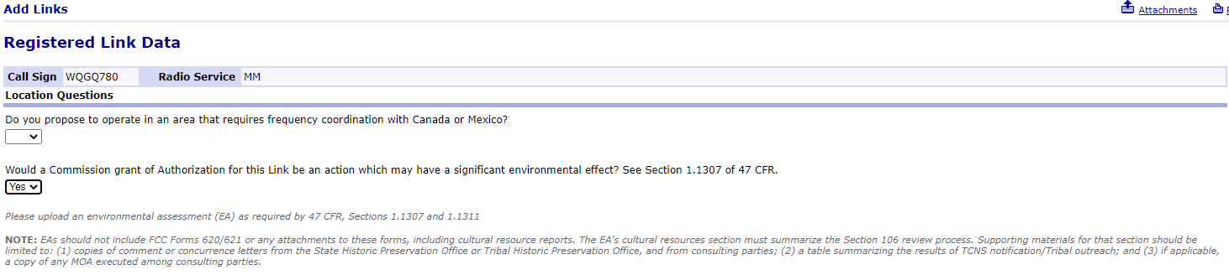

Add a Registered Location to NN License in ULS:
Initial data entry screen (Null and No):
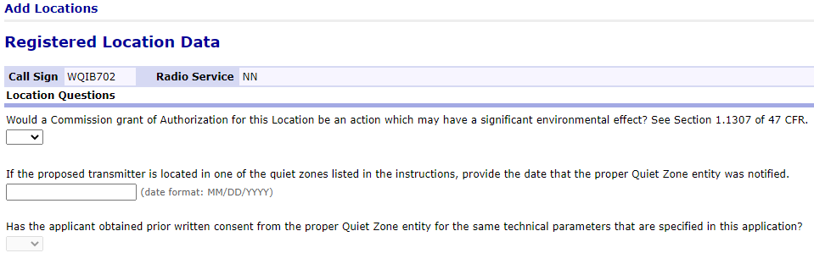
NEPA question answered “Yes”:
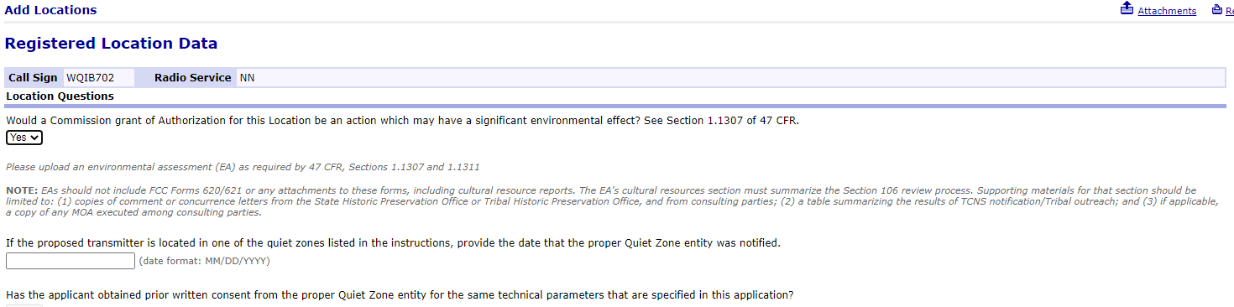

Add a Location to Broadband/EBS (BR/ED) and Other Auctioned/Market-based Licenses in ULS
Initial data entry screen (Null and No):
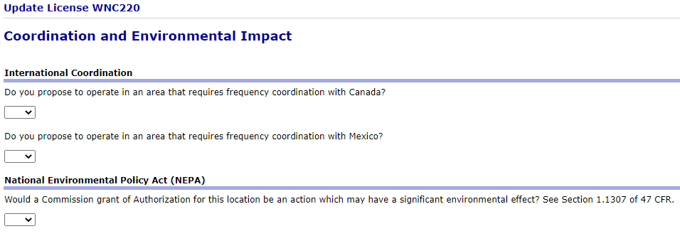
NEPA question answered “Yes”:
