**United States Department of Agriculture**

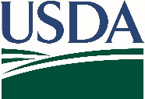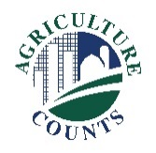

National Agricultural Statistics Service

OMB No. 0535-0213

Approval Expires: 10/31/2022

May 21, 2021

According to the Paperwork Reduction Act of 1995, an agency may not conduct or sponsor, and a person is not required to respond to a collection of information unless it displays a valid OMB control number. The valid OMB number is 0535-0213. The time required to complete this information collection is estimated to average 20 minutes per response, including the time for reviewing instructions, searching existing data sources, gathering and maintaining the data needed, and completing and reviewing the collection of information.

The information you provide will be used for statistical purposes only. Your response will be kept confidential and any person who willfully discloses ANY identifiable information about you or your operation is subject to a jail term, a fine, or both. This survey is conducted in accordance with the Confidential Information Protection and Statistical Efficiency Act of 2018, Title III of Pub. L. No. 115-435, codified in 44 U.S.C. Ch. 35 and other applicable Federal laws. For more information on how we protect your information please visit: https://www.nass.usda.gov/confidentiality. Response is voluntary.

The National Agricultural Statistics Service (NASS) is asking for your help completing the June Area survey, which will help USDA determine comprehensive estimates of U.S. land uses and agricultural activities.

To protect the health of producers, partners, and employees, we are unable to complete this survey with you in person. Instead, a NASS representative will call you to arrange a telephone interview. The interview, estimated to take up to an hour, can be done all at once or in multiple appointments.

An aerial photo and county section map are enclosed.

* Please keep the map as a reference for the survey interview.
* The survey includes questions about land uses and your operation within the red boundaries on the map, along with information related to your entire farm operation.

**How will the survey results be used?**

Data from this survey are a critical foundation for other NASS agricultural reports. The information you provide will be used for statistical purposes only. In accordance with federal law, your responses will be kept confidential, and the results will be available in aggregate form only to ensure that no individual producer or operation can be identified.

Thank you for your support of U.S. agriculture. For more information about this and other NASS surveys, visit nass.usda.gov/Surveys. If you have any questions, please contact us at 888-424-7828.

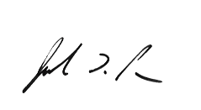

Sincerely,

Joseph L. Parsons

Chairperson, Agricultural Statistics Board