Itemized listing of changes to the ARMS III Cost and Returns Report (CRR) for 2020

- Section B, ACREAGE, PRODUCTION AND SALES, Question 2. – At the bottom of table, under All Other Crops not listed above – add hemp inside the parenthesis.

- Section E, MARKETING and PRODUCTION CONTRACTS and DIRECT SALES, Question 4 – Edit table options in second column
- From No change to No change from 2019
- From More sales to More sales in 2020
- From Fewer sales to Fewer sales in 2020
- Edit description for 4.b. directly to individual consumers from on-farm stores, u-pick, road-side stands, Community Supported Agriculture (CSAs)? (Include) other informal sales
- Section G, GOVERNMENT PAYMENTS & OTHER FARM RELATED INCOME Question 2.f.– edit language change amount still owed to amount forgiven.

- Section H, OPERATING & CAPITAL EXPENDITURES Question 49a: change the (Item 48) dollars to (Item 49) dollars.
- Section K, PERSONAL CHARACTERISTICS and FARM MANAGEMENT Question 14: Change Loss of off-farm employment and unemployment compensation to Loss of off-farm employment and unemployment compensation due to COVID-19 related disruptions or shut-downs.
  - On the next line change it from: Since March 13, 2020 did the principal producer, principal producer’s spouse, or any other member of the household lose an off-farm job or were furloughed? to Since March 13, 2020 did the principal producer, principal producer’s spouse, or any other member of the household lose an off-farm job or were furloughed due to COVID-19 related disruptions or shut downs?

  - In the third column, change the heading from: Amount of assistance received? to Total amount of assistance received?

- Question 15 – Health insurance disruptions – edit language in the table headers
  - Change: Number covered by health insurance prior to March 13, 2020 to Number covered by health insurance as of January 1, 2020
  - Change: Number who lost coverage sometime after March 13, 2020 to Number that experienced a break in coverage at any time during 2020
- Question 17: Change the question from: For either another farm business or a non-farm business owned by you or anyone in your household, did you apply for one of the Coronavirus relief programs below? to For either another farm business or a non-farm business owned by you or anyone in your household, did you apply for one of the COVID-19 relief programs below? (Fill in both columns if applicable)

  - Change column headings to emphasize Another Farm Business and Non-farm Business.
  - Change response description from: Amount of debt owed on December 31, 2020 to Amount forgiven as of December 31, 2020.

- Section M, FARM PRODUCER HOUSEHOLD – INCOME, ASSETS, & DEBT, Question 1, part i. change from: income from public sources? (Include Social Security, military and other public retirement, veteran’s benefits, public disability, unemployment, or other public assistance.) to income from public sources? (Include Social Security, military and other public retirement, veteran’s benefits, public disability, unemployment, or other public assistance including COVID-19 related unemployment. Exclude government COVID-19 related stimulus payments)
- Change subpart (i) from: COVID-19 related stimulus payments? To income from COVID-19 related economic stimulus checks and payments including Economic Impact Payments?
- Question 2.e.ii.(1) – delete - amount of out of pocket expenses related to COVID-19 (testing, treatment, medication)

Itemized listing of changes to the ARMS III Hogs Costs and Returns Report

Most of the changes made to this questionnaire were simply cosmetic changes or grammatical changes.
- Section G, GOVERNMENT PAYMENTS & OTHER FARM RELATED INCOME Question 2.f.– edit language change amount still owed to amount forgiven.

- Section O, ACCESS TO VETERINARY SERVICES Question 3, change from: In 2020, did you obtain one or more Veterinary Feed Directives (VFDs) from a veterinarian that authorized the use of antibiotics in feed for the prevention, control, or treatment of disease in your hogs? to: In 2020, did you receive one or more Veterinary Feed Directives (VFDs) for your hogs from a veterinarian? A VFD authorizes the use of antibiotics in feed for the prevention, control, or treatment of disease.

- Section Q, HOG and PIG PURCHASES, CONTRACT PLACEMENTS and FARROWINGS Question 1: Change If hogs were produced under contract (SECTION F) to If hogs were produced under a production contract (SECTION E).
- Question 4.a., 5, and 6 were changed to ask more detailed information relating to euthanized hogs and pigs for COVID-19-related reasons.
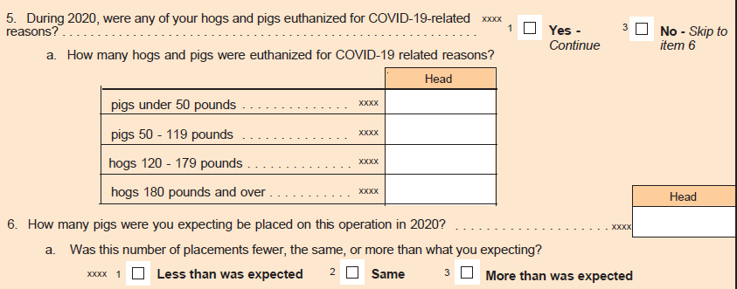
- Section R, HOG SALES and CONTRACT REMOVALS: In question 1, change produced under contract to produced under a production contract. In the heading for column 4, change under contract in 2020 to under a production contract in 2020.
- Section S, HOG FEED: Chang the question from Were there any nursery pigs on this operation in 2020, regardless of ownership? to Did you PURCHASE or did the contractor PLACE any feed for hogs on this operation in 2020?
- Section V HOG MANURE, Question 2 – add Annually as an option for manure removal.
- Section X VEHICLES, TRUCKS, and TRACTORS – Change the section title to Machinery and Equipment

