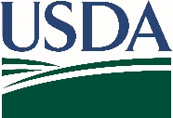
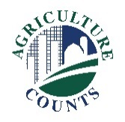
United States Department of Agriculture
National Agricultural Statistics Service
[Choose office]

What do I do next?
Complete your survey:
Online at agcounts.usda.gov. Online reporting is fast, convenient, and secure. All you need is your unique survey code on the enclosed form to begin.

By mail or fax. Complete the questionnaire and mail it back in the prepaid return envelope provided or fax it to [Click to enter FAX # - text].

Click here to enter a date

Why am I getting this letter?

Enclosed is your [Click here to add Survey Title - text] Survey. Please complete the questionnaire online at your earliest convenience. Respond promptly to avoid receiving follow-up contacts. Your information is important. [Click here to enter a brief description of survey benefits]

How will the data be used?

[Click here to describe how this survey data are used]

If we do not hear from you by [Click for date], we [Choose one] attempt to contact you to arrange a telephone interview.

Your survey response is protected by federal law (Title V, Subtitle A, Public Law 107-347), which keeps your identity and answers confidential. We will publish the survey findings in the [Click here to enter report name – text] report, to be released on [Click to add release date].

Thank you for participating and for your support of our programs and U.S. agriculture. If you have any questions, please feel free to contact us at [Click to enter phone number, email, etc. - text]. For more information on this survey, visit: nass.usda.gov/Surveys/Guide_to_NASS_Surveys/index.php.

Sincerely,

[Click here to enter – Name]
Director/State Statistician, [Choose office]

Enclosure

