Non-substantive Change Request
0535-0109 – Agricultural Labor
Agricultural Labor Survey – April and October

As part of continually reviewing comments from data providers about previous surveys and data user needs, the following updates were made to the October and April Agricultural Labor Surveys:
Initial Screening Questions on Front Page – Updated from
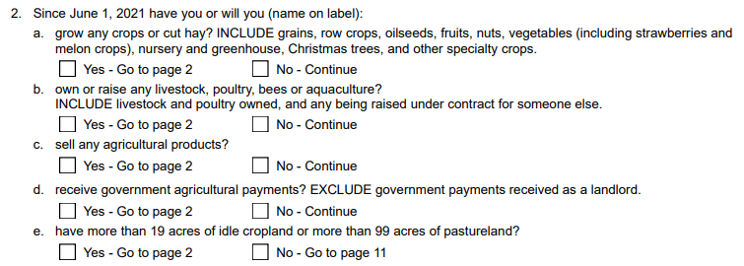
To:
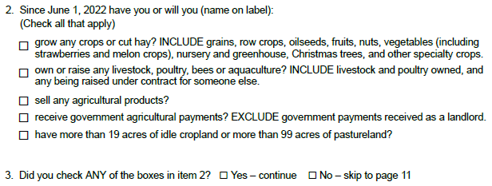

Section 2 – Paid Workers – Instruction
The bulleted instructions on the questionnaires prior to the wages/hours table require one minor change. Currently, one of the bullets reads “For salaried employees, report the standard amount of hours worked on your operation” (see screenshot below). Instead, it should read “For workers on paid leave, report the number of hours normally worked during the week of [insert reference week]”. This verbiage better aligns with the existing questionnaire.
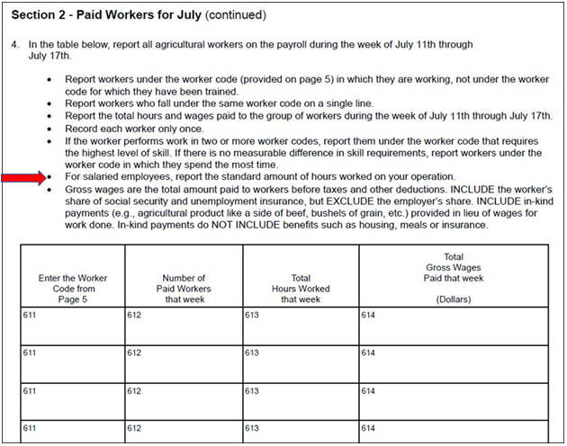

Section 3 – Agricultural Workers on the Payroll
The H2A question in Section 3 will be removed. NASS does not utilize this question and Department of Labor no longer provides supplemental funding for this survey. It is a NASS’ decision to remove.
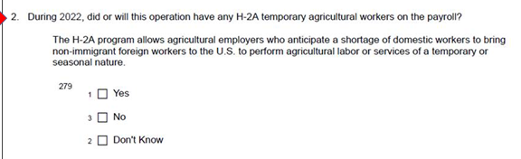

The revised questionnaires are loaded in the ROCIS submission system. These changes will not impact the current sample size or respondent burden.

