[DATE]

«First_Name» «Last_Name»
«Address1»
«City», «State» «Zip»
Dear «First_Name»:
We are reaching out to share some exciting news! At the time of the last Feeding My Baby Study interview when your child turned six, we told you that we would contact you again if you were selected for another study. We are pleased to inform you that you have been selected for the Year 9 Follow-up Study extension of the Feeding My Baby Study sponsored by the Food and Nutrition Service of the USDA. If you agree to take part in the study, you will complete one interview when [CHILD FIRST NAME] turns 9 years old that is similar to the ones you completed as part of the Feeding My Baby Study. You will receive a $70 gift card after you complete that interview with an additional $10 if you use your own cellphone. We will also ask you to take [CHILD FIRST NAME] to WIC or your child’s doctor’s office to be weighed and measured. You will receive an $80 gift card when you return the measurements. We won’t interview you until your child turns 9, but we will ask you to update your current contact information about once every three to four months until [CHILD FIRST NAME] turns nine. You will receive a $10 check each time you complete our contact information update request.
The enclosed consent form provides complete details of the study and what participating in the study means for you.
If you want to stay in the study to age 9, please complete one copy of the enclosed consent form and the Contact Information Form. You can return them to us in the postage-paid envelope. As always, you don’t need to be enrolled in WIC to participate in the Feeding My Baby Study Year 9 Follow-up Study.
We are truly appreciative of your help on this study. If you have any questions, please contact <<Study Liaison Name>> at <<Study Liaison Toll free Phone Number>> or <<Study Liaison cellphone number>> or <<Study Liaison Email Address>>
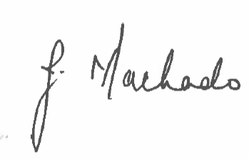
Best wishes,

Janice Machado
Feeding My Baby Study Project Director

