TBD
*xxxx.xx.xx.xx*

APPENDIX H1
Year 9 H/W measurement card - English

1600 Research Boulevard
Rockville, Maryland 20850-9973

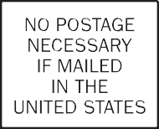

Fold along the dotted line. Pull off adhesive strip to seal.
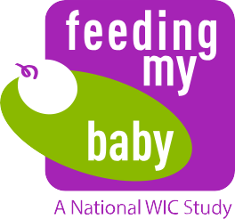

Measurement Card

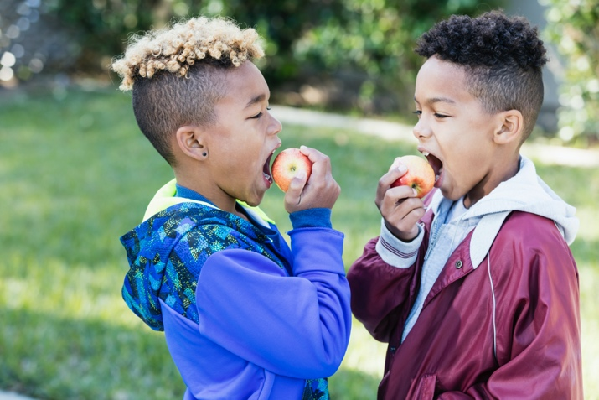

Privacy Act Statement
Authority: Per §246.26 (i)(C), USDA Food and Nutrition Service is authorized to collect information to enhance the health, education, or well-being of those who use WIC services. Code of Federal Regulations. §215.11 requires WIC State and local agency directors to cooperate in the conduct of studies and evaluations. Per §246.2 of the WIC regulations, “local agencies” include public or private non-profit health or human service agencies, Indian Health Service units, and health clinics of ITOs and intertribal councils or groups.
Purpose: Information is collected primarily for use by the Food and Nutrition Service in the administration and evaluation of Special Supplemental Program for Women, Infants and Children.
Routine Use: FNS published a system of record notice (SORN) titled FNS-8 USDA/FNS Studies and Reports in the Federal Register on April 25, 1991, volume 56, pages 19078-19080, that discusses the terms of protections that will be provided to respondents.
Disclosure: Your participation in the collection of measurement data is voluntary.

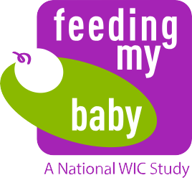
Measurement Card Instructions
OMB Approval No. 0584-0580
Approval Expires: XX/XX/20XX

This child is taking part in the WIC Feeding My Baby Study sponsored by the United States Department of Agriculture (USDA), Food and Nutrition Service. The purpose of this study is to understand health, growth, and feeding practices of children between birth and 9 years of age. To study growth, we are obtaining the height and weight measurements for these children during this critical development period. For any questions, please call [Toll-free number] (toll free).

Please complete and return this postage-paid card to Westat by mail. The parent/ caregiver will receive an incentive for bringing the child in for measurements when the card is received by Westat.

Child’s First and Last Name | Child’s Birthdate
Parent/Caregiver’s First and Last Name

To be completed by WIC/Health Care Provider staff only

Provider Type (check box)

 WIC Program  Healthcare Provider/Clinic  Other
Provider Address Stamp OR
WIC/Health Care Provider Name Address Phone Number
Measurements
Height | in OR cm
Weight | lb oz OR kg
I (PRINT NAME) certify that the measurements were completed in the office on (DATE)
Signature of staff completing measurements Title

The Food and Nutrition Service (FNS) is collecting this information to investigate the dietary practices and the health and nutritional status of the WIC ITFPS-2 children during the ninth year of life. This is a voluntary collection and FNS will use the information to inform WIC service delivery. The collection does request personally identifiable information under the Privacy Act of 1974. Responses will be kept private to the extent provided by law and FNS regulations. According to the Paperwork Reduction Act of 1995, an agency may not conduct or sponsor, and a person is not required to respond to, a collection of information unless it displays a valid OMB control number. The valid OMB control number for this information collection is 0584-xxxx. The time required to complete this information collection is estimated to average 0.1667 hours 10 minutes) per response, including the time for reviewing instructions, searching existing data sources, gathering and maintaining the data needed, and completing and reviewing the collection of information. Send comments regarding this burden estimate or any other aspect of this collection of information, including suggestions for reducing this burden, to: U.S. Department of Agriculture, Food and Nutrition Service, Office of Policy Support, 1320 Braddock Place, 5th Floor, Alexandria, VA 22314. ATTN: PRA (0584-0580). Do not return the completed form to this address.

