G27. Parent Confirmation of Enrollment (Youth)
This page has been left blank for double-sided copying.

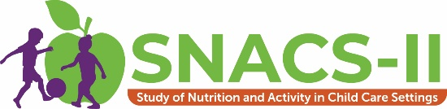
Parent Confirmation of Enrollment Letter – Parent of Youth
Thank you for agreeing to participate in the second Study of Nutrition and Activity in Child Care Settings (SNACS-II). Your participation will make a difference! IF TEEN STUDY SAMPLE: Your interview is scheduled for: [# WEEK OF MONTH]. IF MAIN STUDY SAMPLE: Your first interview is scheduled for [# WEEK OF MONTH.] We will send you a packet of materials shortly before that interview.
How to contact us:
WEBSITE: [study website]; enter passcode [passcode]
PHONE: [STUDY TOLL-FREE #] (toll-free)
EMAIL: [STUDY EMAIL ADDRESS]

