G13. Parent Recruitment Letter (Children)
This page has been left blank for double-sided copying.

Note to reviewers: The QR code is an example. The actual QR code will take sample members to the recruitment website.

[DATE]
Dear Parent/Guardian of [CHILDNAME]:
We are pleased to invite you and your child to participate in a new and exciting study! It is called the second Study of Nutrition and Activity in Child Care Settings (SNACS-II). Your child care provider and your child were randomly selected to participate. The study will help child care providers and the U.S. Department of Agriculture understand how to better help children learn and grow.
As a study participant, you will:
- Take part in up to three telephone interviews to tell us about your child’s activities and what [s/he] eats outside of child care. Each interview will take no more than 30 minutes.
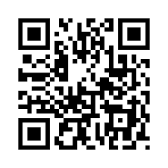
- Receive up to $60 in gift cards for your time.
To sign up for this study:
- Go to www.SNACSII.com or scan the QR code:
  - Enter your passcode [###].
- Or return the enclosed consent and permission form by mail or to [POC NAME/the person who gave you this packet].

We will also visit your child care provider to observe your child at meal and play times and measure your child’s height and weight. We will make every effort to keep the information about you and your child private. The study report will not include names or other information that could be used to identify you or your child. Your participation is voluntary and there are no penalties if you decide not to participate.
We have enclosed a brochure with more information about the study. Thank you for your time and consideration!
Sincerely,
[SIGNATURE]
Mary Kay Fox
SNACS-II Project Director, Mathematica

Enclosures: Parent Brochure and Parent Consent and Permission Form for Children

