Survey Name: Annual Retail Trade Survey (ARTS)
OMB Approval Number: 0607-0013
OMB Expiration Date: 2/29/2024
Type of Request: Non-substantive change

This non-substantive change request pertains to the 2022 Annual Retail Trade Survey (ARTS), which is tentatively slated to be sent to select respondents (Odyssey combined reporting companies) in January 2023 and all remaining respondents in February 2023. This change impacts the two form types associated with the survey: ARTS forms SA-44D (without merchandise lines) and SA-44T (with merchandise lines). In the original clearance package approved by OMB for this survey (with an expiration date of 2/29/2024), the United States Census Bureau noted, “As requested by the Bureau of Economic Analysis (BEA), every five years, in survey years ending in “2” and “7”, ARTS requests data on detailed operating expenses from firms. The last time ARTS collected detailed operating expenses was in 2018 for the 2017 survey year. The plan is to reinstate some of these questions in 2023 as part of the 2022 survey year ARTS data collection.” As described above, survey year 2022’s data will be collected from respondents during calendar year 2023. Consequently, the United States Census Bureau is officially seeking OMB’s permission to again, add the detailed operating expenses questions to SA-44D and SA-44T.
The detailed operating expenses questions used for survey year 2022 will be the same as the ones used for survey year 2017. Therefore, respondents will not be seeing anything different with one exception. For survey year 2017, the set of detailed operating expenses questions included a question about interest expense. The interest expense question will not be included for survey year 2022. The overall burden estimates will not be affected by the inclusion of the additional detailed operating expenses questions. The estimates provided in the most recent clearance take into account the periodic collection of these added expenses questions.
The drafts of the two impacted form types, SA-44D and SA-44T, have been provided with this request and below are screenshots showing how the detailed operating expenses will be presented to respondents during survey year 2022:

Detailed Operating Expenses

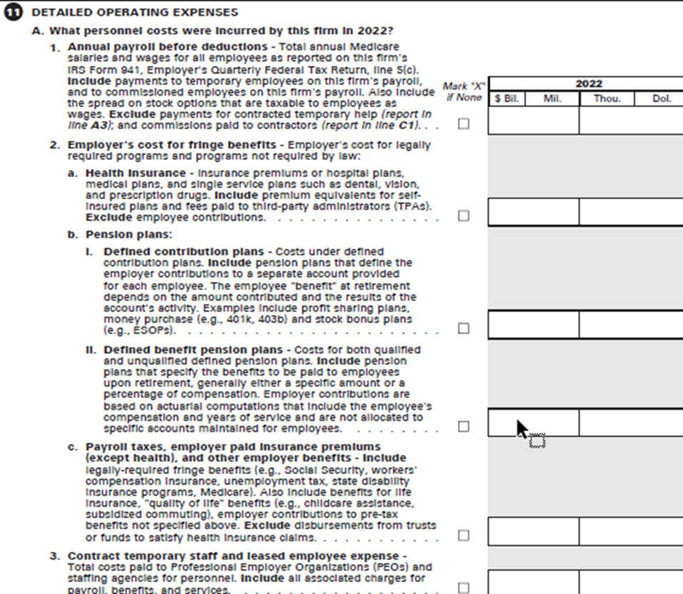
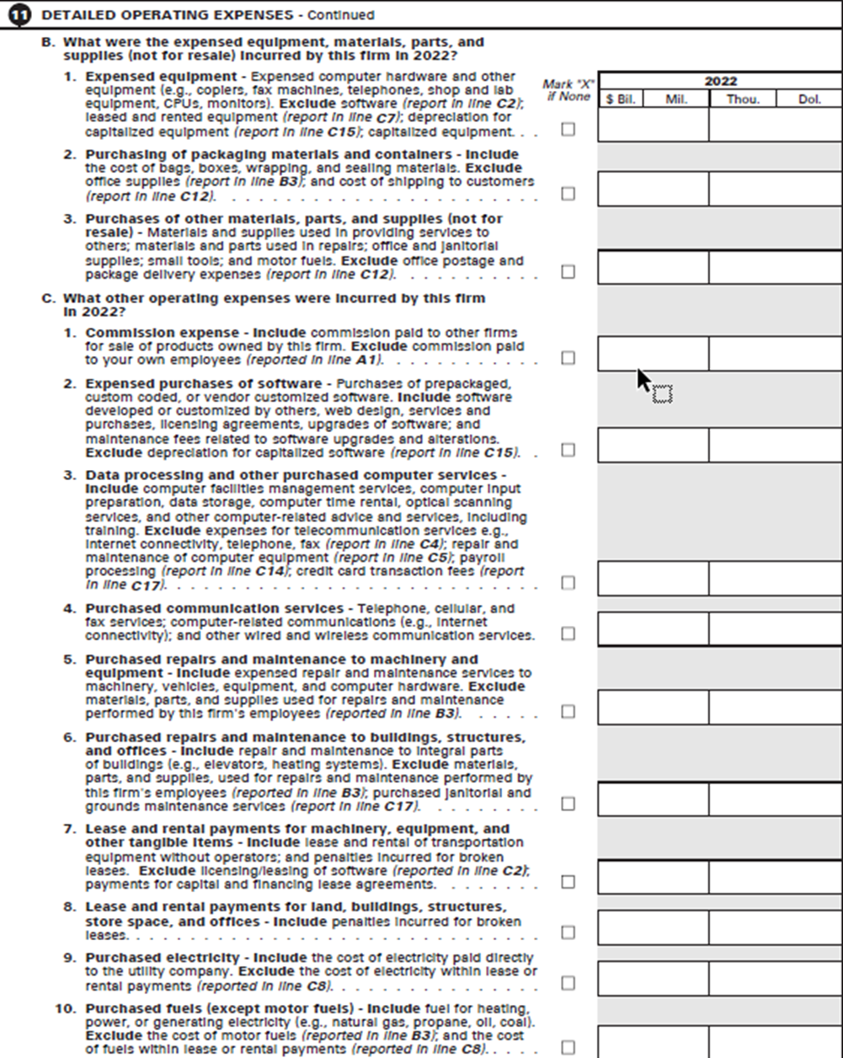

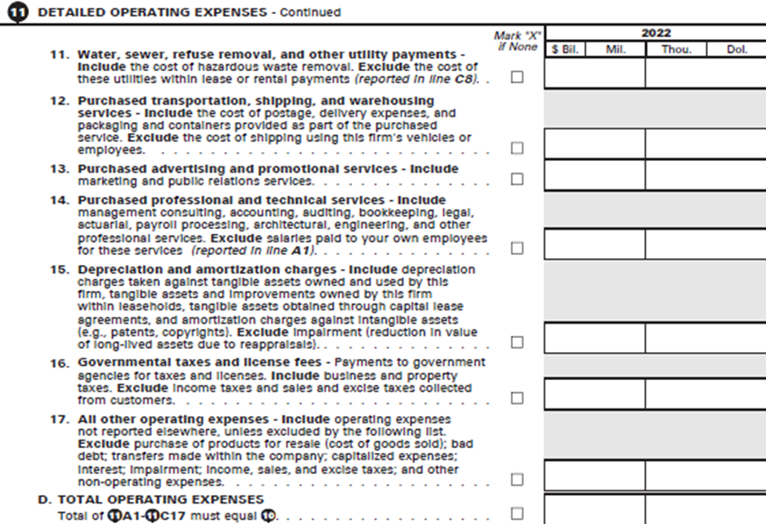

Any questions related to this request can be directed to John “Chris” Savage (john.c.savage@census.gov).

