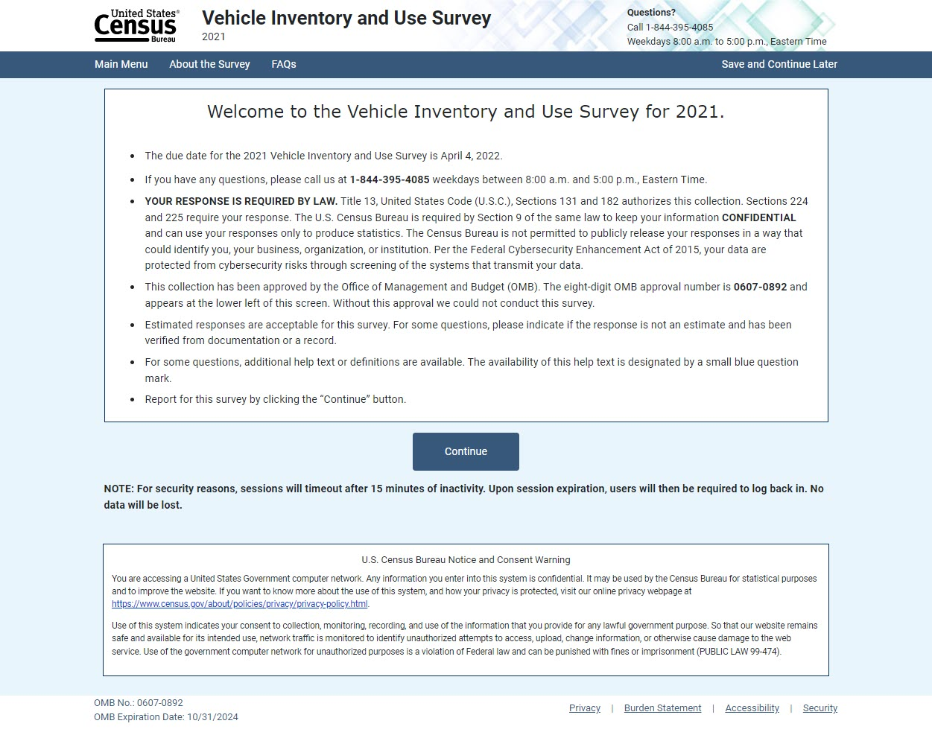
Sections requiring change circled below.
Title 13, United States Code (U.S.C), Sections 131 and 182 authorizes this collection. Sections 221, 224, and 225 require your response.
OMB No.: 0607-0892 and 0607-XXXX

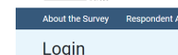

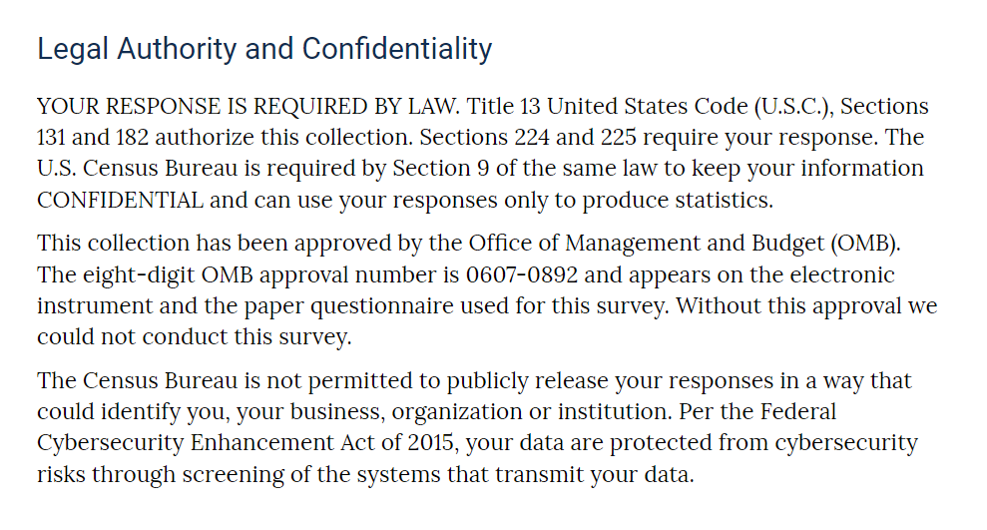
The Centurion instrument links to the Information for Respondents page. Information for Respondents (census.gov)
Title 13, United States Code (U.S.C), Sections 131 and 182 authorizes this collection. Sections 221, 224, and 225 require your response.

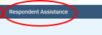

Information about OMB approval is shown on the Information for Respondents page linked from the Centurion instrument.
Information for Respondents (census.gov)

