# SUPPORTING STATEMENT

**U.S. Department of Commerce**

**National Oceanic & Atmospheric Administration**

**Annual Economic Survey of Federal Gulf and South Atlantic Shrimp Permit Holders**

**OMB Control No. 0648-0591**

**B. Collections of Information Employing Statistical Methods**

# Describe (including a numerical estimate) the potential respondent universe and any sampling or other respondent selection method to be used. Data on the number of entities (e.g., establishments, State and local government units, households, or persons) in the universe covered by the collection and in the corresponding sample are to be provided in tabular form for the universe as a whole and for each of the strata in the proposed sample. Indicate expected response rates for the collection as a whole. If the collection had been conducted previously, include the actual response rate achieved during the last collection.

The population of interest is all vessels fishing for penaeid and rock shrimp in the federal waters of the Gulf of Mexico and South Atlantic, i.e. off the States of North Carolina, South Carolina, Georgia, Florida, Alabama, Mississippi, Louisiana, and Texas, during one calendar year. An excellent sampling frame is available for this survey effort, because vessels shrimping in the federal waters of the Gulf and South Atlantic are required to have a federal permit. Their contact information should be up-to-date due to the annual permit renewal process. The sampling frame consists of all fishermen holding at least one of four federal shrimp permits at any time during the previous calendar year (including individuals whose permits might have expired but are still legally renewable, i.e. “latent permit holders”). Note that the survey effort conducted each year, e.g., 2023, will be collecting the previous year’s annual economic data, e.g. 2022.

While four permits create eligibility to be part of the survey, we only sample unique vessels, within the overall population of permitted vessels. By treating all four permit populations as one population for economic data collection purposes, multi-permit holders (~220) are only exposed to sampling once each year. The downside of this approach for NMFS is that we cannot have different sampling intensities (%) for different permits. As a result, to achieve a confidence level of a least 90% and 95% for SPA (~429) and SPGM (~1,411) permits, respectively, as well as achieving reasonable significance for the shrimp fisheries of the major shrimp fishing states (LA and TX), we sample roughly one third of the population each year. Other reasons to sample about a third of the population (rather than less and thereby reducing burden on the public) include: a) There are always some 'latent permits' or 'effectively terminated' in the population that are ineligible (but we only know that in retrospect because the permits terminate 1 year after expiration), so our effective populations are somewhat smaller. b) Fishery managers are especially interested in active vessels (those that actually harvested shrimp in a year). Again, we do not know at sampling which vessels were active due to data lags beyond our control. Historically, roughly 80% of permitted vessels are active in a given year. c) Even with 85% response rate, we are still losing 15% of the sample size; and d) fishery variables of interest always have a lot of noise (variation).

Roughly, we aim to randomly sample without replacement about a third of the whole population each year, covering the population once every three years. The primary reason for this approach is not statistical in nature. When we originally started this data collection, we used a different sampling design. However, during the first few years we were very frequently getting the respondent complaints of the following nature: "I get selected every year" or "I had to do this last year, unfair." After many phone conversations of this nature, we decided to 'start fresh' each 3-year cycle with a very simple, easily explainable, “obviously fair”, and to-the-shrimpers-intuitive design. We randomly sample 33% of the frame the first year; the 2nd year we eliminate the previously sampled vessels from the frame and then randomly sample 50% of the remaining vessels (50% of ~67% of the population---but there's always a bit of fluctuation of vessels, but not much); and the third year we would remove all 1st year and 2nd year sampled vessels from the frame and simply select the rest (100% of ~34% of the population---again, with some fluctuations). So we are able to tell respondents: "You (and every other vessel) will be sample exactly ONE time in each 3-year time period---we are100% certain of that!" In addition, the number of respondent being sampled two years in a row is minimized (1/9 if the population at the start of the next cycle (in the “4th year”), while protecting the overall random sampling nature of the data collection. This has helped a lot with dealing with respondent complaints and overall data collection buy-in with the respondents.

As of January 2021, the total population was 1,585 unique vessels with one or more federal shrimp permits. For the 2020 survey, we sampled 582 vessels. Due to the management and political importance attributed to delineation by state, we stratify the total population by state. Within each stratum, we randomly sample vessels in proportion to each stratum’s weight in the total population. By sticking to a simple, straightforward design, we hope to avoid many potential problems.

These numbers are unlikely to change dramatically in the coming years. The actual number of permit holders in the fishery might change a little due to new entrants (the South Atlantic penaeid permit and rock shrimp permit (Carolinas zone) are open access permits), owners and vessels leaving the fishery (permits non-renewed or terminated), or changes in vessel ownership or state of registration. The final sampling frame will use all the information available just prior to the survey implementation.

The table below breaks down the 2018 sampling frame into the state strata and provides the number of respondents/vessels sampled and number of surveys returned during 2019. The most recent data collection (2020 annual data collected during 2021) has not yet been finalized due to an IT problem (Oracle migration). We also do not report the previous year (2019 data collected during 2020) due to the COVID19 pandemic, which led to an uncharacteristically low response rate of only 73%.

Table: 2018 Sampling frame, sample, sampling rate, responses (count), and response rate by State Strata

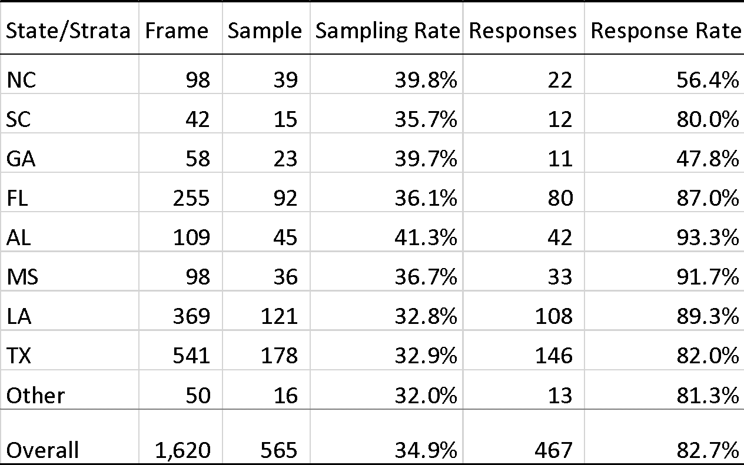

As can be seen in the next table, most vessels, 1,411 of 1,620 held a limited access Gulf of Mexico shrimp permit (SPGM permit). The S. Atlantic shrimp fishery is much smaller scale than the Gulf; only 429 vessels hold the S. Atlantic penaeid shrimp permit (SPA permit). Note that vessels can hold multiple permits, and many do. The SPA permit is an open access permit, meaning anyone can apply for one. Hence, the SPA population is much more transient than the limited access SPGM. In addition, the implicit threat of non-renewal of a permit is much less binding in an open access fishery, e.g., reapply next year under wife’s name or LLC. This leads to different survey response rates by permit type, as can be seen in the following table.

Table: 2018 Population, sample, responses (count), and response rate by permit type

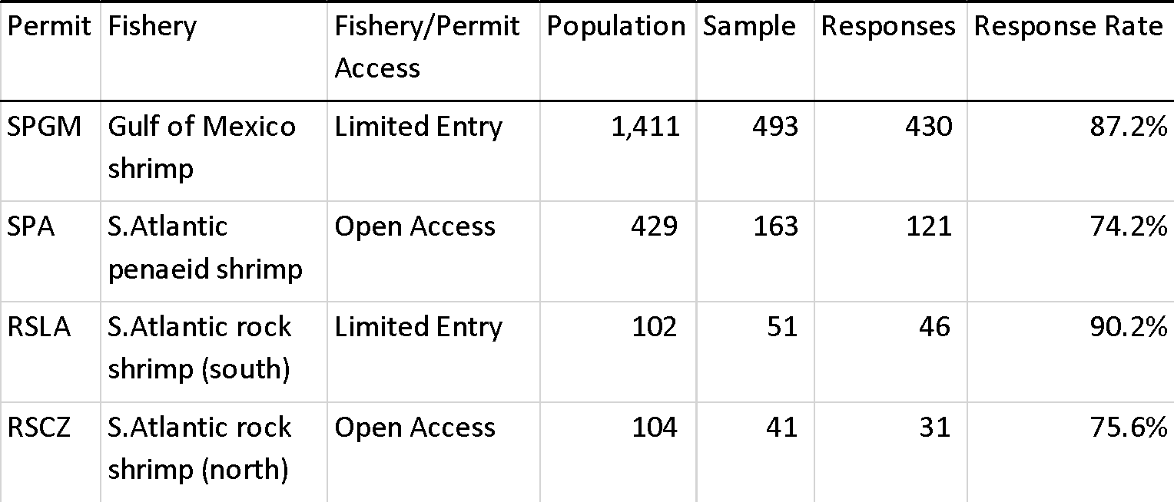

The owner of each vessel selected will be contacted by mail in late February/early March of each year with a selection letter including the survey package. The package will contain a cover letter, instructions, the two-page survey instrument and a return envelope. They will be asked to return the completed survey instrument to us in the enclosed, pre-paid envelope. If no response is received by April 30, up to two further letters will be sent (including additional survey instruments). We will also attempt to contact the non-responders by phone and urge them to return the survey. Information will not be collected during the phone call, and a further survey instrument will be sent – by mail, fax, or email – if requested.

# Describe the procedures for the collection of information including:

* + Statistical methodology for stratification and sample selection,
  + Estimation procedure,
  + Degree of accuracy needed for the purpose described in the justification,
  + Unusual problems requiring specialized sampling procedures, and
  + Any use of periodic (less frequent than annual) data collection cycles to reduce burden.

For sampling, we will stratify the population by state as this is a policy relevant variable. We will then randomly sample in each strata proportional to each strata’s weight in the population. Each year, we will sample approximately a third of the population. The very tractable proportional random sampling approach should require only simple adjustments to the inclusion probabilities used for the estimation of population means and other aggregate statistics if non-response is significant and skewed across the strata.

After data entry, verification and cleaning, descriptive statistical analysis will be conducted on the relevant variables collected (costs and profits). Results will be reported for different definitions of the fleet (all permitted, Gulf shrimp vessels, active, inactive, etc.) and by state. Post-stratification takes account of response rate variations across states and active status. The accuracy for the population level totals and means of the important variables should exceed the standard +/- 10% confidence interval at a 95% significance level for the larger groups, such as by state (LA or TX) or by activity status. Given the overall uncertainty inherent to policy assessments of economic conditions in fisheries and given the quality and accuracy of other data used, the standard accuracy should suffice.

The use of periodic instead of annual collection is being actively considered in discussions with the priory users of the result (the management process, Council and SERO economists). The burden on the public will depend on how frequently significant changes occur in this industry. Currently, the fishery is still undergoing substantial changes making the annual collection of data necessary.

# Describe methods to maximize response rates and to deal with issues of non-response. The accuracy and reliability of information collected must be shown to be adequate for intended uses. For collections based on sampling, a special justification must be provided for any collection that will not yield "reliable" data that can be generalized to the universe studied.

The central approach to maximizing the response rate is to make answering a very concise and simple survey a requirement for future permit renewal. The first cover letter will politely emphasize this point. The second and third reminder letters will be more explicit. The telephone call will also explain the consequences of not complying. The call has the further advantage of being a different mode of contact and should discover non-response due to an incorrect address. Given the potential loss of permit, we expect compliance from all fishermen wanting to continue to fish for shrimp in federal waters. The behavior by those who have left the fishery by the time of the survey, or are planning to leave it before their current permit expires, will not be influenced by the implicit threat. Since the data will be used primarily for assessments and predictions about future developments, under-reporting by individuals leaving the fishery is less problematic.

A good sampling frame, with annually updated contact information (through the ongoing permit renewal), will help to reduce the non-contact component of non-response.

Beyond the above, we will take every action available to us to facilitate completing and returning the survey by the fishermen. General survey design techniques (Dillman method) and experience from the previous surveys will guide us. Noteworthy actions include:

• Timing of the survey during the slow shrimp fishing season (winter and spring) and coinciding with tax time, when business records are being consulted and financial concerns are “top of mind.”

• Using plain language and translating the survey into “language” spoken by southeast shrimp fishermen (including a Vietnamese version).

The statistical design and size of this sample survey will allow for valid generalizations of the results to the population and larger subpopulation levels/statistical domains. The anticipated accuracy of the results is discussed in more detail in the previous question (Part B, Question 2).

# Describe any tests of procedures or methods to be undertaken. Testing is encouraged as an effective means of refining collections of information to minimize burden and improve utility. Tests must be approved if they call for answers to identical questions from 10 or more respondents. A proposed test or set of tests may be submitted for approval separately or in combination with the main collection of information.

No tests are planned during the next 3 years. At some point in the future, we might want to reevaluate digital submissions by asking for respondents’ interests in such a system.

# Provide the name and telephone number of individuals consulted on statistical aspects of the design and the name of the agency unit, contractor(s), grantee(s), or other person(s) who will actually collect and/or analyze the information for the agency.

Individual consulted (a long time ago) on the statistical aspects of the design:

Elizabeth Overstreet, MSc in Applied Statistics

National Marine Fisheries Service

Southeast Fisheries Science Center

Social Science Research Group

(305) 361-4496

Kaming Lo, M.P.H.

Biostatistics Collaboration and Consulting Core (BCCC)

Department of Public Health Sciences

University of Miami, Miller School of Medicine

(305) 243-2506

James R. Waters, Ph.D.

National Marine Fisheries Service

Southeast Fisheries Science Center

Beaufort Laboratory

(252) 728–8710

Persons who will actually collect and analyze the information:

Christopher Liese, Ph.D.

National Marine Fisheries Service

Southeast Fisheries Science Center

Social Science Research Group

(305) 365-4109

Felix Martin (contractor)

University of Miami / Cooperative Institute of Marine and Atmospheric Studies

Onsite at the Southeast Fisheries Science Center / Social Science Research Group

(305) 361-4263