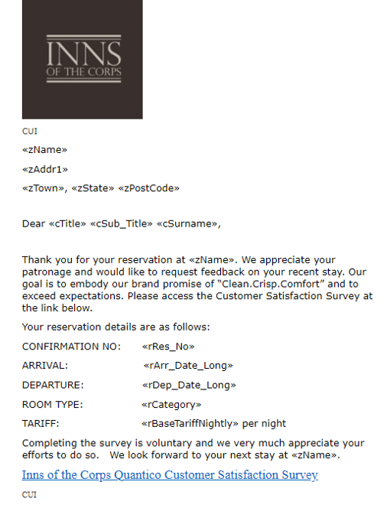
Customer Feedback Email Cover Sheet Sample
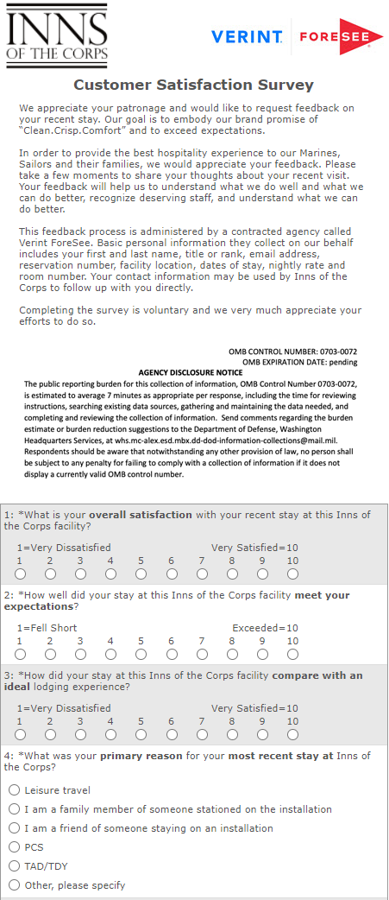
Customer Feedback Questionnaire (slide 1 of 5)
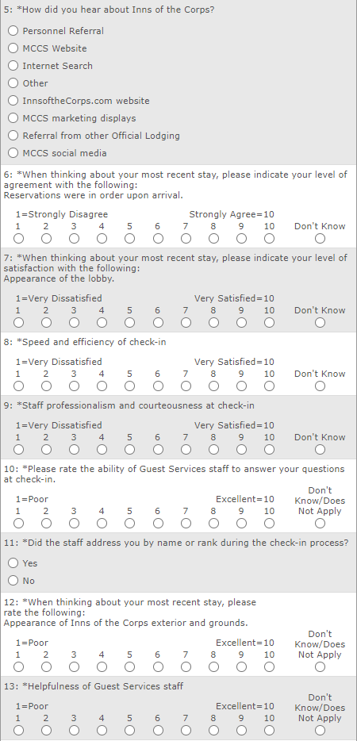
Customer Feedback Questionnaire (slide 2 of 5)
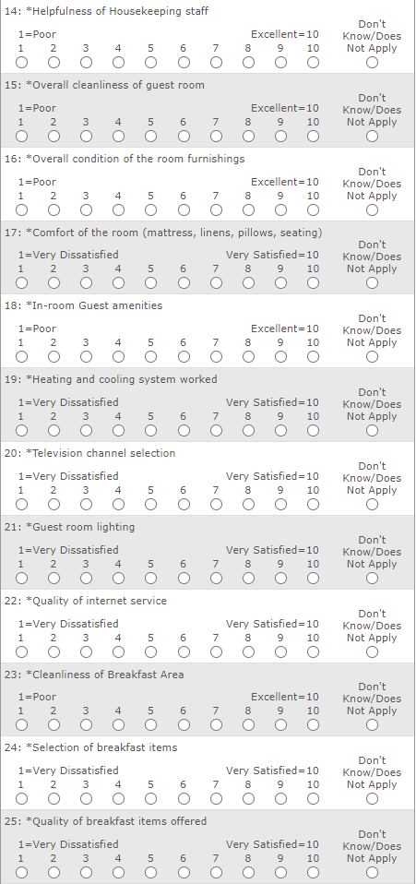
Customer Feedback Questionnaire (slide 3 of 5)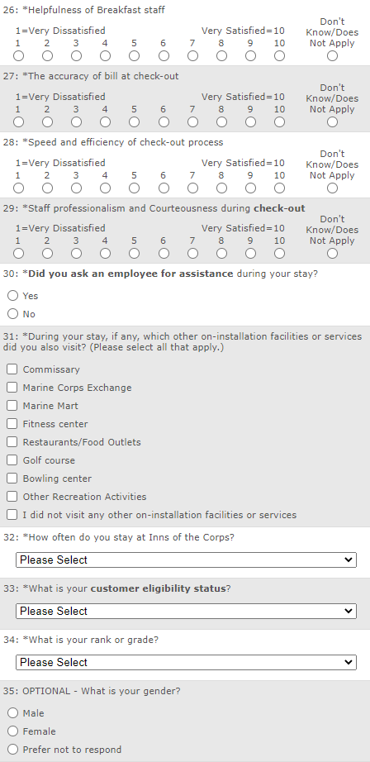
Customer Feedback Questionnaire (slide 4 of 5)
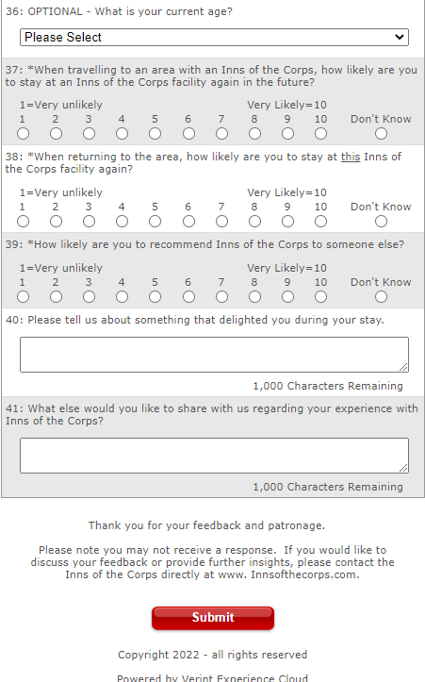
Customer Feedback Questionnaire (slide 5 of 5)

