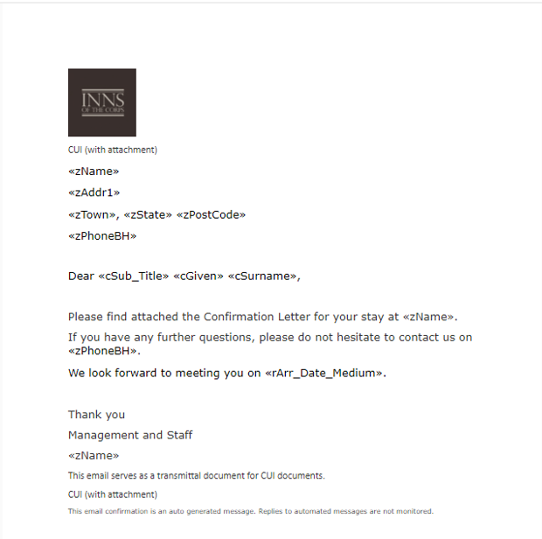
Confirmation Email Cover Sheet Sample

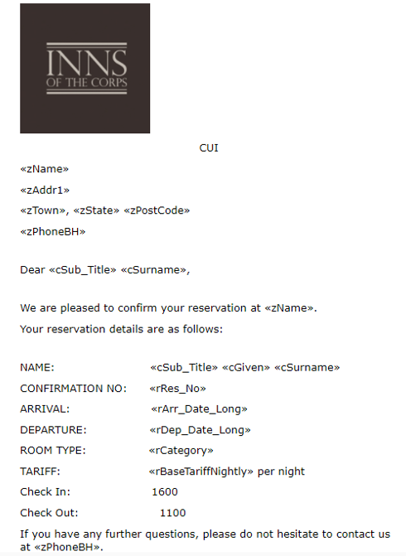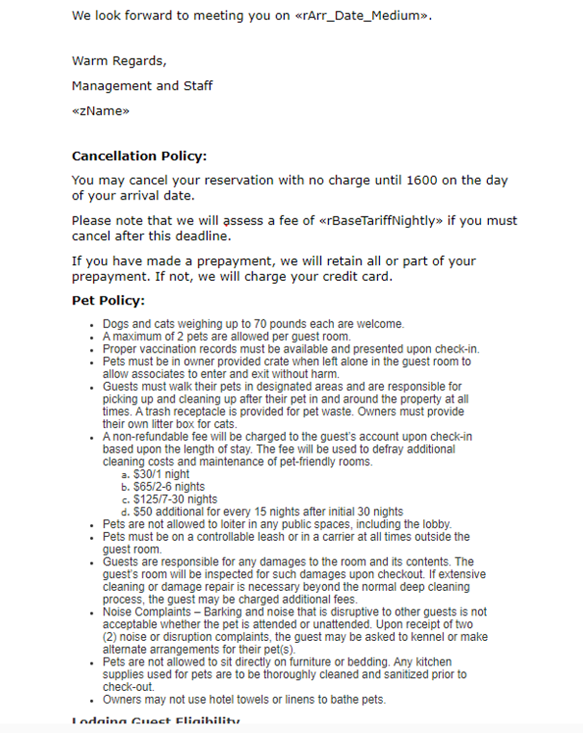
Confirmation Email Sample (screenshot 1 of 4) Confirmation Email Sample (screenshot 2 of 4)
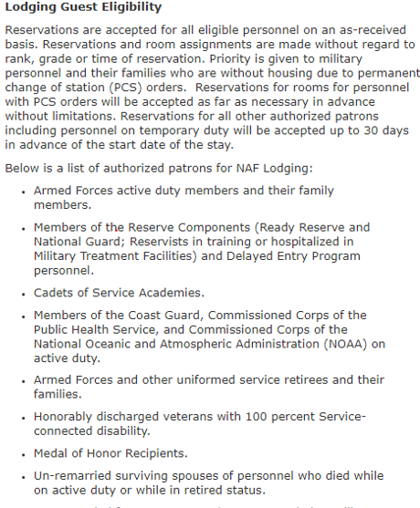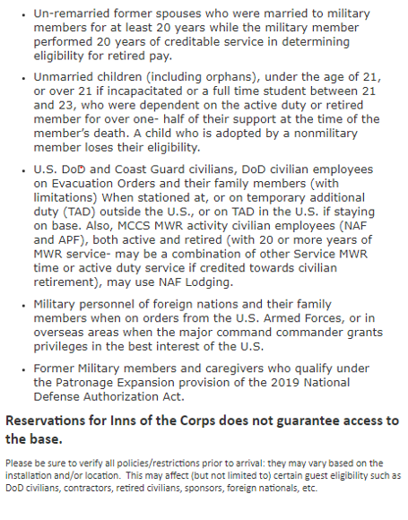
Confirmation Email Sample (screenshot 3 of 4) Confirmation Email Sample (screenshot 4 of 4)
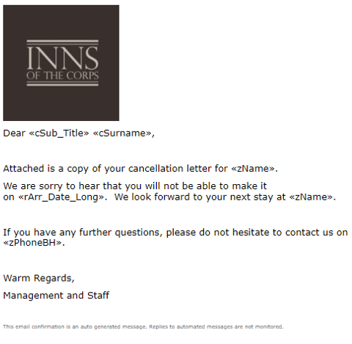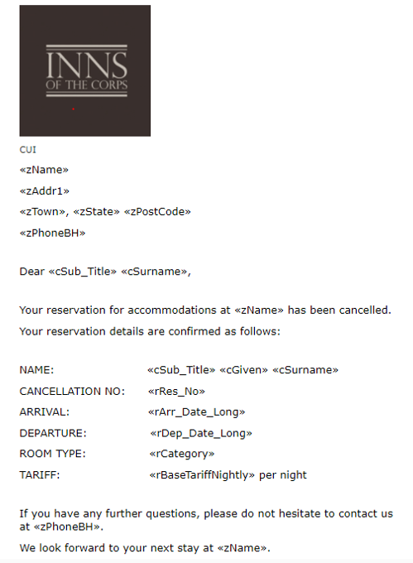
Cancellation Email Cover Sheet Sample Cancellation Email Sample

