Paperwork Reduction Act Statement: According to the Paperwork Reduction Act of 1995, an agency may not conduct or sponsor, and a person is not required to respond to a collection of information unless it displays a valid OMB control number. The valid OMB control number for this information collection is 0910-0360. The time required to complete this information collection is estimated to average 10 minutes per response, including the time for reviewing instructions, searching existing data sources, gathering and maintaining the data needed, and completing and reviewing the collection of information.

Send comments regarding this burden estimate or any other aspects of this collection of information, including suggestions for reducing burden to PRAStaff@fda.hhs.gov.

Food and Drug Administration; Script for Food Industry Customer Satisfaction Survey; Coronavirus Disease 2019 (COVID-19)-Related Materials
For consistency we would like you to begin the phone call with the following:
Hello. My name is XX and I am a Consumer Safety Officer at the Food and Drug Administration located in XX and part of the Human and Animal Food Program.
We are calling you because we are contacting FDA-registered food facilities in geographical areas or communities that are experiencing a rise in COVID-19 cases or are anticipated to do so, and your facility is located in one of these areas. Our purpose is to seek input on whether FDA’s COVID-19 information for the food industry has been useful, to see how food facilities are doing, and to offer our assistance if needed. This call is not pre-announcing any inspections and is not a part of a regulatory inspection. Your participation or nonparticipation is completely voluntary. Your responses do not affect your eligibility for receipt of any FDA services and will not have an effect on future FDA inspections or your facility’s compliance status.
Before I go further, I know you are busy and appreciate your time and cooperation. It should only take 10 minutes. Is this a good time and are you comfortable proceeding? May I have your name and title? (Capture information)
***[If a new time is requested, schedule and thank them.]
***[If concerns are raised about whether this is really a call from FDA]
- If you need to verify my employment you can search the HHS employee directory (https://directory.psc.gov/employee.htm)

Thank you. Let me begin by saying that FDA has been working closely with other federal agencies, including the Centers for Disease Control and Occupational Safety and Health Administration and United States Department of Agriculture, as well as state and local health departments, and others to provide information and technical assistance to food facilities in need, all available on our COVID-19 webpage. We have also established a process by which FDA-regulated human food facilities can request dialogue with FDA on issues related to continuing or restarting food production safely during the pandemic. (If talking to an animal food facility: While this process is for human food facilities, our offer for technical assistance still applies to animal food facilities and you can report into the reporting mechanism linked on the FDA Foods COVID-19 webpage or contact CVM directly at askcvm@fda.hhs.gov.)
In addition, we are tracking the incidence of COVID-19 across the country and identifying areas in which increased COVID-19 spread could impact key segments of the food system. Again, we are calling you because data indicate that your region is already experiencing or is likely to experience an increase in community spread in the coming weeks. Given this, we want to understand what, if any, challenges you are experiencing right now, and ensure that you are aware of the various resources available.
With your permission, I’d like to ask you a few questions to better learn about your facility’s experience with COVID-19 and any experience in using the COVID-19 tools for food facilities on the FDA website.
(Q1) First, have you experienced or are you currently experiencing a reduction or slowdown in your production due to COVID-19?
- If yes: I’m sorry to hear that. [Capture information.] [If needed inquire: Can you describe what has happened in your facility and do you expect this reduction or slowdown in operations will continue?]
Thanks for sharing that information. FDA has developed some resources to help food firms address COVID-19 impacts on their operations.
- If no: It’s helpful to hear that you haven’t experienced any reductions or slowdown in operations due to COVID-19.
[Go to Question 2]

(Q2) Before this call, were you aware that FDA’s website has several COVID-19-related guidances and other tools for the food industry?
    - If yes: Was that information helpful?
[Capture feedback.] Thank you for this feedback. We want to make sure that our materials are as helpful as possible to you, and we will take this feedback into consideration for our future work. Would you like to provide your email address so we can send you more information about FDA COVID-19 resources for the food industry?
If interested in more information: [Capture information.] Thank you for your email address, we will send you that information.
If not interested: Okay. We encourage you to check our website for updates as we plan to continue adding COVID-19 resources for the food industry.
- If no: Would you like to provide your email address so I can send more information about FDA COVID-19 resources?
If interested in more information: [Capture information.] Thank you for your email address, we will send you that information.
If not interested; Should you become interested, you can find the information on the COVID-19 page on FDA’s website.
[Go to Question 3]
(Q3) Before this call, were you aware that FDA-regulated food facilities can request dialogue with FDA on issues related to continuing or restarting safe food production during the pandemic?
- If yes: Was this information helpful? [Capture feedback.] Thank you for this feedback. We want to make sure that the resources we are offering are as helpful as possible. We will take this feedback into consideration as we move forward.
- If no: Information about how to request this dialogue is on the FDA resources list that I mentioned earlier. [If e-mail has not been provided: If you haven’t already provided your email address, I’d be happy to take your email address now, so that we can send you the FDA COVID-19 resource list for food firms.]
- Additional follow-up if facility is experiencing challenges (regardless of yes/no response): Given that you are currently experiencing challenges in your operations, I can also directly link you to one of our technical experts to discuss any issues you are having related to continuing or restarting safe food production. Would you like for me to have one of our technical experts to reach out to you by e-mail? [Capture information.] Thank you for your email address. An FDA technical expert will contact you as requested.
[Go to Question 4]
(Q4) I’d also like to ask about potential supply chain issues during COVID-19. Have you been experiencing challenges with receiving supplies needed to manufacture your food products?
    - If yes: Can you tell me more about that?
[After hearing their feedback: Thank you for making me aware of this issue. We will ensure that this information gets shared with those at FDA that are working to help address raw material supply chain challenges. Would you be comfortable with receiving a follow-up e-mail if needed?]
    - If no: That’s good to hear.
[Go to Question 5]

(Q5) Do you have any questions or comments you would like to provide before we conclude?
    - If yes: [Respond accordingly: Thank you for those comments. I will take those back. Or Let me see about getting you an answer to that question. If not already provided, what is your email address? Then proceed to wrap up]
    - If no: Okay. Thank you. [Proceed to wrap up.]

I want to thank you for taking the time to talk with me today
If you do encounter additional challenges in the future, please consider letting us know through the reporting mechanism I mentioned previously.
Also, I want to emphasize that this call is not pre-announcing any inspections or part of a regulatory inspection. Again, it is part of our efforts to seek input on whether FDA’s COVID-19 information for the food industry has been useful, closely monitor the impact of COVID-19 on the food supply and offer our assistance if needed.
Thank you, and we wish you all the best.

Attachment 1
The attached screenshot of FDA’s Food Industry COVID-19 Resources webpages is provided to facilitate OMB review and is not part of the script that will be read to respondents.
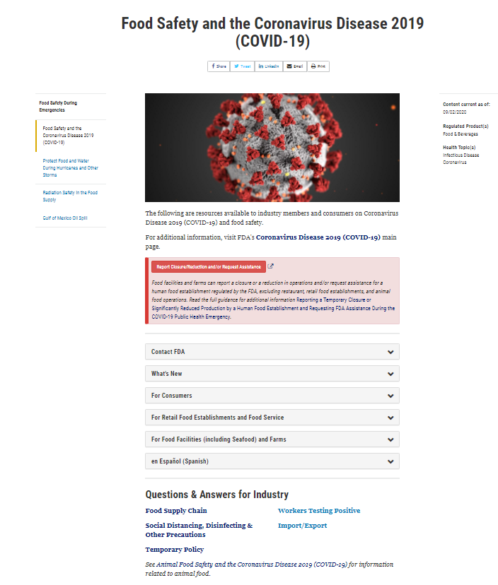
This webpage is available at https://www.fda.gov/food/food-safety-during-emergencies/food-safety-and-coronavirus-disease-2019-covid-19)

