SCREENER

TITLE OF INFORMATION COLLECTION: FDA CTP 2021 Scholastic Vaping Education Materials Survey

Note: The survey respondent will not see any text in blue.

Screening Questions
The purpose of the 2021 Scholastic Vaping Education Materials Survey is to understand educators’ experiences with vaping and other tobacco prevention education materials offered by Scholastic Inc. in partnership with the U.S. Food and Drug Administration (FDA) Center for Tobacco Products (CTP). Vapes are a popular type of tobacco product that contain nicotine. Scholastic’s The Real Cost of Vaping program provides classroom lessons and activities, along with other resources, to help teachers and administrators educate youth in grades 6–12 about the harms of vaping and other tobacco products.

Participation in the 2021 Scholastic Vaping Education Materials Survey is completely voluntary. FDA is offering a $10 electronic gift card for completing the survey. Choosing not to participate in the survey will not affect your ability to access future tobacco prevention resources from FDA.

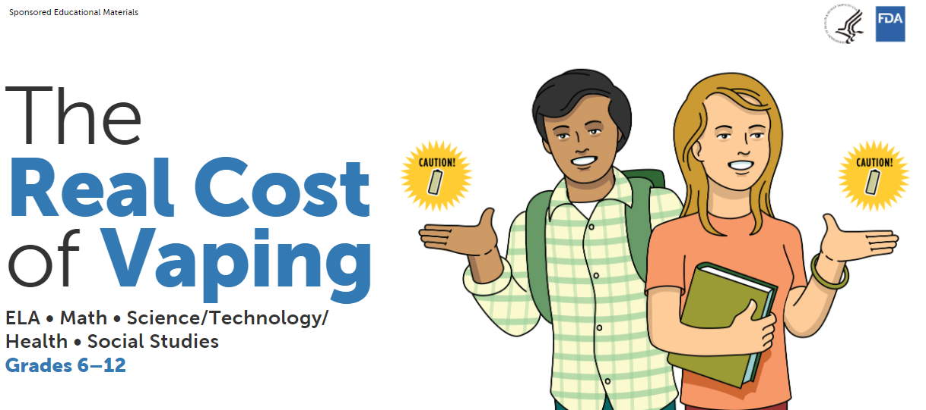

The following survey questions aim to assess potential respondents’ interest in taking the survey and their eligibility to participate.

- Are you willing to take part in this screening questionnaire to assess your eligibility for this survey study?
- Yes
- No [TERMINATE SURVEY; GO TO TERMINATION TEXT 1]

- Are you involved, in any way, in the education of middle school- and/or high school-level students (i.e., grades 6–12) in the United States?
- Yes
- No [TERMINATE SURVEY; GO TO TERMINATION TEXT 2]

- Which grade level or levels did you teach during the 2019/2020 and 2020/2021 school years? [SELECT ALL THAT APPLY] [QUOTA N = 600–800 FROM GRADES 6–8 AND N = 600–800 FROM GRADES 9–12]
- Grade 5 or earlier/younger [TERMINATE SURVEY; GO TO TERMINATION TEXT 2]
- Grade 6
- Grade 7
- Grade 8
- Grade 9
- Grade 10
- Grade 11
- Grade 12
- Higher than grade 12 [TERMINATE SURVEY; GO TO TERMINATION TEXT 2]

- Have you ever used The Real Cost of Vaping materials offered by Scholastic to create, supplement, or enhance your tobacco prevention and education lessons or activities with students? Any level of use of these materials is acceptable. Or, did you help a student(s) enter the “Vaping’s Not My Thing” Challenge PSA contest?

A sample of The Real Cost of Vaping lessons and activities is visually shown below. Visit https://www.scholastic.com/youthvapingrisks/index.html to view more.
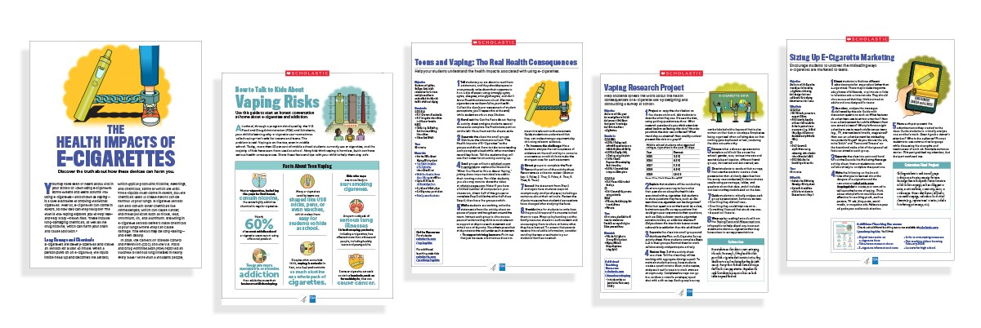
- Yes
- No [TERMINATE SURVEY; GO TO TERMINATION TEXT 2]

[TERMINATION TEXT 1:] You have indicated that you do not want to participate in the 2021 Scholastic Vaping Education Materials Survey and will now exit the survey. If you decide later that you would like to participate, you can use the same email invitation to access the survey. Thank you for your time!

[TERMINATION TEXT 2:] Based on your answer, you do not qualify for this survey. Thank you very much for your time.

Paperwork Reduction Act Statement: An agency may not conduct or sponsor, and a person is not required to respond to, a collection of information unless it displays a currently valid OMB control number. The public reporting burden for this information collection has been estimated to average 1-2 minutes per response to complete the screener (the time estimated to read, review, and complete). Send comments regarding this burden estimate or any other aspects of this information collection, including suggestions for reducing burden, to PRAStaff@fda.hhs.gov.

