# ATTACHMENT 13_E2a: NOTIFICATIONS RELATED TO THE EVALUATION OF THE PUBLIC EDUCATION CAMPAIGN ON TEEN TOBACCO COHORT II (ExPECTT II)

## Interview—Unable to Contact (Not applicable for FU3, which is web-only)

Form Approved

OMB No. 0910-0753

Exp. Date 01/31/2023

[DATE]

Parent First Name Parent Last Name Attention: Youth First Name Youth Last Name OR [age] year old [gender] resident

[STREET ADDRESS]

[CITY], [STATE] [ZIP]

Dear Parent First Name Parent Last Name:

Recently, a Field Interviewer from RTI International came to your home and asked you and your child to take part in the Evaluation of the Public Education Campaign on Teen Tobacco (ExPECTT). Your child could not complete the interview at that time and has been away or was not free each time the interviewer has come back since then. Your help in this study is important—this is why we keep trying to reach you and your child.

A limited number of people were randomly chosen to represent the population of the United States. You and your child cannot be replaced. If you choose not to take part, your experiences and views—as well as the thousands of people you represent—will not be heard.

Your child’s answers to the survey questions are combined with the answers of thousands of other people and reported only as overall numbers. To further protect your privacy, the survey is set up so that your child records most of their own answers—the interviewer never sees or hears them. Also, your child can always refuse to answer any question.

To ensure the accuracy of survey results, we need to interview as many eligible youth as we can. The results of this study will help policy makers and researchers understand media use among today’s youth as well as their attitudes and beliefs about tobacco use.

Your help is critical to the success of this study, and we are happy to work around your schedule so that you and your child can be included. Please feel free to call me to set up an interview time—the interview can also be done at another location such as a public library.

We know that your time is important. To thank you for your time, your child will be given a $20 cash incentive at the end of the interview.

Thank you for your time. I hope you and your child will choose to take part in this very important and useful study.

Sincerely,

[FS NAME], Field Supervisor

P.S. Please, if you have any questions or would like to set up an appointment, call me toll-free at [TOLL-FREE NUMBER].

## Interview—Needs Clarification (Not applicable for FU3, which is web-only)

Form Approved

OMB No. 0910-0753

Exp. Date 01/31/2023

[DATE]

Parent First Name Parent Last Name Attention: Youth First Name Youth Last Name OR [age] year old [gender] resident [STREET ADDRESS]

[CITY], [STATE] [ZIPCODE]

Dear Resident,

Recently, a Field Interviewer from RTI International came to your home and asked you to take part in a research study for the U.S. Food and Drug Administration (FDA) Center for Tobacco Products. At the time, you had some concerns about the study.

A limited number of households were randomly chosen to represent the population of the United States. You and your child cannot be replaced. If you choose not to take part, your experiences and views—as well as the thousands of people your household represents—will not be heard.

Your child’s answers to the survey questions are combined with the answers of thousands of other youth and reported only as overall numbers. To further protect their privacy, the survey is set up so that your child enters most of their own answers into a laptop computer—the interviewer never sees or hears them. Also, your child can always refuse to answer any question.

The results of this study help policy makers and researchers understand youth awareness of and exposure to campaign ads—including their knowledge, attitudes, and beliefs about tobacco use—so that informed decisions about policies and programs can be made. By taking part in this study, you and your child will make a direct impact on important tobacco-related education activities.

Your help is critical to the success of this study, and we are happy to work around your schedule so that you can be included.

We know that you and your child’s time is important. To thank you for your time, your child will be given a $20 cash incentive at the end of the interview.

Thank you for your time. I hope you’ll reconsider and choose to take part in this very important and useful study.

Sincerely,

[FS NAME], Field Supervisor

P.S. Please, if you have any questions or would like to set up an appointment, call me toll-free at [TOLL-FREE NUMBER].

## Interview —"Nothing in it for me"/Uncooperative (Not applicable for FU3, which is web-only)

Form Approved

OMB No. 0910-0753

Exp. Date 01/31/2023

[DATE]

Parent First Name Parent Last Name Attention: Youth First Name Youth Last Name OR [age] year old [gender] resident [STREET ADDRESS]

[CITY], [STATE] [ZIPCODE]

Dear Resident,

Recently, a Field Interviewer from RTI International came to your home and asked you and your child to take part in the Evaluation of the Public Education Campaign on Teen Tobacco (ExPECTT). At the time, you did not want to participate. We are writing this letter to ask you to reconsider.

The results of this study will help policy makers and researchers understand youth awareness of and exposure to campaign ads—including their knowledge, attitudes, and beliefs about tobacco use—so that informed decisions about policies and programs can be made. By taking part in this study, you and your child will make a direct impact on important tobacco-related education activities.

A limited number of households were randomly chosen to represent the population of the United States—and yours was one of them! You cannot be replaced. If you choose not to take part, your experiences and views—as well as the thousands of people your household represents—will not be heard.

We know that your time is important. To thank you for your time, your child will be given a $20 cash incentive at the end of their interview.

Thank you for your time. I hope you’ll reconsider and choose to take part in this very important and useful study.

Sincerely,

[FS NAME], Field Supervisor

P.S. Please, if you have any questions, call me toll-free at [TOLL-FREE NUMBER].

## Interview—Too Busy/No Time (Not applicable for FU3, which is web-only)

Form Approved

OMB No. 0910-0753

Exp. Date 01/31/2023

[DATE]

Parent First Name Parent Last Name Attention: Youth First Name Youth Last Name OR [age] year old [gender] resident

[STREET ADDRESS] resident

[CITY], [STATE] [ZIPCODE]

Dear Resident:

Recently, a Field Interviewer from RTI International came to your home and asked you and your child to take part in the Evaluation of the Public Education Campaign on Teen Tobacco (ExPECTT). At the time, you were reluctant to let your child spend the time needed to do the interview.

A limited number of youth were randomly chosen to represent the population of the United States. Your child cannot be replaced. If your child chooses not to take part, their experiences and views—as well as the thousands of people they represent—will not be heard.

As you know, this country is made up of all kinds of people, and so we are interviewing all kinds of people—including busy people like you and your child. If we only interviewed people who have a lot of free time, then active people like you would not be fairly represented. You and your child’s participation is critical to the success of this study, and we are happy to work around your schedule so that they can be included.

We know that your time is important. To thank you for your time, your child will be given a $20 cash incentive at the end of the interview.

We combine your child’s answers with the answers of thousands of other youth and report them only as overall numbers. The survey is set up so that your child records most of his or her own answers—the interviewer never sees or hears them. Also, your child can always refuse to answer any question.

The results of this study will help policy makers and researchers understand media use among today’s youth as well as their attitudes and beliefs about tobacco use. By taking part in this study, you and your child will make a direct impact on important education activities to reduce tobacco use.

Thank you for your time. I hope you’ll reconsider and choose to take part in this very important study.

Sincerely,

[FS NAME], Field Supervisor

P.S. Please, if you have any questions or would like to set up an appointment, call me toll-free at [TOLL-FREE NUMBER].

## Youth Interview Incentive Receipt Form (Not applicable for FU3, which is web-only)

**Evaluation of the Public Education Campaign on Teen Tobacco (ExPECTT)**

RTI International • P.O. Box 12194 • Research Triangle Park, North Carolina 27709-2194 USA

**YOUTH INTERVIEW INCENTIVE RECEIPT FORM**

Thank you for taking part in an interview as part of a research study being carried out by RTI International for the U.S. Food and Drug Administration’s Center for Tobacco Products. To thank you for your time, we are offering you a $20 cash incentive.

___________________________________ _________ __ __ __ __ __ __ __ __ Interviewer Date Case ID

□ Accepted Cash Incentive □ Declined Cash Incentive

## Mail Back Survey Verification (Not applicable for FU3, which is web-only)

Disposition: Send original to supervisor; retain yellow copy; pink copy to respondent.

|  |  |
| --- | --- |
|  |  |

Form Approved

OMB No. 0910-0753

Exp. Date 01/31/2023

RESIDENT [DATE]

[ADDRESS]

RTI International has been conducting a nationwide survey for the U.S. Food and Drug Administration on tobacco and media use among youth. Our records show that a [AGE] year old [GENDER] in your household was interviewed. We would appreciate it if [HE/SHE] would take some time to answer a few questions about [HIS/HER] experience.

This information is only used to check the quality of our interviewer’s performance.

1. **Were you/your child interviewed in-person or over the telephone?**

In-person ___ Over the telephone___

2. **Did the interviewer provide you/your child with a laptop computer for you to enter some of your answers?**

Yes___

No___ Please explain:___________________________________________

3. **Did you/your child complete a computer practice session that showed you how to enter your answers in the computer?**

Yes___ No___

4. **Were you/your child paid for your participation?**

Yes___ No___

If yes, how much were you paid? $_____

5. **Was the interviewer professional and polite?**

Yes___

No___ Please describe how our interviewer could improve his/her behavior:

_________________________________________________________________________

_________________________________________________________________________

A stamped, pre-addressed envelope is included for you to return this form. Thank you for your help.

Sincerely,

National Field Director, RTI

## Controlled Access Letter (Not applicable for FU3, which is web-only)

Form Approved

OMB No. 0910-0753

Exp. Date 01/31/2023

[DATE]

[NAME], [TITLE]

[COMPLEX/COMMUNITY NAME]

[ADDRESS]

[CITY], [STATE] [ZIP]

Dear [MR./MS.] [NAME]:

Recently, one of our field interviewers, [FIRST & LAST NAMES], tried to contact specific residences within [COMPLEX/COMMUNITY NAME] that were randomly chosen to participate in a national study conducted by RTI International for the U.S. Food and Drug Administration. So far, [MR./MS.] [LAST NAME] has been unable to [GAIN ACCESS/GAIN FULL ACCESS] to [NAME OF COMPLEX/COMMUNITY], and we are asking for your help.

We understand your responsibility to protect your residents and want to provide you with more information about the study:

* We are not selling anything. This is not a marketing survey.
* The **Evaluation of the Public Education Campaign on Teen Tobacco** (ExPECTT) provides valuable information about important health-related issues, including experiences with and opinions about media awareness and tobacco use among youth.
* A limited number of household addresses were randomly chosen to take part. We do not have any information about the residents other than an address.
* The RTI interviewer only needs a few minutes of the residents’ time to see if someone in the household will be asked to participate in an interview. If selected, those completing the interview receive a cash incentive.
* All information provided is kept private to the fullest extent allowed by law.

By helping our interviewer access the selected households in [NAME OF COMPLEX/COMMUNITY], you will make a direct contribution to this important research effort. [FIRST & LAST NAMES], our supervisor in your area, will contact you soon to address any questions, or you may call [HIM/HER] toll-free at [**TOLL FREE NUMBER**].

Your assistance is very important to the success of this study, and I thank you in advance for your help.

Sincerely,

National Field Director, RTI

## Sorry I Missed You Card (Not applicable for FU3, which is web-only)

**Sorry I Missed You**

**Dear Resident: I am sorry that I did not find you at home. I will call you in the next few days to reschedule our appointment. Thank you in advance for your participation.**

**Sincerely*, _____________________________________________***

**Date: __________________________ Time: ______________**



Incentive Check and Thank You Letter, for Follow Up 1 only

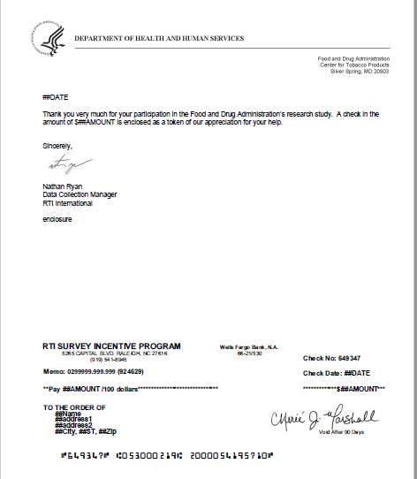

Thank You Email to Accompany Digital Gift Card Incentive for Follow Up 3

Subject line: How to redeem your incentive for research participation

Hello,

Thank you very much for [YOUTH FNAME] [YOUTH LNAME]’s participation in the Food and Drug Administration’s research study.

To redeem your incentive, please complete the instructions below:

Here is the link to your $XX digital gift card.

[INSERT PERSONALIZED LINK HERE AND ANY ADDITIONAL INSTRUCTIONS SPECIFIC TO THE SELECTED DIGITAL CARD]

Please redeem your prepaid card on or before DATE. After you have redeemed your card, you will have 12 months to spend the funds on your card before they expire.

Thank You,

Nathan Ryan

Data Collection Manager

RTI International

Appointment reminder card (Not applicable for FU3, which is web-only)

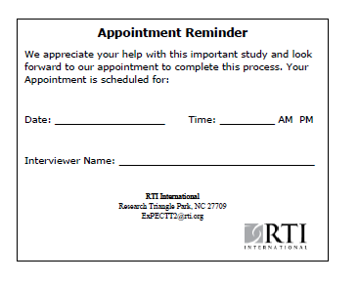

Spanish card (Not applicable for FU3, which his web-only)

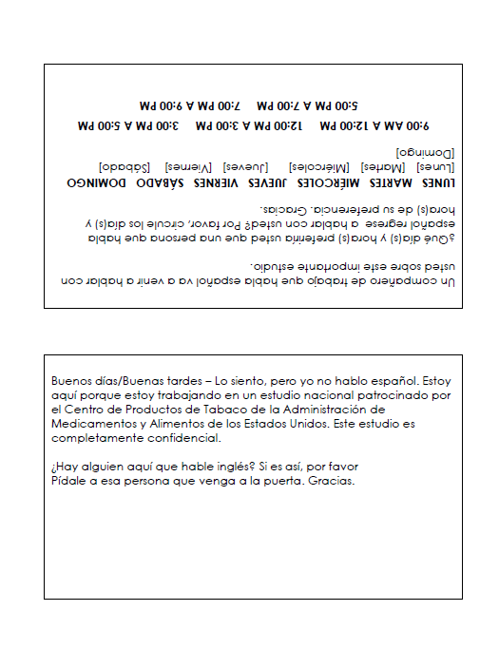

Post card 1

|  |  |
| --- | --- |
| RTI International  ATTN: Data Capture  (0215534.001.001.004.005.001)  5265 Capital Blvd.  Raleigh, NC 27616  ADDRESS SERVICE REQUESTED  [Parent_FName] [Parent_LName]  [Address1], [Address2]  <CITY>, <STATE> <ZIP>    <caseid> |  |
|  |
|  |

Dear [Parent_FName] [Parent_LName],

Recently, I mailed you a letter asking your child [Child First Name] to complete an online questionnaire to for the next round of the Evaluation of the Public Education Campaign on Teen Tobacco (ExPECTT), an important study sponsored by the U.S. Food and Drug Administration.

If your child already completed the online questionnaire, please accept my sincere thanks. If not, we hope they will please do so today.

They will receive $25 if they complete the questionnaire online and a bonus $5 ($30 total) if they do so on or before [ADD DATE].

If you have any questions, please call us at 1-800-608-2955 between 9 am and 5 pm, Eastern Time, Monday through Friday or email us at expectt2@rti.org.

Many thanks,

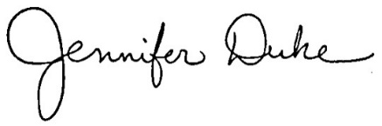

Dr. Jennifer Duke, ExPECTT Study Director, RTI International

|  |  |
| --- | --- |
| 1. **In your web browser type the study website address:** https://expectt.rti.org 2. **On the login screen, type the username and password exactly as shown below:**   **Username: [Case ID]**  **Password: [Password]**  IMPORTANT: This Username and Password is unique to the specific child, **[Child’s first name]**, and cannot be used for other children in the household.   1. Once you’ve typed in your username and password, you will see instructions for completing this round of the study. If your child is not yet [IF NE OR AL FILL 19/ALL OTHER STATES FILL 18] years old, a parent or legal guardian must follow the steps to provide permission for her or him to complete the survey. If your child is [IF NE OR AL FILL 19/ALL OTHER STATES FILL 18] years old, parental permission is not required. Your child can enter the username and password and begin**.**   Your child will receive $25 if they complete the questionnaire online and a bonus $5 ($30 total) if they do so on or before [ADD DATE]. This incentive will be provided via email as a digital gift card. |  |
|  |
|  |

0

Post card 2

|  |  |
| --- | --- |
| RTI International  ATTN: Data Capture  (0215534.001.001.004.005.001)  5265 Capital Blvd.  Raleigh, NC 27616  ADDRESS SERVICE REQUESTED  [Parent_FName] [Parent_LName]  [Address1], [Address2]  <CITY>, <STATE> <ZIP>    <caseid> |  |
|  |
|  |

Dear [Parent_FName] [Parent_LName],

A few weeks ago, I mailed you a letter asking your child [Child First Name] to complete an online questionnaire to for the next round of the Evaluation of the Public Education Campaign on Teen Tobacco (ExPECTT), an important study sponsored by the U.S. Food and Drug Administration.

If your child already completed the online questionnaire, please accept my sincere thanks. If not, we hope they will please do so today.

They will receive $25 if they complete the questionnaire online [FILL IF BEFORE EARLY BIRD END DATE: and a bonus $5 ($30 total) if they do so on or before [ADD DATE]].

If you have any questions, please call us at 1-800-608-2955 between 9 am and 5 pm, Eastern Time, Monday through Friday or email us at expectt2@rti.org.

Sincerely,



Dr. Jennifer Duke, ExPECTT Study Director, RTI International

|  |  |
| --- | --- |
| 1. **In your web browser type the study website address:** https://expectt.rti.org 2. **On the login screen, type the username and password exactly as shown below:**   **Username: [Case ID]**  **Password: [Password]**  IMPORTANT: This Username and Password is unique to the specific child, **[Child’s first name]**, and cannot be used for other children in the household.   1. Once you’ve typed in your username and password, you will see instructions for completing this round of the study. If your child is not yet [IF NE OR AL FILL 19/ALL OTHER STATES FILL 18] years old, a parent or legal guardian must follow the steps to provide permission for her or him to complete the survey. If your child is [IF NE OR AL FILL 19/ALL OTHER STATES FILL 18] years old, parental permission is not required. Your child can enter the username and password and begin**.**   Your child will receive $25 if they complete the questionnaire online and a bonus $5 ($30 total) if they do so on or before [ADD DATE]. This incentive will be provided via email as a digital gift card. |  |
|  |
|  |