## Sample Study Invitation Email

The sample email will be modified using the information provided below.

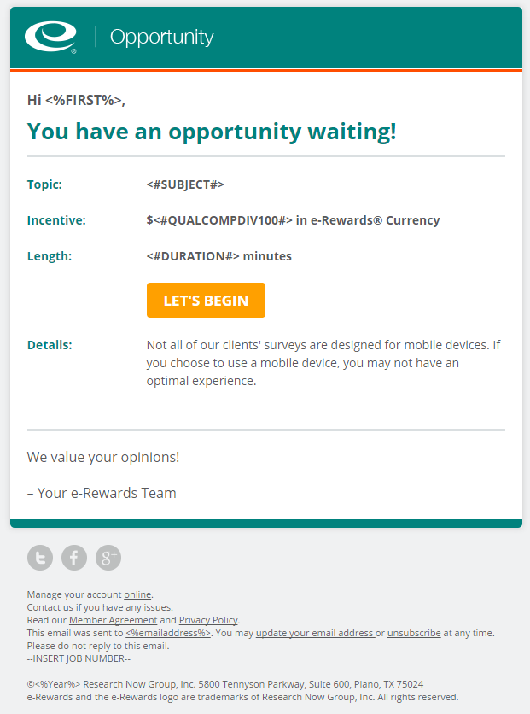

Topic: Prescription Drug information

Incentive: [*approximately $5 in e-Rewards currency*]

Length: 20 minutes

Details: This survey is **not** designed for use by mobile devices.