Attachment 8. MIDRS Template

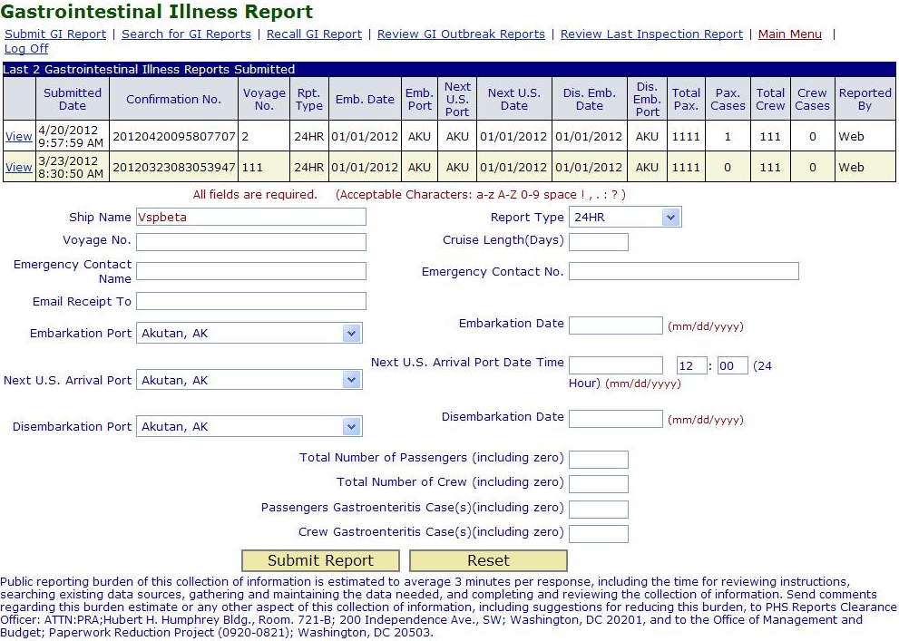

***Note that once the information collection is approved by OMB, the program will include the correct OMB text box and burden statement shown below within MIDRS:
Form approved
OMB No: 0920-XXXX
Expiration Date: XX/XX/XXXX
CDC estimates the average public reporting burden for this collection of information as 3 minutes per response, including the time for reviewing instructions, searching existing data/information sources, gathering and maintaining the data/information needed, and completing and reviewing the collection of information. An agency may not conduct or sponsor, and a person is not required to respond to a collection of information unless it displays a currently valid OMB control number. Send comments regarding this burden estimate or any other aspect of this collection of information, including suggestions for reducing this burden, to: CDC/ATSDR Information Collection Review Office, 1600 Clifton Road NE, MS D-74, Atlanta, Georgia 30333; ATTN: PRA (0920-XXXX)

