CDC estimates the average reporting burden for this collection of information as 8,760 hours (12 months) per response, including the time for reviewing instructions, searching existing data/information sources, gathering and maintaining the data/information needed, and completing and reviewing the collection of information. An agency may not conduct or sponsor, and a person is not required to respond to a collection of information unless it displays a currently valid OMB Control Number. Send comments regarding this burden estimate or any other aspect of this collection of information, including suggestions for reducing this burden to CDC/ATSDR Information Collection Review Office, 1600 Clifton Road, NE, MS D-74, Atlanta, Georgia 30333; ATTN: PRA (0920-1260).
Form Approved
OMB No. 0920-1260
Exp. Date 04/30/2022
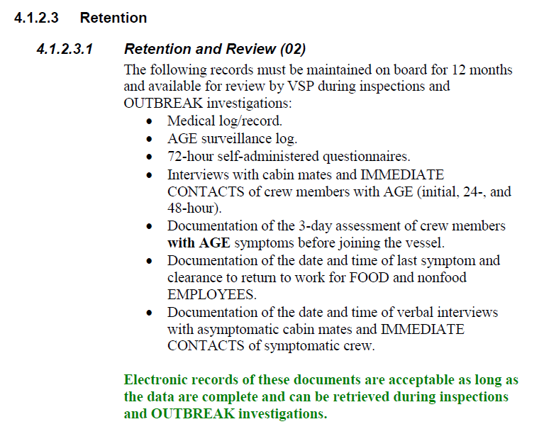
Source: Vessel Sanitation Program 2018 Operations Manual

