Attachment 5 – Sick Food Worker Toolkit
Having a plan to keep sick workers home is key to preventing the spread of foodborne illness.
Develop a plan
To Manage Sick Workers

Eventually, every restaurant has a sick employee.
How management handles the situation can make the difference in whether other workers and customers get sick too.
Having a plan for handling sick workers is key to preventing the spread of foodborne illness.
- More than 250 diseases can be transmitted through food [1].
- Restaurants can lose customers, profits, and reputation as a result of illness spread by sick workers.
- Restaurant managers or owners must make sure workers do not come to work sick and spread their illness by contaminating food, utensils, or surfaces in the restaurant.
This guide provides the tools to help you make a plan to keep sick workers home instead of spreading their germs around the restaurant. It contains examples of policies and resources that can be implemented in the restaurant. The guide may not address all requirements of your local jurisdiction. Work with your local health department to make sure that you comply with your local requirements.

Table of Contents
How to Create or Improve Your Sick Worker Plan 2
Step 1: Use Our Checklist to Identify Gaps in Your Plan 3
Step 2: Improve or Create Your Plan with Our Sample Language 3
Step 3: Train Employees on Sick Worker Plan 9
Step 4: Enforce Your Plan Even When Inconvenient 11
Want to Learn More? 12
Appendix 1: Employee Health Reporting Agreement 13
Appendix 2: Example Employee Symptom Reporting Posters 14
Appendix 3: Example Employee Illness Reporting Log 16
Appendix 4: Example Employee Health Decision Guide 17
Appendix 5: Example Employee Handwashing Posters 18
Appendix 6: Norovirus Clean Up Poster 20
Appendix 7: 3 Things Restaurant Managers Need To Know About Talking to Sick Workers 21

How to Create or Improve Your Sick Worker Plan
An important line of defense to keeping your staff and guests healthy is developing and enforcing a sick worker plan. This guide provides tools to help you plan for keeping sick workers out of the restaurant.
Infected food workers cause 70% of norovirus outbreaks in restaurants [2].
A sick worker plan (also called an employee health policy) explains expectations for a restaurant and responsibilities of employees and management in preventing the spread of illness from a sick worker to co-workers or restaurant patrons.

Use our checklist to identify gaps in your plan.
An effective sick worker plan will address training and symptom reporting and outline responsibilities of managers and employees.

Use our sample language to improve or create your plan.
Sample language that aligns with [insert language about the food code followed by your jurisdiction] is provided below for each section of your sick worker plan. You can use this language to create or update your policies.

Train employees on the sick worker plan.
Print posters, a reporting log, and enough agreements for all employees. You can use or adapt the talking points in this guide when you talk to your workers about the plan.

Enforce your plan even when inconvenient.
Follow your plan to reduce your restaurant’s risk of an outbreak. Having a plan in place for when an employee calls out sick can help you control a stressful situation and prevent the spread of illness to both workers and customers.

Step 1: Use Our Checklist to Identify Gaps in Your Plan
and

Step 2: Improve or Create Your Plan with Our Sample Language
Use this checklist to review your current employee health policies and procedures. Check the box next to each item that is covered by your current plan. If an item is not covered, use the sample language provided or consult with your local health department to revise your plan so it addresses all necessary items.
Note: If your restaurant primarily serves a highly susceptible population (for example, young children, the elderly, immunocompromised), check with your local health department to determine the minimum standards that apply to food establishments serving those populations (for example, a long-term care facility, daycare center, or hospital).
 | Does Your Plan Cover… | Sample Language for Your Plan—Ensure Your Plan Meets Requirements in Your Jurisdiction
 | Who the plan applies to | This plan applies to all restaurant employees, including front of house, back of house, and management staff.
 | Reporting of employee illnesses to managers/owners  See Appendix 1: Employee Health Reporting Agreement and Appendix 2: Example Employee Symptom Reporting Posters | Employees with any of the symptoms below must immediately tell the manager:  - Vomiting  - Diarrhea  - Sore throat with fever  - Jaundice (yellowing of the skin and eyes)  - Open, infected cuts or sores on hands or wrists  - A foodborne illness diagnosed by a doctor  If there is any doubt about whether you have any of the symptoms listed above, notify your manager.  If you have been diagnosed with any infectious or communicable illness that can be transmitted through food, you must immediately tell your manager. Examples of these diseases include but are not limited to the following:  - Norovirus  - Hepatitis A  - Salmonella  - Shiga-toxin producing E. coli  - Shigella  Notify your manager if you have been exposed to any of these symptoms and/or illnesses from a household member. Also notify your manager if you have close contact with someone who has any of these illnesses or has been diagnosed with any of them.  We encourage you to also tell your manager when someone in your household has diarrhea, vomiting, jaundice, or sore throat with fever.
 | Documentation of illness for each employee who reports an illness  See Appendix 3: Example Employee Illness Reporting Log and Appendix 4: Example Employee Health Decision Guide | Employees will report their illness, or exposure to anyone in their household who is sick, to the manager before their shift, preferably over the phone. The manager will add the information to the Employee Illness Reporting Log.
 | When to exclude food workers from the restaurant or from working with food or utensils that may contact food  See Appendix 3: Example Employee Illness Reporting Log | Employees with reportable symptoms must not work in any restaurant until they have been cleared by methods specified in the [insert language about the food code followed by your jurisdiction].  The illness and when the employee returned to work will be recorded on the Employee Illness Reporting Log and any medical letters will be added to the employee’s personnel file.
 | Updating the reporting log for each employee who calls in or reports being sick  See Appendix 3: Example Employee Illness Reporting Log | The manager will talk to the sick employee and fill out the Employee Illness Reporting Log.
 | When and who needs to be notified if an employee reports an illness (for example, restaurant owner, local health department, etc.) | If an employee has a symptom of jaundice or is diagnosed with a reportable illness, the manager must contact the [insert language about the regulatory authority for your jurisdiction] with the relevant information. Notification limits the potential spread of illness.
 | When an employee who was sick can return to work | If an employee is diagnosed with an illness by a doctor, they may only return to work after they have been cleared by methods specified in the [insert language about the food code followed by your jurisdiction].  If they didn’t get a medical diagnosis but had the symptoms listed above, they can only be cleared to return to work if they meet the following conditions (as applicable):  - They are free of all symptoms listed above for a minimum of [insert language appropriate to your jurisdiction] without the aid of medication.  - They have been medically cleared.  - Their exposed wound or lesion can be safely covered with two barriers (e.g., a bandage and a disposable glove.)
 | Provisions to address financial and social pressures on workers (e.g., sick pay, makeup shifts, cross-training, on-call roster, etc.) | Sick Pay  It is the policy of this restaurant to provide [RESTAURANT: insert number of days] number of days per year of sick leave to encourage employees to remain at home and not feel that they need to work while ill. This will help to prevent spreading illness to customers and among the staff of the restaurant.  Makeup Shifts  If employees miss shifts due to illness, it is the policy of this restaurant to provide the employee the opportunity to work additional shifts to make up the lost income from the missed shifts.  Cross-Training  To ensure the smooth operation of this restaurant, employees will be cross-trained to perform the job duties of other employees. This will allow employees to assist one another in the event the restaurant is short-staffed due to an employee being sick.  Voluntary On-Call Roster  To minimize disruptions, the manager will maintain a voluntary on-call roster of employees who are willing be contacted on short notice to cover a shift. The manager will use this list to bring in additional staff to cover a shift for a sick worker.
 | Additional practices that minimize spread of illness  See Appendix 5: Example Handwashing Posters | Because some infected individuals may spread germs without showing any signs of illness, it is important that all food workers follow good hygienic practices at all times. These practices include proper and frequent handwashing, such as  - After touching bare human body parts other than clean hands and clean exposed portions of arms  - After using the bathroom/restroom  - After coughing, sneezing, using a handkerchief or disposable tissue, using tobacco, eating, or drinking  - After handling soiled equipment or utensils  - During food preparation (as often as necessary to remove soil and contamination and to prevent cross-contamination)  - When changing tasks  - When switching between working with raw food and working with ready-to-eat food  - Before putting on gloves to begin a task that involves working with food  - After engaging in other activities that contaminate the hands  - After caring for or handling service animals or aquatic animals  In addition to proper and frequent handwashing, this restaurant’s policy is not to have bare hand contact with ready-to-eat foods. We also strive to minimize bare hand contact with raw foods. You can avoid bare hand contact by using the utensils provided, deli paper, or single use gloves as a barrier. Proper use of barriers is covered during employee orientation.
 | Proper cleanup procedures for vomit and diarrhea  See Appendix 6: Norovirus Clean Up Poster | If a guest or employee vomits or has diarrhea in the restaurant, the contaminated area must be cleaned immediately. A cleanup kit and procedures for cleaning such spills are located near the restaurant cleaning supplies.
 | Training managers and supervisors on the plan and how to implement it | The general manager will review the plan and how it is intended to be implemented with all managers and supervisors on an annual basis. This is to ensure that the plan is being consistently implemented with all employees.
 | Training new employees on the plan  See Appendix 1: Employee Health Reporting Agreement | The manager will train all new employees on this plan. After training, employees will complete and sign an Employee Health Reporting Agreement.
 | Providing periodic refresher trainings for existing employees  See Appendix 1: Employee Health Reporting Agreement | All existing employees will complete an annual refresher training and sign a new Employee Health Reporting Agreement after the training.
 | Making a copy of the plan available to managers and employees | A hard copy of the sick worker plan will be available [RESTAURANT: specify where plan will be kept or posted].
 | Maintaining copies of employee reporting agreements  See Appendix 1: Employee Health Reporting Agreement | The manager will provide a copy of the Employee Health Reporting Agreement to each employee. The original will be stored in the employee’s personnel file.
 | Employees responsibilities | Employees are responsible for adhering to these policies. This includes  - Reporting symptoms of illness, diagnosis of an illness, or potential exposure to an illness.  - Waiting to return to work until they are symptom-free for [insert language appropriate to your jurisdiction].  - Preparing and handling food in a safe and sanitary manner even when they are feeling well.
 | Management responsibilities  See Appendix 3: Employee Illness Reporting Log and Appendix 4: Employee Health Decision Guide | Management is responsible for  - Ensuring that employees are trained on these policies.  - Talking to employees about their illness, diagnosis, or potential exposure and following the appropriate action based on the decision trees.  - Filling out and maintaining the Employee Illness Reporting Log.  - Talking with employees after an illness to ensure they have been free of symptoms for [insert language appropriate to your jurisdiction] before returning to work.  - Monitoring employees and talking to employees who may have not reported illness but who are showing signs of illness.  - Ensuring hand sinks are functional, stocked with supplies, and accessible.  - Ensuring sufficient supplies are provided to prevent bare hand contact with ready-to-eat foods (foods that will not need to be cooked further to be eaten).

Step 3: Train Employees on Sick Worker Plan

Before training, print the following materials to cover with staff:
- Employee Health Reporting Agreements (Appendix 1)
- Employee Symptom Reporting Posters (Appendix 2)
- Employee Illness Reporting Log (Appendix 3)
1 in 5 food service workers reported working while sick with vomiting and diarrhea [3].
- Employee Health Decision Guide (Appendix 4)
- Employee Handwashing Posters (Appendix 5)
- Norovirus Clean Up Poster (Appendix 6)

During training, highlight the following points to staff:

Why These Efforts Are Important: Real-Life Examples
- Testimonial videos showing real life consequences of not following good food safety procedures:
  - https://www.fda.gov/food/retail-food-industryregulatory-assistance-training/educational-videos-retail-food-employees
- Case Study:
  - It is a nice sunny July day, and Cook A is feeling sick. He is vomiting and running to the bathroom with diarrhea. He calls his restaurant manager to tell him that he is sick and won’t be able to come in to cover his shift. The manager tells him he has to come in and work. No one else can cover his shift, and it’s their busy season with the upcoming 4th of July holiday.
  - Cook A comes to work. He is pale, has a slight temperature, and is still running to the bathroom with vomiting and diarrhea. The manager sees this, tells him to buck up and wash his hands more often. The manager heads home.
  - Ultimately, at least 43 people contracted norovirus from this one episode—the actual number was likely higher because the restaurant primarily served tourists. Five people required medical transport to the hospital for care. In this incident, both the general and kitchen managers lost their jobs; the restaurant was liable for the illness they caused; and, with local media reporting on the incident, the restaurant suffered a loss of its reputation and a significant decrease in business for the rest of the summer.

Why it’s important to stay home when sick
- More than 250 diseases can be transmitted through food.
- Infected food workers are the source of contamination for 70% of norovirus outbreaks caused by contaminated food.
- People can still spread foodborne illness germs for a time even after their symptoms have resolved.

Ways of transmitting foodborne illnesses as food workers
- Many foodborne germs are spread by poop getting into the food. When someone is ill with diarrhea, feces is likely to get on their hands after wiping and this can make its way into the food.
- When someone is ill with norovirus, they can release billions of norovirus particles and it only takes a few virus particles to make other people sick.
- Someone can shed harmful germs without having symptoms, and someone who was sick can shed germs for days after their symptoms resolve.

Review of employee illness plan
- Types of symptoms to report
- How the restaurant addresses sick workers (for example, sick pay, makeup shifts, etc.)
- How to follow the new plan being implemented in the restaurant
  - Manager responsibilities – Employee Health Reporting Log and Employee Health Decision Guide
  - Employee responsibilities – Reporting an illness, when to return to work, preparing and handling food in a safe and sanitary manner.
- Employees read and sign Employee Health Reporting Agreements

Review good hand hygiene practices that minimize the spread of germs
- Proper and frequent handwashing technique and timing—especially after using the restroom or changing tasks
- No bare hand contact with ready-to-eat foods
  - Eliminating bare hand contact with foods like lettuce, tomatoes, deli meats, and cooked meats reduces the potential for contamination by a food worker.
  - Barriers, such as gloves, utensils, or deli paper, should be used between the employee’s hands and the food.
  - Single use gloves should be changed at the times outlined in [insert language appropriate to your jurisdiction].

Review the plan for properly cleaning up vomit or diarrhea that occurs in the restaurant.
- These events have a high potential to spread harmful pathogens to guests and staff.
- Rapid and proper clean up with the right materials can prevent the spread of the pathogens throughout the restaurant.
- Review norovirus cleanup poster.

After training, put materials in the following places:
- Put handwashing posters above all sinks where employees will wash hands.
- Put the norovirus cleanup poster near the cleaning supplies.
- Post the Employee Health Decision Guide in the office and beside the clock-in station.
- Add signed Employee Health Reporting Agreements to employee files.
- Put the Employee Illness Reporting Log with other important restaurant operation documents.

Step 4: Enforce Your Plan Even When Inconvenient
It isn’t always convenient to enforce your sick worker plan. However, the busy times are the most important times to practice good food safety, since that is when you are serving the most meals and have the potential to make the most people sick.

Talk to Your Employees about Their Symptoms and Diagnoses
- The Food Code encourages employee and manager conversations about foodborne illness.
- The Health Insurance Portability and Accountability Act of 1996 (HIPAA) does not prevent restaurant managers from asking employees about foodborne illness symptoms and diagnoses.
- The Americans with Disabilities Act of 1990 (ADA) does not prevent managers from asking employees about foodborne illness symptoms and diagnoses.
- See Appendix 7 for more information.

Consider Financial Pressures and Why Staff Might Work While Ill
Food service workers have reported working while ill because they cannot afford to stay home while they are sick [3, 4]. They need the income. Financial pressures can be reduced by having policies such as
- Offering sick pay (many localities now require sick pay for food service workers).
- Allowing the employee to make up the missed shifts when they are healthy.
Although these kinds of policies may incur additional costs for restaurants, weigh the expense against
On average, each case of foodborne illness costs over $1,600 [1].
- Loss of productivity if other workers get sick.
- Direct cost if a customer gets sick.
- Loss of reputation in the age of social media.
- Potential closure by the local health department.

Consider Social Pressures and Why Staff Might Work While Ill
Food service workers have also reported working while ill because of pressure from both their managers and co-workers [3, 4]. They do not want to risk losing their job or leaving their co-workers short-staffed. Social pressures may be alleviated by
- Maintaining a voluntary on-call roster of other employees who can pick up the shift.
- Providing cross training to employees to ensure remaining staff have the capability to fill in for the sick worker.
- Having managers find a replacement for the sick worker instead of requiring a sick worker to do so.
- Ensuring employees are aware that they should not be at work while they are ill and that management supports this plan.

Consider Additional Activities
These practices are not often associated with an employee working while ill, but they can affect the spread of an illness.
- Having a plan and supplies for properly cleaning up vomiting or diarrhea that occur in the restaurant. These events have a high potential to spread harmful pathogens to guests and staff. Rapid and proper clean up with the right materials can prevent the spread of the pathogens throughout the restaurant.
  - Various organizations have sample plans that can be adapted to your restaurant. Examples include the following:
    - https://waterandhealth.org/resources/posters/#norovirus
    - http://www.fmi.org/docs/food-safety/norovirus_info_guide.pdf?sfvrsn=2
- Increasing the amount of time an ill worker is required to stay out of the restaurant. One of the most common causes of vomiting and diarrhea is norovirus. People with norovirus can be contagious even after they have recovered from the illness. Increasing the amount of time that someone with vomiting and/or diarrhea is excluded from work can help minimize the risk of illness transmission to other workers and your customers.

Want to Learn More?
Contact your local health department for more information on preventing illness in your restaurant. They can provide you with the local requirements that apply to your restaurant.
Also, see these resources for additional information and educational materials:
- FDA Employee Health and Personal Hygiene Handbook (with sample forms for talking to employees about their illness)
  - https://www.fda.gov/food/retail-food-industryregulatory-assistance-training/retail-food-protection-employee-health-and-personal-hygiene-handbook
  - NOTE: Check with your local health department for specific requirements.
- FDA Retail Food Protection Industry Educational Materials for a selection of posters on bare hand contact with food and other food safety topics (available in nine languages).
  - https://www.fda.gov/foodemployeetraining
- CIFOR Industry Guidelines for what actions to take if you have a foodborne illness outbreak
  - https://cifor.us/products/industry

References
- Centers for Disease Control and Prevention. Foodborne Illnesses and Germs. 2016 9/1/2016 [cited 2016 11/18/2016]; Available from: http://www.cdc.gov/foodsafety/foodborne-germs.html.
- Hall, A.J., et al., Vital signs: foodborne norovirus outbreaks - United States, 2009-2012. MMWR Morb Mortal Wkly Rep, 2014. 63(22): p. 491-5.
- Carpenter, L.R., et al., Food Worker Experiences with and Beliefs about Working While Ill. Journal of Food Protection, 2013. 76(12): p. 2146-2154.
- Sumner, S., et al., Factors Associated with Food Workers Working while Experiencing Vomiting or Diarrhea. J Food Prot, 2011. 74(2): p. 215-20.

Appendix 1: Employee Health Reporting Agreement

Employee Health Reporting Agreement
The purpose of this agreement is to inform conditional employees or food employees of their responsibility to notify the person in charge when they experience any of the conditions listed so that the person in charge can take appropriate steps to preclude the transmission of foodborne illness.
I, ________________________, AGREE TO REPORT TO THE PERSON IN CHARGE:
Any onset of the following symptoms, either while at work or outside of work, including the date of onset:

- Diarrhea
- Vomiting
- Jaundice
- Sore throat with fever
- Infected cuts or wounds, or lesions containing pus on the hand, wrist, an exposed body part, or other body part and the cuts, wounds, or lesions are not properly covered (such as boils and infected wounds, however small)

Future Medical Diagnosis:
Whenever diagnosed as being ill with norovirus, typhoid fever (Salmonella Typhi), shigellosis (Shigella spp. infection), Escherichia coli O157:H7 or other Shiga toxin-producing E. coli (STEC) infection, nontyphoidal Salmonella or hepatitis A (hepatitis A virus infection).
Future Exposure to Foodborne Pathogens:
- Exposure to or suspicion of causing any confirmed disease outbreak of norovirus, typhoid fever, shigellosis, E. coli O157:H7 or other STEC infection, or hepatitis A.
- A household member diagnosed with norovirus, typhoid fever, shigellosis, illness due to STEC, or hepatitis A.
- A household member attending or working in a setting experiencing a confirmed disease outbreak of norovirus, typhoid fever, shigellosis, E. coli O157:H7 or other STEC infection, or hepatitis A.
I have read (or had explained to me) and understand the requirements concerning my responsibilities under the [insert language about the food code followed by your jurisdiction] and this agreement to comply with:
- Reporting requirements specified above involving symptoms, diagnoses, and exposure;
- Work restrictions or exclusions that are imposed upon me; and
- Good hygienic practices.
I understand that failure to comply with the terms of this agreement could lead to action by the food establishment or the food regulatory authority that may jeopardize my employment and may involve legal action against me.
Food Employee Name (please print) _______________________________________________
Signature of Food Employee _____________________________________ Date ____________
Signature of Permit Holder or Representative _______________________ Date ____________

Appendix 2: Example Employee Symptom Reporting Posters

English
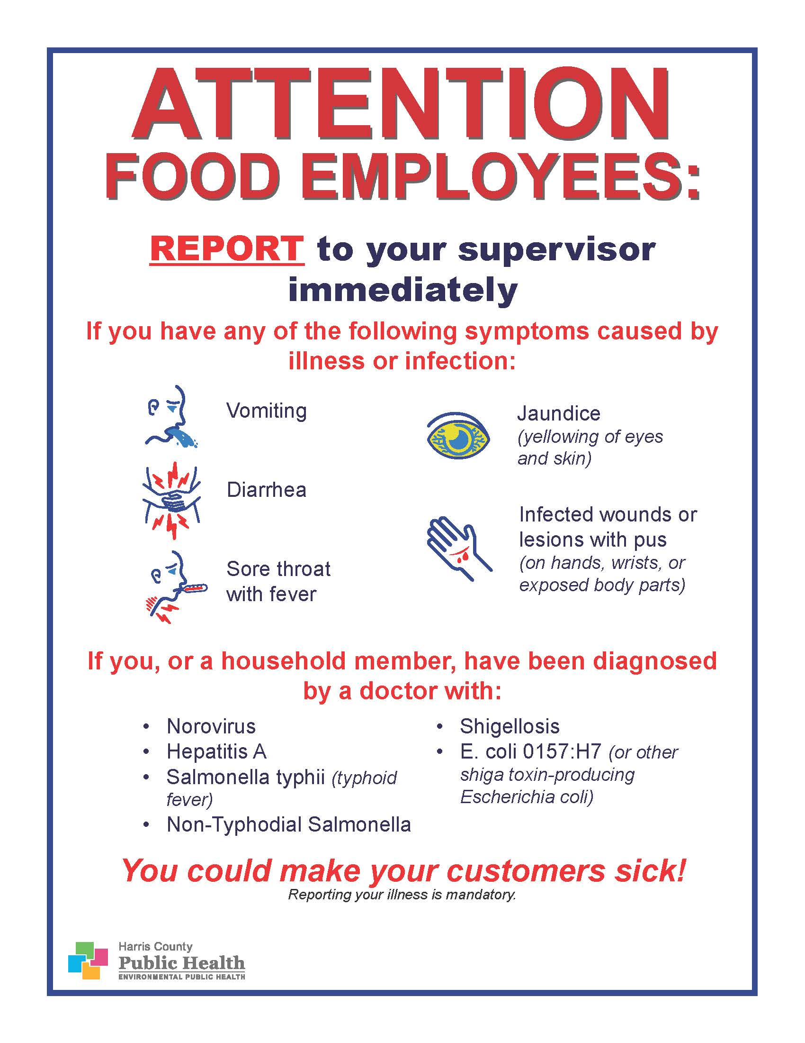

Spanish
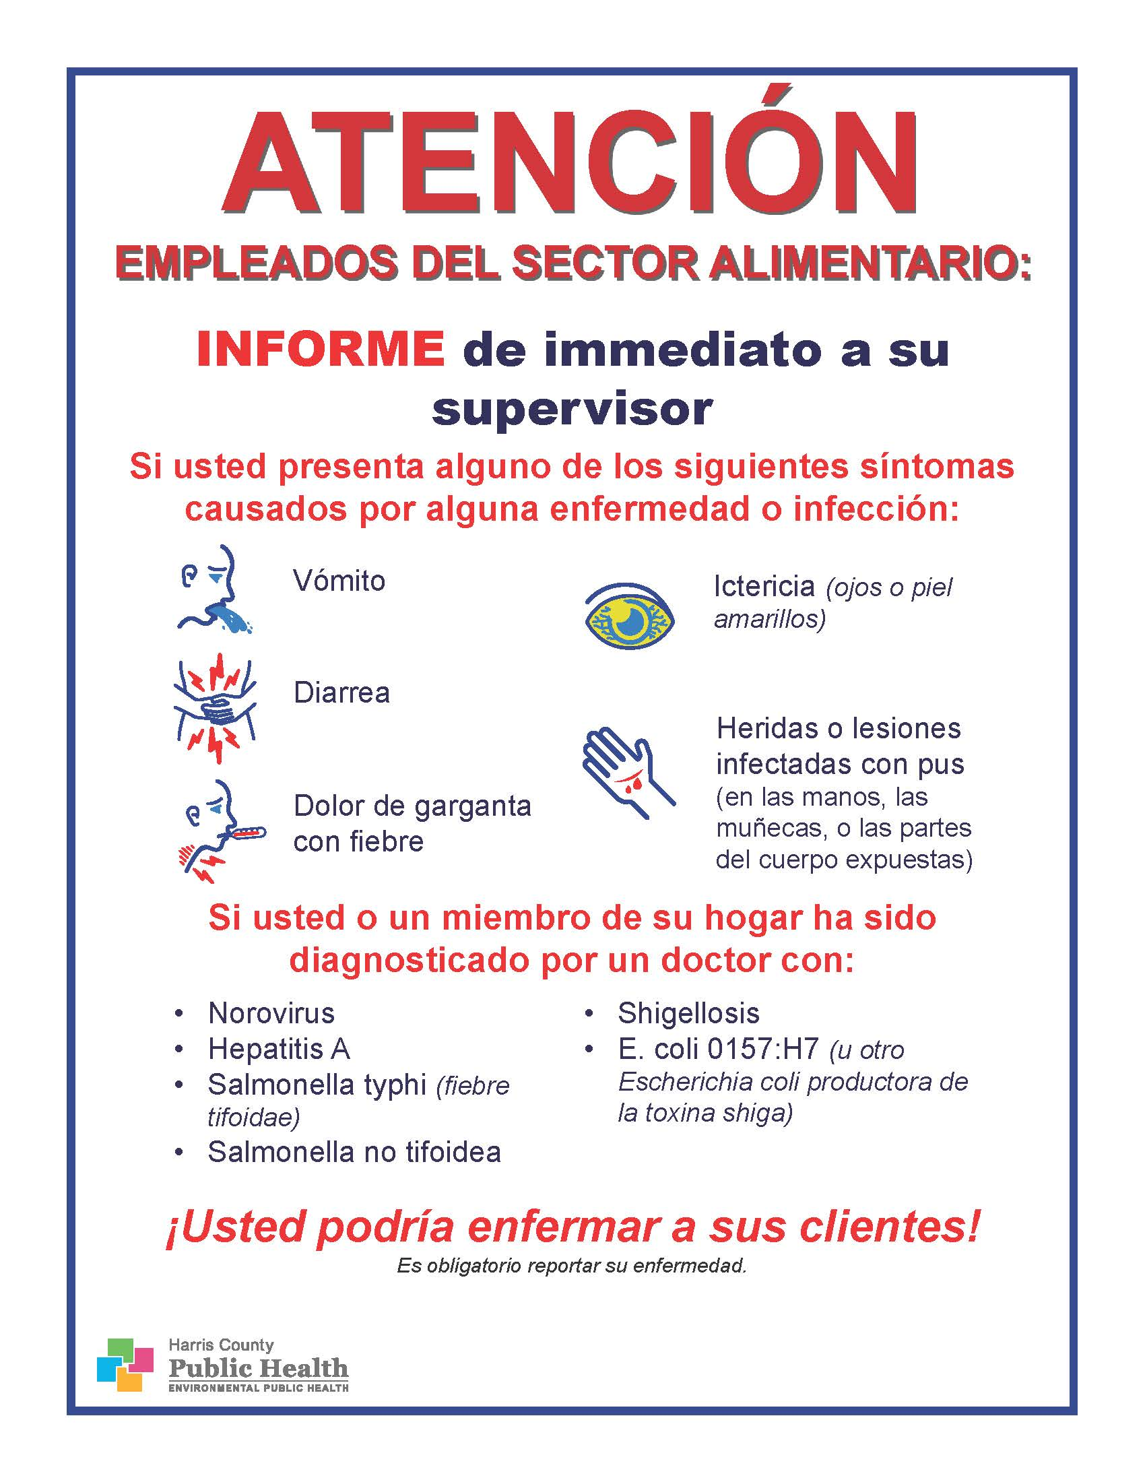

Appendix 3: Example Employee Illness Reporting Log

Appendix 4: Example Employee Health Decision Guide

Appendix 5: Example Employee Handwashing Posters

Sample 1

Sample 2

Appendix 6: Norovirus Clean Up Poster
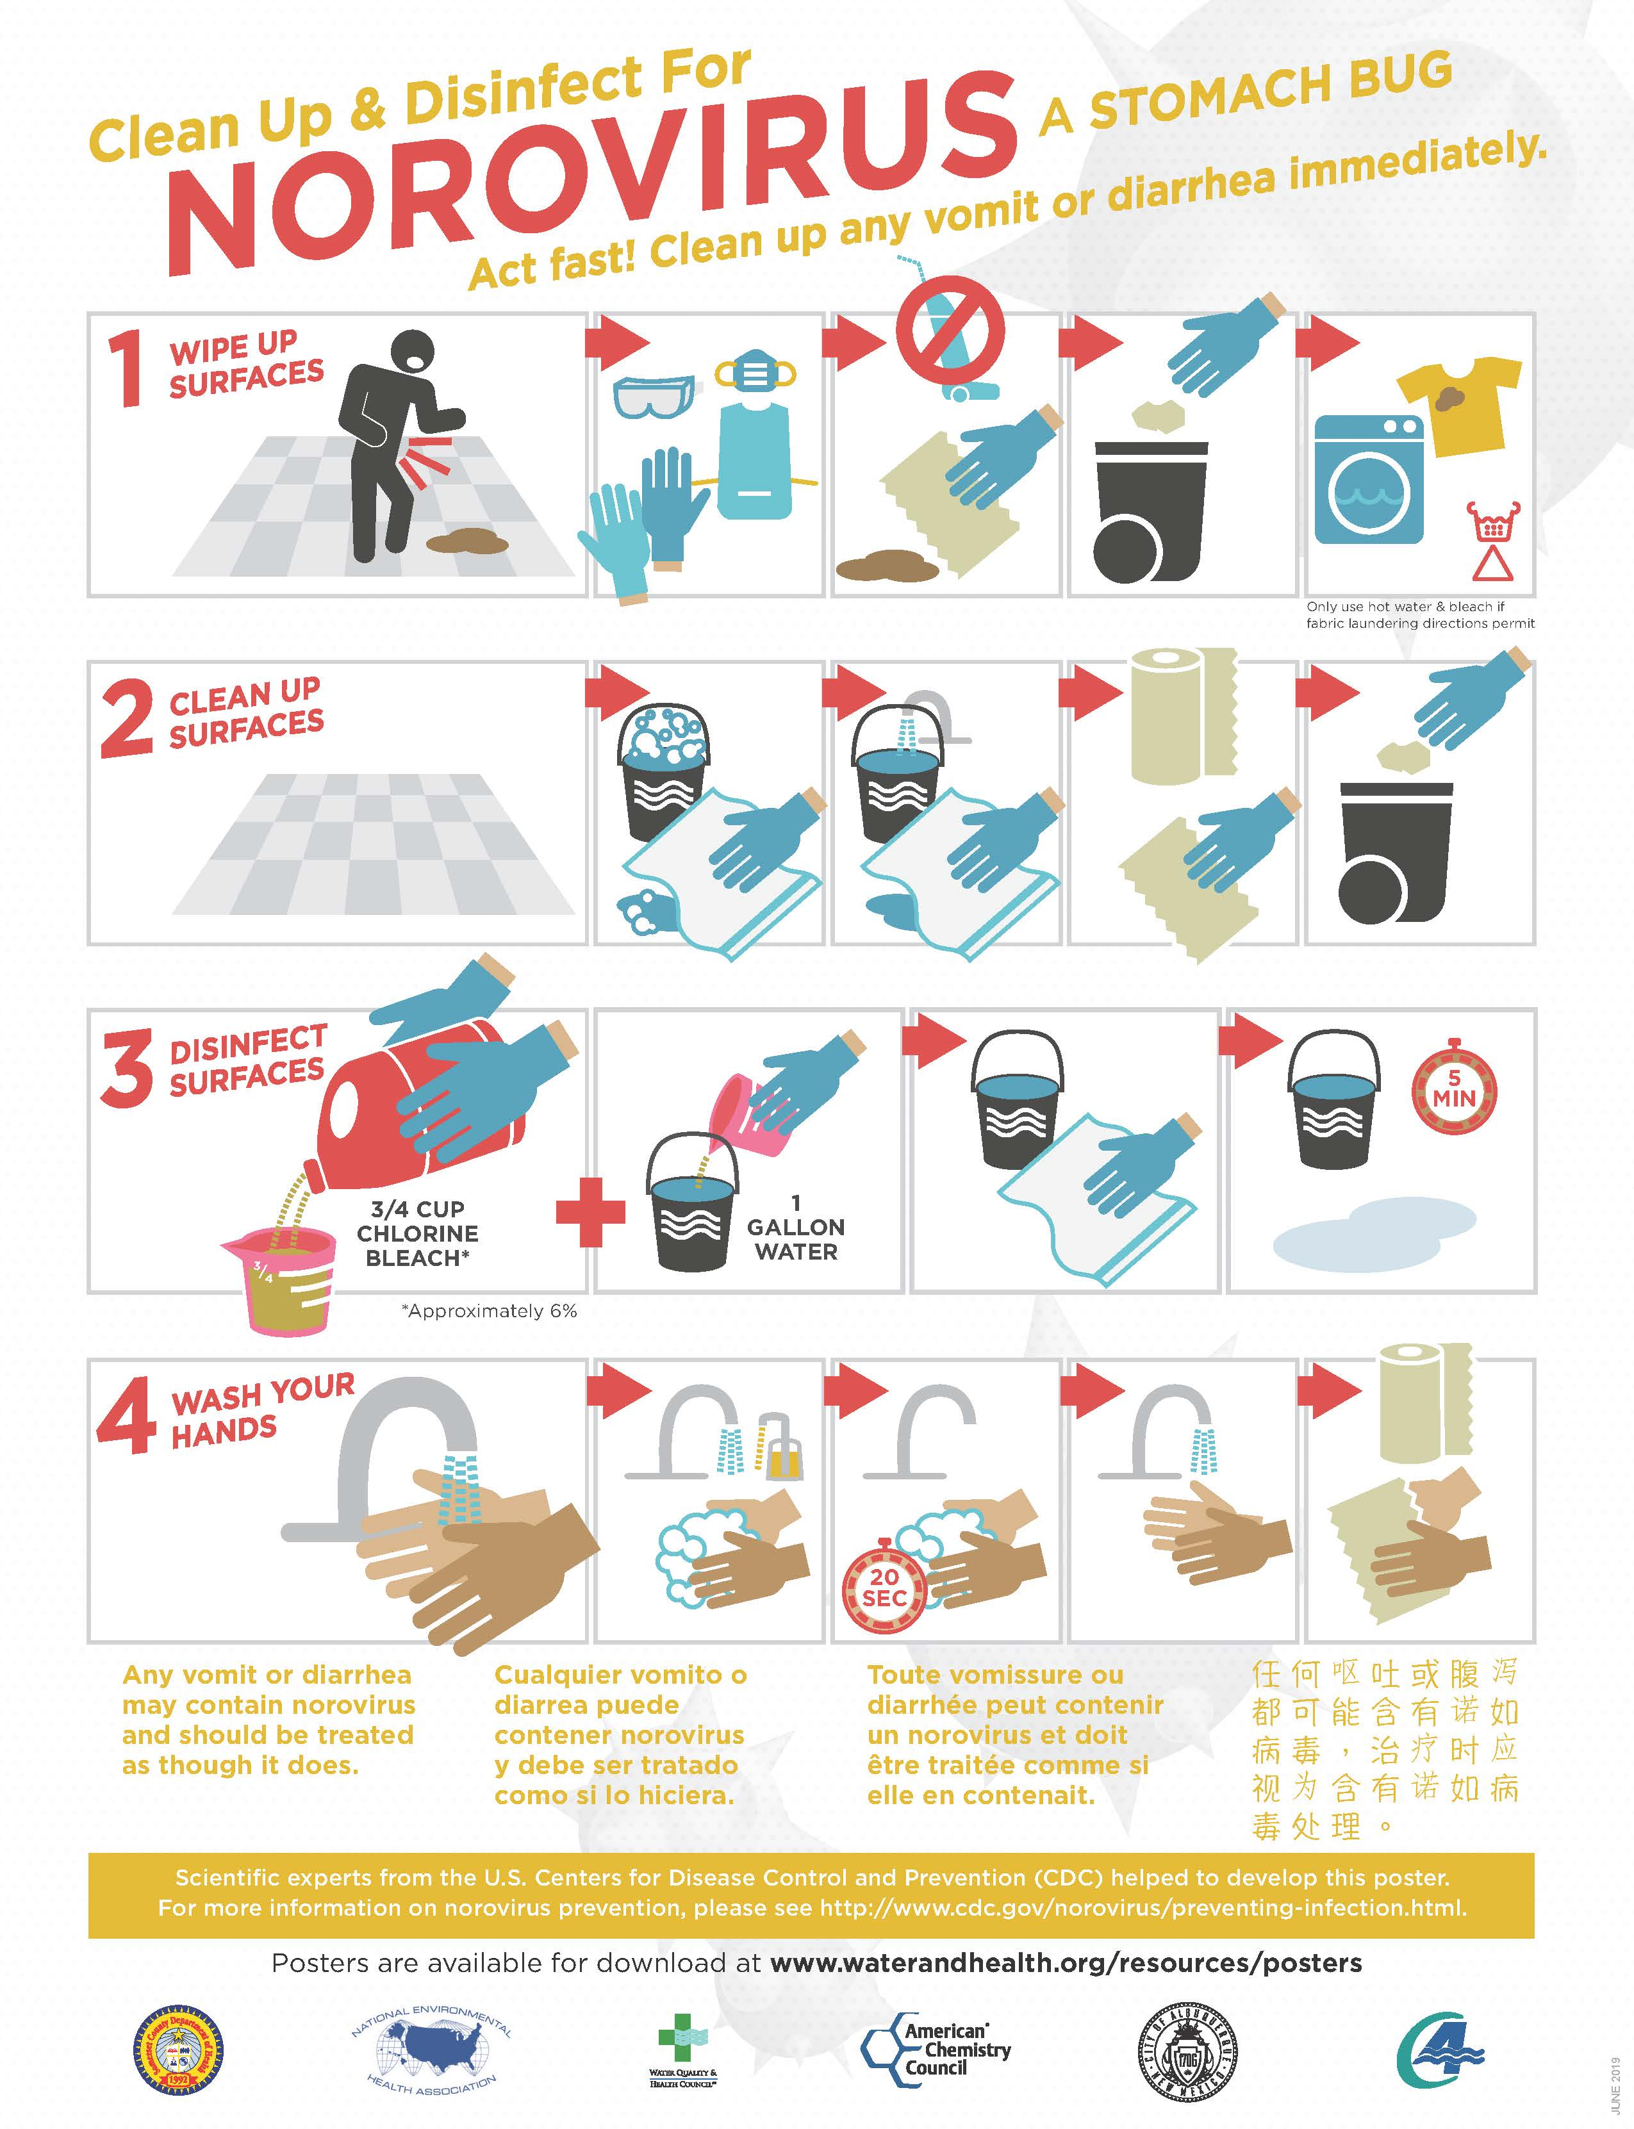

Appendix 7: 3 Things Restaurant Managers Need To Know About Talking to Sick Workers
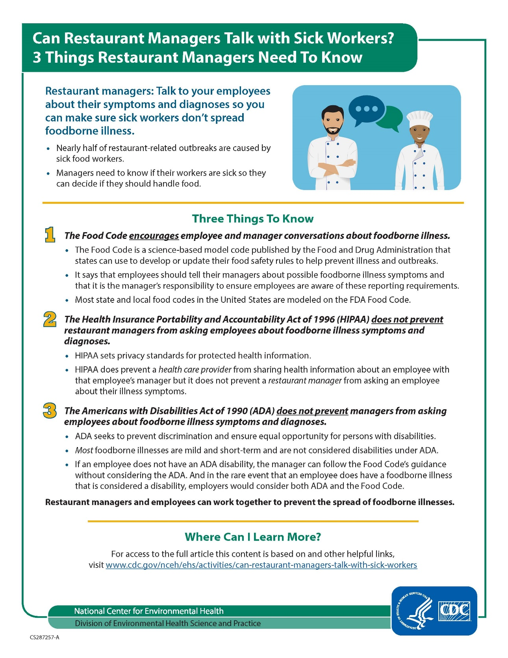

U.S. Food and Drug Administration: https://www.fda.gov/food/retail-food-industryregulatory-assistance-training/retail-food-protection-employee-health-and-personal-hygiene-handbook or https://www.fda.gov/media/77864/download
Harris County Public Health: http://publichealth.harriscountytx.gov/Portals/27/Documents/Organization/EPH/big%206%20Eng.pdf?ver=2017-07-05-103741-777
Minnesota Department of Health: https://www.health.state.mn.us/people/foodsafety/dwi/empillog.html
Minnesota Department of Health: https://www.health.state.mn.us/people/foodsafety/dwi/decisionguide.pdf
Rhode Island Department of Health: http://health.ri.gov/publications/factsheets/Handwashing.pdf
Minnesota Department of Health: https://www.health.state.mn.us/people/handhygiene/wash/dontforget.html
Water Quality and Health Council: https://waterandhealth.org/resources/posters/#norovirus
Centers for Disease Control and Prevention: https://www.cdc.gov/nceh/ehs/activities/can-restaurant-managers-talk-with-sick-workers.html

