PREVENTIVE HEALTH AND HEALTH SERVICES BLOCK GRANT MEASUREMENT FRAMEWORK
VERSION 1.5

Table of Contents

Preface 3
Background 5
What Is the PHHS Block Grant Measurement Framework? 5
Flexibility 6
Use of Funds 6
Results 8
How Is the Framework Used in the Evaluation? 9
What Are the Measures? 9
Public Health Infrastructure Improved Measures 11
Emerging Needs Addressed Measures 15
Evidence-Based Public Health Practiced Measures 17

List of Figures, Tables, and Appendices
Figure 1: Components of the PHHS Block Grant Measurement Framework 6
Table 1. Examples: Use of PHHS Block Grant Funds 7
Table 2: Link Between the Evaluation Questions, Logic Model, and Measurement Framework 9
Table 3: PHHS Block Grant Measures 10
Appendix A: PHHS Block Grant—Logic Model 20
Appendix B: Healthy People 2020 Topic Areas 21

Preface
This document provides an updated overview of the Preventive Health and Health Services (PHHS) Block Grant Measurement Framework (Version 1.0) to reflect modifications made after data collection in 2017. The updated document (Version 1.5) defines the purpose of the framework, provides details of its various components, and offers specific information about the four related measures for future data collections beginning in 2019.

Grantees will report data on the measures every other year (i.e., data were first collected in 2017; and in 2019; the next data collection will take place in 2022, and then every other year). Given the complexity of the measurement and evaluation of the PHHS Block Grant, the framework will be reviewed for potential updates including the revision of existing measures, the addition of new measures for other aspects of the results, and/or the development of new results and measures. Further guidance for data collection on the measures will be provided through training and technical assistance prior to the data collection period.

If you have questions about the measurement framework, measures, or data collection, please contact the PHHS Block Grant evaluation team at phhsblockgranteval@cdc.gov.
Important Terms to Know

Agencies: The collective term used in the framework to reference recipient health departments, local health departments, tribal health departments, and local organizations.

Recipient: The PHHS Block Grant-funded jurisdictional health department (i.e., state, District of Columbia, American Indian tribe, US territory, freely associated state).

Local and tribal health departments: Governmental health entities within a recipient’s jurisdiction that receive PHHS Block Grant-funded support to implement public health efforts in communities within that jurisdiction.

Local organizations: Governmental and non-governmental entities within a recipient’s jurisdiction that receive PHHS Block Grant-funded support to implement public health efforts in communities within that jurisdiction. Types of local agencies include community-based organizations, schools, faith-based organizations, community health centers, and medical clinics. For the purposes of the framework, the term ‘local organizations’ does not include local health departments.

PHHS Block Grant-funded support: Use of PHHS Block Grant funds, in any amount, to directly fund, provide staff for, or provide technical assistance to support an activity.

Public health efforts: Programs, services, or activities supported by the PHHS Block Grant that are implemented as potential solutions to public health problems and that address other public health needs.

Use of PHHS Block Grant funds: Use of PHHS Block Grant funds, in any amount, to address prioritized public health needs. Recipients can use grant funds to address their jurisdictions’ needs, as well as provide support to other entities (i.e., local health departments, tribal health departments, and local organizations) to address their specific, prioritized public health needs.

Background

The Centers for Disease Control and Prevention’s (CDC’s) Center for State, Tribal, Local, and Territorial Support is evaluating the Preventive Health and Health Services (PHHS) Block Grant. The purposes of the evaluation are to assess the grant’s value, describe and measure select outputs and outcomes of the grant, and strengthen its performance and accountability. The evaluation assesses the grant as a whole—not individual recipientactivities or outcomes.

There are two overarching evaluation questions:
- How does the PHHS Block Grant support grantees in addressing their jurisdictions’ prioritized public health needs related to Healthy People 2020 objectives?

- How does the PHHS Block Grant contribute toward the achievement of organizational, systems, and health-related outcomes?

These evaluation questions are intended to assess how the PHHS Block Grant contributes to the recipient’s ability to meet prioritized public health needs and achieve outcomes. To help address the evaluation questions, CDC developed the PHHS Block Grant Measurement Framework.
About the PHHS Block Grant

Through legislative authority, the PHHS Block Grant provides federal funding to 61 recipients—all 50 States, the District of Columbia, 2 American Indian tribes, 5 US territories, and 3 freely associated states. With these flexible funds, grantees address public health needs that are a priority within their jurisdictions in collaboration with local and tribal public health organizations. The legislation requires recipients to align their program objectives to Healthy People 2020, a set of national objectives designed to guide health promotion and disease prevention efforts.

What Is the PHHS Block Grant Measurement Framework?

The PHHS Block Grant Measurement Framework is an innovative approach to assessing the outputs and outcomes resulting from the use of flexible grant funds. Flexible funding is a key aspect of the grant because it allows recipients to set their own goals and program objectives and implement strategies designed to meet their prioritized public health needs. The framework defines a set of measures that enable CDC to standardize the collection of data on the recipient’s achievements. The framework is intended to apply to the activities, regardless of how funds are invested, or which Healthy People 2020 objectives are selected. Recipients should be able to see alignment between their work and the framework. However, depending on their activities, not every aspect of the framework will necessarily be relevant in any given reporting period. The framework consists of three components—flexibility, use of funds, and results (see Figure 1).

Figure 1: Components of the PHHS Block Grant Measurement Framework
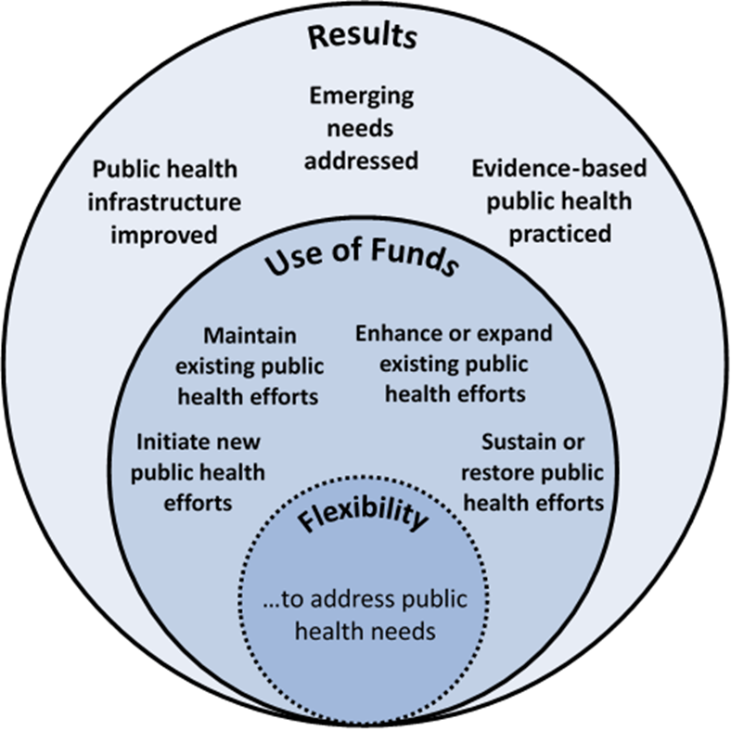

Results – Outcomes of the grant resulting from successful use of PHHS Block Grant funds
Flexibility – Ability to identify, prioritize, and address public health needs

Use of Funds – Recipients use PHHS Block Grant funds to address their prioritized public health needs

Flexibility
The core component of the framework is the flexibility of the PHHS Block Grant, as it gives recipients control over identifying which jurisdictional public health needs to prioritize and determining appropriate strategies to address those needs. The public health needs can be at the recipient level or at the local level. Flexible funding allows grantees to address public health needs for which other categorical types of funding are insufficient, unavailable, or too restrictive on how program funds can be used.

Use of Funds
The use of funds component reflects the different ways recipients use grant funds to implement public health efforts to address prioritized public health needs, including using funds to support the needs of local health departments, tribal health departments, and local organizations. It shows how flexibility in the use of these funds helps attain the results identified in the framework. This component outlines four ways grantees may use PHHS Block Grant funds:

- Initiate new public health efforts: Develop and implement new programs, services, and activities that address public health needs that were previously not funded, either due to a lack of available funds or an absence of funding allotted to the need.

- Maintain existing public health efforts: Support established programs, services, and activities from year to year.

- Enhance or expand existing public health efforts: Enhance an effort by refining and improving its quality or expand an effort by adding components or outreach to additional populations.

- Sustain or restore public health efforts: Sustain or restore efforts that have experienced a partial or complete loss in funding, and are at risk for discontinuation.
  - Sustain: Continue an effort without disruptions after original funding for the effort has ended.
  - Restore: Reinstate or rebuild an effort that was significantly disrupted or had ended due to loss of original funding.

Examples of the use of funds are provided in Table 1.

Table 1. Examples: Use of PHHS Block Grant Funds
Use of Funds | Examples
Initiate new public health efforts | - Testing new or innovative approaches to addressing needs  - Implementing programs, services, or activities that may have been conducted elsewhere but are new to the jurisdiction
Maintain existing public health efforts | - Providing ongoing support to longer-term efforts  - Ensuring consistency and continuation of efforts
Enhance or expand existing public health efforts | - Fully implementing or scaling up pilots or smaller efforts  - Establishing new or expanding existing partnerships, or increasing integration across categorical programs  - Advancing existing work, such as updating plans or assessments
Sustain or restore public health efforts | - Ensuring a program continues, when facing impending loss of funds, until other funding sources are identified (e.g., stop-gap funding)  - Institutionalizing public health efforts (e.g., restoring ongoing funding in the wake of funding loss)

Results

The results component includes three cross-cutting outcomes of agency performance and public health practice that result from the use of the PHHS Block Grant’s flexible funding.

Public health infrastructure improved
Public health infrastructure includes the organizational capacity (i.e., the systems, workforce, partnerships, and resources) that enables agencies to perform their core functions and provide essential services. Improvements to infrastructure may occur within the recipient health department, either department-wide or within a specific program, or across the recipient jurisdiction’s public health system (e.g., within local organizations). There are several aspects of improving public health infrastructure, such as improving information systems capacity, quality, and communications strategies, as well as strengthening the workforce, addressing public health standards, and supporting partnerships.

Emerging needs addressed
Emerging needs are public health issues that are beginning to present themselves as problems within the recipient’s jurisdiction. Emerging needs may be newly arising problems, reemerging problems, or existing problems that have developed new characteristics (e.g., affecting new populations or geographic areas). Public health emergencies, or unexpected natural or manmade events that cause an immediate risk to the public’s health, are also considered emerging needs. Emerging needs may occur in response to external factors or to changing priorities within a jurisdiction.

Evidence-based public health practiced
Evidence-based public health practice involves implementing effective interventions. It also includes both building and using evidence (i.e., data and information) to
- Assess and define the public health need to be addressed (e.g., surveillance data)
- Prioritize public health needs for action (e.g., health improvement plans)
- Determine the effectiveness of specific interventions with respect to outcomes (e.g., evaluation data)
- Describe how to effectively implement interventions with respect to relevant contextual factors such as setting, population, social norms (e.g., translational research data)

How Is the Framework Used in the Evaluation?

The PHHS Block Grant Measurement Framework is a practical, yet outcome-focused, approach to evaluating the grant as a whole. Data collected for the measures are used to help answer the evaluation questions. These data show the ways the PHHS Block Grant supports recipient activities and outputs and influences achievement of outcomes in the grant logic model across all grantees. For example, data collected for the public health infrastructure improved result are used to demonstrate how recipients are improving organizational and systems capacity, which is an intermediate outcome. (See Appendix A for the complete grant logic model.)

Table 2 shows how the framework lines up with the evaluation questions and logic model components.

Table 2: Link Between the Evaluation Questions, Logic Model, and Measurement Framework
Overarching Evaluation Question | Logic Model Component | Measurement Framework Component
- How does the PHHS Block Grant support grantees in addressing their jurisdictions’ prioritized public health needs related to Healthy People 2020 objectives? | - Activities  - Outputs  - Short-Term Outcomes | - Flexibility  - Use of Funds
- How does the PHHS Block Grant contribute toward the achievement of organizational, systems, and health-related outcomes? | - Short-Term Outcomes  - Intermediate Outcomes  - Long-Term Outcomes | - Results

What Are the Measures?

The framework includes four measures that assess specific aspects of the results. The measures, presented in Table 3, are relevant to recipient’s objectives and activities, lend themselves to accurate measurement, and allow for aggregating data across grantees. Where feasible, the measures capture results both within the recipient health department and among local and tribal health departments as well as local organizations receiving support from recipients. These four measures focus on select aspects of each result that were considered most important, relevant, measurable, and feasible for data collection. Additional measures may be developed for future versions of the framework. Data collected for the measures will complement other recipient information, such as success stories.

Table 3: PHHS Block Grant Measures

Results | Measure
- Public Health Infrastructure Improved | Information Systems Capacity Improved  1.1 Number of state, territorial, tribal, and local agencies whose capacity to collect or enhance data that provide information of public health importance was improved or maintained through the use of PHHS Block Grant funds  Quality Improved  1.2 Number of state, territorial, tribal, and local agencies in which the efficiency or effectiveness of operations, programs, or services was improved through the use of PHHS Block Grant funds
- Emerging Needs Addressed | Emerging Public Health Needs Addressed  2.1 Number of emerging public health needs that were addressed through the use of PHHS Block Grant funds
- Evidence-Based Public Health Practiced | Evidence-Based Public Health Interventions Implemented  3.1 Number of evidence-based public health interventions implemented through the use of PHHS Block Grant funds

More information about these measures is outlined below:
- When will grantees report on the measures? Grantees will report on the measures during the fall every other year, reflecting the results and improvements achieved during the prior 12-month period (July 1–June 30). Reporting on the measures is based on whether the PHHS Block Grant was used to support achievement of results or improvements; it does not matter which fiscal year funding supported the work.
- How will grantees report on the measures?
Grantees will report data on the measures by completing a web-based questionnaire administered to the PHHS Block Grant Coordinators. The Block Grant Management Information System (BGMIS) will not be used to collect data on the measures.
- Will grantees report on every measure?
Grantees will report data only on the measures that align with their work. All, some, or none of the measures might be relevant in any given reporting period, depending on the recipient’s activities.
The next section provides descriptions of the four measures for the results included in the framework.

Public Health Infrastructure Improved Measures
Introduction
Public health infrastructure includes the organizational capacity (i.e., the systems, workforce, partnerships, and resources) that enables agencies to perform their core functions and provide essential services. Improvements to infrastructure may occur within the recipient health department, either department-wide or within a specific program, or across the recipients jurisdiction’s public health system (e.g., within local organizations). For the Public Health Infrastructure Improved result, there are two measures. These measures assess information systems capacity and quality improvement.

Information Systems Capacity Improved
1.1: Number of state, territorial, tribal, and local agencies whose capacity to collect or enhance data that provide information of public health importance was improved or maintained through the use of PHHS Block Grant funds.

What are the key definitions?
Capacity to collect or enhance data was improved or maintained:
Improved or maintained ability of health departments to use data for decision-making through the
- Collection of new data
- Enhancement of existing data
- Maintenance of existing data
Examples of capacity to collect or enhance data:
- Developed a new surveillance system
- Addition of an online, query-enabled database
- Improved standardization of existing data
- Improved reporting functionality
- Establishment of linkages across data systems
Information of public health importance:
Any data that provide insight into health, health inequities, contributing factors or causes of health challenges, and/or potential policy, public health, or community solutions. These are data that are needed for the planning, implementation, and evaluation of public health practice.

What gets counted?
Each agency (i.e., recipient health department, local health departments, tribal health departments, and local organizations) that used PHHS Block Grant-funded support to newly develop, improve, or maintain one or more information systems will be counted for this measure. This includes improvements that were under way during the reporting period, not just those that were completed.

What information will be reported?
Grantees will provide the following information for the information systems that were newly developed, improved, or maintained using PHHS Block Grant-funded support:
- The number of agencies (i.e., recipient health department, local health departments, tribal health departments, and local organizations) that newly developed, improved, or maintained information systems through the use of PHHS Block Grant funds.
- The type of data system improved or maintained:
  - Laboratory data system
  - Surveillance system
  - Vital events database (e.g., birth, death, fetal death)
  - Registry (e.g., cancer)
  - Performance management system
  - Program administration
  - Financial management system
  - Human capital management system (e.g., human resources, personnel)
  - Health information exchange
  - Electronic health record (EHR) system
  - Public health database (e.g., public facing database)
  - Public health digital library (e.g., access to publications, journals)
  - Online mapping system (e.g., GIS)
  - Other information system
- The name/title of the information system improved or maintained
- Whether funds were used to
  - Initiate development of a new system or module
  - Maintain a system or module
  - Enhance or expand an existing system or module
  - Sustain or restore a system or module
- Whether the information system improved or maintained at the recipient health department was also used by local health departments, tribal health departments, and/or local organizations and, if yes, by how many

Why is the measure important?
A key component of public health infrastructure is establishing, maintaining, and using state-of-the-art data and information systems to inform public health action. Data from information systems can document the impact of an intervention or monitor and clarify the epidemiology of health problems to facilitate priority setting. These data are the foundation for decision making in public health and empower decision makers to lead and manage more effectively by providing timely, useful evidence.

This measure determines whether agencies use flexible PHHS Block Grant funds to ensure robust and functional information systems for systematically collecting, managing, analyzing, and interpreting data to plan, implement, and assess programs and services within their jurisdictions.

Quality Improved
1.2: Number of state, territorial, tribal, and local agencies in which the efficiency or effectiveness of operations, programs, or services was improved through the use of PHHS Block Grant funds.

What are the key definitions?
Efficiency of operations, programs, or services: Improvements in efficiency result in reductions in the amount of resources required to implement the effort.

Effectiveness of operations, programs, or services: Improvements in effectiveness result in a greater ability to achieve agency or program goals through improved delivery of services or programs, or improved implementation of organizational processes.
Types of Efficiency and Effectiveness
Efficiency
- Time saved
- Reduced number of steps
- Costs saved
- Costs avoided
- Revenue generated due to billable service
- Other efficiency improvements

Effectiveness
- Increased staff satisfaction
- Organizational design improvements
- Quality enhancement of services or programs
- Other effectiveness improvements

What gets counted?
Each agency (i.e., recipient health department, local health departments, tribal health departments, and local organizations) that demonstrated improved efficiency or effectiveness of one or more operations, programs, or services through the use of PHHS Block Grant-funded support will be counted for this measure. This includes efficiency and effectiveness improvements that were achieved during the reporting period.

What information will be reported?
Recipients will provide the following information on the efficiency and effectiveness improvements achieved using PHHS Block Grant funds:
- The number of agencies (i.e., recipienthealth department, local health departments, (non-grantee) tribal health departments, and local organizations) that improved efficiency and effectiveness through the use of PHHS Block Grant funds
- The number of operations, programs, or services that achieved each type of efficiency and effectiveness improvement. Types of improvements include:
  - Time saved
  - Reduced number of steps
  - Costs saved
  - Costs avoided
  - Revenue generated due to billable service
  - Increased staff satisfaction
  - Organizational design improvements
  - Quality enhancement of services or programs
  - Other – specify

- Whether funds were used to
  - Initiate a new effort to improve efficiency and effectiveness
  - Maintain an ongoing effort to improve efficiency and effectiveness
  - Enhance/expand an existing effort to improve efficiency and effectiveness
  - Sustain or restore an effort to improve efficiency and effectiveness
- One example of an operation, program, or service in which the efficiency and effectiveness was improved through the use of established quality improvement methods

Why is the measure important?
Quality improvement is a formal approach to strengthen organizational performance and increase efficiency and effectiveness in public health operations, programs, and services. While individual employee performance may contribute to increased efficiency and effectiveness, it is important that the processes to improve efficiency and effectiveness are infused into agency-wide public health practice and operations to effect significant and lasting improvements in quality.

This measure determines the extent to which flexible PHHS Block Grant funds assist agencies in improving the efficiency or effectiveness of operations, programs, or services.

Emerging Needs Addressed Measures
Introduction
Emerging needs are public health issues that are beginning to present themselves as problems within the recipient’s jurisdiction. They can affect the jurisdiction as a whole or specific areas within the jurisdiction, such as counties, tribes, and cities. There is one measure that assesses addressing emerging needs.

Emerging Public Health Needs Addressed
2.1: Number of emerging public health needs that were addressed through the use of PHHS Block Grant funds.

What are the key definitions?
Emerging public health needs: Public health needs within a grantee’s jurisdiction that are newly developing or newly prioritized.
- Newly developing: A public health need that
  - Is newly arisen
  - Exists but has developed new characteristics
  - Re-emerged
- Newly prioritized: A public health need that
  - Has been known to the recipient but lacked funding or support
  - Is new to the public health field
  - Has new expectations for a public health response

Addressed: Implemented an intervention, service, or activity designed to reduce or prevent further impact of the emerging public health need.
Examples of emerging public health needs:
- Infectious disease outbreaks
- Migrant health
- Opioid overdoses
- Mental health
- Natural disasters

Examples of emerging public health needs
- Infectious disease outbreaks
- Migrant health
- Opioid overdose epidemic
- Mental health
- Natural disasters
What gets counted?
Each emerging public health need within the recipient’s jurisdiction addressed through the use of PHHS Block Grant-funded support will be counted for this measure. This includes any efforts to address the emerging public health need that were under way during the reporting period, not just those that were completed.

What information will be reported?
For each emerging public health need reported, grantees will provide the following information.
- The name and description of the need and if it is newly developing or newly prioritized
- How the emerging public health need was prioritized:
  - Jurisdiction health assessment (e.g., state health assessment)
  - Topic or program specific assessment (e.g., tobacco assessment, environmental health assessment)
  - Identified via surveillance systems or other data sources
  - Prioritized within a strategic plan
  - Declared as an emergency within recipient jurisdiction
  - Governor (or political leader) established as a priority
  - Legislature established as a priority
  - Tribal government/elected official established as a priority
  - Other – specify
- The Healthy People 2020 health topic area that best aligns with the emerging need (see Appendix B for full list)
- The focus of the emerging need (i.e., health- related or organizational or systems-related)
  - If health-related, the geographic area affected by the emerging need
  - If health-related, the estimated size of the population potentially affected by the emerging public health need as well as a brief description of how the population estimate was identified
- Whether funds were used to
  - Initiate a new effort to address the emerging public health need
  - Maintain an effort to address the emerging public health need
  - Enhance/expand an existing effort to address the emerging public health need
  - Sustain or restore an effort to address the emerging public health need

Why is the measure important?
Emerging public health needs may be unique to each jurisdiction. An outcome of the PHHS Block Grant is improved capacity of the public health system to respond to these emerging public health needs. The flexibility of the grant enables recipients to identify, prioritize, and address emerging public health needs within their jurisdiction, which may help lessen their potential effect, including long-term health impact.

This measure helps determine the extent to which PHHS Block Grant funds assist in responding to and addressing emerging public health needs that occur within the recipient’s jurisdiction at the state, territorial, local, and tribal levels.

Evidence-Based Public Health Practiced Measures
Introduction
Evidence-based public health practice involves implementing effective interventions. It also includes both building and using evidence (i.e., data and information) to assess and define the public health needs, prioritize public health needs for action, and determine the effectiveness of interventions. For the Evidence-based Public Health Practiced result, there is one measure. This measure assesses the implementation of evidence-based public health interventions.

Evidence-Based Public Health Interventions implemented
3.1: Number of evidence-based public health interventions implemented through the use of PHHS Block Grant funds.

What are the key definitions?
Evidence-based public health interventions: Any type of planned activity, such as a program, service, or policy, designed to prevent disease or injury or promote health in a group of people. Public health interventions may be supported by varying levels of evidence ranging from weak to rigorous. For the purposes of this measure, evidence-based public health interventions are based on having rigorous, strong, or moderate evidence according to Healthy People 2020 strength of evidence rating criteria.

Healthy People 2020 strength of evidence rating criteria:
- Rigorous evidence (Rating category 4) – Formal, comprehensive, and systematic review of all relevant literature (i.e., published intervention evaluations or studies that have evidence of effectiveness, feasibility, reach, sustainability, and transferability).
Examples of evidence include
- Recommendations of the Community Preventive Services Task Force
- Recommendations of the US Preventive Services Task Force
- Systematic reviews published in peer-reviewed journals
- Strong evidence (Rating category 3) – An informal, non-comprehensive, non-systematic review of some but not all relevant literature (i.e., multiple published evaluations or studies that have evidence of effectiveness, feasibility, reach, sustainability, and transferability).
Examples of evidence include
  - Non-systematic reviews published by the federal government
  - Non-systematic reviews published in peer-reviewed journals
- Moderate evidence (Rating category 2) – At least one published evaluation or study, with peer review, that has evidence of effectiveness, feasibility, reach, sustainability, and transferability.
Examples of evidence include
  - Journal articles of individual studies
  - Published intervention research
  - Published pilot studies
- Weak evidence (Rating category 1) – At least one unpublished evaluation or study without peer review, which has evidence of effectiveness, feasibility, reach, sustainability, and transferability.
Examples of evidence include
  - Unpublished intervention research
  - Unpublished pilot studies
  - Unpublished case studies
  - Unpublished field-based summaries
Additional information about building evidence
Grantees rate the strength of evidence for each intervention according to the Healthy People 2020 criteria. Although interventions supported by “weak evidence” are not counted in this measure, additional information about these interventions will be collected to learn more about any recipients’ efforts to build practice-based evidence through testing or evaluation.

What gets counted?
Each evidence-based public health intervention implemented through the use of PHHS Block Grant funds that has a rigorous, strong, or moderate strength of evidence will be counted. This includes interventions that were delivered for the first time, are ongoing, or were completed within the reporting period. The same public health intervention implemented in multiple settings or in multiple health departments is counted once.

What information do we report?
For each agency type (i.e., recipient health department, local health departments, tribal health departments, and local organizations) implementing PHHS Block Grant-supported public health interventions grantees will provide the following information:
- The number of unique public health interventions implemented by that agency
- The level of evidence supporting the public health intervention:
  - Rigorous evidence (Rating Category 4)
  - Strong evidence (Rating Category 3)
  - Moderate evidence (Rating Category 2)
  - Weak evidence (Rating Category 1)
  - No evidence
  - For both “Weak evidence” and “No evidence,”
    - The number of interventions that were untested, new, and/or innovative.
    - The number of interventions for which data or information was collected to determine effectiveness
- The primary Healthy People 2020 health topic area addressed by the public health intervention (see Appendix B for full list).
- Whether funds were used to
  - Initiate a new (i.e., previously not funded or implemented) public health intervention
  - Maintain implementation of an existing public health intervention
  - Enhance/expand an existing public health intervention
  - Sustain or restore a public health intervention

Why is the measure important?
A key component of evidence-based public health practice is selecting and implementing interventions based on the best available evidence. Implementing public health interventions shown to be effective is an important practice for maximizing public health outcomes. In cases where evidence of effectiveness is unavailable, or weak, the public health interventions that are implemented can be tested or evaluated with the intent of determining effectiveness. This is important for building practice-based evidence, which can support further decision-making by the recipient and contribute to the overall evidence base for public health. This measure determines the extent to which the PHHS Block Grant supports the implementation of evidence-based public health interventions.

Appendix A: PHHS Block Grant—Logic Model

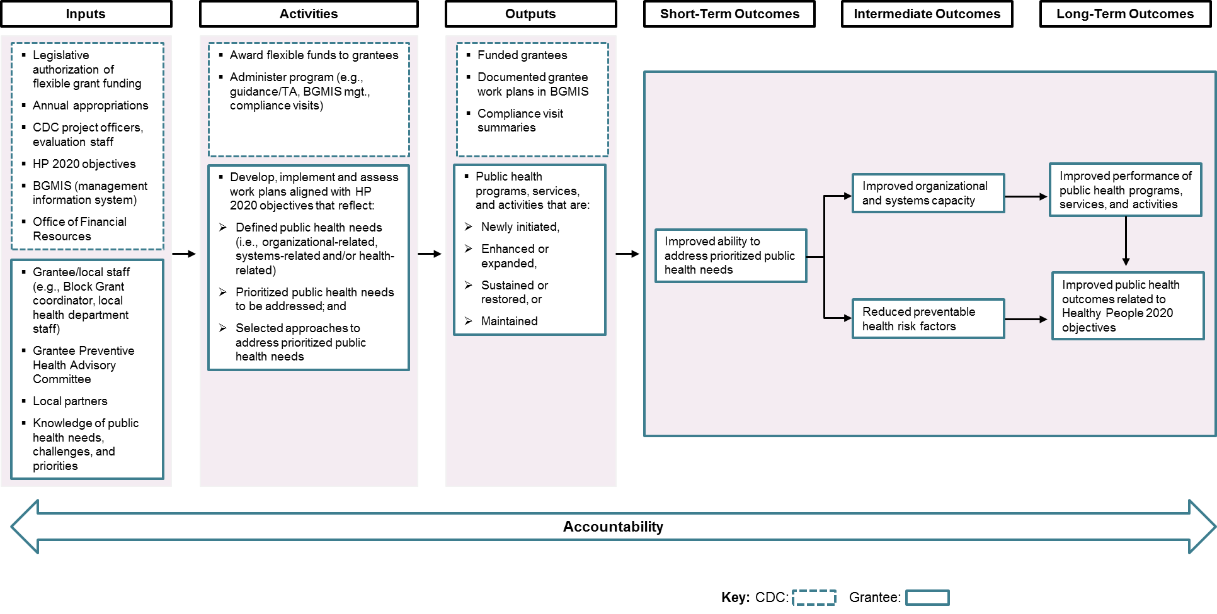

Appendix B: Healthy People 2020 Topic Areas

- Access to Health Services
- Adolescent Health
- Arthritis, Osteoporosis, and Chronic Back Conditions
- Blood Disorders and Blood Safety
- Cancer
- Chronic Kidney Disease
- Dementias, including Alzheimer's Disease
- Diabetes
- Disability and Health
- Early and Middle Childhood
- Educational and Community-Based Programs
- Environmental Health
- Family Planning
- Food Safety
- Genomics
- Global Health
- Health Communication and Health Information Technology
- Health-Related Quality of Life and Well-Being
- Healthcare-Associated Infections
- Hearing and Other Sensory or Communication Disorders
- Heart Disease and Stroke
- HIV
- Immunization and Infectious Diseases
- Injury and Violence Prevention
- Lesbian, Gay, Bisexual, and Transgender Health
- Maternal, Infant, and Child Health
- Medical Product Safety
- Mental Health and Mental Disorders
- Nutrition and Weight Status
- Occupational Safety and Health
- Older Adults
- Oral Health
- Physical Activity
- Preparedness
- Public Health Infrastructure
- Respiratory Diseases
- Sexually Transmitted Diseases
- Sleep Health
- Social Determinants of Health
- Substance Abuse
- Tobacco Use
- Vision
- Emergency Medical Services*
- Rape or Attempted Rape*

* Note: Healthy People 2020 has designated 42 health topic areas. Two additional categories—“emergency medical services” and “rape or attempted rape”—are included in the Block Grant Management Information System as health topic areas that grantees can select to identify the focus of their work.

PHHS Block Grant funds may not be used to supplant state or local funds.
Once a public health effort is restored, it would move into the “maintain” category in subsequent years.
Brownson RC, Fielding JE, Maylahn CM. Evidence-based public health: a fundamental concept for public health practice. Annual Review of Public Health 2009;30:175–201.
Public Health Accreditation Board (PHAB) Standard 1.2: Collect and maintain reliable, comparable, and valid data that provide information on conditions of public health importance and on the health status of the population.
CDC. CDC’s vision for public health surveillance in the 21st century. MMWR 2012;61(Suppl).
PHAB Standard 9.2: Develop and implement quality improvement processes integrated into organizational practice, programs, processes, and interventions.
Public health emergencies are considered emerging public health needs. They can be prioritized within the recipient’s jurisdiction and can occur locally, regionally, or jurisdiction-wide. These threats include natural disasters, chemical threats, biological threats, disease outbreaks, and environmental exposures.
Healthy People 2020. Evidence-Based Resources. www.healthypeople.gov/2020/Implement/EBR-glossary#selection-criteria. Accessed April 21, 2017.

