Drug Enforcement Administration

Controlled Substances Act Online: Renewal Applications

User Manual

Version 5.3
April 13, 2021

Change Control Page
Revision | Date | Section | Description | Author
1.0 | 10/9/2007 | All | Initial Draft | Scott M. Roberts
2.0 | 12/28/2009 | All | Update image headers to account for new website design. | Scott M. Roberts
3.0 | 7/10/2014 | All | Updated screenshots | Scott M. Roberts
4.0 | 9/11/2014 | All | Updated screenshots for Web 2.0 | Scott M. Roberts
5.0 | 9.17.19 | All | Separated into dedicated New and Renewal Manuals  Updated for new online application  Changed all references and acronyms for Office of Diversion Control to DC and SID | Kevin Baker
5.1 | 2.24.20 | 1.3; 1.4; 2.0; 2.1.1; 2.3; 2.9; 2.10; A.0; B.0 | 1.3  - Updated login procedure  1.4  - Separated from login requirements  2.0  - All 2.0 subsection, added note that the Cancel button exits the online application  2.1.1  - Added note concerning business activity applicability per state  2.3  - Added note concerning controlled license field applicability if not required by a state  2.9  - Added Section  2.10  - Added section  A.0  - Added EMS  B.0  - Added EMS | Kevin Baker
5.2 | 10.5.20 | 2.1 | 2.1  - Added section | Kevin Baker
5.3 | 4.13.21 | SP; 1.4; 2.3; 2.4; 2.8.1; 2.8.1; 2.11; A.0 | SP  - Updated signatories  1.4  - Updated SSN and Tax ID language  2.3  - Updated order form language  2.4  - Added types of applicants that require a state license  - Updated language on controlled license requirements  2.8.1  - Updated division name  2.8.2  - Updated Tracking ID definition  2.11  - Removed EMS Locations section  A.0  - Updated fees | Amanda Blake

Signature Page
Document Name: | Controlled Substances Act Online: Renewal Applications  User Manual
Publication Date: | April 13, 2021
Prepared by: | Amanda Blake, ASRC Federal Mission Services
System Owner:
 | Anna Pacula, Section Chief  Diversion Technology Section  TC Information Systems Division |  | Date
Concurrence:
 | Scott M. Roberts, Chief  Enterprise Application Unit  Diversion Technology Section  Information Systems Division |  | Date
Program Manager:
 | Martin Redd, Section Chief  Registration and Program Support Section  Office of Diversion Control Regulatory |  | Date

Preface
It is the reader’s responsibility to ensure they have the latest version of this document. Questions should be directed to the owner of this document or the project manager.
This document was developed by the Information Systems Division, Diversion Technology Section.
Approval
Approval of this document is contingent upon the review of and signatures by the project and program managers and by specified members of TQD.
System Owner
Anna Pacula, Chief
Diversion Technology Section
Information Systems Division

(571) 362-0101
anna.pacula@usdoj.gov
Privacy Information
Unlimited Distribution
Copies may be made without contacting the owner of the document.
Table of Contents
1.0 Introduction 1
1.1 Basic Navigation 2
1.2 Access 2
1.3 Login 2
1.4 Identity Verification 3
2.0 CSA Registration Online Applications: Renewal 5
2.1 First Steps 6
2.1.1 Pre-Acceptance Checklist 6
2.2 Personal Information 6
2.2.1 Page 1 6
2.2.2 Page 2 9
2.3 Business Activity/Schedules 11
2.4 State Licenses 12
2.5 Background Information 14
2.5.1 Page 1 14
2.5.2 Page 2 15
2.6 Select Drug Codes 16
2.7 Manufacturer Details 18
2.8 Payment Information 19
2.8.1 Page 1 19
2.8.2 Page 2 20
2.9 Review and Submit Application 22
2.10 Print Certificate and Receipt 24
A.0 Business Activity Table 24
B.0 Acronyms 34

Introduction
In 1970, the United States Congress created the Controlled Substances Act (CSA), legislation mandating that all entities manufacturing, distributing, dispensing, administering, and prescribing controlled substances must maintain an active registration within the Drug Enforcement Administration (DEA). All registrants must comply with all drug security, records accountability, and standards adherence requirements.
The Renewal Application web form allows registrants nearing the expiration date of their registration the ability to reapply online for a continuation of their registration. Note that applying does not guarantee approval. Every application is subject to a thorough investigation, which may end in a rejected application. Application fees are nonrefundable.

Basic Navigation
Do not use the browser’s navigation buttons.
Use the buttons at the bottom of the page to navigate the application. Button functionality is as follows:
: proceed to the next page in sequence.
: return to the previous page.
: exit the application. Note that any progress made will be lost.
Required fields (indicated by a ‘*’) must be filled out properly before clicking .
Hover the cursor over a field’s button to receive a description of that field.

Access
The Renewal Application web form may be accessed by clicking the following link:
https://apps.deadiversion.usdoj.gov/webforms2/spring/renewalLogin
Note: the browser must support 128-bit encryption.

Login
In order to renew a registration, registrants must first log in to their account. Enter a valid DEA number and click the button.
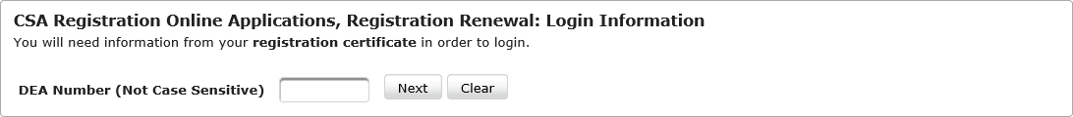 Figure 1: Login Information
The button will clear all data from the field without saving.

Identity Verification
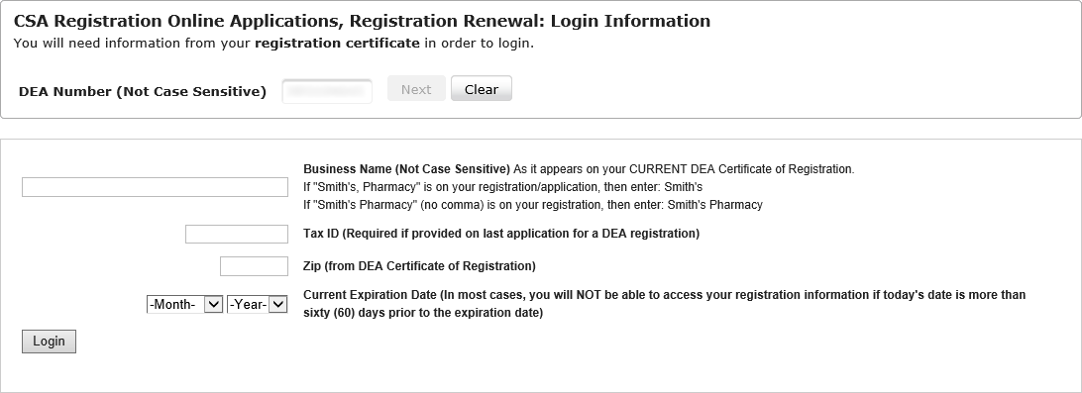
Figure 2: Identity Verification
Once a DEA number is accepted as valid, it will become grayed out and may not be edited without first clicking the button.
Enter the following information into the required fields.
Last Name or Business Name: individuals should enter their last name, while businesses should enter the name of the business.
- This is a required field and must be entered exactly as it appears on the registration.
SSN or Tax ID: the registrant’s Social Security Number (SSN) or tax identification (ID) number.
- This is a required field for registrants who have an SSN or Tax ID as part of their registration.
Zip: the zip code associated with the registrant’s business address.
- This is a required field.
- Only the first five (5) digits of the zip code are required.
Current Expiration Date: the date on which the registration is due to expire.
- A selection is required from both drop-down menus.
When finished, click the button.
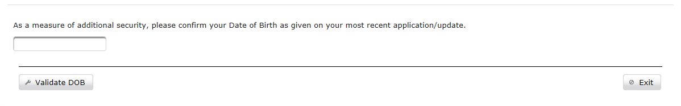
Figure 3: Date of Birth Validation
Individuals must provide further validation via their date of birth. Businesses will not see this page.
- Click the field to make a calendar appear.
- Select from the calendar the date of birth listed on the most recent application or update.
- Click the button to continue.
Once the registrant’s information has been validated, those registrants entering their renewal cycle will see the following screen.
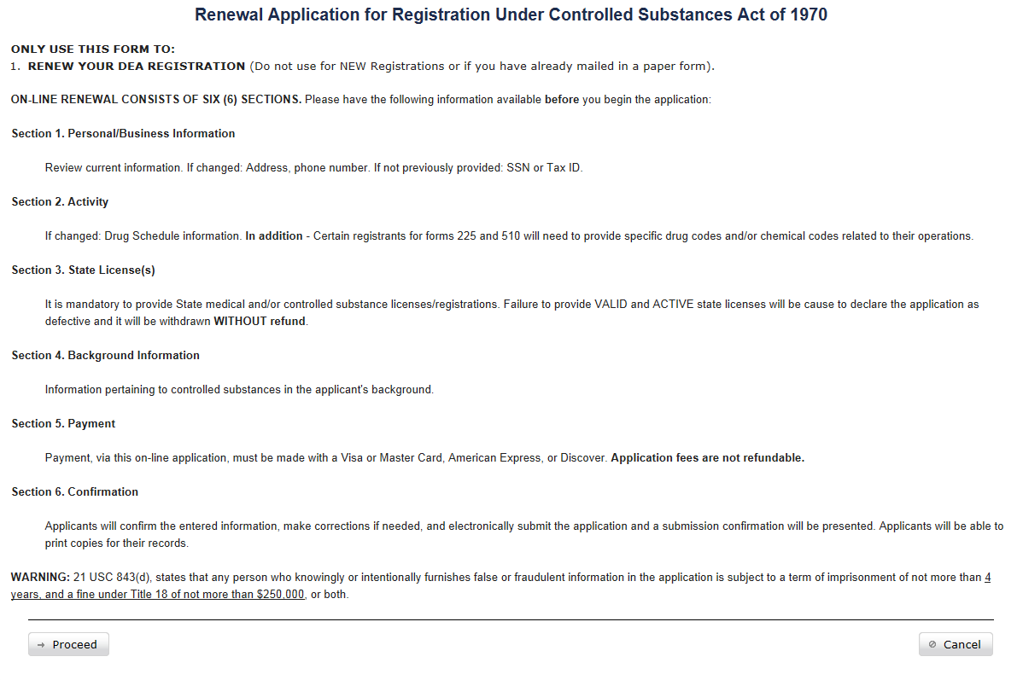
Click the button to begin the registration renewal (see section 0).

CSA Registration Online Applications: Renewal
The images found in the sections below are composites of every field available, regardless of business activity. They are intended for illustration purposes only, and are therefore not true representations of what users will see when applying for registration. Many of the fields appear for individuals rather than business or for specific business activities and will be noted where appropriate.

First Steps

Pre-Acceptance Checklist
Select business activities must acknowledge the completion of a pre-application checklist before completing a new application.
List of Business Activities with Pre-Application Checklists:
- Practitioner
- Practitioner — Military
- MLP — Military
- Practitioner — DOD Contractor
- MLP — DOD Contractor
- Researcher I
- Emergency Medical Services

Personal Information

Page 1
The first page of the renewal application form lists personal information. Correct any information that has changed. When ready, continue to the next page by clicking the button.
Note that clicking the button will exit the online application, not just the current page.
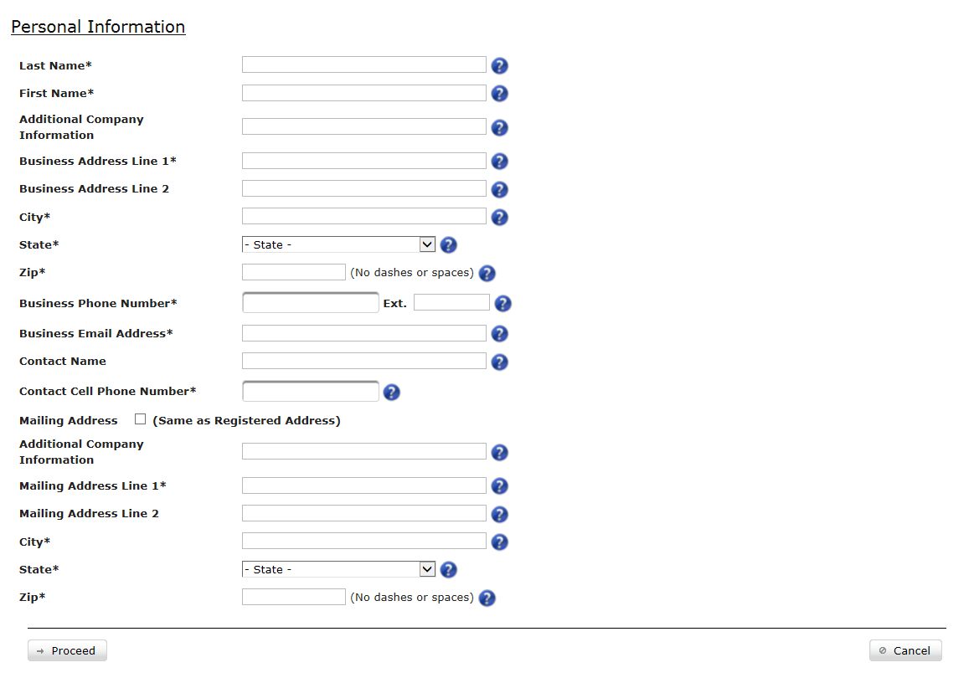
Figure 4: Personal Information, page 1
Note that fields marked with an asterisk (*) are required fields.
- Last / Business Name: for businesses and other facilities, the name of the business or facility; for individual practitioners, the last name of the practitioner. This is a required field.
- First Name: the first name, middle initial and medical degree of the individual practitioner. This field only appears when an individual practitioner is selected as the business activity (i.e.: practitioner, medical psychologist, optometrist, etc.). For individuals only, this is a required field.
- Additional Company Information: any additional information concerning the registrant. This is usually a subdivision of the primary registrant or an individual doing business as the named registrant.
- Business Address Line 1: the physical address from which the registrant conducts business
  - This is a required field.
  - The address must be between 2 and 60 characters.
  - Only valid addresses will be accepted.
- Business Address Line 2: any additional address information, such as suite and apartment numbers, if required
- City: the city in which the registrant conducts business
  - This is a required field.
  - The city must be between 2 and 35 characters.
  - The city must be valid for the entered state and zip code.
- State: the state in which the registrant conducts business, selected from the menu
  - This is a required field.
  - The state must be valid for the entered city and zip code.
  - Note that not every business activity is available in every state.
- Zip: the registrant’s postal code, plus four- (4) digit extension, if available.
  - This is a required field.
  - The zip code most be valid for the entered city and state.
- Business Phone Number: the registrant’s telephone number, plus extension, if available.
  - This is a required field.
  - Valid formats: 1234567890 or (123) 456-7890
- Business Email Address: the registrant’s email address
  - This is a required field.
  - The email address must be no more than 60 characters.
- Contact Name: the name of the business’s or individual’s primary contact
- Contact Cell Phone Number: the business contact’s cell phone number
  - This is a required field.
  - Valid formats: 1234567890 or (123) 456-7890
The next fields contain the mailing information. Click the checkbox next to Mailing Address (same as Registered Address) if the mailing address is identical to the address entered in the above fields. The information will automatically be copied to the relevant fields. If the information is different, the following fields must be manually completed.
- Additional Company Information: any additional information concerning the registrant. This is usually a subdivision of the primary registrant or an individual doing business as the named registrant.
- Business Address Line 1: the physical address where the registrant may be contacted
  - This is a required field.
  - The address must be between 2 and 60 characters.
- Business Address Line 2: any additional address information, such as suite and apartment numbers, if required
- City: the city in which the registrant conducts business
  - This is a required field.
  - The city must be between 2 and 35 characters.
- State: the state in which the registrant conducts business, selected from the drop-down menu. This is a required field.
- Zip: the registrant’s postal code, plus the four- (4) digit extension, if available. This is a required field.

Page 2
The Fee exempt checkbox is checked automatically for military business activities. Note that neither the tax ID nor SSN may be changed if already validated during login.
Note that clicking the button will exit the online application, not just the current page.
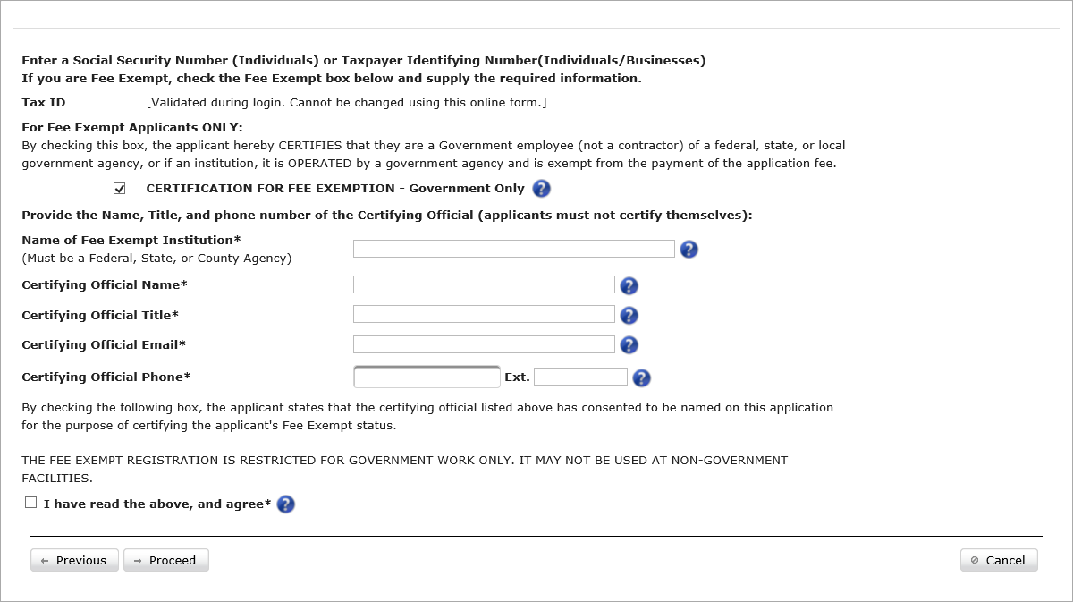
Figure 5: Personal Information, page 2
The following fields are applicable and required for government applicants only. Non-government applicants may click the button to continue to the next page.
- Certification for Fee Exemption: indicates that the applicant is eligible for fee exemption. This should only be clicked by government authorities. The box will be checked automatically for all military applicants.
- Name of Fee Exempt Institution: the name of the registrant’s organization. This field is applicable only when the Fee Exemption box has been checked. This is a required field.
- Certifying Official Name: the name of the individual at the facility authorizing the applicant for certification. This field is applicable only when the Fee Exemption box has been checked. This is a required field.
- Certifying Official Title: the certifier’s title. This field is applicable only when the Fee Exemption box has been checked. This is a required field.
- Certifying Official Email: the certifier’s email address. This field is applicable only when the Fee Exemption box has been checked. This is a required field.
- Certifying Official Phone: the certifier’s phone number, plus extension, if available. This field is applicable only when the Fee Exemption box has been checked. This is a required field.
Once the Fee Exemption fields have been filled, applicants must acknowledge that they have read the following:
THE FEE EXEMPT REGISTRATION IS RESTRICTED FOR GOVERNMENT WORK ONLY. IT MAY NOT BE USED AT NON-GOVERNMENT FACILITIES.
Once the I have read the above and agree checkbox is selected, click the button to continue to the next page.
Note that if the application detects that the Social Security Number (SSN) entered is already in the system, a warning will display advising applicants to file a renewal application instead. However, it is possible to continue the application process with the entered SSN.

Business Activity/Schedules
Applicants request drug schedules on this page. At least one selected drug schedule must be selected to complete this section.
Note that clicking the button will exit the online application, not just the current page.
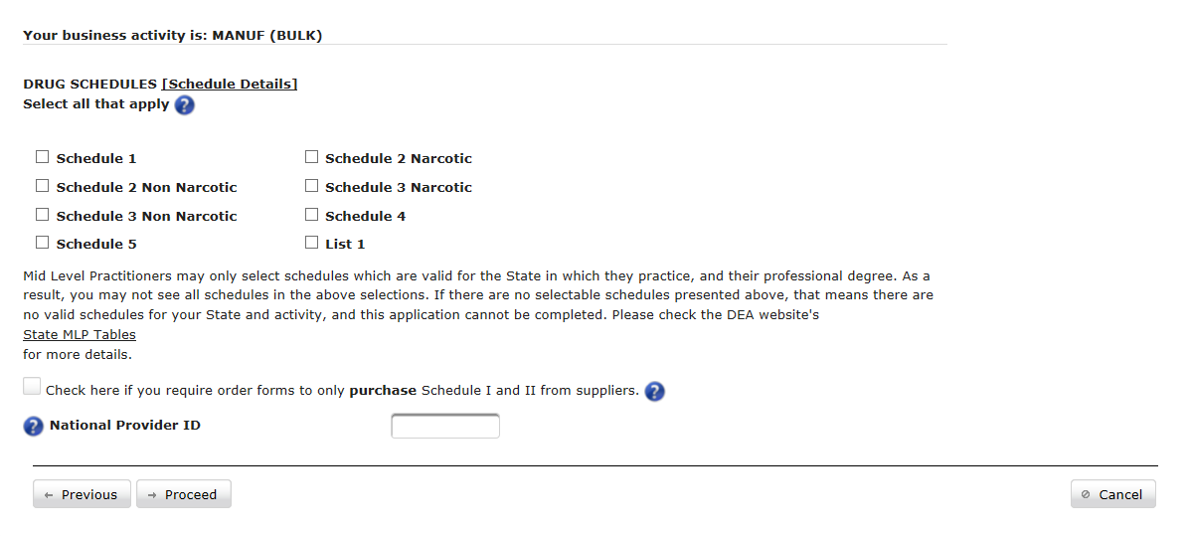
Figure 6: Business Activity/Schedule
- Drug Schedules: select one or more of the available drug schedules. Some checkboxes will be unavailable depending on the selected business activity.
  - Note: individual fee exempt MLPs use the state license from the issuing state instead of the applicant’s zip code to determine drug schedule eligibility. If no state license is available, it defaults to the state determined by the zip code.
  - Note: Schedules available to an MLP will vary based upon state eligibility and selected business activity.
- National Provider ID: the registrant’s National Provider Identification number (NPI). This field is required for any Form 224 business activity. Note that NPIs must be entered in the correct format. Numbers must consist of ten (10) numeric characters and must not begin with a zero (0).
- Professional Degree: select a degree from the drop-down menu. This applies to Individuals.
- Date of Birth: enter the applicant’s (individual’s) date of birth. This applies to Individuals.
- Graduation Year: the year the applicant received a degree from medical school. This applies to Individuals only.
- Medical/Professional School: the medical school from which the applicant received a degree. This applies to Individuals only.
Registrants who require order forms should check the “Check here if you require order forms…” checkbox. Once the renewal is approved, order forms will be sent out.
Once the fields have been completed, click the button to continue to the next page.

State Licenses
Applicants enter state license and state-issued controlled substance license information on this page. State licenses are required for applicants that fall into one of the following categories:
- Practitioner
- Hospital/Clinic
- Teaching Institution
- MLP.
This page will be unavailable for applicants in all other business activities. See A.0 Business Activity Table for more information.
If the previous state license on record has expired, a new one is required before registrants may continue.
Note that clicking the button will exit the online application, not just the current page.
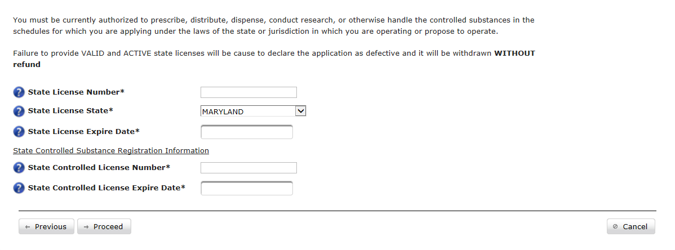
Figure 7: State Licenses
- State License Number: the license assigned to the registrant by the registrant’s home state.
  - This is a required field for Individuals.
  - The license number must be between 2 and 20 characters.
- State License State: select the state from the drop-down menu if either blank or different to the one previously selected. This is a required field for Individuals.
- State License Expire Date: the date on which the license is no longer valid. Click the field to bring up a calendar from which a new date may be selected. This is a required field for Individuals.
- State Controlled License Number: the Controlled Substance (CS) license number assigned to the registrant by the state in which said registrant conducts business.
- State Controlled License Expire Date: the date in which the CS license is no longer valid. Click the field to bring up a calendar from which a new date may be selected.
Note: the system will allow you to save your renewal application without filling in the Controlled License fields. However, your state may require a controlled license, in which case you must complete these fields in order to be compliant with state and federal DEA requirements.
Once the information has been entered, click the button to continue to the next page.

Background Information
The next two pages collect liability-reporting information.

Page 1
Registrants are required to respond to all liability questions.
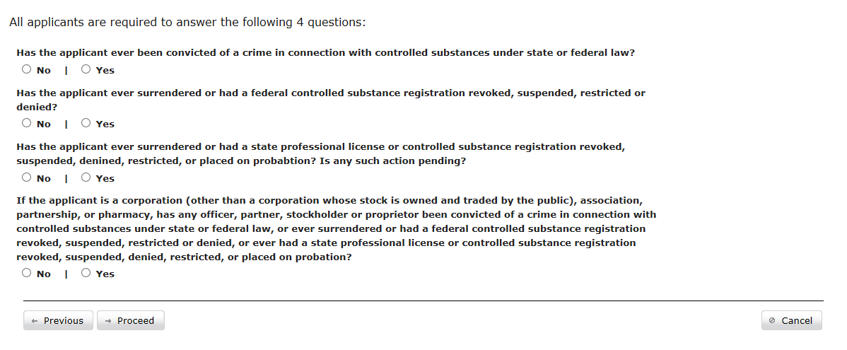
Figure 8: Liability Questions
If there are no liabilities to report, select the No radio button for every question.
Every question that can be answered in the affirmative should be marked with Yes.
If no liabilities were reported, click the button to continue and turn to section 2.6. Otherwise, continue to section 2.5.2.
Note that clicking the button will exit the online application, not just the current page.

Page 2
For every question answered in the affirmative, an explanation must be provided to describe the date, location, nature, and result of the incident.
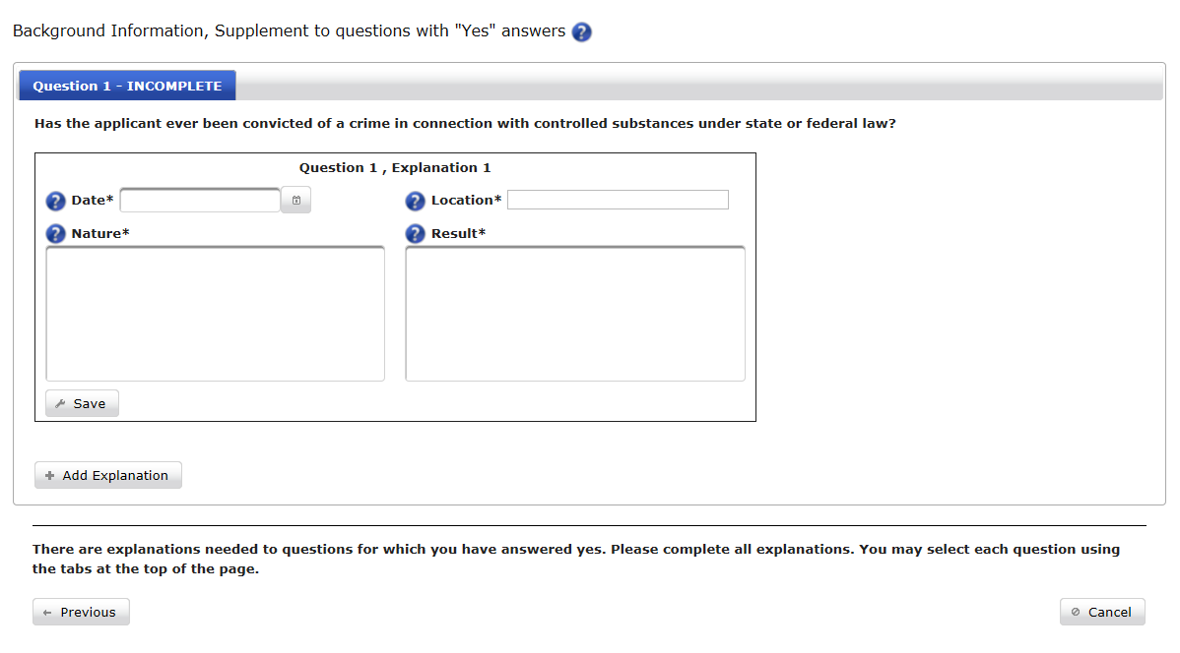
Figure 9: Liability Explanation
- Date: the date the incident occurred. Click the calendar icon ( ) to select the correct date from the displayed calendar.
- Location: the location in which the incident occurred.
- Nature: a detailed description of the incident, including the events leading up to the incident as well as the incident itself.
- Result: the result of the incident as it applies to the applicant’s standing as a DEA registrant.
After filling out the fields, click the button to save the incident data.
If more than one incident occurred that fits the current liability question, click the button.
Once every incident has been detailed and saved, the button will appear. Click it to continue to the next screen.
Note that clicking the button will exit the online application, not just the current page.

Select Drug Codes
Manufacturers must specify at least one (1) drug code for every drug schedule requested. Make any necessary changes, if any, to the selected drug codes (see below).
Note that clicking the button will exit the online application, not just the current page.
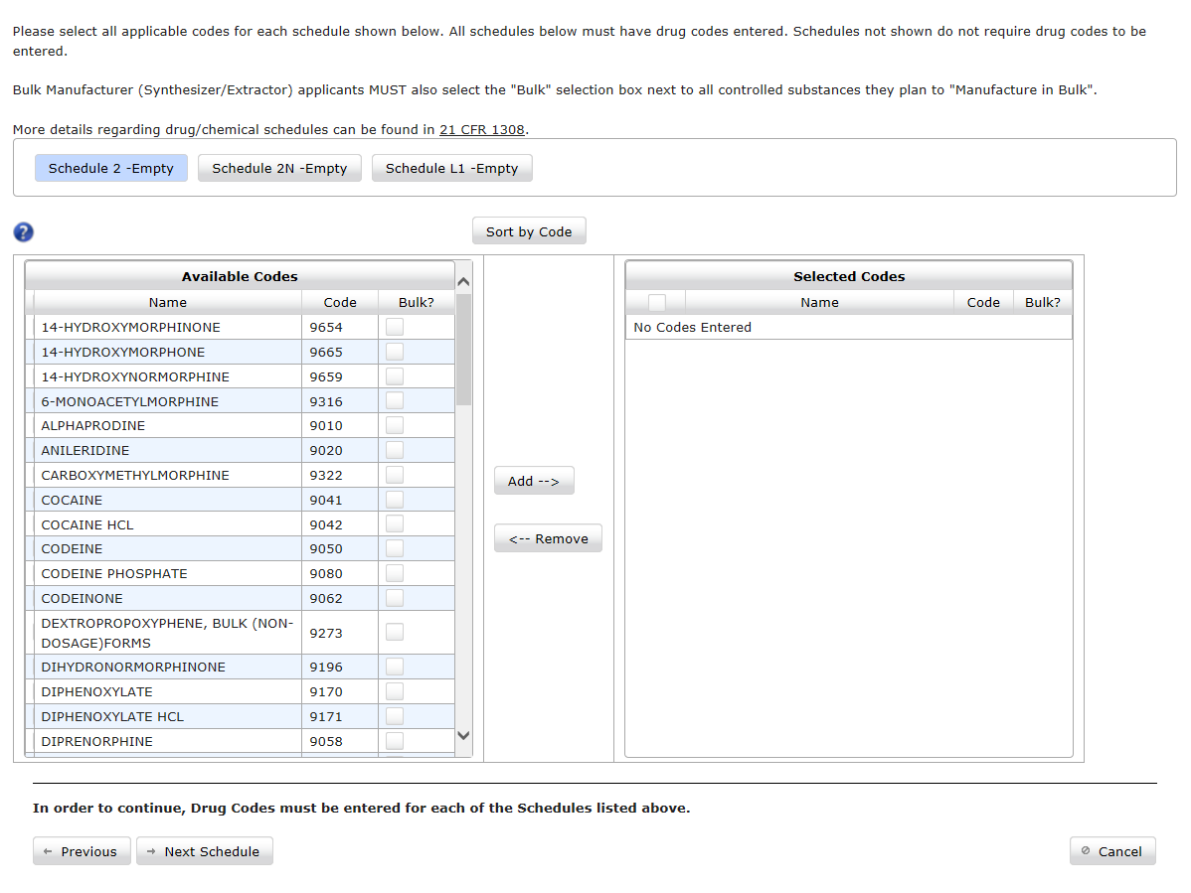
Figure 10: Select Drug Codes
Complete the following steps:
- Select one (1) or more drugs in the Available Codes column.
  - Drugs that will be manufactured in bulk must be indicated by checking the box in the Bulk? Column.
  - Click the button to sort the listed substances by drug code. The button will change to .
  - Click the button to sort the drugs by name.
- Click the button.
  - Each selected drug will appear in the Selected Codes column.
  - The word “Empty” will be removed from the Schedule buttons.
  - Remove mistakenly added drug codes by selecting the drug code and clicking the remove button.
- Click the button.
  - The word “Empty” will be removed from the schedule buttons when at least one drug code from that schedule has been added. For example, the button will change to read .
- The button will appear. Click it to continue to the next screen.

Manufacturer Details
Manufacturers must select specific categories, which will be applied to requested drug schedules. For example, manufacturers that request Schedule II must also choose at least one (1) activity (see below) in Schedule II.
Only the Manufacturers business activity will see this page.
Note that clicking the button will exit the online application, not just the current page.
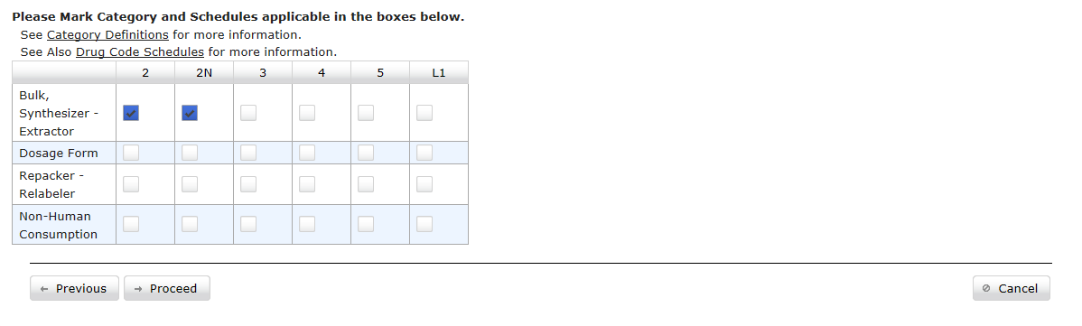
Figure 11: Manufacturer Details
- Bulk, Synthesizer - Extractor: select every drug schedule to be involved in the registrant’s bulk synthesis and extraction process.
- Dosage Form: select every drug schedule to be involved in the registrant’s dosage form manufacture process.
- Repacker - Relabeler: select every drug schedule to be involved in the packaging/repacking and labeling/relabeling process.
- Non-Human Consumption: select every drug schedule that will be manufactured for non-human consumption.
Make any necessary changes. Click the button to continue to the next page.

Payment Information

Page 1
Unless fee exempt, all applicants must pay a non-refundable registration fee. The cost will vary depending on the selected business activity and will be indicated on the screen.
Fee exempt registrants will not see this page.
Note that clicking the button will exit the online application, not just the current page.
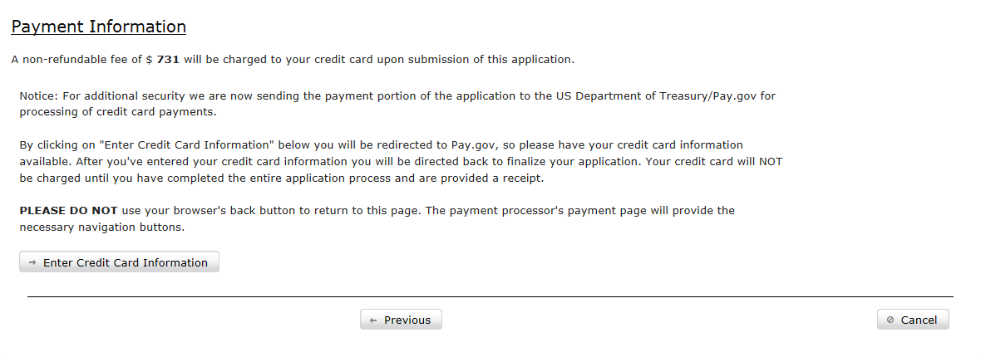
Figure 12: Payment Information
Click the button. The page will redirect to the pay.gov government payment site (see next page). Pay.gov is not owned or maintained by the Diversion Control Division (DC) or the Information Systems Division, Diversion Technology Section (TQD).

Page 2
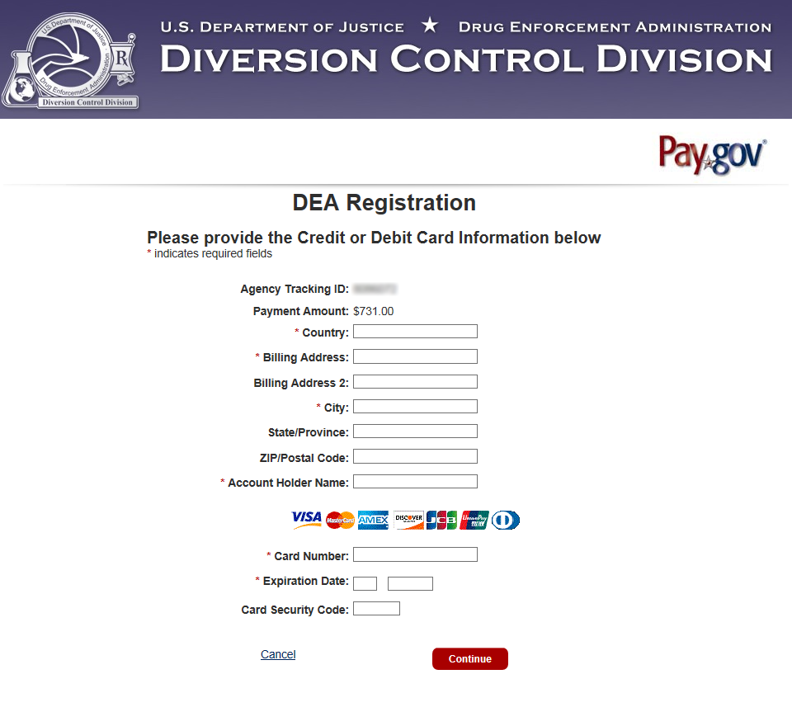
Figure 13: pay.gov
Enter the following information:
- Agency Tracking ID: the Tracking ID is a reference number used by the system.
- Payment Amount: the amount charged to the applicant. The amount is dependent upon the selected Business Activity and cannot be edited.
- Country: the country in which the applicant resides.
- Billing Address: the applicant’s billing address.
- Billing Address 2: the applicant’s additional address information (apartment/suite numbers, etc.), if necessary.
- City: the city in which the applicant resides.
- State/Province: the state or province in which the applicant resides.
- Zip/Postal Code: the applicant’s postal code.
- Account Holder Name: the name as it appears on the credit or debit card.
- Card Number: the credit card number used to pay for the application fee.
- Expiration Date: the date on which the entered credit card will expire
- Card Security Code: the three (3)-digit security code found on the back of the card.
Click the button.
Click the checkbox to confirm all payment information is accurate. Click the button.
Pay.gov will return the applicant to the Renewal Application web form.
Click Cancel to return to the web form without submitting payment.
Note that once the button is clicked, the entered card will be charged. All application fees are non-refundable.

Review and Submit Application
Review the completed information, and submit the application (Figure 14, page 22).
Click any button to make changes to the application, if necessary.
The applicant may choose to answer the following question.
In the last 3 years, have you received any medical education training concerning the prescribing or dispensing of opioid substances? The DEA understands your response is strictly voluntary and not part of the application process.
To submit the application, enter the name of one of the following in the e-Signature field:
- The applicant, if an individual
- A partner of the applicant, if a partnership
- An officer of the applicant, if a corporation, corporate division, association, trust, or other entity
Click the button.
Note that by signing the application, you agree that any information you provide is true and correct. Any information willfully falsified may be subject to legal actions imposed under 21 USC 843(d).
The certificate will be delivered as a PDF file.
Note that clicking the button will exit the online application, not just the current page.

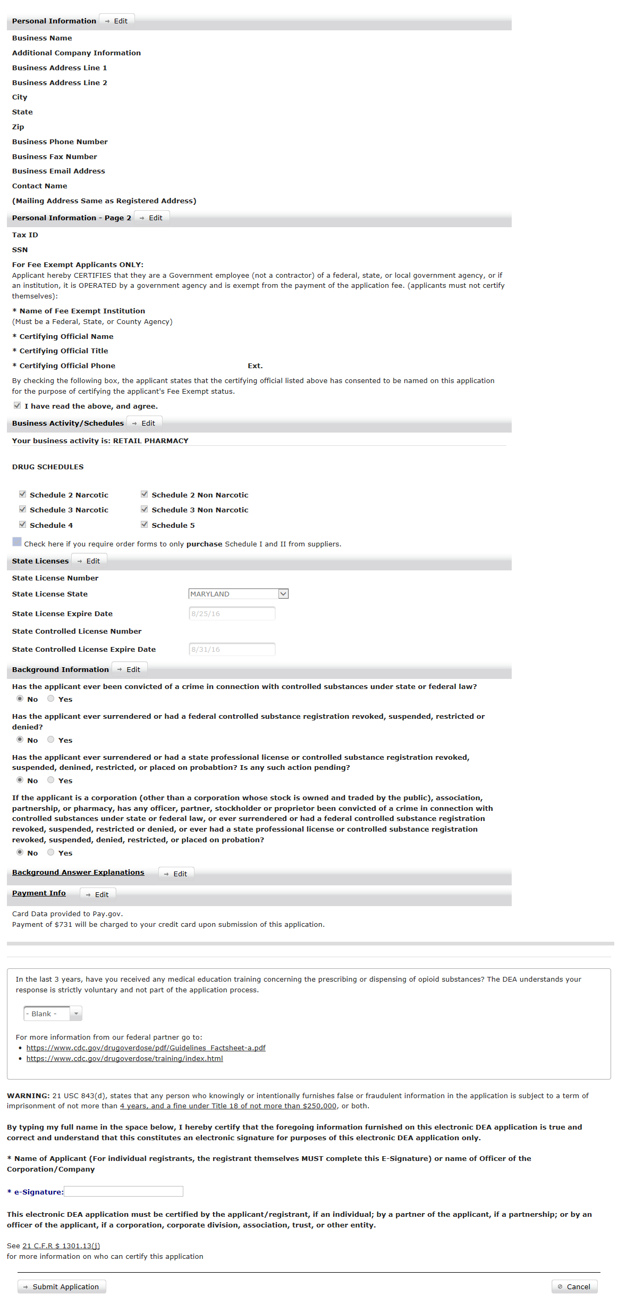
Figure 14: Review and Submit

Print Certificate and Receipt
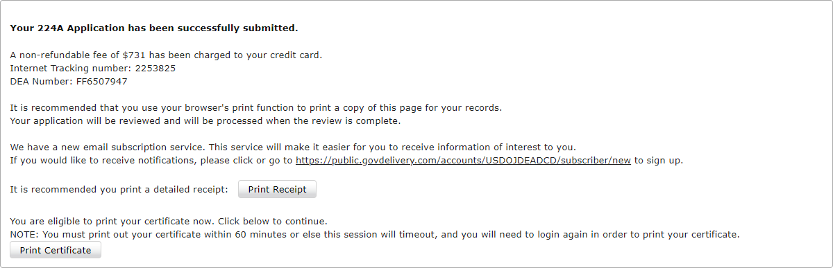
Figure 15: Certificate and Receipt
Once a submission is complete, the transaction receipt and new certificate may be printed. Note that these actions must occur within 60 minutes of reaching the screen above. The receipt and certificate will not be available after 60 minutes.
Click the button to print the receipt.
Click the button to print the certificate.
- Business Activity Table
Business Activity | Fee | Years Valid | Form Number | State License Required? | Description
Analytical Lab | $296 | 1 | 225 | No | A business or facility who analyzes controlled substances through analytical chemistry.
Canine Handler | $296 | 1 | 225 | No | Any individual who works with trained police dogs in the detection of illegally possessed controlled substances.
Central Fill Pharmacy | $888 | 3 | 224 | Yes | A pharmacy permitted by the state in which it is located to prepare controlled substances orders for dispensing, pursuant to a valid prescription transmitted to it by a registered retail pharmacy and to return the labeled and filled prescriptions to the retail pharmacy for delivery to the ultimate user.
Chemical Distributor | $1,850 | 1 | 510 | No | A grocery store, general merchandise store, drug store, or other entity or person whose activities as a distributor relating to drug products containing pseudoephedrine or phenylpropanolamine are limited almost exclusively to sales for personal use, both in number of sales and volume of sales, either directly to walk-in customers or in face-to-face transactions by direct sales.
Chemical Exporter | $1,850 | 1 | 510 | No | A regulated person who, as the principal party in interest in the export transaction, has the power and responsibility for determining and controlling the sending of the listed chemical out of the United States.
Chemical Importer | $1,850 | 1 | 510 | No | A regulated person who, as the principal party in interest in the import transaction, has the power and responsibility for determining and controlling the bringing in or introduction of the listed chemical into the United States.
Chemical Manufacturer | $3,699 | 1 | 510 | No | A business or facility who manufactures a listed chemical, whether under a registration as a manufacturer or under authority of registration as a researcher or chemical analyst.
Chempack/SNS Distributor | $1,850 | 1 | 225 | No | A business or facility authorized to distribute self-centralized units placed in centralized locations with controlled substances (chempacks) from the Strategic National Stockpile (SNS) to enable first responders to quickly administer those lifesaving substances.
Compounder | $296 | 1 | 363 | No | The business activity that engages in maintenance or detoxification treatment who also mixes, prepares, packages or changes the dosage form of a narcotic drug listed in Schedules II, III, IV or V for use in maintenance or detoxification treatment by another narcotic treatment program.
Detoxification | $296 | 1 | 363 | No | The business activity that dispenses, either short- or long-term, a narcotic drug in decreasing doses to an individual in order to alleviate adverse physiological or psychological effects incident to withdrawal from the continuous or sustained use of a narcotic drug for the purposes of bringing the individual to a narcotic drug-free state within such period of time.
Distributor | $1,850 | 1 | 225 | No | A business or facility who does not administer or dispense controlled substances, but delivers a controlled substance or listed chemical to another entity registered with the DEA.
Emergency Medical Services | $888 | 3 | 224 | Yes | An organization that provides EMS only. This includes an organization that is governmental, nongovernmental, private, or volunteer-based; provides emergency medical services by ground, air, or otherwise; and is authorized by the State in which the organization is providing such services to provide emergency medical care, including the administering of controlled substances, to members of the general public on an emergency basis.
Exporter | $1,850 | 1 | 225 | No | A regulated person who, as the principal party in interest in the export transaction, has the power and responsibility for determining and controlling the sending of the controlled substance out of the United States.
Hospital/Clinic | $888 | 3 | 224 | Yes | A hospital or other person (other than an individual) licensed, registered, or otherwise permitted, by the United States or the jurisdiction in which it practices, to dispense a controlled substance in the course of professional practice, but does not include a pharmacy.
Hospital/Clinic — Military | $0 | 3 | 224 | Yes | A military hospital or other person (other than an individual) licensed, registered, or otherwise permitted, by the United States or the jurisdiction in which it practices, to dispense a controlled substance in the course of professional military practice, but does not include a pharmacy.
Importer | $1,850 | 1 | 225 | No | A regulated person who, as the principal party in interest in the import transaction, has the power and responsibility for determining and controlling the bringing in or introduction of the controlled substance into the United States.
Importer  (C I, II) | $1,850 | 1 | 225 | No | Any person who imports, or who acts as an import broker for importation of List I and List II chemicals.
Maintenance | $296 | 1 | 363 | No | The business activity that dispenses for a period in excess of twenty-one days a narcotic drug in the treatment of an individual for dependence upon heroin or other morphine-like drug.
Manufacturer | $3,699 | 1 | 225 | No | A business or facility who manufactures a drug or other substance, whether under a registration as a manufacturer or under authority of registration as a researcher or chemical analyst.
Manufacturer (Bulk) | $3,699 | 1 | 225 | No | A business or facility who manufactures a drug or other substance in bulk quantity, whether under a registration as a manufacturer or under authority of registration as a researcher or chemical analyst.
MLP — Ambulance Service | $888 | 3 | 224 | Yes | Any individual that works for a ground ambulance vehicle service with the provision of medically necessary supplies and services including an Advanced Life Support (ALS) assessment or at least one ALS intervention.
MLP — Animal Shelter | $888 | 3 | 224 | Yes | Any individual that uses controlled substances in the licensed care of animals within a private or state-run facility intended for the care of lost, abandoned, or surrendered animals.
MLP — Assistant Physician | $888 | 3 | 224 | Yes | Any individual licensed as a PA. PAs in Kentucky, Puerto Rico, and US Virgin Islands may not prescribe controlled substances.
MLP — Certified Chiropractor | $888 | 3 | 224 | Yes | Any individual certified and licensed to diagnose and treat mechanical disorders of the musculoskeletal system, and prescribe drugs related to such treatment.
MLP — Doctor of Oriental Medicine | $888 | 3 | 224 | Yes | Any practitioner of non–traditional medicine of predominantly Eastern origin. This does not include general practitioners or any other business activity that specializes in traditional Western medicine.
MLP — DOD Contractor | $0 | 3 | 224 | Yes | An individual practitioner, other than a physician, dentist, veterinarian, or podiatrist, who is licensed, registered, or otherwise permitted by the United States and contracted with the DOD to dispense a controlled substance in the course of professional practice. All business activities are authorized only to dispense controlled substances by the State in which they practice.
MLP — Euthanasia Technician | $888 | 3 | 224 | Yes | Any individual that employs pharmacological methods, including the injection of drugs and gases, in the euthanization of an animal.
MLP — Homeopathic Technician | $888 | 3 | 224 | Yes | Any individual who prescribe controlled substances and listed chemicals in the practice of homeopathic medicine.
MLP — Medical Psychologist | $888 | 3 | 224 | Yes | Any individual applying the application of psychological principles to the practice of medicine if both physical and mental disorders.
MLP — Military | $0 | 3 | 224 | Yes | An individual practitioner, other than a physician, dentist, veterinarian, or podiatrist, who is licensed, registered, or otherwise permitted by the United States Military to dispense a controlled substance in the course of professional practice.
MLP — Naturopathic Physician | $888 | 3 | 224 | Yes | Any individual who prescribes controlled substances in the course of alternative, or naturopathic, medicine.
MLP — Nurse Practitioner | $888 | 3 | 224 | Yes | Any Advanced Practice Registered Nurse (APRN) educated with the knowledge base and decision-making skills to treat medical conditions without the supervision of a doctor.
MLP — Nursing Home | $888 | 3 | 224 | Yes | Any private care facility providing residential accommodations with health care, especially for elderly people.
MLP — Optometrist | $888 | 3 | 224 | Yes | Any medically trained individual licensed to deliver primary, secondary, and tertiary eye care.
MLP — Physician Assistant | $888 | 3 | 224 | Yes | Any nationally certified and state-licensed medical professional able to prescribe medication.
MLP — Registered Pharmacist | $888 | 3 | 224 | Yes | Any individual with a license to practice the preparation, composition, and dispensation of drugs pursuant to a valid prescription.
Pharmacy — Military | $0 | 3 | 224 | Yes | An entity permitted to prepare controlled substance orders for dispensing, pursuant to a valid prescription for the United States Military and its personnel.
Practitioner | $888 | 3 | 224 | Yes | A physician, dentist, veterinarian, or other individual licensed, registered, or otherwise permitted, by the United States or the jurisdiction in which he/she practices, to dispense a controlled substance in the course of professional practice, but does not include a pharmacist, a pharmacy, or an institutional practitioner.
Practitioner — DOD Contractor | $0 | 3 | 224 | Yes | A physician, dentist, veterinarian, or other individual licensed, registered, or otherwise permitted, by the United States and contracted with the Department of Defense (DOD) to dispense a controlled substance in the course of professional practice, but does not include a pharmacist, a pharmacy, or an institutional practitioner.
Practitioner — Military | $0 | 3 | 224 | Yes | A military physician, dentist, veterinarian, or other individual licensed, registered, or otherwise permitted, by the United States Military to dispense a controlled substance in the course of professional practice, but does not include a pharmacist, a pharmacy, or an institutional practitioner.
Researcher  (I) | $296 | 1 | 225 | No | Any individual who conducts diligent and systematic inquiry or investigation into controlled substances listed in schedule I.
Researcher  (II-IV) | $296 | 1 | 225 | No | Any individual who conducts diligent and systematic inquiry or investigation into controlled substances listed in schedules II-V.
Retail Pharmacy | $888 | 3 | 224 | Yes | An entity permitted by the state in which it is located to prepare controlled substance orders for dispensing, pursuant to a valid prescription.
Reverse Distributor | $1,850 | 1 | 225 | No | A person registered with the Administration to acquire controlled substances from another registrant or law enforcement for the purpose of return to the registered manufacturer or another registrant authorized by the manufacturer to accept returns on the manufacturer's behalf; or destruction.
Teaching Institution | $888 | 3 | 224 | Yes | A physical location where medicine is taught under the authority of a State accredited college or university.

- Acronyms
Acronym | Description
ALS | Advanced Life Support
APRN | Advanced Practice Registered Nurse
CS | Controlled Substance
CSA | Controlled Substances Act
DEA | Drug Enforcement Administration
DOD | Department of Defence
EMS | Emergency Medical Services
MLP | Mid-Level Practitioner
NPI | National Provider Identification
PA | Physician Assistant
PDF | Portable Document Format
SNS | Strategic National Stockpile
SSN | Social Security Number

