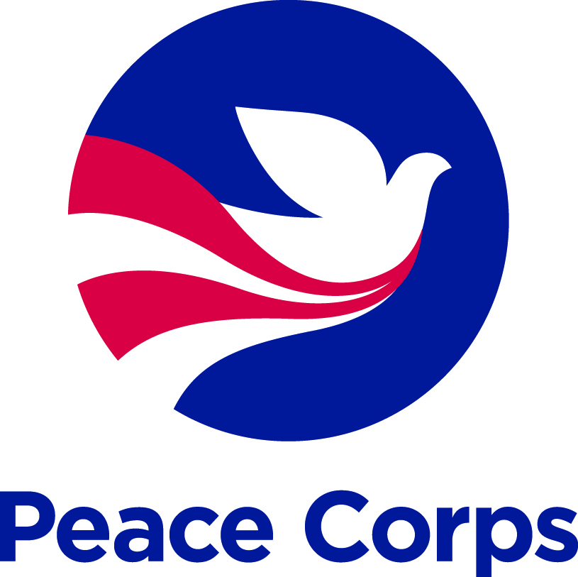

If you are inspired by impact that is hands-on, grassroots-driven, and lasting, making a donation
to the Peace Corps Partnership Program (PCPP) is a powerful way to make a difference in our world.

DONOR INFORMATION
First Name: |  | Last Name:
Company/Group:
Address Line 1: |  | Line 2:
City: |  | State: |  | Zip/Postal Code:
Primary Phone: |  | Email:
Are you a Returned Peace Corps Volunteer?
Country of Service: |  | Years of service: (MM/YY – MM/YY)

GIFT INFORMATION
Charitable contributions to the Peace Corps are tax-deductible under section 170(c)(1) of the Internal Revenue Code.
I would like to support (chose one) |  | In the amount of (chose one)
Project Name*: |  |  | $50
Country Fund: |  |  | $100
Special Fund: |  |  | Other:_________________________

Payment Type:

Check/Money Order (Please attach) Visa Master Card American Express Discover
Make checks payable to the “Peace Corps” and, in memo section indicate “Peace Corps Partnership Program.”
Check/Credit Card Number: | Expiration Date (mm/yy):
Cardholder Name:

*The Peace Corps is only able to fund a project up to the amount that a Volunteer requests. Once a project becomes fully funded, any extra or unused restricted donations will be allocated to the Global Fund to support other PCPP Volunteer projects worldwide.

SPECIAL DESIGNATION
I would like to make this donation In Honor Of or In Memory Of:
First Name of Honoree: |  |  |  | Last Name of Honoree:
Who should we notify? Please provide information for the person we should contact about your dedication.
Dedication Contact Name:
Dedication Address: |  |  |  | Line 2:
City: |  |  |  | State: |  | Zip/Postal Code:
Dedication Email:
Dedication Message (optional):
Required: | Yes No |  | I authorize the Peace Corps to make my name and contact information available to the honoree or person who will be notified of the dedication.

STAY CONNECTED (Required)
Yes | No | I would like to stay informed of exciting Volunteer stories from the field and upcoming opportunities to donate to or partner with the Peace Corps. Peace Corps will not share your information with outside organizations.
Yes | No | I authorize the Peace Corps to make my name and contact information available to the Volunteer coordinating the project I am supporting.
Yes | No | I authorize the Peace Corps to include my name on the Donor Recognition Page of the Peace Corps website.
If you, your business, your employer, or an immediate family member is currently doing business or seeking to do business with Peace Corps, or otherwise has business, financial or other substantial interests that may be affected by the Peace Corps, please check the box above and contact the Peace Corps Partnership Program at 202.692.2170 or donate@peacecorps.gov. Note: Serving as a Peace Corps Volunteer does not create a business, financial or other substantial interest in this context.
Paperwork Reduction Act Burden Statement: Public reporting burden for this information collection is estimated to average 10 minutes. This includes the time for reviewing instructions and completing the information. This is voluntary information collection. An agency may not conduct or sponsor, and persons are not required to respond to, a collection of information unless it displays a currently valid OMB control number. Send comments regarding this burden estimate or any other aspect of this collection of information, including suggestions for reducing this burden, to: the FOIA Officer, Peace Corps, 1275 First Street NE, Washington, D.C. 20526.
Privacy Act Notice: The Peace Corps, a U.S. government agency, is required by the Privacy Act of 1974 (5 U.S.C. 552a) to advise you of the following information regarding this form and how we protect personal information that the agency maintains and uses in its systems of records.
Authority: The Peace Corps Act (22 U.S.C. 2501 et seq.), as amended which authorizes the Peace Corps to accept gifts in furtherance of the purposes under the Act.
Purpose: The primary use of the information on this form is to process your financial donation.
Routine Use: Use of the information collected on this form is restricted to the purposes cited in this privacy statement or unless the disclosure is otherwise permitted under the provisions of the Privacy Act of 1974, 5 U.S.C. 552a (b) "Conditions of Disclosure," and the agency’s privacy policy. The information you provide on this form may be shared under the general system of records routine uses A through M that apply to this system. For information on these routine uses, click on the link to the Peace Corps Privacy webpage. This information collection is covered by System of Records Notice PC-10, Office of Private Sector Initiatives Database. Your name and donation amount may be disclosed as part of a valid FOIA request to obtain access to donor information collected by the Peace Corps as an independent agency under the Executive branch of the United States government. The agency is committed to ensuring that any personal information it receives is safeguarded against unauthorized disclosure.
Disclosure: Completion of this form is voluntary; however, failure to complete this form may impair or delay the Peace Corps’ ability to process your donation.

