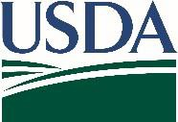

United States Department of Agriculture
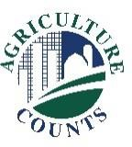
National Agricultural Statistics Service

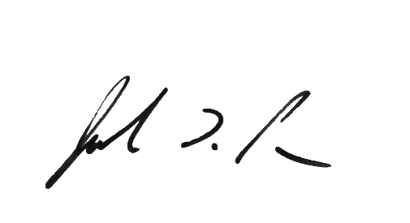
<DATE> DRAFT

Why am I getting this letter?
What should I do next?
Complete your survey in one of the following ways:

Online at www.agcounts.usda.gov beginning on October 16. Online reporting is fast, cost-effective, and secure. All you need is the 17-digit survey code on the enclosed questionnaire to begin.

By mail or fax. Complete the survey questionnaire and mail it back in the return envelope provided or fax it to (855) 415-3687.

The National Agricultural Statistics Service (NASS) is reaching out to farmers to determine pollination costs incurred by crop producers. Please complete your questionnaire online or by mail at your earliest convenience. If you do not respond by <DATE>, a representative from our office may contact you to arrange a telephone interview or a personal interview.

What is this data used for?

- Pollination expenditures are a necessary part of the crop industry and are directly tied to the health of the honey bee industry.
- Survey responses help producers and beekeepers monitor and react to changes in production costs.

The results of this survey will be available in aggregate form only, ensuring that no individual operation or producer can be identified, as required by federal law. We will publish the survey findings in the annual Cost of Pollination report on <DATE>.

Thank you for participating and for your support of our programs and U.S. agriculture. If you have any questions, please feel free to contact us at (888) 424-7828.

Sincerely,
Release Dates of Upcoming Honey Bee Reports
Cost of Pollination: <DATE> Honey: <DATE>
Honey Bee Colonies: <DATE>
Cost of Pollination: <DATE>

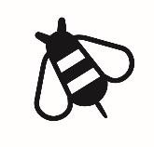
Joseph L. Parsons
Chairman, Agricultural Statistics Board Enclosure

1400 Independence Avenue, SW · Washington, D.C. 20250
www.nass.usda.gov
USDA is an equal opportunity provider, employer, and lender.

