Non-substantive Change Request
0535-0258 – Cost of Pollination Survey
Cost of Pollination Survey

In an effort to add publicity for the reinstated Cost of Pollination Survey and increasing response, NASS would like to send a presurvey announcement postcard to the entire sample prior to the questionnaire mailing. The data collection plan is now:
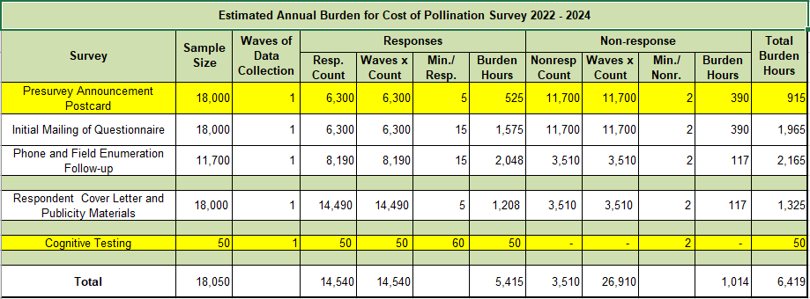
The highlighted row is the change. As a result of this request, annual burden would increase by 11,750 responses and 965 hours.
The presurvey announcement postcard is loaded in the ROCIS submission system.
This change also includes a request to add 50 cognitive interviews per year to test questionnaire updates.

