**Description**

The Census Bureau is planning to add two yes/no questions to the 2022 Report of Organization survey (0607-0444). The questions will ask if a multi-establishment company exports and/or imports services to/from foreign firms.  The collected responses will be used for research purposes and potential future frame development. The answers should be first-hand knowledge for the respondents, and they will answer these questions at the company level as opposed to the individual establishment level.  Single establishment companies will not be asked to respond as they will receive these questions on the 2022 Economic Census. These questions will only be asked for the 2022 survey year.

We expect these inquiries to add approximately a minute per question to each respondent’s reporting burden, increasing the average burden per response during 2022 from 24 to 26 minutes. The newly estimated annual reporting burden for the collection is 127,238 hours. This is an increase of 2,222 hours over the current annual burden.

**Justification from Center for Economic Studies**

Services trade (exports and imports) has traditionally not been as well measured as goods trade because unlike goods trade, there is no central customs agency that provides administrative collection of information on services trade transactions. The primary source of information on services trade is collected by the Bureau of Economic Analysis (BEA) on firm-level surveys.[1] However, the BEA surveys only collect information for firms that export (import) services valued at or above 2 (1) million USD, hence, smaller services traders are excluded (Ibarra-Caton, 2010; Jensen and Kamal, 2020). Comprehensive identification of services traders is ultimately motivated by the shift in aggregate economic activity from goods-producing to services-producing sectors and the growing importance of service trade in the U.S. economy. In 2019, manufacturing industries accounted for only 9 percent of employment while services accounted for 64 percent.[2] In 2019, services accounted for 35 percent of US exports and the US maintained a services trade surplus.[3]

**References**

Ibarra-Caton, Marilyn, 2010. “An Examination of the Sources of Differences Between Exports of Services Statistics Published by the Census Bureau and the U.S. Bureau of Economic Analysis,” mimeo.

Jensen, J. Bradford and Fariha Kamal, 2020. “Assessing Prospects to Incorporate Service Trade in Business Dynamics Statistics – Globally Engaged Firms (BDS-GEF),” internal Census Bureau memo.

**Cognitive Testing Findings**

In Round 3 of cognitive testing for these questions, the respondents reviewed the Report of Organization (aka COS) versions of the Exported and Imported Services questions. These were auxiliary establishments that support manufacturing operations.

The following questions would be on the Report of Organization which would be completed before the Economic Census questions are presented. Note that they ask about the company, rather than a specific establishment.

COS1. Did this company **provide services to foreign businesses** in 2022 (that is, exported services)?

Exclude:

* Exported goods
* Services provided to domestic subsidiaries of foreign businesses

Foreign businesses located outside the United States (i.e., outside the 50 States, District of Columbia, U.S. Commonwealth Territories, or U.S. possessions)

Include services provided to unaffiliated foreign businesses (i.e., foreign parent firms, subsidiaries, branches, etc.) located outside the U.S.

Yes

No

COS2. Did this company **purchase services from foreign businesses** in 2022 (that is, imported services)?

Exclude:

* Imported goods
* Services purchased from domestic subsidiaries of foreign businesses

Foreign businesses located outside the United States (i.e., outside the 50 States, District of Columbia, U.S. Commonwealth Territories, or U.S. possessions)

Include services purchased from unaffiliated foreign businesses (i.e., foreign parent firms, subsidiaries, branches, etc.) located outside the U.S.

Yes

No

Overall Findings:

* Some respondents initially thought the first question was asking about goods.
* Some respondents were not sure what types of services would be included (i.e., what is the “definition” of services).
* Wording of instruction about unaffiliated businesses was confusing to some respondents.
* Wording of second exclude about domestic subsidiaries of foreign businesses was confusing to some respondents.

Recommendations:

* Add “(not goods)” to questions
  + COS1. Did this company **sell services (not goods) to foreign businesses** in 2022 (i.e., exported services)?
  + COS2. Did this company **purchase services (not goods) from foreign businesses** in 2022 (i.e., imported services)?
  + This was tested at the single unit level with the establishment version of the question, and it performed well.
* Initial recommendation was to put all supplemental information (definition, excludes, includes) in the more link. However, EC22 content team decided to keep all info on screen, so for consistency, that is recommended here as well.
* The EC22 content team also recommended replacing “that is” in the question with “i.e.,” to be consistent with other questions on the EC22, so again, for consistency, that is recommend here as well.

Revised Questions:

COS1. Did this company **sell services (not goods) to foreign businesses** in 2022 (i.e., exported services)?

Foreign businesses are those located outside the United States (i.e., outside the 50 States, District of Columbia, U.S. Commonwealth Territories, or U.S. possessions).

Include:

* Services provided to any foreign businesses, whether affiliated or unaffiliated (i.e., foreign parent firms, subsidiaries, branches, etc.)

Exclude:

* Exported goods
* Services provided to domestic subsidiaries of foreign businesses

Yes

No

COS2. Did this company **purchase services (not goods) from foreign businesses** in 2022 (i.e., imported services)?

Foreign businesses are those located outside the United States (i.e., outside the 50 States, District of Columbia, U.S. Commonwealth Territories, or U.S. possessions).

Include:

* Services purchased from any foreign businesses, whether affiliated or unaffiliated (i.e., foreign parent firms, subsidiaries, branches, etc.)

Exclude:

* Imported goods
* Services purchased from domestic subsidiaries of foreign businesses

Yes

No

**Questionnaaire Mockups**

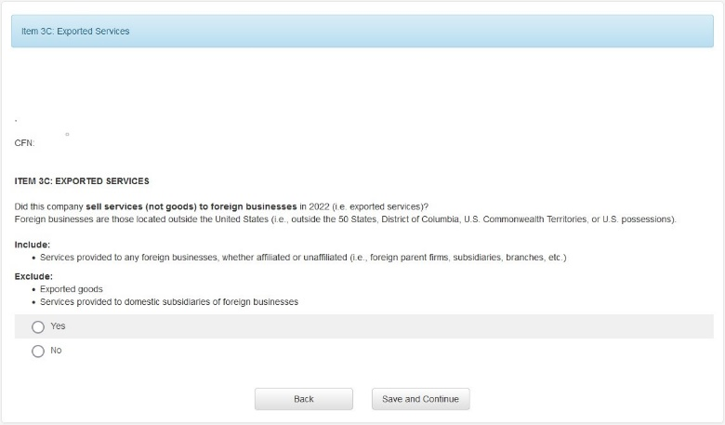

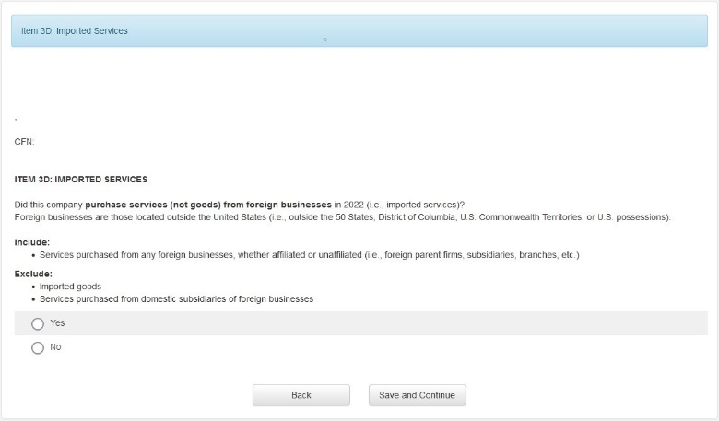

1. See [International Surveys: U.S. International Services Transactions | U.S. Bureau of Economic Analysis (BEA)](https://www.bea.gov/international-surveys-us-international-services-transactions) for a list of all surveys on international services transactions and [surveysu.pdf (bea.gov)](https://www.bea.gov/system/files/2018-08/surveysu.pdf) for details..
2. Calculated using 2019 County Business Patterns ([CBP Tables (census.gov)](https://www.census.gov/programs-surveys/cbp/data/tables.html)) where services (manufacturing) is defined as the following two-digit NAICS: 51, 52, 53, 54, 55, 56, 61, 62, 71, 72, 81 (31, 32, 33).
3. Calculated from [International Trade in Goods and Services | U.S. Bureau of Economic Analysis (BEA)](https://www.bea.gov/data/intl-trade-investment/international-trade-goods-and-services).