PRA Application Supporting Statement

OMB Control #0693-0078
Expiration Date: 07/31/2022
NIST Generic Clearance for Community Resilience Data Collections

NIST HURRICANE MARIA STUDY,
HURRICANE MARIA RECOVERY OF CRITICAL SOCIAL FUNCTIONS PROJECT:
HOSPITAL RECOVERY FOLLOWING HURRICANE MARIA
HOSPITAL RECOVERY SURVEY WAVE 1

FOUR STANDARD SURVEY QUESTIONS
This PRA application covers the Wave 1 Survey for the Recovery of Hospitals component of the scientific study of Hurricane Maria (henceforth the Recovery of Social Functions Project).

1. Explain who will be surveyed and why the group is appropriate to survey.

Data collection will target specific organizational representatives (e.g., Administrator, Executive Director, and Manager) who can complete the survey on behalf of hospitals. Participation in the study will be limited to organizational representatives who meet certain eligibility criteria. Criteria include (1) being a knowledgeable organizational representative of a hospital, i.e., having administration experience before and after Hurricane Maria, familiarity with the hurricane impacts sustained by their schools, and relevant participation in key recovery activities, and (2) the individual is an adult (18 years of age or older). By targeting suitable organizational representatives, the study will provide direct insight into the services and resources offered by hospitals before and after Hurricane Maria, the damage and disruption to hospital functioning caused by the hurricane, the repair and recovery process from Hurricane Maria, as well as actions taken by hospital administrators to prepare for future hurricanes.

Hospitals are in many ways a defining characteristic of modern industrial societies. Hospitals often serve as the primary source of medical care and health education in communities, while supporting medical research and technological innovation more broadly. The societal functions provided by hospitals may be key to understanding the recovery of communities in disaster contexts. By identifying the underlying characteristics and conditions associated with recovery of critical social functions from Hurricane Maria as well as the interdependencies of the broader community (e.g., households, businesses), this work will allow us to make recommendations for 1) community resilience metrics for the healthcare sector and 2) guidance on recovery actions for critical social functions that support prioritization within different phases of the hazard event.

Project Background: The research objective of the Recovery of Social Functions Project is to identify the underlying characteristics and conditions associated with recovery of critical social functions from Hurricane Maria in Puerto Rico and to examine the recovery trajectories of sampled social organizations (specifically, hospitals and K-12 schools). This study falls within a broader program of activity at NIST - the Hurricane Maria Program. Under this program, there is both a technical investigation of Hurricane Maria and its impacts on Puerto Rico and a scientific study of the impacts of and recovery from Hurricane Maria. As complementary components of the NIST Hurricane Maria Program, the NCST technical investigation and the NWIRP research study are closely coordinated. Under the National Windstorm Impact Reduction Act Reauthorization of 2015 (Public Law 114-52), NIST is conducting a scientific study of the impacts of and recovery from Hurricane Maria. The National Windstorm Impact Reduction Act Reauthorization (Public Law 114-52) designates NIST as the lead agency for the National Windstorm Impact Reduction Program (NWIRP) and gives NIST responsibility to:
- Ensure that the Program includes the necessary components to promote the implementation of windstorm risk reduction measures;
- Support the development of performance-based engineering tools, and working with appropriate groups to promote the commercial application of such tools;
- Request the assistance of Federal agencies other than the Program agencies, as necessary;
- Coordinate all Federal post-windstorm investigations to the extent practicable; and
- When warranted by research or investigative findings, issue recommendations to assist in informing the development of model codes, and provide information to Congress on the use of such recommendations.

NWIRP was established by Congress “…to achieve major measurable reductions in the losses of life and property from windstorms through a coordinated Federal effort, in cooperation with other levels of government, academia, and the private sector, aimed at improving the understanding of windstorms and their impacts and developing and encouraging the implementation of cost-effective mitigation measures to reduce those impacts.”

Under the NWIRP authority, NIST is conducting a scientific study of Hurricane Maria’s impacts on Puerto Rico and subsequent recovery processes. The three main goals of the study are to characterize the impacts to and recovery of: (1) small and medium-sized manufacturers (SMMs), as well as businesses in retail and service industries, (2) education and healthcare services, and (3) infrastructure systems, with a focus on infrastructure that supports the functioning of critical buildings (i.e., schools and hospitals) and emergency communications.

2. Explain how the survey was developed including consultation with interested parties, pre-testing, and responses to suggestions for improvement.

The survey instrument was developed by NIST scientists and contractors with backgrounds in sociology, geography, anthropology, and economics through a series of development and quality control activities. The survey instrument was reviewed in depth by scientists and engineers with backgrounds in disaster resilience, public policy, emergency medicine, and clinical psychology. The survey instrument captures the characteristics and conditions that influence institutional recovery and resilience in the context of hydro-meteorological disasters.

First, a review of previous hurricane literature, relevant news media, and survey instruments was conducted to better understand the types of factors that influence the recovery of organizational functioning during these types of disaster events and develop the basis of our survey. When possible, established scales and items were used from previous hurricane and/or organizational recovery and resilience research. The literature review employed Web of Science, Google Scholar, and Google to identify papers, reports, and survey instruments in peer-review journals and the grey literature.

Next, after a draft survey was developed, NIST researchers obtained feedback from subject matter experts in the study of disaster recovery to better assess question wording, complexity, and overall burden. This review also included members of the contractor team that is working with NIST. Additional revisions were made that focused on the content of the survey questions (i.e. which concepts were measured and included), and the instrument was condensed to reduce its length.

Then, NIST contractors conducted a pilot study of the survey instrument (n=5). Based on pilot study findings, changes were made to the pre-notification and outreach process, respondent screening questions, and the final survey instrument to facilitate study participation and reduce respondent burden (e.g., select sets of survey questions were cut, time periods referenced were reduced). The pre-notification and outreach process has been modified to include physical mailing of the introductory letter describing the scope and objective of the Hurricane Maria investigation, in addition to the emailed introductory letter. Respondent screening questions were also revised to account for hospitals that may have relocated after Hurricane Maria. Finally, minor revisions were made to the survey instrument to enhance clarity and consistency in wording. These include changes to word choice, formatting, and ordering of questions.

3. Explain how the survey will be conducted, how customers will be sampled if fewer than all customers will be surveyed, expected response rate, and actions your agency plans to take to improve the response rate.

NIST, in partnership with contractors who can utilize trained personnel local to Puerto Rico, will survey hospitals in the study area. Structured surveys of hospitals will be implemented at three points in time or “waves” along a continuum of recovery. Surveys shall be administered to the same sample with emphasis on maintaining the same panel of respondents (i.e., hospitals). Figure 1 provides an overview of the survey data collection.

An introductory email describing the scope and objective of the Hurricane Maria study will be sent to email addresses associated with individual hospitals in the study area. Respondents will have the option to complete the surveys in-person, over the phone or self-administered online. The priority mode will be self-administered online. For the in-person survey, NIST contractors will obtain verbal consent and interview respondents at their place of work. For the telephone survey, NIST contractors will telephone the respondent at a predetermined time and administer the survey after obtaining verbal consent. Both the telephone and in person interviews will exactly follow the questions as outlined on the electronic / online surveys. For the online surveys, respondents will access the survey link to the Qualtrics website sent in an earlier email, logon to the survey platform using a unique ID and password, and complete the survey. Any in person interviews will comply COVID-19 safety protocols. In person data collection will also depend upon successful initial contact and a prior appointment with the respondent. It is anticipated that 25% of respondents will opt to complete the survey in-person, while 25% will opt to complete the survey by telephone. The remaining 50% of respondents are expected to complete the survey online. See supporting materials for the Hospital Survey Email and Phone Scripts and Screen Text.

Location | Data Collection Instrument | Number of Organizations | Average Length  (per)
NIST Study Area - Municipios and barrios within the 2017 emergency management zones selected by NIST (I,VII,X,XI), plus Mayaguez | Wave 1 hospitals survey | 45 Hospitals (45 organizational representatives) | 25 minutes
 | Wave 2 hospitals survey | 45 Hospitals (45 organizational representatives) | 25 minutes
 | Wave 3 hospitals survey | 45 Hospitals (45 organizational representatives) | 25 minutes
Figure 1. Health Technical Component - Survey Data Collection

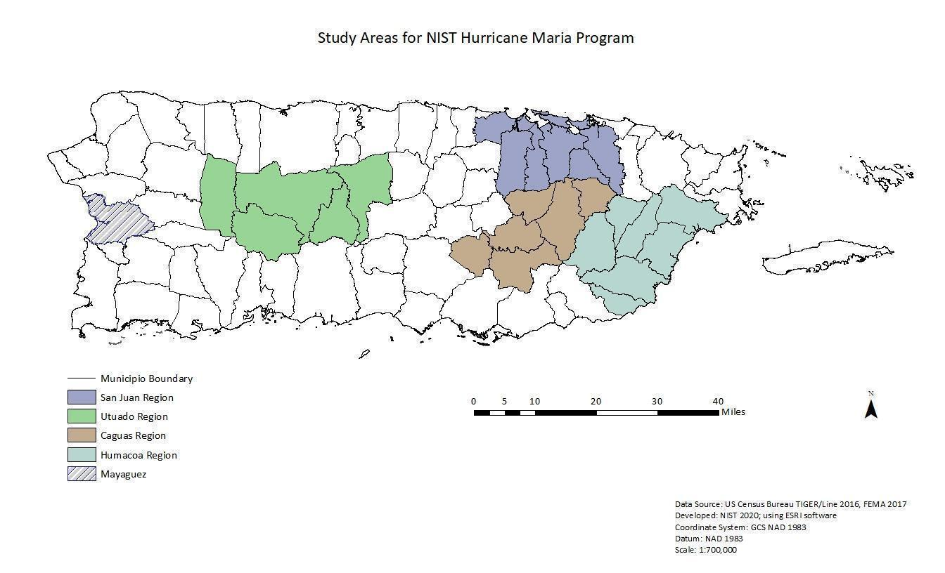
Figure 2. Health Technical Component - Study Area

There are 68 hospitals in Puerto Rico, 45 of which are in the study area. Due to the limited number of hospitals, all 45 will be selected to participate in the study (Linking=10, Non-Linking=35). The hospital sample is in effect a census of hospitals in the study area. A secondary sample frame was developed that includes the remaining hospitals in Puerto Rico that are located outside of the study area. The secondary frame contains 23 hospitals, which will serve as replacements for non-respondents hospitals within the study area as needed.

Response rates will be closely monitored to achieve the expected 100% survey completion rate for hospitals. A number of outreach efforts were undertaken in order to enhance the visibility and legitimacy of the project and achieve expected response rates. First, the NIST Hurricane Maria webpage is used to generate awareness of the project, planned data collection, and to prepare respondents for study participation requests. Second, introductory letters describing the scope and objective of the Hurricane Maria investigation were sent to physical and email addresses associated with individual hospitals in the study area. Third, NIST researchers held a series of meetings with stakeholders and representatives of the relevant governing bodies (e.g., Puerto Rico Department of Health) to understand local needs and concerns and identify perspectives less likely to be captured in surveys. The survey landing page provides additional project background information, including an introductory letter from NIST and contact information for NIST contractors assisting with data collection.

In addition to pre-survey outreach efforts, the Recovery of Social Functions Project has developed a multi-mode approach for respondent completion (i.e., by telephone, self-administered online, in person) and secondary sample frames from which to draw replacement hospitals located outside the study area.

Depending on the response rates realized, all hospitals in Puerto Rico may be needed in order to attain the desired number of complete responses. If survey completion rates fall below the goal threshold as identified during weekly assessments, additional measures will be evaluated to help improve the number of completed surveys. Measures to improve response rates may include multiple communication attempts with individual organizations as needed as well as contacting key representatives at each institution identified through professional associations, such as the Puerto Rico Hospitals Association. Should respondent replacement be necessary, methods have been developed to allow for respondent replacement from a secondary sample frame. Replacement hospitals will be based on selections from the secondary sampling frame with similar characteristics as the non-respondent hospital including similar geographic location and size (i.e., number of beds).

Although minimal personally identifiable information (PII) will be collected, data will not be retrieved in a Privacy Act System in which information is retrieved by a personal identifier. Therefore, a Privacy Act Statement and SORN are not applicable.

4. Describe how the results of the survey will be analyzed and used to generalize the results to the entire customer population.

NIST has selected four regions of Puerto Rico for particular focus, in light of the geographic and socio-economic diversity of these regions, the path of the storm, and the variety of Hurricane Maria’s hazards and impacts in these regions (i.e., rainfall and flooding, landslides, wind damage, and impacts to hospitals). Four regions (San Juan, Caguas, Humacao, and Utuado) were selected as the study area, as well as the municipality of Mayagüez which has been added as an additional area of study so as to align with the goals and objectives of the investigation. The initial basis for the selection of these regions was the 2017 map of emergency management zones, which was in effect at the time of Hurricane Maria. The hospital sample is in effect a census of hospitals in the study area. In other words, the sample represents 100% of the population of hospitals in the study area. Because of the limited number of hospitals in the study area, the data collection and subsequent analysis may include organizations outside of the study area.

The information on hospitals that will be collected in this study relate to the following main topics: (1) a screening and information about respondent, (2) impacts and recovery for services and resources, (3) physical damage and repair, (4) non-physical impacts, (5) decisions, planning, and communication, and (6) recovery. Longitudinal survey data will support the development of an empirical model that seeks to explain variation in recovery status. Inferential statistics will enable the identification of underlying characteristics and conditions associated with the recovery of critical social functions following the impacts of Hurricane Maria, as well as the study of interdependencies of the broader community (e.g., infrastructure, households, businesses) and the social functions provided by hospitals. Subgroup analyses will examine variation in recovery status by variables such as geographic region and institution size (e.g., bed count). The study will explore associations between recovery (a composite of several recovery indicators) and multiple independent variables (e.g., the impact of Hurricane Maria, response to Hurricane Maria, organizational characteristics prior to Hurricane Maria, etc.) while controlling for initial vulnerabilities, pre-existing conditions, and complicating events. For example, collecting retrospective data on Puerto Rico prior to the recent earthquake sequence and COVID-19 pandemic will allow an assessment of the impacts to the recovery process associated with these events. The longitudinal survey design will control for potential confounding effects by observing the same cases over three points in time.

