PRA Application Supporting Statement

OMB Control #0693-0078
Expiration Date: 07/31/2022
NIST Generic Clearance for Community Resilience Data Collections

NIST HURRICANE MARIA STUDY,
HURRICANE MARIA RECOVERY OF CRITICAL SOCIAL FUNCTIONS PROJECT:
SCHOOL RECOVERY FOLLOWING HURRICANE MARIA
SCHOOL RECOVERY SURVEY WAVE 1

FOUR STANDARD SURVEY QUESTIONS
This PRA application covers the Wave 1 Survey for the Recovery of Schools component of the scientific study of Hurricane Maria (henceforth the Recovery of Social Functions Project).

1. Explain who will be surveyed and why the group is appropriate to survey.

Data collection will target specific organizational representatives (i.e., Principals) who can complete the survey on behalf of K-12 schools. Participation in the study will be limited to organizational representatives who meet certain eligibility criteria. Criteria include (1) being a knowledgeable organizational representative of a K-12 school, i.e., having administration experience before and after Hurricane Maria, familiarity with the hurricane impacts sustained by their schools, and relevant participation in key recovery activities, and (2) the individual is an adult (18 years of age or older). By targeting suitable organizational representatives, the study will provide direct insight into the services and resources offered by schools before and after Hurricane Maria, the damage and disruption to school functioning caused by the hurricane, the repair and recovery process from Hurricane Maria, as well as actions taken by school administrators to prepare for future hurricanes.

Schools are in many ways the foundation of modern industrial societies. Schools offer upward economic and social mobility and anchor communities, by providing places for large, daily gatherings and the means to build social cohesion. The critical social functions provided by schools may be key to facilitating community recovery from hurricane-related impacts. By identifying the underlying characteristics and conditions associated with recovery of critical social functions from Hurricane Maria as well as the interdependencies of the broader community (e.g., households, businesses), this work will allow us to make recommendations for 1) community resilience metrics for the education sector and 2) guidance on recovery actions for critical social functions that support prioritization within different phases of the hazard event.

Project Background: The research objective of the Recovery of Social Functions Project is to identify the underlying characteristics and conditions associated with recovery of critical social functions from Hurricane Maria in Puerto Rico and to examine the recovery trajectories of sampled social organizations (specifically, K-12 schools and hospitals). This study falls within a broader program of activity at NIST - the Hurricane Maria Program. Under this program, there is both a technical investigation of Hurricane Maria and its impacts on Puerto Rico and a scientific study of the impacts of and recovery from Hurricane Maria. As complementary components of the NIST Hurricane Maria Program, the NCST technical investigation and the NWIRP research study are closely coordinated. Under the National Windstorm Impact Reduction Act Reauthorization of 2015 (Public Law 114-52), NIST is conducting a scientific study of the impacts of and recovery from Hurricane Maria. The National Windstorm Impact Reduction Act Reauthorization (Public Law 114-52) designates NIST as the lead agency for the National Windstorm Impact Reduction Program (NWIRP) and gives NIST responsibility to:
- Ensure that the Program includes the necessary components to promote the implementation of windstorm risk reduction measures;
- Support the development of performance-based engineering tools, and working with appropriate groups to promote the commercial application of such tools;
- Request the assistance of Federal agencies other than the Program agencies, as necessary;
- Coordinate all Federal post-windstorm investigations to the extent practicable; and
- When warranted by research or investigative findings, issue recommendations to assist in informing the development of model codes, and provide information to Congress on the use of such recommendations.

NWIRP was established by Congress “…to achieve major measurable reductions in the losses of life and property from windstorms through a coordinated Federal effort, in cooperation with other levels of government, academia, and the private sector, aimed at improving the understanding of windstorms and their impacts and developing and encouraging the implementation of cost-effective mitigation measures to reduce those impacts.”

Under the NWIRP authority, NIST is conducting a scientific study of Hurricane Maria’s impacts on Puerto Rico and subsequent recovery processes. The three main goals of the study are to characterize the impacts to and recovery of: (1) small and medium-sized manufacturers (SMMs), as well as businesses in retail and service industries, (2) education and healthcare services, and (3) infrastructure systems, with a focus on infrastructure that supports the functioning of critical buildings (i.e., schools and hospitals) and emergency communications.

2. Explain how the survey was developed including consultation with interested parties, pre-testing, and responses to suggestions for improvement.

The survey instrument was developed by NIST scientists and contractors with backgrounds in sociology, geography, anthropology, and economics through a series of development and quality control activities. The survey instrument was reviewed in depth by scientists and engineers with backgrounds in disaster resilience, public policy, emergency medicine, and clinical psychology. The survey instrument captures the characteristics and conditions that influence institutional recovery and resilience in the context of hydro-meteorological disasters.

First, a review of previous hurricane literature, relevant news media, and survey instruments was conducted to better understand the types of factors that influence the recovery of organizational functioning during these types of disaster events and develop the basis of our survey. When possible, established scales and items were used from previous hurricane and/or organizational recovery and resilience research. The literature review employed Web of Science, Google Scholar, and Google to identify papers, reports, and survey instruments in peer-review journals and the grey literature.

Next, after a draft survey was developed, NIST researchers obtained feedback from subject matter experts in the study of disaster recovery to better assess question wording, complexity, and overall burden. This review also included members of the contractor team that is working with NIST. Additional revisions were made that focused on the content of the survey questions (i.e. which concepts were measured and included), and the instrument was condensed to reduce its length. The Puerto Rico Department of Education also reviewed the survey instrument prior to the pilot study.

Then, NIST contractors conducted a pilot study of the survey instrument (n=5). Based on pilot study findings, changes were made to the respondent screening questions and the final survey instrument to reduce respondent burden and facilitate study participation. Respondent screening questions were revised to account for schools that may have relocated after Hurricane Maria and to ensure that the most appropriate respondent was completing the survey. In addition, minor revisions were made to the survey instrument to enhance clarity and consistency in wording. These include changes to word choice, formatting, and ordering of questions.

3. Explain how the survey will be conducted, how customers will be sampled if fewer than all customers will be surveyed, expected response rate, and actions your agency plans to take to improve the response rate.

NIST, in partnership with contractors who can utilize trained personnel local to Puerto Rico, will survey schools in the study area. Structured surveys of schools will be implemented at three points in time or “waves” along a continuum of recovery. Surveys shall be administered to the same sample with emphasis on maintaining the same panel of respondents (i.e., schools). Figure 1 provides an overview of the survey data collection.

An introductory email describing the scope and objective of the Hurricane Maria study will be sent to email addresses associated with individual schools in the study area. When email addresses for schools are not available, the team will contact the school by phone. All respondents, regardless of initial mode of contact, will have the option to complete the surveys over the phone or self-administered online. For the telephone survey, NIST contractors will telephone the respondent at a predetermined time and administer the survey after obtaining verbal consent. For the online surveys, respondents will access the survey link to the Qualtrics website sent in an earlier email, logon to the survey platform using a unique ID and password, and complete the survey. It is anticipated that 25% of respondents will opt to complete the survey by telephone; 75% of respondents are expected to complete the survey online. See supporting materials for the School Survey Email and Phone Scripts and Screen Text.

Location | Data Collection Instrument | Number of Organizations | Average Length  (per)
NIST Study Area - Municipios and barrios within the 2017 emergency management zones selected by NIST (I,VII,X,XI), plus Mayaguez | Wave 1 schools survey | 410 Schools (410 organizational representatives) | 25 minutes
 | Wave 2 schools survey | 410 Schools (410 organizational representatives) | 25 minutes
 | Wave 3 schools survey | 410 Schools (410 organizational representatives) | 25 minutes
Figure 1. Education Technical Component - Survey Data Collection

An integrated sampling framework was developed to link data on recovery across multiple research components of the broader Hurricane Maria investigation. All components (e.g., schools and hospitals, businesses, etc.) focus on a common study area and align sampling strategies through specific elements of the data collection plan. The goal of the sampling framework is to ensure accurate representation of all establishments and institutions including: small- and medium sized business enterprises (business component), all hospitals, and public and private K-12 Schools (health and education component). The areas (e.g., ZIP codes) surrounding Linking Hospitals will provide the focus for selecting the sample of schools. The study area will also include ZIP codes without Linking Hospitals in order to better characterize and generalize findings to the entire population of schools in Puerto Rico. Sharing a common study area (selected according to hospital characteristics) from which the total sample of schools will be drawn will allow characterization of the interdependencies within the broader community.

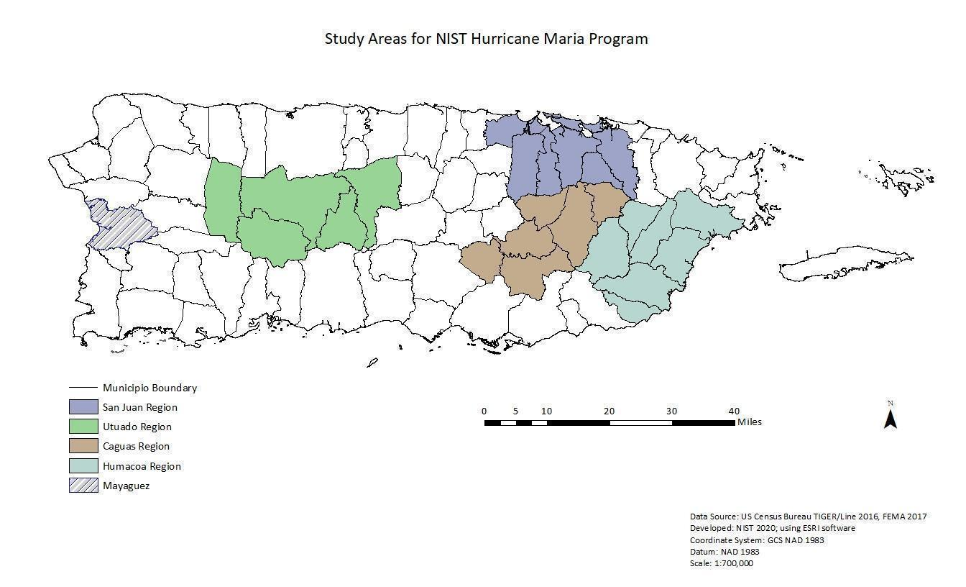
Figure 2. Education Technical Component - Study Area

Schools selected to participate in the study will be drawn from study areas with Linking Hospitals, Non-Linking Hospitals, and areas with no hospitals. There are a total of 1,008 schools in the study area depicted in the map above (See Figure 2). A sample size of 410 schools was selected based on the population of schools in the study area and a desire to perform statistical analyses with a confidence level of 95% and a confidence interval of +/-4%. The target sample size accounts for anticipated attrition over the three waves of data collection, as well as withdrawals and dropouts. The sample represents 40% of the population of schools in the study area. Because response rates have proven challenging during the pilot test, a secondary sample frame was developed that includes the remaining schools in Puerto Rico that are located outside of the study area. The secondary frame will serve as replacements for non-respondent schools within the study area as needed.

Response rates will be closely monitored to achieve the expected 50% survey completion rate for schools. A number of outreach efforts were undertaken in order to enhance the visibility and legitimacy of the project and achieve expected response rates. First, the NIST Hurricane Maria webpage is used to generate awareness of the project, planned data collection, and to prepare respondents for study participation requests. Second, introductory letters describing the scope and objective of the Hurricane Maria investigation were sent to email addresses associated with individual schools in the study area. Third, NIST researchers held a series of meetings with stakeholders and representatives of the relevant governing bodies (e.g., Puerto Rico Department of Education) to understand local needs and concerns and identify perspectives less likely to be captured in surveys. Fourth, research authorization was applied for and granted by the Puerto Department of Education, the documentation of which is similarly available online to study participants. The survey landing page will be used as an additional space to provide additional project background information, including a letter of support from the Puerto Rico Department of Education, an introductory letter from NIST, and contact information for NIST contractors assisting with data collection.

In addition to pre-survey outreach efforts, the Recovery of Social Functions Project has developed a multi-mode approach for respondent completion (i.e., by telephone, self-administered online, in person) and a secondary sample frame from which to draw replacement schools located outside the study area.

Depending on the response rates realized, schools beyond the study area may be needed in order to attain the desired number of complete responses. If survey completion rates fall below the goal threshold as identified during weekly assessments, additional measures will be evaluated to help improve the number of completed surveys. Measures to improve response rates may include multiple communication attempts with individual schools as needed as well as contacting key representatives at each institution identified through professional associations, such as the Puerto Rico Council on Education. Should respondent replacement be necessary, methods have been developed to allow for respondent replacement from a secondary sample frame. Replacement schools will be based on selections from the secondary sampling frame with similar characteristics as the non-responding school including geographic area, funding structure (i.e., public or private institution), and student enrollment size.

Some personally identifiable information (PII) will be collected; however, data is not stored in a Privacy Act System in which information is retrieved by a personal identifier. Therefore, a Privacy Act Statement and SORN are not applicable.

4. Describe how the results of the survey will be analyzed and used to generalize the results to the entire customer population.

NIST has selected four regions of Puerto Rico for particular focus, in light of the geographic and socio-economic diversity of these regions, the path of the storm, and the variety of Hurricane Maria’s hazards and impacts in these regions (i.e., rainfall and flooding, landslides, wind damage, and impacts to schools). The aim of the analysis is to generalize findings to the population of schools in these four selected regions (San Juan, Caguas, Humacao, and Utuado), as well as the municipality of Mayagüez which has been added as an additional area of study so as to align with the goals and objectives of the investigation. The initial basis for the selection of San Juan, Caguas, Humacao, and Utuado regions was the 2017 map of emergency management zones, which was in effect at the time of Hurricane Maria. To ensure a representative sample of schools, replacement respondents will be drawn from a secondary sample frame. In the event a representative sample of schools is not received, results will be weighted. Results of the survey will be generalizable to the entire population of schools in the study area.

The information on schools that will be collected in this study relate to the following main topics: (1) a screening and information about respondent, (2) impacts and recovery for services and resources, (3) physical damage and repair, (4) non-physical impacts, (5) decisions, planning, and communication, and (6) recovery. Longitudinal survey data will support the development of an empirical model that seeks to explain variation in recovery status. Inferential statistics will enable the identification of underlying characteristics and conditions associated with the recovery of critical social functions following the impacts of Hurricane Maria, as well as the study of interdependencies of the broader community (e.g., infrastructure, households, businesses) and the social functions provided by schools. Subgroup analyses will examine variation in recovery status by variables such as geographic region and institution size (e.g., student enrollment). The study will explore associations between recovery (a composite of several recovery indicators) and multiple independent variables (e.g., the impact of Hurricane Maria, response to Hurricane Maria, organizational characteristics prior to Hurricane Maria, etc.) while controlling for initial vulnerabilities, pre-existing conditions, and complicating events. For example, collecting retrospective data on Puerto Rico prior to the recent earthquake sequence and COVID-19 pandemic will allow an assessment of the impacts to the recovery process associated with these events. The longitudinal survey design will control for potential confounding effects by observing the same cases over three points in time.

