Emergency Communications Survey Distribution Postcard

[Front]

Did you live at this location when Hurricane Maria hit Puerto Rico?
If so, we need your help. Would you please take our survey? We are gathering information on how emergency communications were used prior to and after the hurricane. Respondents should be at least 21 and involved in preparing for the hurricane.
- To complete online, go to: www.EstudioHuracanMaria.com, and enter code: [PASSCODE]
- To complete by phone, call: 787-344-1445 and tell us your code (above).

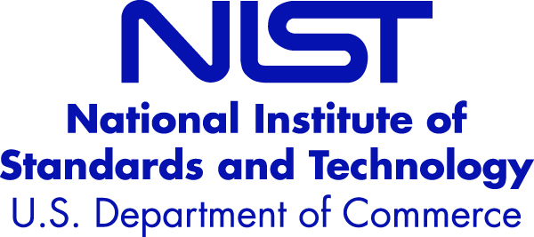
[Back]
Your household has been randomly selected to participate in a 25 minute survey to gather input across Puerto Rico on emergency communication messages. Your participation is voluntary, and your responses will be kept anonymous.
Graduate students from Albizu University are conducting the survey on behalf of the U.S. National Institute of Standards and Technology. This investigation is authorized by the National Construction Safety Team Act and will help generate recommendations to improve emergency communication policies and procedures for future events such as hurricanes.
Thank you for your assistance!
This information collection is approved under OMB Control #0693-007.

