PRA Application Supporting Statement

OMB Control #0693-0078
Expiration Date: 07/31/2022
NIST Generic Clearance for Community Resilience Data Collections

NIST HURRICANE MARIA STUDY,
HURRICANE MARIA RECOVERY OF CRITICAL SOCIAL FUNCTIONS PROJECT:
HOSPITAL RECOVERY FOLLOWING HURRICANE MARIA
HOSPITAL RECOVERY INTERVIEW WAVE 1

FOUR STANDARD SURVEY QUESTIONS
This PRA application covers the Wave 1 Interview for the Recovery of Hospitals component of the scientific study of Hurricane Maria (henceforth the Recovery of Social Functions Project).

1. Explain who will be surveyed and why the group is appropriate to survey.

NIST is conducting a longitudinal survey of a stratified random sample of hospitals in Puerto Rico in order to track their progress toward recovery from the impacts of Hurricane Maria. A subset of the survey sample will be contacted for a separate and complementary semi-structured interview, the subject of the present PRA supporting statement. This portion of the information collection will provide a richer, more detailed understanding of the critical factors underlying institutional recovery, and, ultimately, community resilience. The interview will target specific organizational representatives (e.g.., Administrator, Executive Director, and Manager) who can complete the interview questionnaire on behalf of public and private hospitals. Participation in the interview will be limited to organizational representatives who meet certain eligibility criteria. Criteria include (1) representing a participating hospital of the aforementioned Wave 1 Survey, (2) demonstrating interest in being interviewed about their hospital’s experience before and after Hurricane Maria, including the hurricane impacts sustained by their hospitals and any relevant participation in key recovery activities, (3) organizational characteristics across the sample (e.g., public/private, size), (4) survey responses on recovery questions, and (5) the individual is an adult (18 years of age or older). By targeting suitable organizational representatives, the study will provide direct insight into the services and resources offered by hospitals before and after Hurricane Maria, the damage and disruption to hospitals functioning caused by the hurricane, the repair and recovery process from Hurricane Maria, as well as actions taken by hospital administrators to prepare for future hurricanes.

Hospitals are in many ways a defining characteristic of modern industrial societies. Hospitals often serve as the primary source of medical care and health education in communities, while supporting medical research and technological innovation more broadly. The critical functions provided by hospitals may be key to facilitating community recovery from hurricane-related impacts. By identifying the underlying characteristics and conditions associated with recovery of critical social functions from Hurricane Maria as well as the interdependencies of the broader community (e.g., households, businesses), this work will allow us to make recommendations for 1) community resilience metrics for the healthcare sector and 2) guidance on recovery actions for critical social functions that support prioritization within different phases of the hazard event.

Project Background: The research objective of the Recovery of Social Functions Project is to identify the underlying characteristics and conditions associated with recovery of critical social functions from Hurricane Maria in Puerto Rico and to examine the recovery trajectories of sampled social organizations (specifically, K-12 schools and hospitals). The interview (the information collection being requested in this Supporting Statement) is one of two related data collection activities. The interview will be administered to a sub-sample of respondents participating in a survey previously approved by PRA. For more information on the survey, please refer to the PRA supporting statement titled, NIST HURRICANE MARIA STUDY, HURRICANE MARIA RECOVERY OF CRITICAL SOCIAL FUNCTIONS PROJECT: HOSPITAL RECOVERY FOLLOWING HURRICANE MARIA SCHOOL RECOVERY SURVEY WAVE 1.

This study falls within a broader program of activity at NIST - the Hurricane Maria Program. Under this program, there is both a technical investigation of Hurricane Maria and its impacts on Puerto Rico and a scientific study of the impacts of and recovery from Hurricane Maria. As complementary components of the NIST Hurricane Maria Program, the NCST technical investigation and the NWIRP research study are closely coordinated. Under the National Windstorm Impact Reduction Act Reauthorization of 2015 (Public Law 114-52), NIST is conducting a scientific study of the impacts of and recovery from Hurricane Maria. The National Windstorm Impact Reduction Act Reauthorization (Public Law 114-52) designates NIST as the lead agency for the National Windstorm Impact Reduction Program (NWIRP) and gives NIST responsibility to:
- Ensure that the Program includes the necessary components to promote the implementation of windstorm risk reduction measures;
- Support the development of performance-based engineering tools, and working with appropriate groups to promote the commercial application of such tools;
- Request the assistance of Federal agencies other than the Program agencies, as necessary;
- Coordinate all Federal post-windstorm investigations to the extent practicable; and
- When warranted by research or investigative findings, issue recommendations to assist in informing the development of model codes, and provide information to Congress on the use of such recommendations.

NWIRP was established by Congress “…to achieve major measurable reductions in the losses of life and property from windstorms through a coordinated Federal effort, in cooperation with other levels of government, academia, and the private sector, aimed at improving the understanding of windstorms and their impacts and developing and encouraging the implementation of cost-effective mitigation measures to reduce those impacts.”

Under the NWIRP authority, NIST is conducting a scientific study of Hurricane Maria’s impacts on Puerto Rico and subsequent recovery processes. The three main goals of the study are to characterize the impacts to and recovery of: (1) small and medium-sized manufacturers (SMMs), as well as businesses in retail and service industries, (2) education and healthcare services, and (3) infrastructure systems, with a focus on infrastructure that supports the functioning of critical buildings (i.e., schools and hospitals) and emergency communications.

2. Explain how the survey was developed including consultation with interested parties, pre-testing, and responses to suggestions for improvement.

The interview guide was developed by NIST scientists and contractors with backgrounds in sociology, geography, anthropology, and economics through a series of development and quality control activities. The interview guide was reviewed in depth by scientists and engineers with backgrounds in disaster resilience, public policy, emergency medicine, and clinical psychology. The interview guide explores the characteristics and conditions that influence institutional recovery and resilience in the context of disasters.

First, a review of previous disaster literature, relevant news media, and interview questionnaires was conducted to better understand the types of factors that influence the recovery of organizational functioning during disaster events and to develop the basis of our interview guide. When possible, previously vetted questions were used from the existing studies of disaster recovery and resilience research. The literature review employed Web of Science, Google Scholar, and Google to identify papers, reports, and interview questionnaires in peer-review journals and the grey literature.

Next, after a draft interview guide was developed, NIST researchers obtained feedback from subject matter experts in the study of disaster recovery to better assess question wording, complexity, and overall burden. This review also included members of the contractor team that is working with NIST. Additional revisions were made that focused on the chronological ordering of interview questions and content (i.e. what damages were linked to reductions in which services and why), and the questionnaire was condensed to reduce its length. In addition, minor revisions were made to the interview questionnaire to enhance clarity and consistency in wording. These include changes to word choice, formatting, scripting for interviewers, and ordering of questions.

3. Explain how the survey will be conducted, how customers will be sampled if fewer than all customers will be surveyed, expected response rate, and actions your agency plans to take to improve the response rate.

NIST, in partnership with contractors who can utilize trained personnel local to Puerto Rico, will interview hospitals in the study area. Semi-structured interviews shall be administered to a subset of the larger sample of hospitals participating in the longitudinal survey. The interviews will allow for in-depth questioning on particular topics, such as decision-making following Hurricane Maria and throughout the recovery process. Whereas the longitudinal survey will be carried out over three points in time or “waves” along a continuum of recovery, the interviews will be carried out following Wave 1 Survey administration, the preliminary findings of which will inform the selection of hospitals invited to participate in the interview. Figure 1 provides an overview of the interview data collection.

For those hospitals participating in the Wave 1 Survey that are selected for the interview using the criteria described above, NIST contractors will reach out through email or telephone. During this initial outreach, potential respondents will receive an introduction to the interview, including a description of the scope and objective of the interview, as well as a formal invitation to participate. All respondents, regardless of initial mode of contact, will have the option to specify their preferred mode for completing the interview (over the telephone, online via video conference, or in-person depending on COVID-19 rates at the time of data collection). If the respondent accepts the invitation to participate, an appointment for the 60-minute interview will be created. For the telephone interview, NIST contractors will telephone the respondent at a predetermined time and conduct the interview after obtaining verbal consent. For the online video conference interview, respondents will access the meeting link to the video conference website sent in an earlier email, logon to the meeting platform using a unique ID and password, and complete the interview. Any in-person data collection will observe COVID-19 safety protocols. In-person data collection will also depend upon successful initial contact and a prior appointment with the respondent. It is anticipated that 50% of respondents will opt to complete the interview in person; 20% of respondents will opt to complete the interview by telephone; 30% of respondents are expected to complete the interview online via teleconference. These anticipated percentages may change if COVID-19 rates disrupt in-person data collection. See supporting materials for the Hospital Interview Outreach Communication Scripts.

Consistent with IRB requirements, interviews will only take place once consent to be interviewed and permission to be audio-recorded has been granted by the interviewee. In-person interviews will be recorded using a digital audio recorder, with a phone serving as a back-up recording device. Telephone interviews will be recorded using the Nuxiba CenterWare Kolob voice-over-internet audio-recording service. Video conference interviews will be recorded using the conferencing platform. At the conclusion of the interview, interviewers will thank participants for their time, and instructions will be provided on how to access online the status of the project and eventually study findings. See supporting materials for the Hospital Interview Outreach Communication Scripts.

Location | Who | Number of Organizations | Average Length  (per)
Municipios and barrios within the emergency management zones selected by NIST (I,VII,X,XI), plus Mayaguez | Subset of Wave 1 respondents | 15 semi-structured interviews | 1 hour
Figure 1. Health Technical Component - Interview Data Collection

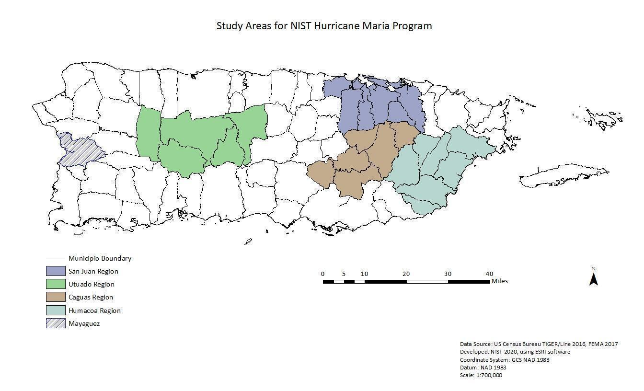
Figure 2. Health Technical Component - Study Area

There are a total of 68 hospitals in Puerto Rico, 45 of which are in the study area depicted in the map above (See Figure 2). Because hospitals will be recruited from a sub-sample of survey respondents, their responses will be linked across the two instruments. As such, the interview is exploratory and intended to elicit a diversity of recovery experiences. A sample size of 15 hospitals was selected to reach saturation and redundancy, based on established grounded theory principles of in-depth interviewing. Hospitals will be selected to participate on the basis of their inclusion in pertinent sample strata (e.g., geographical location, funding structure, hospital size). Additional factors, such as how hospitals responded to a select number of Wave 1 Survey questions (e.g., level of sustained damage, amount of recovery funding received, etc.) and interest in participating in the interview following the survey, will also guide the selection of hospitals invited to participate in the interview.

Because interview respondents will be recruited from Wave 1 Survey participants, we expect a 99% interview completion rate. In addition, we have planned a combination of proactive measures and alternative data collection procedures to achieve our expected response rate:
- Outreach efforts including the creation of the NIST Hurricane Maria webpage, introductory emails sent to individual hospitals, and a series of meetings between NIST researchers, stakeholders and representatives of the relevant governing bodies (e.g., Puerto Rico Department of Health);
- Daily and weekly monitoring of response rates over the course of data collection;
- Multiple communication attempts to individual hospitals as needed;
- A multi-mode approach for respondent completion (i.e., by telephone, online via video conference, in person).

No sensitive PII will be collected with this instrument, rather the contractor will link appropriate data before the information is translated to NIST, and NIST will retain no sensitive PII. Therefore, this is not a Privacy Act System and SORN and Privacy Act Notice are not applicable.

Time burden is calculated to be 15 respondents * 60 (minutes) = 15 burden hours.

4. Describe how the results of the survey will be analyzed and used to generalize the results to the entire customer population.

The aim of the interview analysis is to establish a range of experiences of Hurricane Maria and subsequent recovery, which will be used to contextualize and enhance understanding of findings from the aforementioned Wave 1 Survey. Following the conclusion of data collection, the interviews will be transcribed and translated into English by the Contractor and delivered to NIST personnel for analysis. Interview transcriptions will be entered into a standard qualitative data software package (e.g., Atlas.ti, NVivo) for database construction and analysis. Descriptive coding techniques will be applied to interview content in order to identify key themes and constructs relating to institutional recovery. Once formalized, the final codebook will be applied to all 15 interview transcripts in order to identify overarching themes in the recovery process for hospitals, as well as similarities and differences among organizations’ experiences of hospital recovery from the impacts of Hurricane Maria.

Ultimately, the results of the interview analysis will support the development of an empirical model that seeks to explain variation in the recovery status of hospitals. Interview findings, while not statistically generalizable, will nevertheless be important for interpreting the statistical model results and for characterizing the social context in which recovery processes play out. While each response will be unique to a specific individual or setting, a diversity of recovery experiences taken together will provide a representative picture of hospital recovery following Hurricane Maria. Interview findings will aid in establishing the sequence of recovery-related events, provide insight into the role of pre-existing conditions (e.g., out-migration) as well as the co-occurrence of complicating events (e.g., COVID-19 pandemic), and potentially shed light on causal relationships.

