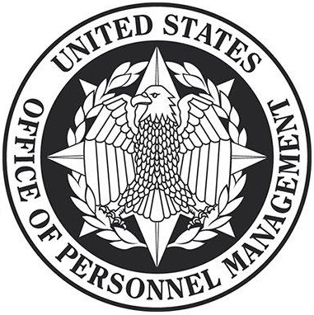

A | B | C | D | E
PIN CODE

NAME:

Thank you for contacting the Verification Center to determine if you were impacted by the malicious cyber intrusion carried out against the U.S. Government, which resulted in the theft of background investigation and personnel records.

You are receiving this notification because we have determined that your Social Security number and other personally identifiable information were included in the 2015 background investigation records and personnel records incidents.

If you applied for a position or submitted a background investigation form, the information that may have been taken in the background investigations records incident includes your name, Social Security number, address, date and place of birth, residency, educational and employment history, personal foreign travel history, information about immediate family as well as business and personal acquaintances, and other information used to conduct and adjudicate your background investigation.

If your information was listed on a background investigation form by a spouse, or co-habitant, the information that may have been taken in the background investigations records incident includes your name, Social Security number, address, date and place of birth, and in some cases, your citizenship information.

The information that may have been taken in the personnel records incident includes your name, date of birth, home address and Social Security number.

We share your concern and frustration and want you to know we are working hard to help those impacted by this incident. At no cost to you, the U.S. Government is providing impacted individuals with a comprehensive suite of services through ID Experts (MyIDCare). These services include credit monitoring, identity monitoring, identity restoration, and identity theft insurance. ID Experts will also extend identity monitoring, identity theft insurance, and identity restoration services to your dependent children who were under the age of 18 as of July 1, 2015.

As an impacted individual, you will be automatically covered for full-service identity restoration and up to $5 million of identity theft insurance coverage, but you will need to enroll with ID Experts if you would like to receive credit and identity monitoring services. The U.S. Office of Personnel Management (OPM) is currently working to extend coverage to all impacted individuals to 10 years.

To take advantage of the monitoring services being offered at no cost to you, you must enroll with ID Experts using the 25-digit PIN code at the top of this letter. To enroll, please go to https://www.opm.gov/cybersecurity and follow the enrollment instructions. You may also call ID Experts at 1-800-750-3004 to enroll for services, get assistance, or get answers to frequently asked questions. I hope you will take advantage of these services.

Please note that you will not receive any unsolicited phone calls or emails from OPM and ID Experts in which you are asked to confirm any personal information. If you are contacted by anyone asking for your personal information in relation to this incident, do not provide it.

To access our frequently asked questions, learn tips on how to protect your personal information, or to sign up for our email update list, please visit our Cybersecurity Resource Center at https://www.opm.gov/cybersecurity.
UNITED STATES OFFICE OF PERSONNEL MANAGEMENT
Washington, DC 20415

opm.gov Empowering Excellence in Government through Great People usajobs.gov

