SUPPORTING STATEMENT - PART A
Software Resource Data Reports (SRDRs) - 0704-SRDR

1. Need for the Information Collection

Cost Assessment and Program Evaluation (CAPE) is statutorily required by Title 10, United Stated Code (U.S.C.) in Section 2334(g), to “develop policies, procedures, guidance and a collection method to ensure that quality acquisition cost data are collected to facilitate cost estimation and comparison across acquisition programs.” Section 2334(g) also contains a $100,000,000 threshold statutory requirement to provide cost data from each acquisition program that exceeds this amount. Section 2334(g) also states the policies, procedures, guidance and collection method may be waived only by the Director of Cost Assessment and Program Evaluation. This requirement is codified in the table below:
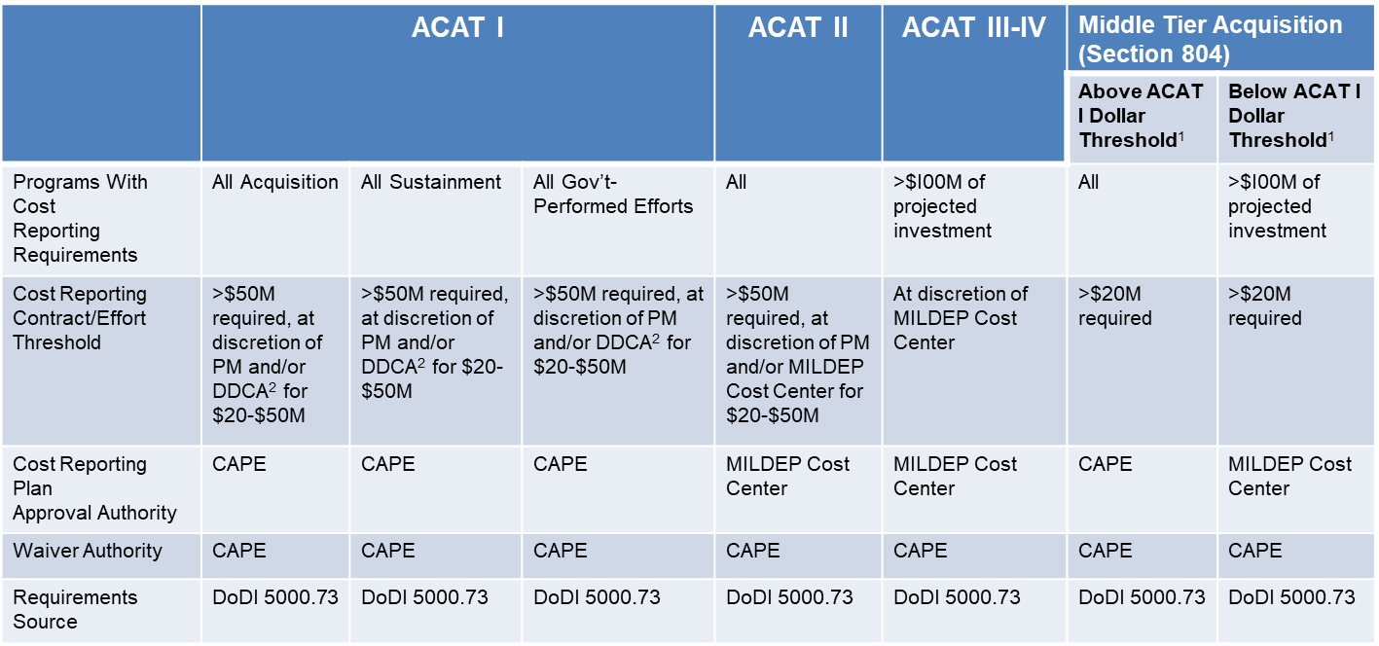

Department of Defense (DoD) Directive (DoDD) 5105.84, “Director of Cost Assessment and Program Evaluation (DCAPE),” Change 1 effective May 29, 2020, DoD Instruction (DoDI) 5000.73, “Cost Analysis Guidance and Procedures,” March 13, 2020, and DoDM 5000.04, Cost and Software Data Reporting Manual, dated May 7, 2021 document these requirements.

2. Use of the Information

The intent of the Software Resource Data Reports (SRDR) is to capture software resource and effort data, at the Software Release and Computer Software Configuration Item (CSCI) levels that are significant either for a current program or when a similar effort may be required for a future program. The three SRDR are DD Form, 3026-1, “Software Development Report,” DD Form 3026-2, “Software Maintenance Report,” and DD Form 3026-3, “Enterprise Resource Planning (ERP) Software Development Report.” The collected data is the primary data source utilized when completing cost estimates. Respondents are any weapons system contractor or government entity with contracts, subcontracts, or agreements that are required to provide Cost and Software Data Reports (CSDRs) based on all anticipated costs that individually or collectively surpass the corresponding dollar thresholds established in DoDI 5000.73.

The SRDRs are available for download at https://www.esd.whs.mil/Directives/forms/dd3000_3499/

The reporting entity submits the DD forms directly into the secure CADE Submit-Review portal, where the submission is reviewed by the Defense Cost and Resource Center (DCARC) for quality, completeness, and accuracy to the original requirement. When the submission is approved by the government, an automatic email is sent to the respondent alerting them that the submission was accepted or rejected. The finalized submission is made available in CADE Data & Analytics for download and retrivial by government cost analysts and used for estimating and analysis.

3. Use of Information Technology
100% of submissions are received into CADE electronically. The reporting entity submits the forms into the secure CADE Submit-Review portal, which is all electronic.

4. Non-duplication
The information obtained through this collection is unique and is not already available for use or adaptation from another cleared source.

5. Burden on Small Businesses
This information collection does not impose a significant economic impact on a substantial number of small businesses or entities. All CSDR plans are tailored to the contractor's accounting system(s) and technical approach to accomplish the contractor's scope of work requirements, irrespective of the size of the contractor, experience with CSDR, or the type of contract (e.g., Federal Acquisition Regulation, Middle Tier of Acquisition). The review of the CSDR plan's requirement and potential tailoring occur at the CSDR Readiness Review. The CSDR Readiness Review should happen as early in the acquisition process as is practical and allowed by the contracting officer (preferably before contract award) in order to ensure accounting systems and the like are prepared to collect data as required.

6. Less Frequent Collection
The CSDR data is collected annually, or based on program/contract milestones, where data is needed to support major programmatic decisions. If the data is not collected annually, the Program will be documented as non-compliant with CSDR data collection and potentially subjected to review delays.

7. Paperwork Reduction Act Guidelines
This collection of information does not require collection to be conducted in a manner inconsistent with the guidelines delineated in 5 CFR 1320.5(d)(2).
8. Consultation and Public Comments
Part A: PUBLIC NOTICE
A 60-Day Federal Register Notice (FRN) for the collection published on Friday, May 13, 2022). The 60-Day FRN citation is 87 FRN 29300.
No comments were received during the 60-Day Comment Period.
A 30-Day Federal Register Notice for the collection published on Thursday, August 4, 2022. The 30-Day FRN citation is 87 FRN 47731.
Part B: CONSULTATION
No additional consultation apart from soliciting public comments through the Federal Register was conducted for this submission.
9. Gifts or Payment
No payments or gifts are being offered to respondents as an incentive to participate in the collection.

10. Confidentiality
A Privacy Act Statement is not required for this collection because we are not requesting individuals to furnish personal information for a system of records.

A copy of the SORN (SORN K809.21) has been provided with this package for OMB’s review.

A copy of the PIA, Cost Assessment Data Enterprise-IT (CADE-IT) has been provided with this package for OMB’s review.

FILE NUMBER: 1403-02
FILE TITLE: Manpower Resources
FILE DESCRIPTION: Analysis of policy and planning guidance to identify and evaluate DoD peacetime and wartime military and civilian manpower requirements. Reviews and analyses of manpower requirements in terms of functions, skills, costs, and training capacity. Reviews of budget implications and alternative manpower programs.
DISPOSITION: Permanent. Cut off annually. Transfer to NARA 25 years after cutoff.
AUTHORITY: NC1-330-77-003, item 1403-02

11. Sensitive Questions
No questions considered sensitive are being asked in this collection.

12. Respondent Burden and its Labor Costs
Part A: ESTIMATION OF RESPONDENT BURDEN

- Collection Instrument(s)
Software Development Report (DD 3026-1)
- Number of Respondents: 12
- Number of Responses Per Respondent: 12
- Number of Total Annual Responses: 144
- Response: 16 hours
- Respondent Burden Hours: 2,304 hours

Software Maintenance Report (DD 3026-2)
- Number of Respondents: 11
- Number of Responses Per Respondent: 14
- Number of Total Annual Responses: 154
- Response Time: 16 hours
- Respondent Burden Hours: 2,464 hours

Enterprise Resource Planning (ERP) Report (DD 3026-3)
- Number of Respondents: 12
- Number of Responses Per Respondent: 11
- Number of Total Annual Responses: 132
- Response Time: 16 hours
- Respondent Burden Hours: 2,112 hours

- Total Submission Burden
  - Total Number of Respondents: 35
  - Total Number of Annual Responses: 430
  - Total Respondent Burden Hours: 6,880 hours

Part B: LABOR COST OF RESPONDENT BURDEN

- Collection Instrument(s)
Software Development Report (DD 3026-1)
- Number of Total Annual Responses: 144
- Response Time: 16 hours
- Respondent Hourly Wage: $115.12
- Labor Burden per Response: $1,841.92
- Total Labor Burden: $265,236.48

Software Maintenance Report (DD 3026-2)
- Number of Total Annual Responses: 154
- Response Time: 16 hours
- Respondent Hourly Wage: $115.12
- Labor Burden per Response: $1,841.92
- Total Labor Burden: $283,655.68

Enterprise Resource Planning (ERP) Report (DD 3026-3)
- Number of Total Annual Responses: 132
- Response Time: 16 hours
- Respondent Hourly Wage: $115.12
- Labor Burden per Response: $1,841.92
- Total Labor Burden: $243,133.44

- Overall Labor Burden
  - Total Number of Annual Responses: 430
  - Total Labor Burden: $792,025.60

The Respondent hourly wage was determined by using the Department of Labor Wage Website (http://www.dol.gov/dol/topic/wages/index.htm)

13. Respondent Costs Other Than Burden Hour Costs
There are no annualized costs to respondents other than the labor burden costs addressed in Section 12 of this document to complete this collection.

14. Cost to the Federal Government

Part A: LABOR COST TO THE FEDERAL GOVERNMENT

- Collection Instrument(s)
Software Development Report (DD 3026-1)
- Number of Total Annual Responses: 144
- Processing Time per Response: 16 hours
- Hourly Wage of Worker(s) Processing Responses: $115.12
- Cost to Process Each Response: $1,841.92
- Total Cost to Process Responses: $265,236.48

Software Maintenance Report (DD 3026-2)
- Number of Total Annual Responses: 154
- Processing Time per Response: 16 hours
- Hourly Wage of Worker(s) Processing Responses: $115.12
- Cost to Process Each Response: $1,841.92
- Total Cost to Process Responses: $283,655.68

Enterprise Resource Planning (ERP) Report (DD 3026-3)
- Number of Total Annual Responses: 132
- Processing Time per Response: 16 hours
- Hourly Wage of Worker(s) Processing Responses: $115.12
- Cost to Process Each Response: $1,841.92
- Total Cost to Process Responses: $243,133.44

- Overall Labor Burden to the Federal Government
  - Total Number of Annual Responses: 430
  - Total Labor Burden: $792,025.60

Part B: OPERATIONAL AND MAINTENANCE COSTS

- Cost Categories
  - Equipment: $0
  - Printing: $0
  - Postage: $0
  - Software Maintenance: $405,708.24
  - Licensing Costs: $0
  - Other: $0

- Total Operational and Maintenance Cost: $405,708.24

Part C: TOTAL COST TO THE FEDERAL GOVERNMENT

- Total Labor Cost to the Federal Government: $792,025.60

- Total Operational and Maintenance Costs: $405,708.24

- Total Cost to the Federal Government: $1,197,733.84

15. Reasons for Change in Burden
This is a collection in use without an OMB Control Number.

16. Publication of Results
The results will be published to the DoD Cost Assessment Data Enterprise (CADE) database for cost estimating and analysis purposes. Specifically, to generate independent cost estimates and analysis supporting DoD, as well as all Services. Projected date of publication is July 30, 2022.

17. Non-Display of OMB Expiration Date
We are not seeking approval to omit the display of the expiration date of the OMB approval on the collection instrument.

18. Exceptions to “Certification for Paperwork Reduction Submissions”
We are not requesting any exemptions to the provisions stated in 5 CFR 1320.9.

