Attachment 3h

Dietary Interview Hand Cards: Dietary Recall (DRQ) and Dietary Supplements (SAQ)

TABLE OF CONTENTS

Dietary Recall (DRQ) Hand Cards 2
Dietary Supplements (SAQ) Hand Cards 5

Dietary Recall (DRQ) Hand Cards

DRQ1

Fish

Breaded fish products
Tuna-canned or fresh
Bass
Catfish
Cod
Flatfish
Haddock
Mackerel
Perch
Pike
Pollock
Porgy
Salmon
Sardines
Sea Bass
Shark
Swordfish
Trout
Walleye
Other type of fish

Shellfish
DRQ2
Clams
Crab
Crayfish (Crawfish)
Lobster
Mussels
Oysters
Scallops
Shrimp
Other shellfish (for example, octopus, squid)

Dietary Supplements (SAQ) Hand Cards

SAQ1

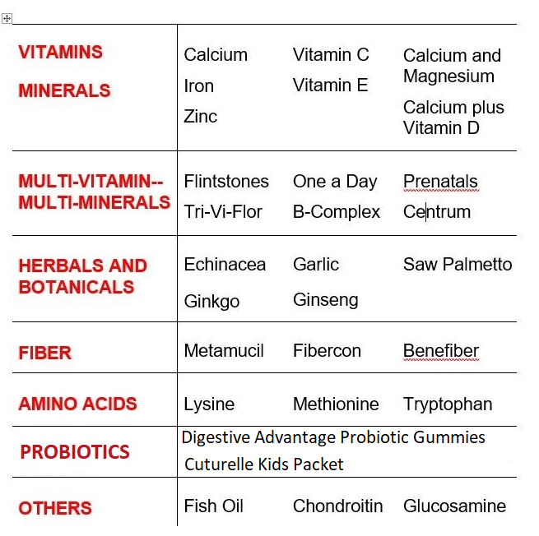

SAQ2

EXAMPLES OF ANTACIDS

Tums
Rolaids
Maalox
Mylanta

