Attachment E-2
Resident and Participant NCHS Data Briefs

(We are providing screenshots of the first page of the 2018 data briefs)

Accessed at: https://www.cdc.gov/nchs/data/databriefs/db404.pdf

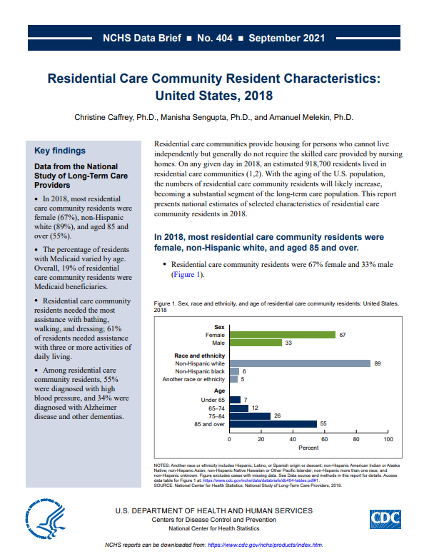

Accessed at: https://www.cdc.gov/nchs/data/databriefs/db411.pdf
