Attachment E-3
Letters of Support from Provider Associations

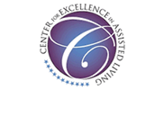
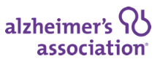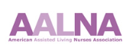
In 2022, CDC’s National Center for Health Statistics will conduct the sixth wave of the National Post-acute and Long-term Care Study (NPALS)—formerly known as the National Study of Long-Term Care Providers (NSLTCP). NPALS is a biennial national study of the major sectors of paid, regulated providers of long-term care services. This data collection effort will include a representative sample of assisted living and similar residential care communities across the country.

National data collection will start in August. The Center for Excellence in Assisted Living (CEAL), a unique collaborative of diverse national organizations representing providers, advocates, and other stakeholders in assisted living (see theceal.org) strongly encourages your participation.

The information collected will help policymakers, health care planners, and providers better understand, plan for, and serve the future long-term care needs of the older population and disabled adults.

While results from this survey will be made publicly available, all data will be kept strictly confidential and aggregated, so that the names of the communities, staff, residents, and respondents will not be identifiable.

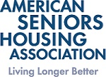



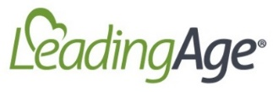
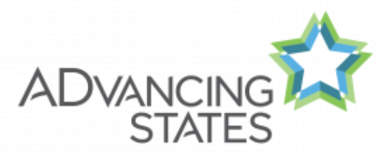
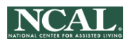

In 2022, CDC’s National Center for Health Statistics is conducting the sixth wave of the National Post-acute and Long-term Care Study (NPALS), formerly known as the National Study of Long-Term Care Providers or NSLTCP. National data collection starts in August.
The information collected will help policymakers, health care planners, and providers better understand, plan for, and serve the future long-term care needs of the older population and disabled adults.

While results from this survey will be made publicly available, all data will be kept strictly confidential and aggregated, so that the names of the centers, staff, participants, and respondents will not be identifiable.

NADSA, LeadingAge, and Advancing States appreciate your participation in this important national initiative. If you have any questions or concerns, please contact us at our national offices.

Many thanks,

Lisa Peters-Beumer Ruth Katz Martha Roherty


Board Chair Senior Vice President, Executive Director
(202-508-9470) Public Policy/Advocacy (877-745-1440)
(202-898-2578)

